#$K+!MODULE SERA CARD 0

Summary

∗ model generalities

∗ topological data

∗ physical and geometrical data

∗ module variables initialization

∗ user's subprograms

∗ residuals

∗ module subprograms

∗ test cases

#$K+!MODULE SERA CARD A

Model Generalities

COMPRESSED AIR TANK

The SERA module simulates a cavity where gas is let in from one or more ducts and exhausted to one or more other ducts. The number of inlet and outlet ducts is selected by the user. In this element, the mass accumulation phenomenon is prevailing.

Main module basic hypothesis are :
- non adiabatic cavity walls
- thermal accumulation inside cavity walls
- gas inside the volume perfectly mixed, such to consider its temperature as uniform.
- the perfect gas law applies to the fluid inside the cavity.

Equations used are:
1) gas energy conservation equation
2) gas mass conservation equation.
3) energy balance of cavity metallic wall

The module maintains its validity in case of flow inversion in the inlet and/or outlet ducts.

#$K+!MODULE SERA CARD B

Topological data

INPUT-OUTPUT SCHEME

i = 1, 2, ..., NE (number of inlet pipes)
j = 1, 2, ..., NU (number of outlet pipes)

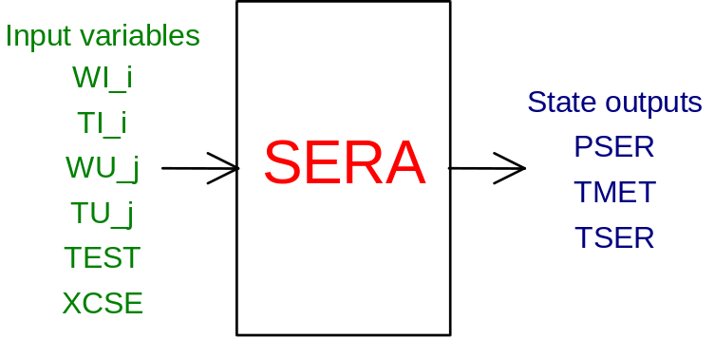

PHYSICAL MEANING OF MODULE INPUT-OUTPUT VARIABLES

[kg/s] WI_i gas flow at tank inlet from i-th duct
[K] TI_i gas temperature at tank inlet from i-th duct
[kg/s] WU_j gas flow rate at ordinary outlet from tank to j-th duct
[K] TU_j gas ordinary outlet temperature with flow inversion
[K] TEST external temperature
[W/m²K] XCSE tank - environment thermal exchange coefficient
[Pa] PSER pressure in tank
[K] TFPL tank metallic wall temperature
[K] TSER gas temperature in the tank

#$K+!MODULE SERA CARD C

Physical and Geometrical Data

In addition to initial values of input and output variables of the SERA module, whose meaning has been defined in Card B, the user must assign the following data to complete the input required by the module:
[ ] N.TU.EN number of inlet ducts
[ ] N.TU.US number of outlet ducts
[m³] VolSer tank internal volume
[m] DiamInt tank internal diameter
[m] Spess tank wall thickness
[kg/m³] DensMet density of tank wall material
[J/kgK] CalSpMet specific heat of tank wall material
[W/m²K] CoefScIn thermal exchange coefficient between tank wall and fluid contained in the tank itself (the default value is 300.)
[ ] IGAS gas type: 1 for air, 2 for methane, 3 for hydrogen

#$K+!MODULE SERA CARD D

Module Variables Initialization

No particular prescription is required for initialization of SERA module variables.

#$K+!MODULE SERA CARD E

User's Subprograms

No user’s subprograms are required for this module.
The SERA module makes use of the procedures contained in the perfect gas thermodynamic tables (TAVGASPERF) which must be present in the user library.

#$K+!MODULE SERA CARD F

Residuals

To show the expressions of the solving residuals is not very enlightening; for that, it should need other explications, that should ask to go back in the mathematical model, but it goes beyond the scope of this document: for the user, it will be enough take note that the three residuals originated from the mathematical model, as already mentioned in Card A1, represent:

- the time derivative of the gas pressure inside the tank;
- the time derivative of the tank metal wall temperature;
- the rime derivative of the gas temperature inside the tank.

The evaluation of the 1st and the 3rd derivatives is performed inside the SERA module solving (internally) an algebraic system (obtained from the manipulation of the gas mass and energy conservation equations).

#$K+!MODULE SERA CARD G

Module subprograms

SUBROUTINE SERAI3 (IFO,IOB,DEBL)

SUBROUTINE SERAI4 (IOB, MOD, IBLOC, NE, NU)

SUBROUTINE SERAI2 (IFUN,VAR,MX1,IV1,IV2,XYU,DATI,ID1,ID2,
$ IBL1,IBL2,IER,CNXYU,TOL)

SUBROUTINE SERAC1 (IFUN,AJAC,MX5,IXYU,XYU,IPD,DATI,RNI,IBL1,IBL2)

SUBROUTINE SERA (IFUN,IXYU,XYU,IPD,DATI,RNI)

SUBROUTINE SERAD1 (BLOCCO,NEQUAZ,NSTATI,NUSCIT,NINGRE,SYMVAR,XYU,
$ IXYU,DATI,IPD,SIGNEQ,UNITEQ,COSNOR,ITOPVA,MXT)

#$K+!MODULE SERA CARD H

Test cases

Test cases for SERA module are not yet defined.

# lg_libproc_SERA_summ
$ SERA process module
K SERA process module
+ lg_pag_modu:1120
! EnableButton("button_up"); ChangeButtonBinding("button_up", "JumpId(`lglibpro.hlp',`lg_libproc_main')")
# lg_libproc_SERA_A
$ SERA process module (A)
K SERA process module (A)
+ lg_pag_sera:0002
! EnableButton("button_up"); ChangeButtonBinding("button_up", "JumpId(`lglibpro.hlp',`lg_libproc_SERA_summ')")
# lg_libproc_SERA_B
$ SERA process module (B)
K SERA process module (B)
+ lg_pag_sera:0003
! EnableButton("button_up"); ChangeButtonBinding("button_up", "JumpId(`lglibpro.hlp',`lg_libproc_SERA_summ')")
# lg_libproc_SERA_C
$ SERA process module (C)
K SERA process module (C)
+ lg_pag_sera:0005
! EnableButton("button_up"); ChangeButtonBinding("button_up", "JumpId(`lglibpro.hlp',`lg_libproc_SERA_summ')")
# lg_libproc_SERA_D
$ SERA process module (D)
K SERA process module (D)
+ lg_pag_sera:0006
! EnableButton("button_up"); ChangeButtonBinding("button_up", "JumpId(`lglibpro.hlp',`lg_libproc_SERA_summ')")
# lg_libproc_SERA_E
$ SERA process module (E)
K SERA process module (E)
+ lg_pag_sera:0007
! EnableButton("button_up"); ChangeButtonBinding("button_up", "JumpId(`lglibpro.hlp',`lg_libproc_SERA_summ')")
# lg_libproc_SERA_F
$ SERA process module (F)
K SERA process module (F)
+ lg_pag_sera:0008
! EnableButton("button_up"); ChangeButtonBinding("button_up", "JumpId(`lglibpro.hlp',`lg_libproc_SERA_summ')")
# lg_libproc_SERA_G
$ SERA process module (G)
K SERA process module (G)
+ lg_pag_sera:0010
! EnableButton("button_up"); ChangeButtonBinding("button_up", "JumpId(`lglibpro.hlp',`lg_libproc_SERA_summ')")
# lg_libproc_SERA_H
$ SERA process module (H)
K SERA process module (H)
+ lg_pag_sera:0011
! EnableButton("button_up"); ChangeButtonBinding("button_up", "JumpId(`lglibpro.hlp',`lg_libproc_SERA_summ')")

