MODULE SERB CARD 0

Summary

• model generalities

• topological data

• physical and geometrical data

• module variables initialization

• user's subprograms

• residuals

• module subprograms

• test cases

MODULE SERB CARD A

Model Generalities

WATER RESERVOIR

The module SERB simulates the behavior of a water reservoir.
Environment pressure is imposed (input variable) and bottom pressure is calculated taking into account a gravitational term.
Evaporation is considered too when the enthalpy of the entering liquid is greater than the saturation enthalpy. In this case an evaporation time constant (fixed inside the module code as 10 s) is considered.
The level is kept in any case under a overflow value defined as a datum.

The three balance equations are used for the calculations:
- MASS CONSERVATION – to calculate the level of the reservoir
- MOMENTUM CONSERVATION – to calculate bottom pressure
- ENERGY EQUATION – to calcuate average enthalpy in the reservoir

The module SERB can be easily coupled with COEX . They simulate respectively the water and the steam part of a biphase cavity: COEX provides SERB with actual environment pressure and a condensation mass flow rate. SERB, in its turn, calculates an evaporation mass flow rate to be sent to the COEX.

MODULE SERB CARD B

Topological data

INPUT-OUTPUT SCHEME

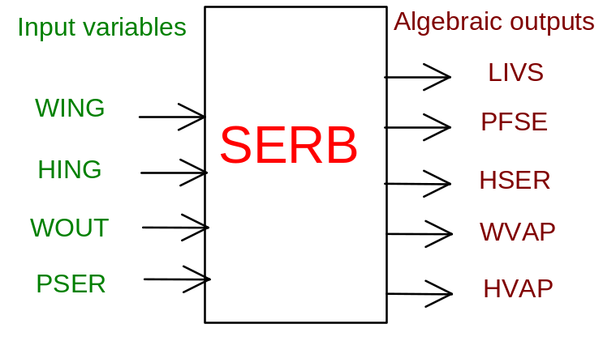

PHYSICAL MEANING OF MODULE INPUT-OUTPUT VARIABLES

[m] LIVS water level
[Pa] PFSE pressure on bottom
[J/kg] HSER average enthalpy
[kg/s] WVAP evaporation mass flow rate
[J/kg] HVAP evaporation enthalpy
[kg/s] WING input mass flow rate
[J/kg] HING input enthalpy
[kg/s] WOUT output mass flow rate
[Pa] PSER reservoir environment pressure

MODULE SERB CARD C

Physical and Geometrical Data

In addition to the initial values of input and output variables, user must assign the following data:

[m²] SEZ reservoir horizontal section (supposed constant)
[m] LMAX maximum allowed level

MODULE SERB CARD D

Module Variables Initialization

To initialize the SERB module variables no particular prescription is required.

MODULE SERB CARD E

User's Subprograms

SERB doesn’t prescribe any FORAUS subroutine.

MODULE SERB CARD F

Residuals

Five residuals are written:

- Mass conservation (level calcualation): ODE seen by LEGO as algebraic equation
- Momentum conservation: algebraic equation calculating bottom pressure
- Energy conservation (enthalpy calculation): ODE seen by LEGO as algebraic
- Evaporation mass flow rate calculation: algebraic equation
- Evaporation enthalpy: algebraic equation

MODULE SERB CARD G

Module subprograms

SUBROUTINE SERBI2(IFUN,VAR,MX1,IV1,IV2,XYU,DATI,ID1,ID2,
$ IBL1,IBL2,IER,CNXYU,TOL)
SUBROUTINE SERBI3(IFO,IOB,DEBL)
SUBROUTINE SERBI4(IOB,MOD)
SUBROUTINE SERBC1(IFUN,AJAC,MX5,IXYU,XYU,IPD,DATI,RNI,IBL1,IBL2)
SUBROUTINE SERBJAC(IFUN,AJAC,MX5,IXYU,XYU,IPD,DATI,RNI,IBL1,IBL2)
SUBROUTINE SERB(IFUN,IXYU,XYU,IPD,DATI,RNI)
SUBROUTINE SERBD1(BLOCCO,NEQUAZ,NSTATI,NUSCIT,NINGRE,SYMVAR,
$ XYU,IXYU,DATI,IPD,SIGNEQ,UNITEQ,COSNOR,ITOPVA,MXT)

MODULE SERB CARD H

Test cases

Reference test cases related to this module aren’t yet available.

