MODULE SHES CARD 0

Summary

∗ model generalities

∗ topological data

∗ physical and geometrical data

∗ module variables initialization

∗ user's subprograms

∗ residuals

∗ module subprograms

∗ test cases

MODULE SHES CARD A

Model Generalities

SIMPLIFIED HEAT EXCHANGER SHELL SIDE MODEL

The SHES module simulates the perfect mixing of "n" water flow rates (at liquid or steam state) flowing into an heat exchanger shell. It determines the enthalpy and pressure temporal evolution of fluid flowing through the heat exchanger as well as the temperature of the metallic shell wall.
In the physic-mathematical model the following simplifying hypotheses are adopted:
- it is admitted that fluid back-flow can occur inside one or more heat exchanger branches (both at inlet and outlet)
- heat exchanger shell metallic wall is able to exchange heat with the external environment
- only one temperature value identifies the thermal condition of the metallic walls
- the heat transfer coefficient between shell side fluid and tubes’ surface is admitted as a function of the fluid temperature and strenght
- the heat transfer coefficient shell wall – external environment is a constant value provided by user
- if the fluid state is biphase (mixture liquid and steam) the extracted fluid enthalpy is the saturated liquid enthalpy if the liquid volume is greater then an assigned fraction of the shell side volume. If the liquid volume is lower then the assigned fraction of the shell side volume, the extracted fluid enthalpy has an interpolation value among saturated liquid enthalpy and saturated steam enthalpy.

The used equations are:
1) shell side fluid mass conservation
2) shell side fluid energy conservation
3) shell metal wall energy conservation.

MODULE SHES CARD B

Topological data

INPUT-OUTPUT SCHEME

Ne = number of heat exchanger shell side inlet branches (max.10)
Nu = number of heat exchanger shell side outlet branches (max.10)
Nz = number of heat transfer zone between shell side water and tubes (max.9)
i = 1, 2, ... Ne
j = 1, 2, ... Nu
n = 1, 2, ... Nz

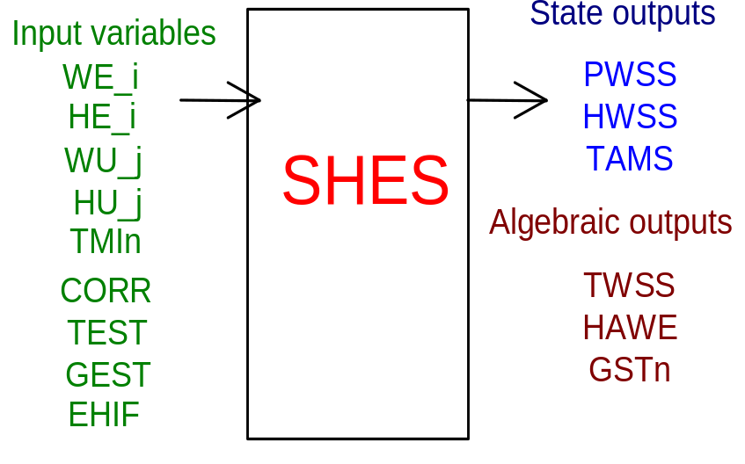

PHYSICAL MEANING OF MODULE INPUT-OUTPUT VARIABLES

[Pa] PWSS shell side water pressure
[J/kg] HWSS shell side water enthalpy
[K] TAMS shell metal average temperature
[K] TWSS shell side water temperature
[J/kg] HAWE extracted water enthalpy
[w m⁻²K⁻¹] GST_n (n = 1, 2,..., Nz) heat transfer coefficient in the n-th zone
[kg/s] WE_i (i = 1, 2,..., Ne) flow rate of fluid flowing into the heat exchanger coming through the i-th branch
[J/kg] HE_i (i = 1, 2,..., Ne) enthalpy of fluid flowing into the heat exchanger coming through the i-th branch
[kg/s] WU_j (j = 1, 2,..., Ne) flow rate of fluid flowing out the heat exchanger through the j-th branch
[J/kg] HU_j (j = 1, 2,..., Ne) enthalpy of fluid flowing out the heat exchanger through the j-th branch (in case of back-flow)
[K] TMI_n (n = 1, 2,..., Nz) tubes metal average temperature in the n-th zone
[-] CORR thermal exchange water-tubes correction factor
[K] TEST external environment temperature
[w m⁻²K⁻¹] GEST shell- external environment heat transfer coefficient
[-] EHIF extracted water enthalpy interpolation factor

MODULE SHES CARD C

Physical and Geometrical Data

In addition to initial values of input and output variables (meaning defined above) user must assign the following data:
[ ] I.BRN.N. number of heat exchanger inlet branches (max.10)
[ ] O.BRN.N. number of heat exchanger outlet branches (max.10)
[m] SH.O.D. shell outsider diameter
[m] SH.THICK shell thickness
[m] SH.LENGH shell length
[kg/m³] SH.M.RO. shell metal density
[J/k*kg] CP MET. shell metal specific heat
[W/m*k] COND MET. shell metal thermal conductivity
[-] TUB.NUMB tubes number
[m] TUB.O.D. tubes outsider diameter
[m] TUB.THIC tubes thickness
[m] TUB.LENG tubes length
[m²] TUB.SURF tubes shell side heat transfer surface
[-] TUB. H/V tubes disposition index (horizontal/vertical) (0= horizontal, any else = vertical)
[-] H.E.Z.N. tubes heat exchange zone number (max. 9)
[-] U.E.H.C user heat transfer correlation index

MODULE SHES CARD D

Module Variables Initialization

To initialize the SHES module variables no particular prescription is required.

MODULE SHES CARD E

User's Subprograms

To assign user heat transfer correlation it need a user subprogram of which the declarative statement is :

SUBROUTINE SHESGAMUT(P, H, S, T, RO, Y, TMI, EQD, VERT, W, FCSA, TUBZSURF, LTUB, DETB, UEHC, GAMMA,VOL, SHIVWT)

Input parameters: P, H, S, T, RO, Y, TMI, EQD, VERT, W, FCSA, TUBZSURF, LTUB, DETB, UEHC, VOL, SHIVWT

output parameters: GAMMA

[Pa] P water shell side pressure
[J/kg] H water shell side enthalpy
[J kg⁻¹K⁻¹] S water shell side entropy
[K] T water shell side temperature
[kg/m³] RO water shell side density
[-] Y shell side water steam ratio
[K] TMI tubes shell side wall temperature
[m] EQD equivalent diameter
[-] VERT tubes disposition index (horizontal/vertical)
[kg/s] W mass flow rate entering the heat exchanger shell side
[m²] FCSA shell side flow cross sectional area
[m²] TUBZSURF tubes’ heat transfer surface per zone
[m] LTUB tubes’ length
[m] DETB tubes’ outsider diameter
[-] UEHC user heat transfer correlation index
[m³] VOL shell side liquid volume
[m³] SHIVWT shell inside volume without tubes’ volume
[W m⁻²K⁻¹] GAMMA heat transfer coefficient

MODULE SHES CARD F

Residuals

The module mathematical model consists of the equations which give rise to the following residuals:
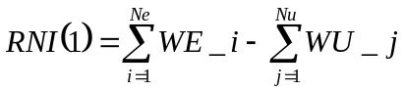- under stationary condition
(normalization factor = W0)
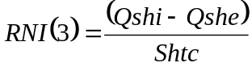 (normalization factor = W0*H0)
(normalization factor = T0)

where:
Qshi is the energy transferred from water to shell wall;
Qshe is the energy transferred from the shell wall to the external environment;
Qwt is the energy transferred from water to the tubes’ wall.

MODULE SHES CARD G

Module subprograms

SUBROUTINE SHESI3(IFO, IOB, DEBL)

SUBROUTINE SHESI4(IOB, MOD)

SUBROUTINE SHESI2(IFUN, VAR, MX1, IV1, IV2, XYU, DATI, ID1, ID2,
$ IBL1, IBL2, IER, CNXYU, TOL)

SUBROUTINE SHESC1(IFUN, AJAC, MX5, IXYU, XYU, IPD, DATI, RNI,
$ IBL1, IBL2)
SUBROUTINE SHESJAC(AJAC, MX5, IXYU, XYU, IPD, DATI, RN, NSTATI,
$ NUSCIT, NINGRE, EPS, EPSLIM, RESIDUI)

SUBROUTINE SHES(IFUN, IXYU, XYU, IPD, DATI, RNI)

SUBROUTINE SHESHTC(P, H, S, T, RO, TIT, TP, D, VERT, W, SEZ, LTUB, DETB,
$ UEHC, HT, VWMASS, SHIVWT)

MODULE SHES CARD H

Test cases

Reference test cases related to this module are in the manual section dedicated to the examples developed under the abbreviations:
" … not available …"

