MODULE TEMP CARD 0

Summary

• model generalities

• topological data

• physical and geometrical data

• module variables initialization

• user's subprograms

• residuals

• module subprograms

• test cases

MODULE TEMP CARD A

Model Generalities

EQUIVALENT STEM POSITION OF A SET OF VALVES

The module TEMP simulates the functioning of a temperature measuring instrument for water/steam. This intrument is supposed constituted by two parts:
- a hot well welded to a metallic body (e.g. a manifold)
- a thermocouple inserted into the hot well and in contact with its lower part through a sheathing
The modelized system can be divided into three control volumes:
- the hot well: the part lying between inner surface of the manifiold and the group “sheathing-thermocouple”. It exchanges heat with the fluid, with the metal body and with the remaining part of the well and the adjoining group “sheathing-thermocouple”. On the contrary it’s supposed adiabatic as far as the exchange in the inner direction is concerned.
- the terminal: the part lying at the end of the hot well and adjoining the group “sheathing-thermocouple”. It exchanges with fluid, hot well and with the group “sheathing-thermocouple” itself.
- the thermocouple: constituted by the group “sheathing-thermocouple”. It exchanges heat with the terminal
The foremost simplifying hypothesis is that the hot well portion inserted and welded to the metallic body, thus not directly exposed to the thermal exchange with the working fluid, is mantained to an isothermic equilibrium by the manifold metal wall.

MODULE TEMP CARD B

Topological data

INPUT-OUTPUT SCHEME

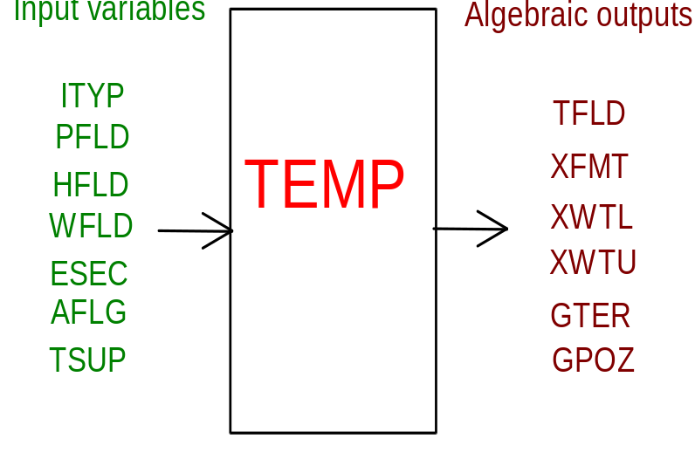
PHYSICAL MEANING OF MODULE INPUT-OUTPUT VARIABLES

[-] ITYP Device type:
0 ðgeometrical characteristics from file f14.dat
1ðHot well type III/IA and standard thermocouple
2ðHot well type II and standard thermocouple
3ðHot well type IIC and fast response thermocouple
[Pa] PFLD working fluid pressure
[J/kg] HFLD working fluid enthalpy
[kg/s] WFLD working fluid mass flow rate
[m²] ESEC equivalent fluid cross-section (for use in the corelations)
[-] AFLG flag of activation (see note 1)
[K] TSUP metal body temperature
[K] TFLD working fluid temperature
[°C] XFMT thermocouple temperature
[°C] XWTL terminal temperature
[°C] XWTU hot well temperature
[W/(m² K)] GTER fluid-terminal thermal exchange coefficient
[W/(m² K)] GPOZ well-fluid thermal exchange coefficient

NOTE 1 For steady state calculations and when AFLG is not active, the three temperatures XFMT, XWTL and XWTU are trivially set to the same phisical value as TFLD. This avoids many calls to steam tables, allowing, thus, a faster solution, while keeping small the involved error (as the thermal resistences are comparatively high, at least if the fluid is not still).

MODULE TEMP CARD C

Physical and Geometrical Data

In addition to the initial values of input and output variables, user must assign the following data (see note 2):
[m] LUNGPO hot well length
[m] RINTPO hot well inner radius
[m] REXTPO hot well external radius
[W/(m K)] CONDPO hot well thermal conductivity
[J/(kg K)] CASPPO hot wells metal walls specific heat
[m] LUNGTE terminal length
[m] RINTTE terminal inner radius
[m] REXTTE terminal external radius
[kg/m³] DENSTC thermocouple metal density
[W/(m K)] CONDTC thermocouple metal thermal conductivity
[J/(kg K)] CASPTC thermocouple metal specific heat

NOTE 2 In case of non-zero ITYP all data values are ignored and can, therefore, be left set to zero

MODULE TEMP CARD D

Module Variables Initialization

To initialize the TEMP module variables no particular prescription is required.

MODULE TEMP CARD E

User's Subprograms

TEMP doesn’t prescribe any FORAUS subroutine.

MODULE TEMP CARD F

Residuals

Residuals are not reported here as their expressions are not significant of the employed calculations.

MODULE TEMP CARD G

Module subprograms

SUBROUTINE TEMPI2(IFUN,VAR,MX1,IV1,IV2,XYU,DATI,ID1,ID2,
$ IBL1,IBL2,IER,CNXYU,TOL)
SUBROUTINE TEMPI3(IFO,IOB,DEBL)
SUBROUTINE TEMPI4(IOB,MOD)
SUBROUTINE TEMPC1(IFUN,AJAC,MX5,IXYU,XYU,IPD,DATI,RNI,IBL1,IBL2)
SUBROUTINE TEMP(IFUN,IXYU,XYU,IPD,DATI,RNI)
SUBROUTINE TEMPD1(BLOCCO,NEQUAZ,NSTATI,NUSCIT,NINGRE,SYMVAR,
$ XYU,IXYU,DATI,IPD,SIGNEQ,UNITEQ,COSNOR,ITOPVA,MXT)

MODULE TEMP CARD H

Test cases

Reference test cases related to this module aren’t yet available.

