MODULE TRA3 CARD 0

Summary

• model generalities

• topological data

• physical and geometrical data

• module variables initialization

• user's subprograms

• residuals

• module subprograms

• test cases

MODULE TRA3 CARD A

Model Generalities

THREE-PHASE THREE COILS TRANSFORMER

The module TRA3 simulates the behavior of a three coils transformer, allowing simulating typical maneuvers such as insertion and shutdown, variation of the transforming ratio in working conditions, etc.
All module equations are written internally using the users sign convention, whilst externally the generators convention is used, so to allow connection between TRA3 and SBAR.
The module is built on the following hypothesis and simplifications:
- the transformer is supposed to function in alternate sinusoidal conditions: any transient phenomenon bound to magnetic field variations in the inductors is omitted. So, electrical quantities can be seen as rotating phasors and currents and tensions can be individuated by means of their real and imaginary parts.
- the three-phase system is supposed symmetric and equilibrated. So we can study one only phase, the other two beeng characterized by quantities having the same module and a phase difference of 120°
- effects of mutual inductance between the coils have not been considered
- the primary and the secondary coils are supposed star-connected in such a manner that no phase displacement is introduced by the transformer.
- non linearities caused by the hysteretic behavior of iron are left out
- impedence with respect to ground is considered much greater than the ones of each coil.
- transformation ratio can be changed in working conditions by modifying the number of turns at the primary coil. The number of turns of the two secondary coils remains unchanged.

MODULE TRA3 CARD B

Topological data

INPUT-OUTPUT SCHEME

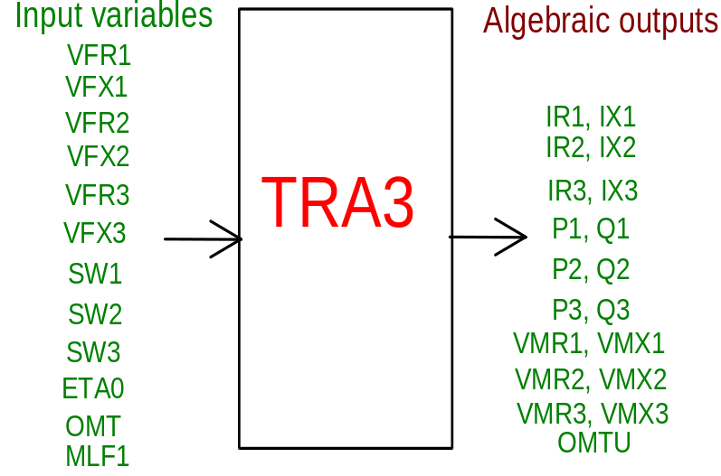

PHYSICAL MEANING OF MODULE INPUT-OUTPUT VARIABLES

[V] VFR1 real component of first coil phase tension
[V] VFX1 imaginary component of first coil phase tension
[V] VFR2 real component of second coil phase tension
[V] VFX2 imaginary component of second coil phase tension
[V] VFR3 real component of third coil phase tension
[V] VFX3 imaginary component of third coil phase tension
[-] SW1 state of switch on first coil (1 = on)
[-] SW2 state of switch on second coil (1 = on)
[-] SW3 state of switch on third coil (1 = on)
[%] ETA0 tension variation on coils 2-3 in percentage with respect to maximum value of tension variation
[rad/s] OMT input electrical duty pulse factor
[-] MLF1 malfunctions switch on/off:
0 = no malfunctions
1 = opening of SW1
2 = short circuit on 40% of primary turns
[A] IR1 real component of first coil current
[A] IX1 imaginary component of first coil current
[A] IR2 real component of second coil current
[A] IX2 imaginary component of second coil current
[A] IR3 real component of third coil current
[A] IX3 imaginary component of third coil current
[W] P1 active power on first coil
[VAR] Q1 reactive power on first coil
[W] P2 active power on second coil
[VAR] Q2 reactive power on second coil
[W] P3 active power on third coil
[VAR] Q3 reactive power on third coil
[V] VMR1 real component of tension as measured at first coil terminal (which can differ from the one measured on primary terminal because of the state of switch SW1)
[V] VMX1 imaginary component of tension as measured at first coil terminal (which can differ from the one measured on primary terminal because of the state of switch SW1)
[V] VMR2 real component of tension as measured at second coil terminal (which can differ from the one measured on secondary terminal because of the state of switch SW2)
[V] VMX2 imaginary component of tension as measured at second coil terminal (which can differ from the one measured on secondary terminal because of the state of switch SW2)
[V] VMR3 real component of tension as measured at third coil terminal (which can differ from the one measured on third terminal because of the state of switch SW3)
[V] VMX3 imaginary component of tension as measured at third coil terminal (which can differ from the one measured on third terminal because of the state of switch SW3)
[rad/s] OMTU output electrical duty pulse factor

MODULE TRA3 CARD C

Physical and Geometrical Data

In addition to the initial values of input and output variables, user must assign the following data (see note 2):
[V] V1N primary nominal tension
[V] V2N second coil nominal tension
[V] V3N third coil nominal tension
[W] P1N primary nominal power
[W] P2N second coil nominal power
[W] P3N third coil nominal power
[VA] AN base power
[rad/s] OMN base electrical duty-pulse factor
[%] PCC12 power at first coil short-circuiting the second with third loadless (in percent of first coil nominal power)
[%] PCC23 power at second coil short-circuiting the third with first loadless (in percent of second coil nominal power)
[%] PCC31 power at third coil short-circuiting the first with second loadless (in percent of third coil nominal power)
[%] VCC12 tension at first coil short-circuiting the second with third loadless (in percent of first coil nominal tension)
[%] VCC23 tension at second coil short-circuiting the third with first loadless (in percent of second coil nominal tension)
[%] VCC31 tension at third coil short-circuiting the first with second loadless (in percent of third coil nominal tension)
[%] PVIDE power at first coil with second and third loadless (in percent of first coil nominal power)
[%] IVIDE current at first coil with second and third loadless (in percent of first coil nominal current)
[-] NL lowest number of turns at first coil
[-] NM highest number of turns at first coil

MODULE TRA3 CARD D

Module Variables Initialization

To initialize the TRA3 module variables no particular prescription is required.

MODULE TRA3 CARD E

User's Subprograms

TRA3 doesn’t prescribe any FORAUS subroutine.

MODULE TRA3 CARD F

Residuals

Equations 1-6 are the ties current/tension at each coil: each coil has two equations for real and imaginary part respectively.
Equations 7-12 calculate active and reactive power at each coil.
Equations 13-18 bind terminal and coil tensions (real and imaginary) keeping into account the state of the three switches SW1, SW2 and SW3.
Equation 19 sets output electrical duty pulse factor equal to the input one (supposing that the transformer causes no phase displacement).

MODULE TRA3 CARD G

Module subprograms

SUBROUTINE TRA3I2(IFUN,VAR,MX1,IV1,IV2,XYU,DATI,ID1,ID2,
$ IBL1,IBL2,IER,CNXYU,TOL)
SUBROUTINE TRA3I3(IFO,IOB,DEBL)
SUBROUTINE TRA3I4(IOB,MOD)
SUBROUTINE TRA3C1(IFUN,AJAC,MX5,IXYU,XYU,IPD,DATI,RNI,IBL1,IBL2)
SUBROUTINE TRA3RES(IFUN,IXYU,XYU,IPD,DATI,RNI)
SUBROUTINE TRA3D1(BLOCCO,NEQUAZ,NSTATI,NUSCIT,NINGRE,SYMVAR,
$ XYU,IXYU,DATI,IPD,SIGNEQ,UNITEQ,COSNOR,ITOPVA,MXT)

MODULE TRA3 CARD H

Test cases

Reference test cases related to this module aren’t yet available.

