#$K+!MODULE TTGS CARD 0

Summary

∗ model generalities

∗ topological data

∗ physical and geometrical data

∗ module variables initialization

∗ user's subprograms

∗ residuals

∗ module subprograms

∗ test cases

#$K+!MODULE TTGS CARD A

Model Generalities

GAS TURBINE FOR SYNGAS-FED TURBOGAS GROUP

The TTGS module simulates an axial turbine for turbogas; the physical-mathematical model used is based on the actual discharge characteristics of the machine, analyzed stage by stage or by groups of stages (delimited by the air injections present on the machine). Certain characteristics of the machine are instead simulated in ground of the global behaviour of the turbine.

The TTGS module allows the correct simulation of the cooling air injections present on the real turbines. It doesn't instead simulate the effect of the turbine metals, which must be simulated in the inlet and/or outlet manifolds.
The global characteristic parameters of the machine (of the whole turbine, and not stage by stage) have to be imposed by the user, assigning (using the related activity) data like the nominal inlet and outlet pressures, the nominal inlet flow rate and temperature and the chemical composition of the flue gases (the one related to the nominal conditions assigned).
The coefficients that define the flowing characteristics of the single stages of the machine and the parameters which define the efficiency variation curves, are instead definite directly inside the Fortran source code of the module for two standard types of turbogas group (the Fiat TG50D and the Siemens V94.3). For other types of group it is possible to define such data using the related routine of the "auxiliary Fortran" (Foraus).

Note that for the Siemens V94.3 group (type 2) the module has been fully tested and validated as regards to the characteristics of the machine supplied by the manufacturer, while for the Fiat TG50D group (type 1) could be required a futher refining of the parameters.

For the evaluation and the conversion of the thermodynamical properties of the air and of the flue gases that flows through the turbine it is used the functions library related to the properties of gas mixtures (TAVSYNGAS library).

#$K+!MODULE TTGS CARD B

Topological data

INPUT-OUTPUT SCHEME

NSTADI = number of compressor stages
NINJEC = number of air injections

i = 1, NSTADI - 1
j = 1, NINJEC

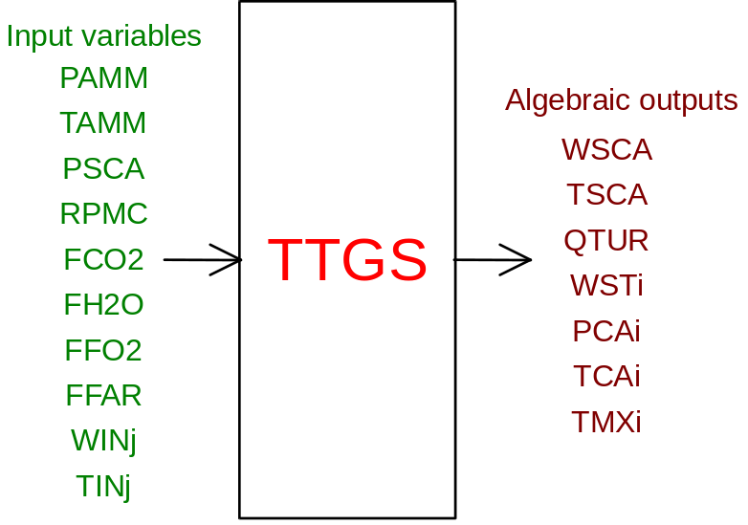

Note: the flow rate in the first stage is called WAMM instead of WST1 (the variable is present only for multi-stage turbines)

PHYSICAL MEANING OF MODULE INPUT-OUTPUT VARIABLES

[Pa] PAMM Flue gas pressure at the turbine inlet
[K] TAMM Flue gas temperature at the turbine inlet
[Pa] PSCA Flue gas pressure at the turbine outlet
[RPM] RPMC Rotational speed of the turbine
[ ] FCO2 Mass fraction of CO2 in the flue gas at the turbine inlet
[ ] FH2O Mass fraction of H2O in the flue gas at the turbine inlet
[ ] FFO2 Mass fraction of O2 in the flue gas at the turbine inlet
[ ] FFAR Mass fraction of Ar in the flue gas at the turbine inlet
[kg/s] WINj Air flow rate through the j-th injection of the turbine
[K] TINj Temperature of the air incoming from the j-th injection
[kg/s] WSCA Flue gas flow rate at the turbine outlet
[K] TSCA Flue gas temperature at the turbine outlet
[W] QTUR Mechanical power produced by the turbine
[kg/s] WSTi Flue gas flow rate in the i-th stage of the turbine
[Pa] PCAi Flue gas pressure in the i-th cavity of the turbine
[K] TCAi Flue gas temperature at the i-th cavity inlet
[K] TMXi Flue gas temperature at the i-th cavity outlet

Note: the flow rate in the first stage is called WAMM instead of WST1 (the variable is present only for multi-stage turbines)

INPUT-OUTPUT VARIABLES NORMALIZATION FACTORS

Variables Normalization
PAMM, PSCA, PCAi P0
TAMM, TINj, TSCA, TCAi, TMXi T0
WINj, WSCA, WAMM, WSTi W0
RPMC 300.
QTUR W0 * H0
FCO2, FH2O, FFO2, FFAR 0.1

#$K+!MODULE TTGS CARD C

Physical and Geometrical Data

In addition to initial values of TTGS module input and output variables, user must assign the following data set to complete the module input on the file F14:
[ ] TG type Type of Turbogas group:
1 = Fiat TG50D
2 = Siemens V94.3
[Pa] Pamm nom Inlet flue gas pressure in nominal conditions
[Pa] Psca nom Outlet flue gas pressure in nominal conditions
[kg/s] Wfum nom Inlet flue gas flow rate in nominal conditions
[K] Tamm nom Inlet flue gas temperature nominal conditions
[ ] EtaS nom Turbine isoentropic efficiency in nominal conditions
[ ] FCO2 nom Mass fraction of CO2 in inlet flue gas in nominal conditions
[ ] FH2O nom Mass fraction of H2O in inlet flue gas in nominal conditions
[ ] F O2 nom Mass fraction of O2 in inlet flue gas in nominal conditions
[ ] F Ar nom Mass fraction of Ar in inlet flue gas in nominal conditions
[ ] Injecn.j Number of the cavity of the j-th air injection (j = 1, NINJEC)

Note: there can’t be more than one air injection in each cavity; also the injections must be sorted in increasing order to respect to the number of the related cavities (therefore the Injecn.j values must be in a strictly increasing order).

#$K+!MODULE TTGS CARD D

Module Variables Initialization

To initialize the TTGS module variables on the file F14, no particular prescription is required.

#$K+!MODULE TTGS CARD E

User's Subprograms

In the auxiliary Fortran (Foraus) of the TTGS module there is only one routine, called TTGSDU, whose declaratory instructions are the followings:

SUBROUTINE TTGSDU (ITIPO, IER, NSTADI, CB, CE)
DIMENSION CB(9), CE(4)

The parameters have the following meanings:
∗ ITIPO [read-only] type of turbine (turbogas group) assigned by the user
∗ IER [write-only] IER parameter of the TTGSI2 subroutine - to be set to 1 in case of errors, in order to abort the data acquisition activity
∗ NSTADI [read-only] number of stages of the turbine (to be used for the check of the coherence between the value assigned in the present routine for the selected type of turbine and the value assigned by the user during topology building phase)
∗ CB [write-only] vector of the multiplying factors for the efflux coefficients of the single stages (the number of elements to assign is equal to the number of stages; see theoretical related description)
∗ CE [write-only] coefficients k1, k2, keta and kpot for the definition of the efficiency variation curves and corrective correlated factors (see theoretical related description)

Also the TTGS module makes use of the procedures contained in the syngas thermodynamic tables (TAVSYNGAS) which must be present in the user library.

#$K+!MODULE TTGS CARD F

Residuals

The equations forming the TTGS module mathematical model (mentioned above) give rise to a set of residuals. Here only their correspondences with the output variables equations have been indicated, also mentioning the respective normalization factors. Further explanations are given in the related theoretical description.
1) RNI(1) - normalization factor = W0
related to the air flow rate at the turbine outlet
2) RNI(2) - normalization factor = T0
related to the air temperature at the turbine outlet
3) RNI(3) - normalization factor = W0 * H0
related to the mechanical power produced by the turbine
do i = 1, NSTADI - 1
4) RNI(4*i) - normalization factor = W0
related to the air flow rate in the i-th stage
5) RNI(4*i+1) - normalization factor = P0
related to the air pressure inside the i-th cavity
6) RNI(4*i+2) - normalization factor = T0
related to the air temperature inside the i-th cavity before injection mixing
7) RNI(4*i+3) - normalization factor = T0
related to the air temperature inside the i-th cavity after injection mixing
enddo

#$K+!MODULE TTGS CARD G

Module subprograms

SUBROUTINE TTGSI3 (IFO,IOB,DEBL)

SUBROUTINE TTGSI4 (NSTADI,NINJEC)

SUBROUTINE TTGSI2 (IFUN,VAR,MX1,IV1,IV2,XYU,DATI,ID1,ID2,
$ IBL1,IBL2,IER,CNXYU,TOL)

SUBROUTINE TTGSC1 (IFUN,AJAC,MX5,IXYU,XYU,IPD,DATI,RNI,IBL1,IBL2)

SUBROUTINE TTGS (IFUN,IXYU,XYU,IPD,DATI,RNI)

FUNCTION TTGSPV (PM, TM, PV)

SUBROUTINE TTGSDT (ITIPO, IER, NSTADI, CB, CE)

SUBROUTINE TTGSD1 (BLOCCO,NEQUAZ,NSTATI,NUSCIT,NINGRE,SYMVAR,XYU,
$ IXYU,DATI,IPD,SIGNEQ,UNITEQ,COSNOR,ITOPVA,MXT)

#$K+!MODULE TTGS CARD H

Test cases

Reference test cases related to this module are reported in the user manual section devoted to the examples developed under the abbreviation:
"........."

# lg_libproc_TTGS_summ
$ TTGS process module
K TTGS process module
+ lg_pag_modu:1360
! EnableButton("button_up"); ChangeButtonBinding("button_up", "JumpId(`lglibpro.hlp',`lg_libproc_main')")
# lg_libproc_TTGS_A
$ TTGS process module (A)
K TTGS process module (A)
+ lg_pag_ttgs:0002
! EnableButton("button_up"); ChangeButtonBinding("button_up", "JumpId(`lglibpro.hlp',`lg_libproc_TTGS_summ')")
# lg_libproc_TTGS_B
$ TTGS process module (B)
K TTGS process module (B)
+ lg_pag_ttgs:0003
! EnableButton("button_up"); ChangeButtonBinding("button_up", "JumpId(`lglibpro.hlp',`lg_libproc_TTGS_summ')")
# lg_libproc_TTGS_C
$ TTGS process module (C)
K TTGS process module (C)
+ lg_pag_ttgs:0005
! EnableButton("button_up"); ChangeButtonBinding("button_up", "JumpId(`lglibpro.hlp',`lg_libproc_TTGS_summ')")
# lg_libproc_TTGS_D
$ TTGS process module (D)
K TTGS process module (D)
+ lg_pag_ttgs:0006
! EnableButton("button_up"); ChangeButtonBinding("button_up", "JumpId(`lglibpro.hlp',`lg_libproc_TTGS_summ')")
# lg_libproc_TTGS_E
$ TTGS process module (E)
K TTGS process module (E)
+ lg_pag_ttgs:0007
! EnableButton("button_up"); ChangeButtonBinding("button_up", "JumpId(`lglibpro.hlp',`lg_libproc_TTGS_summ')")
# lg_libproc_TTGS_F
$ TTGS process module (F)
K TTGS process module (F)
+ lg_pag_ttgs:0008
! EnableButton("button_up"); ChangeButtonBinding("button_up", "JumpId(`lglibpro.hlp',`lg_libproc_TTGS_summ')")
# lg_libproc_TTGS_G
$ TTGS process module (G)
K TTGS process module (G)
+ lg_pag_ttgs:0010
! EnableButton("button_up"); ChangeButtonBinding("button_up", "JumpId(`lglibpro.hlp',`lg_libproc_TTGS_summ')")
# lg_libproc_TTGS_H
$ TTGS process module (H)
K TTGS process module (H)
+ lg_pag_ttgs:0011
! EnableButton("button_up"); ChangeButtonBinding("button_up", "JumpId(`lglibpro.hlp',`lg_libproc_TTGS_summ')")

