#$K+!MODULE TUBO CARD 0

Summary

∗ model generalities

∗ topological data

∗ physical and geometrical data

∗ module variables initialization

∗ user's subprograms

∗ residuals

∗ module subprograms

∗ test cases

#$K+!MODULE TUBO CARD A

Model Generalities

PIPE HEAD LOSS

The TUBO module determines the head loss of a fluid flowing through a piping, also taking into account the gap level between its inlet and outlet sides.
The mathematical model consists of the following relation:
(1)
where:
- RO is the fluid density
- G is the gravitational acceleration
- Z is the level gap between piping inlet and outlet sides
The physical meanings of other variables are defined below.
The fluid density is supposed to be constant and equal to its density at the piping inlet.

#$K+!MODULE TUBO CARD B

Topological data

INPUT-OUTPUT SCHEME

The module can be interconnected with other ones according to the following three methods:
1) output in flow rate
prescription about block name: none
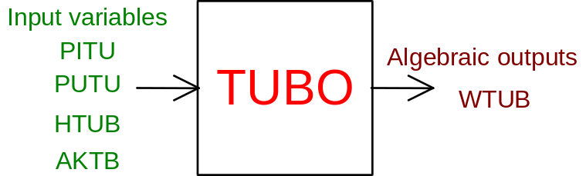
2) outlet in inlet pressure
prescription about block name: preceded by a '+' sign
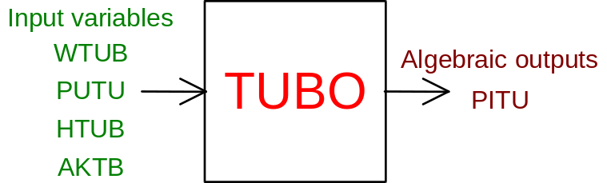
3) output in outlet pressure
prescription about block name: preceded by a '-' sign
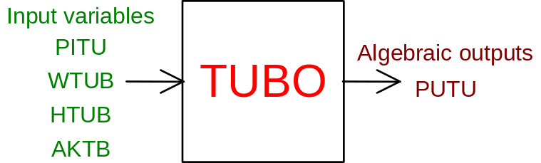

PHYSICAL MEANING OF MODULE INPUT-OUTPUT VARIABLES

[kg/s] WTUB water flow rate inside the piping
[Pa] PITU pressure upstream the piping
[Pa] PUTU pressure downstream the piping
[J/kg] HTUB water enthalpy at the piping inlet
[ ] AKTB corrective factor of piping friction coefficient (see equation (1) above)

#$K+!MODULE TUBO CARD C

Physical and Geometrical Data

In addition to the initial values of input and output variables, user must assign the following data:
[kg/s] PORTATA water flow rate in the piping
[Pa] P1 MONTE pressure upstream the piping
[Pa] P2 VALLE pressure downstream piping
[J/kg] ENTALPIA water enthalpy at the piping inlet
[ ] COEFF head loss coefficient (see equation (1) above)
[m] DISLIV. geodetic gap between the piping inlet and outlet (positive if the piping outlet elevation is higher than the inlet one)

Note
The COEFF piping head loss coefficient must only be assigned when the data related to a known condition are not available (flow rate, upstream and downstream pressures, enthalpy). If these data are assigned, the COEFF coefficient is obtained replacing them in the equation (1) above, without considering the geodetic term:

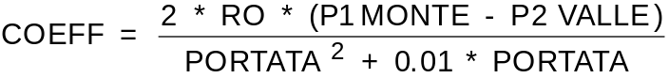 (2)

#$K+!MODULE TUBO CARD D

Module Variables Initialization

To initialize the TUBO module variables no particular prescription is required.

#$K+!MODULE TUBO CARD E

User's Subprograms

In the TUBO module no user subprogram is foreseen.

#$K+!MODULE TUBO CARD F

Residuals

The module has only one residual; it is normalized as regards to the P0 pressure corresponding to the equation (1) above. Its expression is the following:
Its variables have the same physical meanings already indicated above.

#$K+!MODULE TUBO CARD G

Module subprograms

SUBROUTINE TUBOI3(IFO, IOB, DEBL)

SUBROUTINE TUBOI4(IOB, MOD)

SUBROUTINE TUBOI2(IFUN, VAR, MX1, IV1, IV2, XYU, DATI, ID1, ID2,
$ NOM1, NOM2, IER, CNXYU, TOL)

SUBROUTINE TUBOC1(IFUN, AJAC, MX5, IXYU, XYU, IPD, DATI, RN, NOM1,
$ NOM2)

#$K+!MODULE TUBO CARD H

Test cases

Reference test cases related to this module are in the user manual section dedicated to the examples developed under the abbreviations:
"ANELLO"

# lg_libproc_TUBO_summ
$ TUBO process module
K TUBO process module
+ lg_pag_modu:1400
! EnableButton("button_up"); ChangeButtonBinding("button_up", "JumpId(`lglibpro.hlp',`lg_libproc_main')")
# lg_libproc_TUBO_A
$ TUBO process module (A)
K TUBO process module (A)
+ lg_pag_TUBO:0002
! EnableButton("button_up"); ChangeButtonBinding("button_up", "JumpId(`lglibpro.hlp',`lg_libproc_TUBO_summ')")
# lg_libproc_TUBO_B
$ TUBO process module (B)
K TUBO process module (B)
+ lg_pag_TUBO:0003
! EnableButton("button_up"); ChangeButtonBinding("button_up", "JumpId(`lglibpro.hlp',`lg_libproc_TUBO_summ')")
# lg_libproc_TUBO_C
$ TUBO process module (C)
K TUBO process module (C)
+ lg_pag_TUBO:0005
! EnableButton("button_up"); ChangeButtonBinding("button_up", "JumpId(`lglibpro.hlp',`lg_libproc_TUBO_summ')")
# lg_libproc_TUBO_D
$ TUBO process module (D)
K TUBO process module (D)
+ lg_pag_TUBO:0006
! EnableButton("button_up"); ChangeButtonBinding("button_up", "JumpId(`lglibpro.hlp',`lg_libproc_TUBO_summ')")
# lg_libproc_TUBO_E
$ TUBO process module (E)
K TUBO process module (E)
+ lg_pag_TUBO:0007
! EnableButton("button_up"); ChangeButtonBinding("button_up", "JumpId(`lglibpro.hlp',`lg_libproc_TUBO_summ')")
# lg_libproc_TUBO_F
$ TUBO process module (F)
K TUBO process module (F)
+ lg_pag_TUBO:0008
! EnableButton("button_up"); ChangeButtonBinding("button_up", "JumpId(`lglibpro.hlp',`lg_libproc_TUBO_summ')")
# lg_libproc_TUBO_G
$ TUBO process module (G)
K TUBO process module (G)
+ lg_pag_TUBO:0010
! EnableButton("button_up"); ChangeButtonBinding("button_up", "JumpId(`lglibpro.hlp',`lg_libproc_TUBO_summ')")
# lg_libproc_TUBO_H
$ TUBO process module (H)
K TUBO process module (H)
+ lg_pag_TUBO:0011
! EnableButton("button_up"); ChangeButtonBinding("button_up", "JumpId(`lglibpro.hlp',`lg_libproc_TUBO_summ')")

