MODULE VACT CARD 0

Summary

• model generalities

• topological data

• physical and geometrical data

• module variables initialization

• user's subprograms

• residuals

• module subprograms

• test cases

MODULE VACT CARD A

Model Generalities

EQUIVALENT STEM POSITION OF A SET OF VALVES

The module VACT calculates an equivalent stem position of a set of valves allowing to simulate this set of valves with one only module VALV. Moreover, an exact “measure” of each received input variable is also output so to allow a connection with an input variable of a regulation task.
The arrangements of valves considered by VACT are the following:
1. one only valve (the only effect is to replicate the stem position, as received in input, both to the output variable to be connected with the module VALV, and to the “measure” variable that will be sent to the regulation)
2. two valves in serial arrangement (the equivalent is the product of the two stem positions)
3. two valves in parallel arrangement (an arithmetic average is taken as the equivalent of the two)
4. a three way valve (the equivalent is two valves departing by the same node, the former being the serial arrangement of the three-ways-valve stem position with the one of the branch A, whilst the latter is the serial arrangement of the complement to one of the same with the stem position of the branch B).
The simplicity of the used formulas is meant to simplify as much as possible the equivalent calculations: for a more accurate calculation other formulas should be used.
To reduce to the minimum the burden of this complementary module upon the global solving system, the equation(s) that output the “measure(s)” are seen as non-equations as far as the transient calculations are concerned.

MODULE VACT CARD B

Topological data

INPUT-OUTPUT SCHEME

1. ONE ONLY VALVE

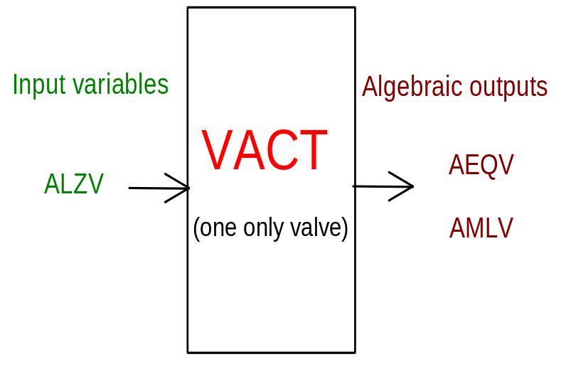
PHYSICAL MEANING OF MODULE INPUT-OUTPUT VARIABLES

[p.u.] ALZV valve stem position (input)
[p.u.] AEQV valve stem position (output)
[p.u.] AMLV valve stem position (“measure”)

2. TWO VALVES IN SERIAL OR PARALLEL ARRANGEMENT

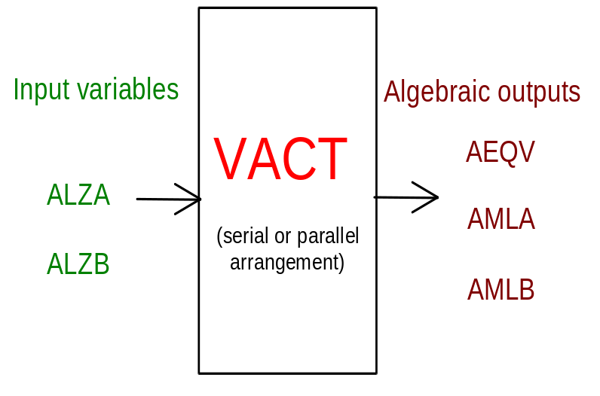

PHYSICAL MEANING OF MODULE INPUT-OUTPUT VARIABLES

[p.u.] ALZA branch A stem position
[p.u.] ALZB branch B stem position
[p.u.] AEQV equivalent stem position
[p.u.] AMLA branch A stem position (“measure”)
[p.u.] AMLB branch A stem position (“measure”)

3. A THREE WAYS VALVE

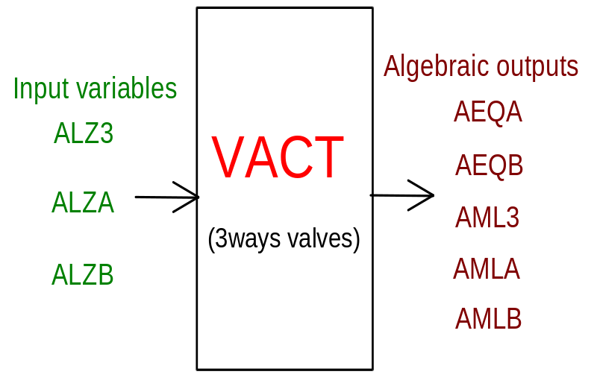
PHYSICAL MEANING OF MODULE INPUT-OUTPUT VARIABLES

[p.u.] ALZ3 three ways valve stem position
[p.u.] ALZA branch A stem position
[p.u.] ALZB branch B stem position
[p.u.] AEQA equivalent branch A stem position
[p.u.] AEQB equivalent branch B stem position
[p.u.] AML3 three ways valve stem position (“measure”)
[p.u.] AMLA branch A stem position (“measure”)
[p.u.] AMLB branch A stem position (“measure”)

MODULE VACT CARD C

Physical and Geometrical Data

In addition to the initial values of input and output variables, user must assign the following data:
[] NC selection index of equivalence configuration:
1: one only valve
2: two valves (serial arrangement)
3: two valves (parallel arrangement)
4: three ways valve

MODULE VACT CARD D

Module Variables Initialization

To initialize the VACT module variables no particular prescription is required.

MODULE VACT CARD E

User's Subprograms

VACT doesn’t prescribe any FORAUS subroutine.

MODULE VACT CARD F

Residuals

C ***************** isolated valve
RNI(1) = AEQV - ALZV
IF (KREGIM) THEN
RNI(2) = AMLV - ALZV
ELSE
RNI(2) = ALZV
ENDIF
C ***************** serial or parallel arrangements
IF (NC .EQ. 1) THEN !serial arrangement
RNI(1) = AEQV - ALZA * ALZB
ELSE !parallel arrangement
RNI(1) = AEQV - 0.5 * (ALZA + ALZB)
ENDIF
IF (KREGIM) THEN
RNI(2) = AMLA - ALZA
RNI(3) = AMLB - ALZB
ELSE
RNI(2) = ALZA
RNI(3) = ALZB
ENDIF
C ***************** 3ways valve
RNI(1) = AEQA - ALZA * ALZ3
RNI(2) = AEQB - ALZB * (1.-ALZ3)
IF (KREGIM) THEN
RNI(3) = AML3 - ALZ3
RNI(4) = AMLA - ALZA
RNI(5) = AMLB - ALZB
ELSE
RNI(3) = ALZ3
RNI(4) = ALZA
RNI(5) = ALZB
ENDIF
ENDIF

MODULE VACT CARD G

Module subprograms

SUBROUTINE VACTI2(IFUN,VAR,MX1,IV1,IV2,XYU,DATI,ID1,ID2,
$ IBL1,IBL2,IER,CNXYU,TOL)
SUBROUTINE VACTI3(IFO,IOB,DEBL)
SUBROUTINE VACTI4(IOB,MOD)
SUBROUTINE VACTC1(IFUN,AJAC,MX5,IXYU,XYU,IPD,DATI,RNI,IBL1,IBL2)
SUBROUTINE VACTD1(BLOCCO,NEQUAZ,NSTATI,NUSCIT,NINGRE,SYMVAR,
$ XYU,IXYU,DATI,IPD,SIGNEQ,UNITEQ,COSNOR,ITOPVA,MXT)

MODULE VACT CARD H

Test cases

Reference test cases related to this module aren’t yet available.

