#$K+!MODULE VAIN CARD 0

Summary

∗ model generalities

∗ topological data

∗ physical and geometrical data

∗ module variables initialization

∗ user's subprograms

∗ residuals

∗ module subprograms

∗ test cases

#$K+!MODULE VAIN CARD A

Model Generalities

REAL GAS VALVE

The VAIN module can simulate the operation of a valve crossed by a real gas, simply assuming a quadratic relation between the pressure head at the valve ends and the flow rate crossing the same. In the case the actual pressure downstream is lower than the critical pressure (sonic valve), the critical pressure is used for the calculation of the flow rate as downstream pressure.
The VAIN module can represent both a valve having the possibility of flow inversion and a check valve, simply making the flow rate null when the pressure head at the valve ends becomes negative or null.

Main hypothesis at the module basis are:

- all thermal capacities are neglectable.
- the pressure drop is related to concentrated load losses;
- there’s no fluid accumulation inside the valve;
- presence of a temperature drop in the throttled gas.

#$K+!MODULE VAIN CARD B

Topological data

INPUT-OUTPUT SCHEME

The module can be interconnected with other ones according to the following three methods:
1) output in flow rate
prescription about block name: none
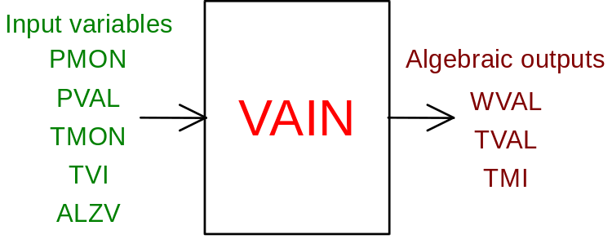
2) outlet in inlet pressure
prescription about block name: preceded by a '+' sign
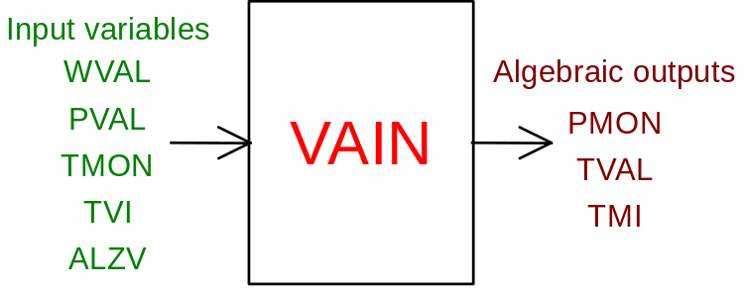
3) output in outlet pressure
prescription about block name: preceded by a '-' sign
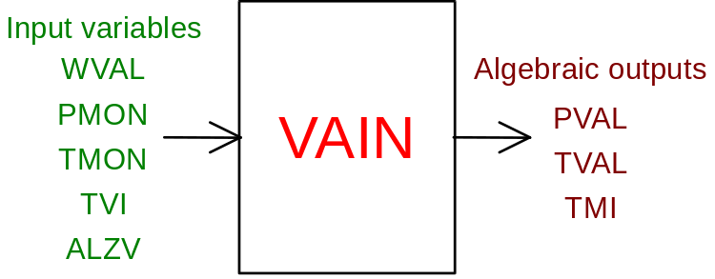

PHYSICAL MEANING OF THE MODULE INPUT - OUTPUT VARIABLES

[kg/s] WVAL gas mass flow rate in the valve
[K] TVAL temperature downstream the valve
[K] TMI fluid temperature upstream the valve with flow inversion
[Pa] PMON pressure upstream the valve
[Pa] PVAL pressure downstream the valve
[K] TMON temperature upstream the valve
[K] TVI temperature downstream the valve with flow inversion
[p.u.] ALZV valve lift

#$K+!MODULE VAIN CARD C

Physical and Geometrical Data

Meaning of data required at VAIN module input:
[Pa] PMONOM rated upstream pressure (see note 1)
[Pa] PVANOM rated downstream pressure (see note 1)
[p.u.] ALZNOM valve lift (see note 1)
[Nm³/h] XWNOM rated flow (see note 1)
[K] TMONOM rated upstream temperature (see note 1)
[K³/Pa] XKTEMP decrease factor of laminated gas temperature according to experimental law:
DeltaT = -XKTEMP / T² ∗ DeltaP
where DeltaT and DeltaP are temperature and pressure drops at the valve ends and T is the temperature at valve inlet.
[ ] CLAPET check valve present or not and therefore impossibility or not of flow inversion according to this configuration:
CLAPET = 1. check valve present
CLAPET = 0. check valve not present
[ ] ALFA coefficient used to define the valve characteristic, that is the law for variation of the path AREA according to the ALZV opening degree, according to the following formula:
AREA = AREAMAX *ALZV ** ALFA
where AREAMAX is the path area of the valve when it is fully open.
The default value for ALFA is 1.

Note 1

To define the valve type, that is, if sonic or supersonic valve, rated operation conditions shall be defined, which indicate if the critical condition of gas outflow is exceeded or not.

#$K+!MODULE VAIN CARD D

Module Variables Initialization

No particular prescription is required to initialize module variables.

#$K+!MODULE VAIN CARD E

User's Subprograms

No user’s subprogram is required in the VAIN module.
The VAIN module makes use of the procedures contained in the perfect gas thermodynamic tables (TAVGASPERF) which must be present in the user library.

#$K+!MODULE VAIN CARD F

Residuals

Three residuals relevant to flow rate, temperature downstream the valve and to the
upstream one in case of inversion are present in the module. For the first, the expression is different if the valve lift ALZV is higher or lower than 0.15; in any case, it deals with the flux characteristics through the valve, according to the value of XCLAP:
XCLAP = -2 check valve not present - reversed flow (ALZV ≥ 0.15)
XCLAP = -1 check valve not present - reversed flow (ALZV < 0.15)
XCLAP = 0 check valve present and closed (flow halted)
XCLAP = 1 normal flow (ALZV < 0.15) (undepending on check valve presence)
XCLAP = 2 normal flow (ALZV ≥ 0.15) (undepending on check valve presence)

The expressions of the residuals are the followings:

IF (XCLAP .EQ. 0.) THEN
RNI(1) = WVAL / W0
ELSE IF (ABS(XCLAP) .EQ. 1.) THEN
RNI(1) = (PMON - PVAL - WVAL * (ABS(WVAL) + WEPS) / ROCC) / P0
ELSE
RNI(1) = (WVAL - (PMON - PVAL) * ROCC / (ABS(WVAL) + WEPS)) / W0
ENDIF

RNI(2) = (TVAL - TVAX) / T0
RNI(3) = (TMOI - TMIX) / T0

#$K+!MODULE VAIN CARD G

Module subprograms

SUBROUTINE VAINI3 (IFO,IOB,DEBL)

SUBROUTINE VAINI4 (IOB,MOD,IBLOC,I1,I4,I5)

SUBROUTINE VAINI2 (IFUN,VAR,MX1,IV1,IV2,XYU,DATI,ID1,ID2,
$ IBL1,IBL2,IER,CNXYU,TOL)

SUBROUTINE VAINC1 (IFUN,AJAC,MX5,IXYU,XYU,IPD,DATI,RNI,IBL1,IBL2)

SUBROUTINE VAIN (IFUN,IXYU,XYU,IPD,DATI,RNI)

SUBROUTINE VAIND1 (BLOCCO,NEQUAZ,NSTATI,NUSCIT,NINGRE,SYMVAR,XYU,
$ IXYU,DATI,IPD,SIGNEQ,UNITEQ,COSNOR,ITOPVA,MXT)

#$K+!MODULE VAIN CARD H

Test cases

Reference test cases relevant to this module are in the manual section dedicated to the examples carried out and marked with the tag:

“...not yet available...”

# lg_libproc_VAIN_summ
$ VAIN process module
K VAIN process module
+ lg_pag_modu:1440
! EnableButton("button_up"); ChangeButtonBinding("button_up", "JumpId(`lglibpro.hlp',`lg_libproc_main')")
# lg_libproc_VAIN_A
$ VAIN process module (A)
K VAIN process module (A)
+ lg_pag_vain:0002
! EnableButton("button_up"); ChangeButtonBinding("button_up", "JumpId(`lglibpro.hlp',`lg_libproc_VAIN_summ')")
# lg_libproc_VAIN_B
$ VAIN process module (B)
K VAIN process module (B)
+ lg_pag_vain:0003
! EnableButton("button_up"); ChangeButtonBinding("button_up", "JumpId(`lglibpro.hlp',`lg_libproc_VAIN_summ')")
# lg_libproc_VAIN_C
$ VAIN process module (C)
K VAIN process module (C)
+ lg_pag_vain:0005
! EnableButton("button_up"); ChangeButtonBinding("button_up", "JumpId(`lglibpro.hlp',`lg_libproc_VAIN_summ')")
# lg_libproc_VAIN_D
$ VAIN process module (D)
K VAIN process module (D)
+ lg_pag_vain:0006
! EnableButton("button_up"); ChangeButtonBinding("button_up", "JumpId(`lglibpro.hlp',`lg_libproc_VAIN_summ')")
# lg_libproc_VAIN_E
$ VAIN process module (E)
K VAIN process module (E)
+ lg_pag_vain:0007
! EnableButton("button_up"); ChangeButtonBinding("button_up", "JumpId(`lglibpro.hlp',`lg_libproc_VAIN_summ')")
# lg_libproc_VAIN_F
$ VAIN process module (F)
K VAIN process module (F)
+ lg_pag_vain:0008
! EnableButton("button_up"); ChangeButtonBinding("button_up", "JumpId(`lglibpro.hlp',`lg_libproc_VAIN_summ')")
# lg_libproc_VAIN_G
$ VAIN process module (G)
K VAIN process module (G)
+ lg_pag_vain:0010
! EnableButton("button_up"); ChangeButtonBinding("button_up", "JumpId(`lglibpro.hlp',`lg_libproc_VAIN_summ')")
# lg_libproc_VAIN_H
$ VAIN process module (H)
K VAIN process module (H)
+ lg_pag_vain:0011
! EnableButton("button_up"); ChangeButtonBinding("button_up", "JumpId(`lglibpro.hlp',`lg_libproc_VAIN_summ')")

