#$K+!MODULE VALV CARD 0

Summary

∗ model generalities

∗ topological data

∗ physical and geometrical data

∗ module variables initialization

∗ user's subprograms

∗ residuals

∗ module subprograms

∗ test cases

#$K+!MODULE VALV CARD A

Model Generalities

STEAM-WATER VALVE

The VALV module simulates different types of valve which can be present in a plant.
The following mathematical models, mentioned in a decreasing order of complexity, are included in the module:
1) Moody-Morris based on Moody correlation (critical flowing) and Morris correlation (sub-critical flowing)
2) CADIPO deriving from dimensioning equations of valves proposed by ISA
3) Simplified model merely assumes a quadratic relation between delta pressure at the valve inlet and outlet sides and the flow rate flowing through it. In case the outlet actual pressure is lower than the critical one (sonic valves), in the flow rate calculation the critical pressure is used as outlet pressure.

With the models 2) and 3) also check valves are representable. They allow to nullify the flow rate when, on the two sides of the valve, it is lower than DP.CHIU prefixed value included in the data (see below). They allow again the flow when the delta pressure is higher than DP.APER.
These models are based on the following main hypotheses:
- thermal capacity of valve metal is negligible
- isenthalpic thermodynamic transformation of fluid inside the valve
- absence of fluid accumulation inside the valve.
It is useful to note that also back-flow can be represented. Nevertheless, since fluid enthalpy is always considered by module on the inlet side, it is possible that the obtained results do not correspond to the physical reality.
Choice of one module rather than another is made assigning a suitable value to the COD. parameter required in input (see below).
In order to choose the most adequate model for user's needs and to allow its more correct use, some suggestions are given:
- The simplified model requires a shorter calculation time than other ones, but it is less sophisticated. Its use is advisable in simulating regulating valves since, because of control system feedback, possible inaccuracies on flow rate calculation particularly affect the valve opening degree. On the contrary, these inaccuracies have a limited influence on the plant thermohydraulic variables tendencies. Utilization of this module is inadvisable in safety valves simulation. In fact, without regulation 2feedback, these valves cause a possible error on flow calculation to affect the whole plant.
- The CADIPO model is able to cover, with a good precision degree, a very wide part of the VALV module application including safety valves simulation.
- The Moody-Morris model has a higher precision degree than the CADIPO model. It is particularly suitable to represent flows caused by little or big pipe burst.
- All models are able to deal with both single-phase and two-phase liquids. Nevertheless for a two phase liquid it is advisable the Moody-Morris model which is more precise.

#$K+!MODULE VALV CARD B

Topological data

INPUT-OUTPUT SCHEME

The module can be interconnected to other ones following three methods:
1) output in flow rate
prescription about block name: none
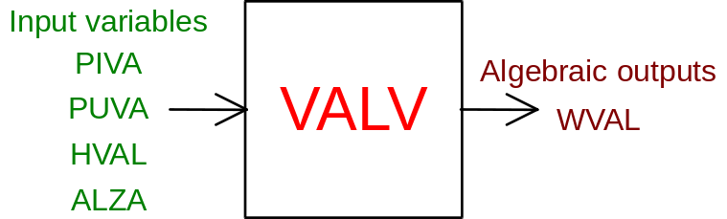
2) output in inlet pressure
prescription about block name: preceded by '+' sign
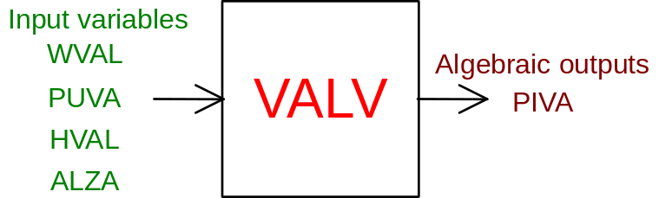
3) output in outlet pressure
prescription about block name: preceded by '-' sign
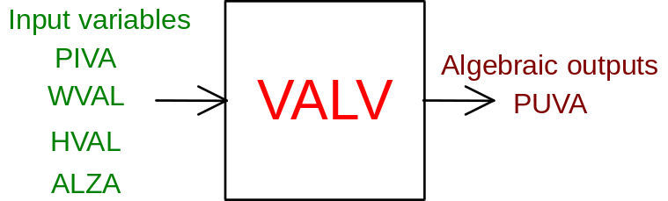

PHYSICAL MEANING OF MODULE INPUT-OUTPUT VARIABLES

[Pa] PIVA valve inlet pressure
[Pa] PUVA valve outlet pressure
[J/kg] HVAL fluid enthalpy at the valve inlet
[p.u.] ALZA valve opening degree
[kg/s] WVAL fluid flow rate

#$K+!MODULE VALV CARD C

Physical and Geometrical Data

Meanings of the required data in VALV module input:
[ ] ALFA coefficient used to define the valve characteristic, that is the cross section area variation law as a function of ALZA opening degree following the formula:
AREA = ALZA**ALFA
AREA is normalized as regards to the valve cross section area when the valve is fully opened. If user knows the manufacturer valve characteristic, this can be assigned through the function AVNS10(ALZA, ALFA) (see below). In this case to ALFA must be assigned any value > 10.
[ ] CFA valve recovery coefficient with fully opened valve (ALZA = 1). Typical value CFA = 0.85. This coefficient is calculated as a function of ALZA and CFA following the law:
CF(ALZA) = CFA+(1.-CFA)*(1.-A(ALZA))²
where A(ALZA) is the normalized cross section area. For CFA > 10 the CF variation law is assigned by user through the function CFNS10(ALZA, A, CFA) (see below).
[ ] COD. parameter for selection of mathematical model to use and type of valve to simulate. Depending on the value assigned to this parameter, several options in accordance with below mentioned scheme are:
COD. < 0. the valve is simulated through the Moody-Morris model using the valve calculated by the CADIPO model as cross section area
0. < COD. < 1. the valve is simulated through the Moody-Morris model giving the COD value to the normalized cross section area
COD. = 0. the valve is simulated through the CADIPO model
COD. = 1. the valve is simulated through the CADIPO model with check valve positioned downstream
COD. = 2. the valve is simulated through the not sonic simplified model
COD. = 3. the valve is simulated through the not sonic simplified model with check valve positioned downstream
COD. = 4. the valve is simulated through the sonic simplified model
COD. = 5. the valve is simulated through the sonic simplified model with check valve positioned downstream
[gal/min*psi^½] CVA identification coefficient of valve working point

If this datum is not available, user leaves the related space blank and provides the following data referred to a known valve functioning point:
[kg/s] PORTATA flow rate
[Pa] P1 MONTE valve inlet pressure
[Pa] P2 VALLE valve outlet pressure
[J/kg] ENTALPIA valve inlet enthalpy
[p.u.] CORSA ALZA value related to the assigned working point.
If chosen valve admits the presence of a check valve downstream it, user must provide the DP values which provoke valve closing and opening.
[Pa] DP.APER differential pressure provoking valve opening
[Pa] DP.CHIU differential pressure provoking valve opening.

#$K+!MODULE VALV CARD D

Module Variables Initialization

To initialize the VALV module variables no particular prescription is required.

#$K+!MODULE VALV CARD E

User's Subprograms

To assign valve characteristic (if user knows its data provided by the manufacturer) it is necessary a subprogram whose declarative statement is:
FUNCTION AVNS10(ALZA, ALFA)
Input parameters: ALZA, ALFA
Output parameters: AVNS10
[p.u.] ALZA valve opening degree
[ ] ALFA (> 10) parameter, coming from input data. It can be used as choice index in case user has to introduce several characteristics through the only one function:
AVNS10(ALZA, ALFA)
[p.u.] AVNS10 value of calculation cross section area. This value has to be normalized as regards to the cross section area of a fully opened valve.
Example of characteristic assigned in points:

FUNCTION AVNS10(Z,ALFA)
DIMENSION X1(12),Y1(12)
DATA X1/0.,.1,.2,.3,.4,.5,.6,.7,.8,.9,1.,1.2/
DATA Y1/.0,.035,.085,.13,.18,.24,..32,.42,.55,.7,1.,1./
C
C CHARACTERISTICS CV=FUNCTION OF VALVE OPENING DEGREE
C
IALF=ALFA-10.
GO TO (1,100),IALF
C
C CHARACTERISTIC FCV OF RECIRCULATION
C
1 CALL AVNSIN(Z,X1,Y1,12,A)
AVNS10=A
GO TO 500
C
100 CONTINUE
500 RETURN
END
SUBROUTINE AVNSIN(Z,X,Y,NP,A)
DIMENSION X(1),Y(1)
C
C INTERPOLATION
C
DO 10 I=1,NP-1
J=I
IF(Z.GE.X(J).AND.Z.LE.X(J+1))GO TO 15
10 CONTINUE
A=0.
GO TO 20
15 A=Y(J)+(Z-X(J))*(Y(J+1)-Y(J))/(X(J+1)-X(J))
20 RETURN
END
User has also the possibility to assign the variation law of valve recovery coefficient through the user subprogram:

FUNCTION CFNS10(ALZA, A, CFA)
Input parameters: ALZA, A, CFA
Output parameters: CFNS10
[p.u.] ALZA valve opening degree
[p.u.] A normalized cross section area
[ ] CFA (>10) parameter coming from input data. It can be used as choice index in case user has to assign several variation laws of recovery coefficient through the only one function:
CFNS10(ALZA, A, CFA).
[ ] CFNS10 value of calculated recovery coefficient.
Example of recovery coefficient assigned through the function:

FUNCTION CFNS10(Z, A, CFA)
C IMPLICIT REAL*8 (A-H, O-Z)
CFNS = 0.95
RETURN
END

#$K+!MODULE VALV CARD F

Residuals

The module has only one residual related to the calculation of the flow rate flowing through the valve. It can be formally written as:
RNI(1) = f(WVAL, PIVA, PUVA, ALZA)
The variables which appear at the second member have physical meaning already defined in the related section on topological data.
The residual is normalized as regards to the flow rate W0.

#$K+!MODULE VALV CARD G

Module subprograms

SUBROUTINE VALVI3(IFO, IOB, DEBL)

SUBROUTINE VALVI4(IOB, MOD)

SUBROUTINE VALVI2(IFUN, VAR, MX1, IV1, IV2, XYU, DATI, ID1, ID2,
$ IBLOC1, IBLOC2, IER, CNXYU, TOL)

SUBROUTINE VALVC1(IFUN, AJAC, MX5, IXYU, XYU, IPD, DATI, RNI,
$ IBLOC1, IBLOC2)

FUNCTION CA10(W, P1, P2, H, Z, ALFA, CFA)

FUNCTION CADI10(P1, H1, P2, Z, CA, ALFA, CFA)

FUNCTION R1VL10(R2, R3, R4, CF, CA)

FUNCTION R1WT10(R2, R3, R4, CF, CA)

FUNCTION R1VP10(R2, R3, R4, CF, CA)

FUNCTION AVAL10(Z, ALFA)

FUNCTION CFNS10(Z, A, CFA)

FUNCTION CFVA10(Z, A, CFA)

FUNCTION R1CISE(P1, H1, P2, CA, A, CF)

FUNCTION MOODY(P1, H1)

FUNCTION MORRIS(P1, H1, P2, CA, A)

FUNCTION AEFFL(CA, CFA)

FUNCTION AVNS10(Z, ALFA)

SUBROUTINE AVNSIN(Z, X, Y, NP, A)

#$K+!MODULE VALV CARD H

Test cases

Reference test cases related to this module are in the user manual section dedicated to the examples developed under the abbreviations:
"CONDENSA"
"CODEQUI"
"MOTORE"
"POMPE"
"TURBINA"

# lg_libproc_VALV_summ
$ VALV process module
K VALV process module
+ lg_pag_modu:1460
! EnableButton("button_up"); ChangeButtonBinding("button_up", "JumpId(`lglibpro.hlp',`lg_libproc_main')")
# lg_libproc_VALV_A
$ VALV process module (A)
K VALV process module (A)
+ lg_pag_VALV:0002
! EnableButton("button_up"); ChangeButtonBinding("button_up", "JumpId(`lglibpro.hlp',`lg_libproc_VALV_summ')")
# lg_libproc_VALV_B
$ VALV process module (B)
K VALV process module (B)
+ lg_pag_VALV:0003
! EnableButton("button_up"); ChangeButtonBinding("button_up", "JumpId(`lglibpro.hlp',`lg_libproc_VALV_summ')")
# lg_libproc_VALV_C
$ VALV process module (C)
K VALV process module (C)
+ lg_pag_VALV:0005
! EnableButton("button_up"); ChangeButtonBinding("button_up", "JumpId(`lglibpro.hlp',`lg_libproc_VALV_summ')")
# lg_libproc_VALV_D
$ VALV process module (D)
K VALV process module (D)
+ lg_pag_VALV:0006
! EnableButton("button_up"); ChangeButtonBinding("button_up", "JumpId(`lglibpro.hlp',`lg_libproc_VALV_summ')")
# lg_libproc_VALV_E
$ VALV process module (E)
K VALV process module (E)
+ lg_pag_VALV:0007
! EnableButton("button_up"); ChangeButtonBinding("button_up", "JumpId(`lglibpro.hlp',`lg_libproc_VALV_summ')")
# lg_libproc_VALV_F
$ VALV process module (F)
K VALV process module (F)
+ lg_pag_VALV:0008
! EnableButton("button_up"); ChangeButtonBinding("button_up", "JumpId(`lglibpro.hlp',`lg_libproc_VALV_summ')")
# lg_libproc_VALV_G
$ VALV process module (G)
K VALV process module (G)
+ lg_pag_VALV:0010
! EnableButton("button_up"); ChangeButtonBinding("button_up", "JumpId(`lglibpro.hlp',`lg_libproc_VALV_summ')")
# lg_libproc_VALV_H
$ VALV process module (H)
K VALV process module (H)
+ lg_pag_VALV:0011
! EnableButton("button_up"); ChangeButtonBinding("button_up", "JumpId(`lglibpro.hlp',`lg_libproc_VALV_summ')")

