#$K+!Valves and pumps
{bmc help.bmp} Abstracts of the user documentation of these modules
∗ Generalities (on these modules)
∗ Valves
∗ Pumps

#$K+!Valves and pumps: generalities
The main hypotheses used in the modelization of these modules are:
∗ no mass storage
∗ no heat storage
∗ no inertia
∗ no heat transfer between fluid and component casing and internals
The basic equations with the above mentioned hypotheses become:
∗ the continuity equation:
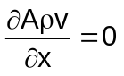
∗ the momentum equation:
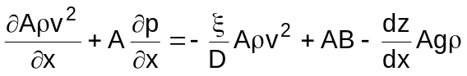
∗ the first law of thermodynamics:
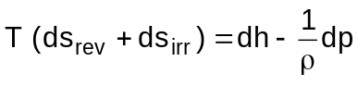
Substituting the continuity equation in the momentum equation the last one becomes:
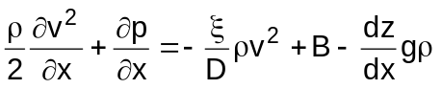
For a constant density fluid the two equations, integrated on the component, become:
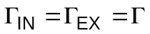
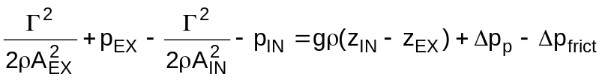
where:
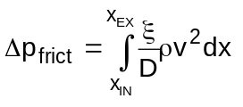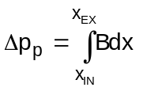
It is moreover assumed:
∗ the inlet and outlet flow cross-section areas of the component are equal, namely:
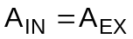
∗ the inlet and outlet component elevations are equal, namely:
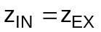
and the momentum equation becomes:
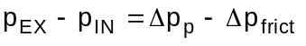

#$K+!Valves and pumps: valves
Modules referred to: VALV.
For valves it is:
dh = 0
namely:
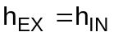
In the momentum equation it is:
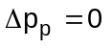
For local momentum losses Δpfric is customarily defined as:
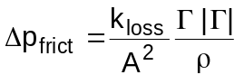
The local momentum loss coefficient kloss/A² can be related to the valve fluid coefficient Cv (see note 1):
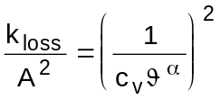
obtaining:
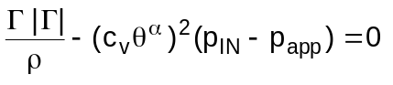
(see note 2).
Making the assumption the last relationship to be valid for a compressible fluid too, where the critical flow can occur, and remembering that:
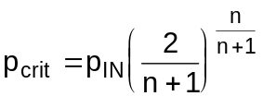
where:
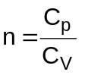
the term papp is defined:
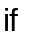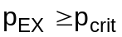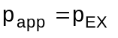
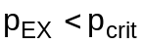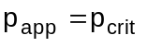
More accurate models can be used to evaluate the mass flow rate when the critical flow occurs, such as the Moody-Morris model, which are not reported here.
The standard form of the momentum equation is:
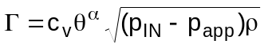
but two peculiar conditions must be taken into consideration for numerical stability reasons:
∗ the valve is closed - the momentum equation must be replaced with the statement:
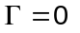
∗ the valve is open and the pressure difference is very small with respect to the inlet pressure - the momentum equation is in the form:
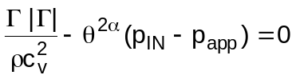

#Note 1:
The valve fluid coefficient Cv is defined as the volumetric fluid flow rate of water at 15 °C and 1 bar through a wide open valve undergoing a pressure difference of one.
Usually the volumetric flow rate is expressed in US gallons per minute and the pressure difference in psi. The conversion factor is:
c_{v} (SI units) = 2.4*10⁻⁵ c_{v} (US units)

#Note 2:
If the momentum equation has the form:
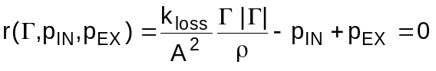
the term ∂r/∂Γ of the jacobian matrix vanishes when it is Γ = 0. To avoid it a linear term with respect to Γ is often added to the equation, which becomes:
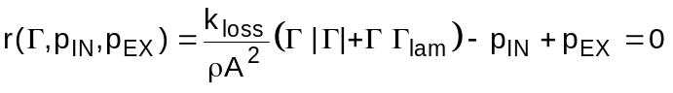
where Γ lam has a constant value, which is small in comparison to the nominal value of Γ, for example Γ lam = 0.1 kg/s.

#$K+!Valves and pumps: pumps
Modules referred to: CPOM.
Defining:
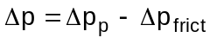
the momentum equation becomes:
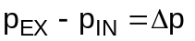
Pump characteristic curves are empirically developed by the pump manufacturer and uniquely define head response as function of volumetric flow and pump rotational speed (see note 1 and note 2).
The pump head is defined as:
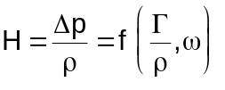
If the pump characteristic curves are not known, but only a working point besides the nominal one is known, the following relationships can be used:
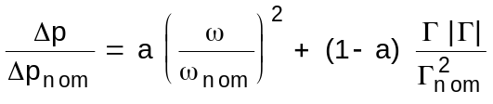
In the first law of thermodynamics it is for the pumps:
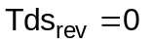
namely:
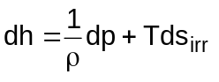
which customarily takes the form:
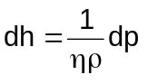
where the total efficiency η is:
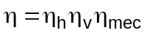
For constant density fluids it is:
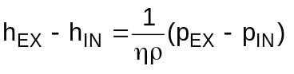
and, multiplying by the mass flow rate Γ, the resistive power Πres is obtained:
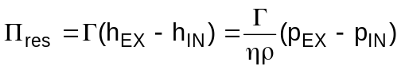
To have the pump outlet enthalpy available when the rotational speed is null and the mass flow is not null the hypotesys of no heat storage has been dropped and the energy conservation equation is:
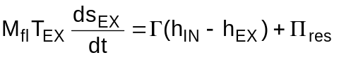
where the fluid mass Mfl inside the pump is considered constant.
The resistive torque:
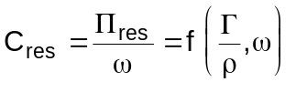
is usually obtained as a pump characteristic curve from the pump manufacturer.
From the relationship:
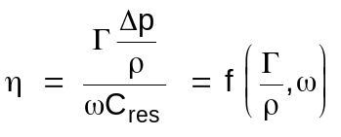
the total efficiency η is determined.
When only the efficiency ηnom at rated conditions is known the following relationship can be used:
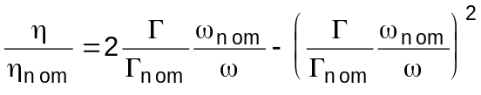
At last the kinetic energy equation is:
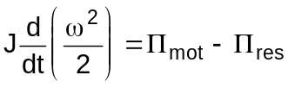

#Note 1:
The pump characteristic curves are usually converted to a simpler form by development of homologous curves, defined in terms of reduced variables (actual value to rated value ratio), namely reduced head and torque versus reduced pump speed and volumetric flow:
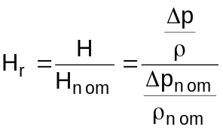
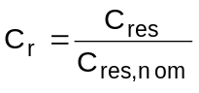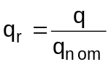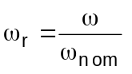
Various methods can be used, all based on the similitude theory, to obtain from these curves the actual values of Hr and Cr everywhere in the qr, ω r plane.

#Note 2:
The similitude theory states that, if two working points 1 and 2 are so related:
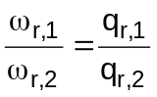
it is:
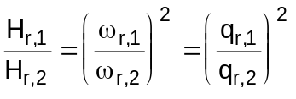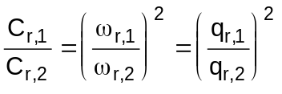
A common method obtains from the manufacturer’s pump characteristics the four curves:
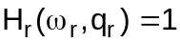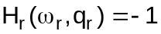
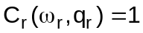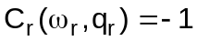
The Suter’s method starts from the original characteristic curves to compute Hr and Cr values along a unit radius circle in the qr, ω r plane.

# lg_lptheo_valves
$ Valves and pumps
K valves and pumps
+ LEGOCAD_LPtheory_mod:000
! EnableButton("button_up");ChangeButtonBinding("button_up", "JumpId(`lglptheo.hlp',`lg_lptheo_main')")
# lg_lptheo_valvgen
$ Valves and pumps: generalities
K valves and pumps: generalities
+ LEGOCAD_LPtheory_valv:000
! EnableButton("button_up");ChangeButtonBinding("button_up", "JumpId(`lglptheo.hlp',`lg_lptheo_valves')")
# lg_lptheo_valvvalv
$ Valves and pumps: valves
K valves and pumps: valves
+ LEGOCAD_LPtheory_valv:000
! EnableButton("button_up");ChangeButtonBinding("button_up", "JumpId(`lglptheo.hlp',`lg_lptheo_valves')")
# lg_lptheo_valvnot1v
# lg_lptheo_valvnot2v
# lg_lptheo_valvpump
$ Valves and pumps: pumps
K valves and pumps: pumps
+ LEGOCAD_LPtheory_valv:000
! EnableButton("button_up");ChangeButtonBinding("button_up", "JumpId(`lglptheo.hlp',`lg_lptheo_valves')")
# lg_lptheo_valvnot1p
# lg_lptheo_valvnot2p

