#$K+!Water and steam cavities, manifolds and mixers
{bmc help.bmp} Abstracts of the user documentation on manifolds, mixers and cavities
{bmc help.bmp} Abstracts of the user documentation on deareators
∗ Generalities (on these modules)
∗ Manifolds
∗ Mixers
∗ Water and steam cavities:
∗ Equilibrium cavities
∗ Non-equilibrium cavities
∗ Non-equilibrium cavities with air (uncondensable gas)
∗ Deareator (one pressure node)

#$K+!Water and steam cavities, manifolds and mixers: generalities
The main hypotheses used in the modelization of these modules are:
∗ constant cavity volume
∗ perfect mixing of the fluid in the cavity for manifolds and mixers or in the liquid and gas zone separately for tanks and mixture reservoirs
∗ fluid properties are computed at the mean fluid pressure value
∗ no friction losses are taken into account.
The momentum equation takes the form:
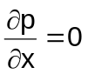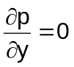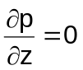
for manifolds and mixers, and the form:
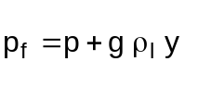
for water and steam cavities.

#$K+!Water and steam cavities, manifolds and mixers: manifolds
Modules referred to: COLT.
Additional hypothesis:
∗ No separation between gas and liquid phases
The continuity equation is:
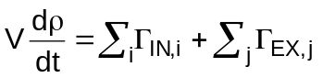
which becomes, assuming s and p as state variables:
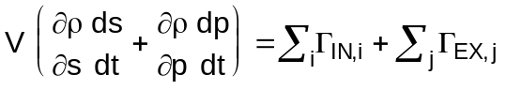
and the fluid energy conservation equation is:
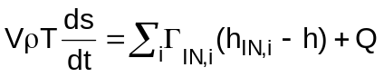
where h is the specific enthalpy of the internal fluid, namely h = h(p,s) and Q is the heat transfer between the internal fluid and the wall:
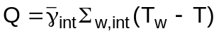
In the previous relation T is the internal fluid temperature, namely T = T(p,s), and:
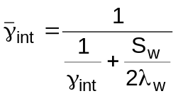
At last defining:
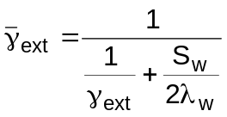
the wall energy conservation equation is:
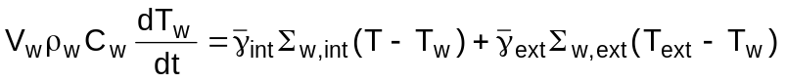
where Text is the temperature of the external fluid or the ambient temperature.

#$K+!Water and steam cavities, manifolds and mixers: mixers
Modules referred to: MIXN.
Additional hypotheses:
∗ no separation between gas and liquid phases
∗ no mass storage
∗ no heat storage
∗ no heat transfer between fluid and mixer walls
∗ one outlet flow
The mass and energy conservation equations become:
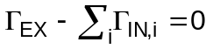
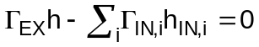
When there is no flow in the mixer the exit enthalpy must be forced.

#$K+!Water and steam cavities, manifolds and mixers: equilibrium cavities
Modules referred to: CAVE.
Main hypotheses:
∗ instantaneous and complete separation between gas and liquid phases
∗ thermal equilibrium between gas and liquid phases
∗ no heat transfer between fluid and cavity walls
Pressure p and enthalpy h are assumed as state variables.
When liquid phase and gas phase contemporaneously exist it is:
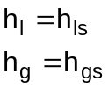
The continuity equation is:
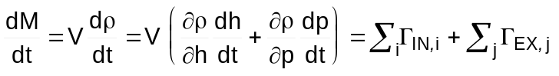
and the fluid energy conservation equation is:
where the former Nl outlet mass flow rates ΓEX,j exit a liquid zone, the latter Ng- Nl+1 outlet mass flow rates ΓEX,j exit a gas zone. Substituting in the energy conservation equation the continuity equation it is:
The steam quality and the mass of liquid are:
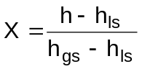
M_{l} = V (1-X) ρ
from which the liquid level can be computed, depending on the geometrical characteristics of the cavity.
Sometimes pressure p and liquid level y are preferred as state variables.
Let it be A the cavity horizontal cross section at level y, that is A = A(y), and l the cavity height.
Remembering that:
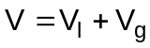
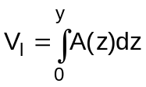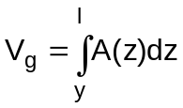
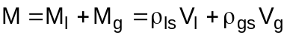
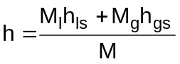
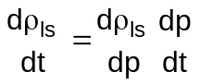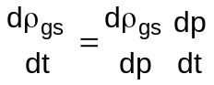
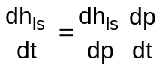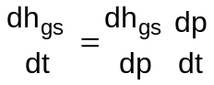
the continuity equation becomes:
Being:
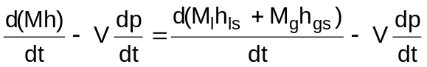
the energy conservation equation becomes:
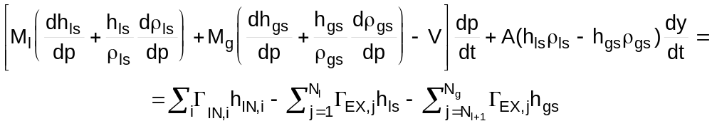
From the set of conservation equations dp/dt and dy/dt can be obtained.
If the cavity horizontal cross section is constant the conservation equations can be written as:
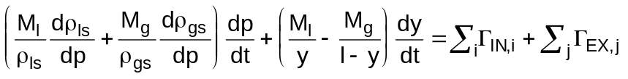
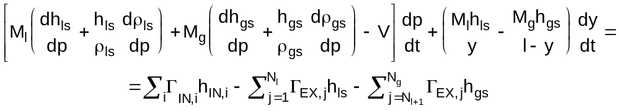

#$K+!Water and steam cavities, manifolds and mixers: non-equilibrium cavities
Main hypotheses:
∗ the cavity is split in two zones: the lower zone, named liquid zone, contains liquid or low quality mixture, and the upper one, named gas zone, contains gas or high quality mixture
∗ the two zones can be in thermal non-equilibrium
∗ no heat transfer occurs between fluid and the cavity wall
The continuity and energy conservation equations are:
∗ liquid zone:
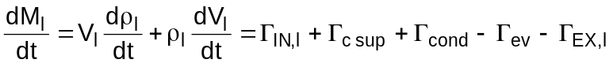
∗ gas zone:
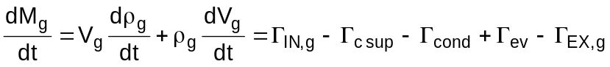
and, of course:
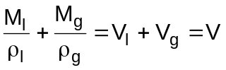
therefore:
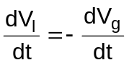
The condensation mass flow rate Γcond and evaporation mass flow rate Γev evaluations are based on the liquid or steam masses which are present in the gas and liquid zones and an estimated separation time τsep.
Defining the steam quality in the gas zone Xg and in liquid zone Xl as:
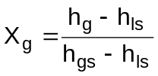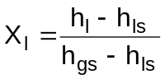
it is:
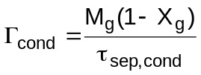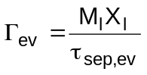
In the balance equations the surface condensation mass flow rate Γcsup and the zones interface heat transfer Q must be evaluated.
Mynkowycz and Sparrow have shown the interface heat transfer in presence of superheated steam and subcooled liquid at the steam-liquid interface is a little greater than in presence of saturated steam and liquid and it is nearly independent on the liquid subcooling. It can considered as the sum of a term Qsur depending on the steam superheating:
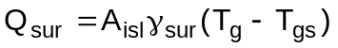
and a term Qs due to the saturated steam and liquid heat transfer, which is associated to a mass transfer (see note). Of course in the energy conservation equations only Qsur appears as a source term, that is:
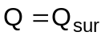
because Qs is included in the enthalpy transport terms related to the Γcsup surface condensation mass flow rate.
Among the many relationships developed to evaluate γsur and Qs, those used in module TANK are reported here.
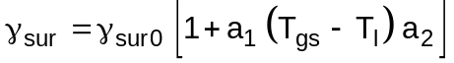
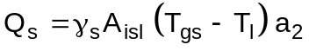
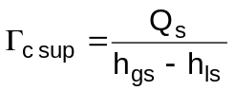
where:
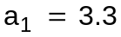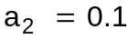
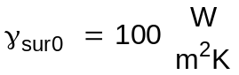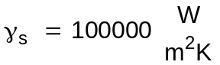

#Note:
A pure saturated steam is considered at a pressure pg and a temperature Tg condensing on its own liquid phase whose surface temperature is Tl. From the standpoint of kinetic theory, the phenomenon of such an interface mass transfer can be viewed as a difference between a rate of arrival of molecules from the gas space towards the interface and a rate of departure of molecules from the surface of the liquid to the gas space. When condensation takes place the arrival rate exceeds the departure rate and during evaporation the reverse occurs. In a stationary container the mass rate of flow passing in either direction is given by:
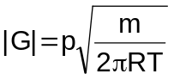
therefore the net mass flux through a gas-liquid interface is:
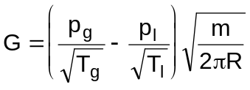
Since the condition close to the surface is not one of thermal equilibrium, for any significant rate of evaporation or condensation, it is really not meaningful to make use of the thermostatic pressure and temperature on each side of the interface. However, good results have been achieved by using simplified kinetic theory techniques and applying correction factors to the resulting predictions. A lot of relationships have been developed to this aim.

#$K+!Water and steam cavities, manifolds and mixers: non-equilibrium cavities with air (uncondensable gas)
Modules referred to: CLAV.
The main hypotheses are the same as for the other non-equilibrium cavities, namely:
∗ the cavity is split in two zones: the lower zone, named liquid zone, contains liquid or low quality mixture, and the upper one, named gas zone, contains gas or high quality mixture
∗ the two zones can be in thermal non-equilibrium
∗ no heat transfer occurs between fluid and the cavity wall.
The additional hypotheses are:
∗ steam and air occupy the same volume
∗ steam and air have the same temperature
∗ no heat transfer between air and liquid zone fluid
∗ the total pressure is the sum of air and steam partial pressures
∗ air is a perfect gas
∗ air is not soluble in water
Two components, steam and air, are present in the gas zone.
The steam conservation equations are:
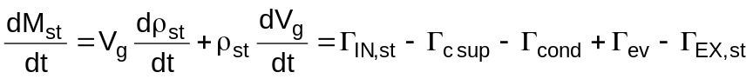
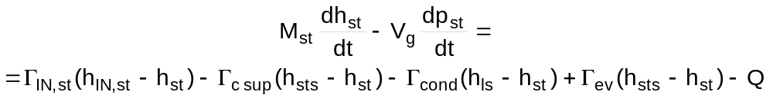
The air conservation equations are:
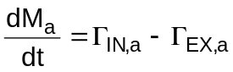
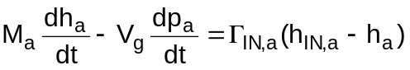
Remembering that:
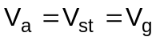
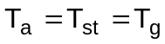
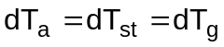
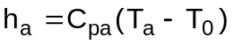
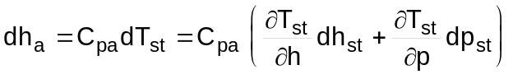
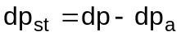
the energy conservation equation for the gas zone, obtained by summing the gas energy equation and the steam energy equation, is:
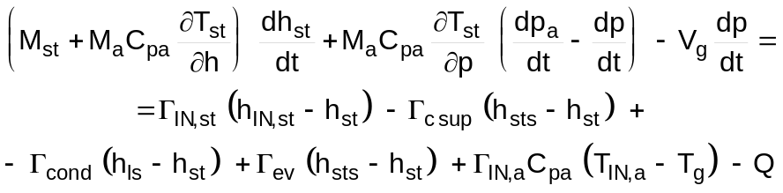
In the liquid region air is not present.
The conservation equations are:
With regard to the interface heat transfer Q evaluation the same considerations hold as in the case with no presence of a non-condensable component. It must be noted that the presence of even a small quantity of non-condensable gas in the condensing vapour has a great influence on the resistance to heat transfer in the region of the liquid-vapour interface. The non-condensable gas is carried with the vapour towards the interface where it accumulates, and the partial pressure of the gas at the interface increases above that in the bulk of the mixture. Since the total pressure remains constant the partial pressure of vapour at the interface is lower that in the bulk mixture.

#$K+!Water and steam cavities, manifolds and mixers: deaerators (one pressure node)
Modules referred to: DEGN.
The uncondensable gas separation is not simulated in the model.
The upper and lower tank of the deaerator are considered as a single non-equilibrium cavity without presence of uncondensable gas.
With reference to the non-equilibrium cavities model, the following additional hypotheses are made:
∗ in the liquid zone the term:
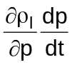
is negligible with respect to the other ones
∗ in the gas zone the feedwater flow ΓFW moves across the gas zone and warms up to reach the saturated liquid enthalpy hls.
There are some inconsistencies.
At first two hypotheses are chosen:
∗ no mass storage
∗ no heat storage
The resulting equations are:
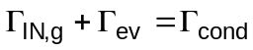
Multiplying the first equation by hg and subtracting it from the second one it is obtained:
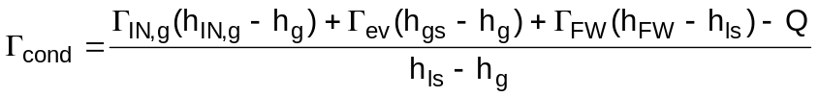
Afterwards the above mentioned hypotheses are dropped and substituted by:
∗ the gas density derivative can be always considered as:
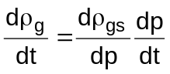
∗ the continuity equation is:
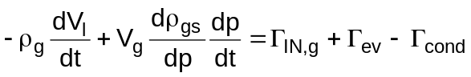
∗ the energy equation is:
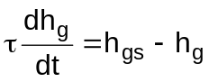
where τ is assigned.

# lg_lptheo_wscavi
$ Water and steam cavities, manifolds and mixers
K water and steam cavities, manifolds and mixers
+ LEGOCAD_LPtheory_mod:000
! EnableButton("button_up");ChangeButtonBinding("button_up", "JumpId(`lglptheo.hlp',`lg_lptheo_main')")
# lg_lptheo_wcavgen
$ Water and steam cavities, manifolds and mixers: generalities
K water and steam cavities, manifolds and mixers: generalities
+ LEGOCAD_LPtheory_wca:000
! EnableButton("button_up");ChangeButtonBinding("button_up", "JumpId(`lglptheo.hlp',`lg_lptheo_wscavi')")
# lg_lptheo_wcavman
$ Water and steam cavities, manifolds and mixers: manifolds
K water and steam cavities, manifolds and mixers: manifolds
+ LEGOCAD_LPtheory_wca:000
! EnableButton("button_up");ChangeButtonBinding("button_up", "JumpId(`lglptheo.hlp',`lg_lptheo_wscavi')")
# lg_lptheo_wcavmix
$ Water and steam cavities, manifolds and mixers: mixers
K water and steam cavities, manifolds and mixers: mixers
+ LEGOCAD_LPtheory_wca:000
! EnableButton("button_up");ChangeButtonBinding("button_up", "JumpId(`lglptheo.hlp',`lg_lptheo_wscavi')")
# lg_lptheo_wcavcav
$ Water and steam cavities, manifolds and mixers: equilibrium cavities
K water and steam cavities, manifolds and mixers: equilibrium cavities
+ LEGOCAD_LPtheory_wca:000
! EnableButton("button_up");ChangeButtonBinding("button_up", "JumpId(`lglptheo.hlp',`lg_lptheo_wscavi')")
# lg_lptheo_wcavtan
$ Water and steam cavities, manifolds and mixers: non-equilibrium cavities
K water and steam cavities, manifolds and mixers: non-equilibrium cavities
+ LEGOCAD_LPtheory_wca:000
! EnableButton("button_up");ChangeButtonBinding("button_up", "JumpId(`lglptheo.hlp',`lg_lptheo_wscavi')")
# lg_lptheo_wcavnot1t
# lg_lptheo_wcavcla
$ Water and steam cavities, manifolds and mixers: non-equilibrium cavities with air (uncondensable gas)
K water and steam cavities, manifolds and mixers: non-equilibrium cavities with air (uncondensable gas)
+ LEGOCAD_LPtheory_wca:000
! EnableButton("button_up");ChangeButtonBinding("button_up", "JumpId(`lglptheo.hlp',`lg_lptheo_wscavi')")
# lg_lptheo_wcavdeg
$ Water and steam cavities, manifolds and mixers: deaerators (one pressure node)
K water and steam cavities, manifolds and mixers: deaerators (one pressure node)
+ LEGOCAD_LPtheory_wca:000
! EnableButton("button_up");ChangeButtonBinding("button_up", "JumpId(`lglptheo.hlp',`lg_lptheo_wscavi')")

