#$K+!Water and steam pipes, exchangers and evaporators
{bmc help.bmp} Abstracts of the user documentation of these modules
∗ Exchangers and evaporators

#$K+!Water and steam pipes, exchangers and evaporators: exchangers and evaporators
Modules referred to: EXCH.
These components are modelled as a series of control volumes, called cells.
The basic 1-D equations in local form for a constant cross-section straight tube are
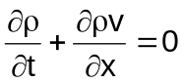
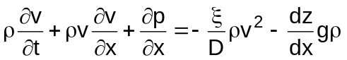
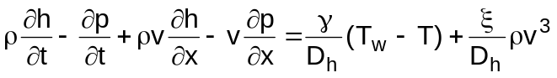
Dropping the terms v(∂p/∂x) and (ξ/Dh)ρv³ in the energy conservation equation and integrating the conservation equations on a fixed control volume, the following equations for the i-th cell are obtained:
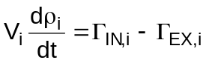
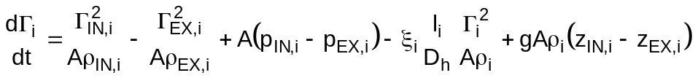
The following assumptions are made:
∗ ΓIN,i = Γi and of course ΓEX,i = Γi+1
∗ hEX,i = hi and of course hIN,i = hi-1
∗ pEX,i = pi and of course pIN,i = pi-1
∗ the terms dΓi/dt, Γ²IN,i/AρIN,i and Γ²EX,i/AρEX,i can be neglected in the momentum equation
∗ the term Vi(dpi/dt) can be neglected in the energy conservation equation
and the conservation equations become:
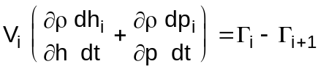
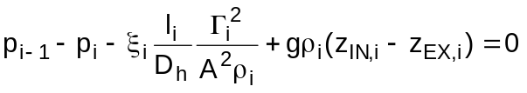
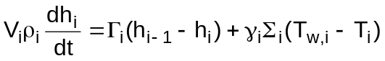
If the two-phase flow drift flux model is adopted new terms are added to the momentum and energy conservation equations
Pressure drop and heat transfer coefficients are computed by means of empirical correlations.
The wall energy conservation equation is, in local form and in cylindrical coordinates,
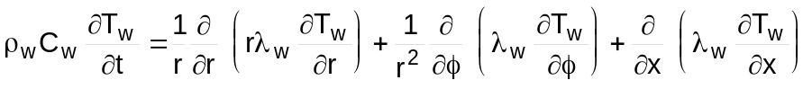
The following assumptions are made:
∗ Tw doesn’ t depend on φ
∗ The axial thermal conduction term can be neglected
∗ The wall thermal conductivity λw is constant
Integrating the wall energy equation on a control volume of length li spanning from rint to rext with the boundary conditions:
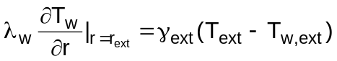
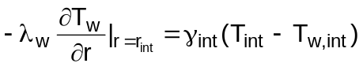
and assuming the whole wall heat capacity is lumped on the mean wall radius it is for each cell:
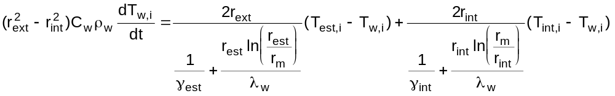

# lg_lptheo_wspipe
$ Water and steam pipes, exchangers and evaporators
K water and steam pipes, exchangers and evaporators
+ LEGOCAD_LPtheory_mod:000
! EnableButton("button_up");ChangeButtonBinding("button_up", "JumpId(`lglptheo.hlp',`lg_lptheo_main')")
# lg_lptheo_wpipexc
$ Water and steam pipes, exchangers and evaporators: exchangers and evaporators
K water and steam pipes, exchangers and evaporators: exchangers and evaporators
+ LEGOCAD_LPtheory_exc:000
! EnableButton("button_up");ChangeButtonBinding("button_up", "JumpId(`lglptheo.hlp',`lg_lptheo_wspipe')")

