#$K+!Steam condensers and feedwater heaters
{bmc help.bmp} Abstracts of the user documentation on steam condensers
{bmc help.bmp} Abstracts of the user documentation on feedwater heaters
∗ Generalities (on these modules)
∗ Steam condensers
∗ Feed water horizzontal heaters
∗ Feed water vertical heaters

#$K+!Steam condensers and feedwater heaters: generalities
The mathematical models regard both the shell side and the tube side fluids, the tube bundles and the casing of a shell-and-tube heat exchanger.
The main hypotheses of the tube side fluid model are:
∗ the fluid always is subcooled liquid
∗ no mass storage
∗ no inertia
It is moreover assumed:
∗ the tube bundle is represented by one equivalent pipe, axially split in cells
∗ the tube flow cross-section area is constant
∗ the inlet and outlet component elevations are equal, namely:
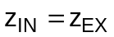
Integrating the conservation equations on a control volume (cell) and assuming:
∗ ΓIN,i = Γi and of course ΓEX,i = Γi+1
∗ hEX,i = hi and of course hIN,i = hi-1
∗ pEX,i = pi and of course pIN,i = pi-1
∗ the terms Γ²IN,i/AρIN,i and Γ²EX,i/AρEX,i can be neglected in the momentum equation
∗ the term Vi(dpi/dt) can be neglected in the energy conservation equation
the conservation equations for the i-th cell become:
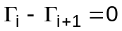
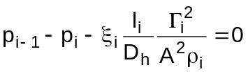
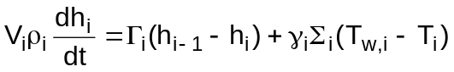
The tubes wall energy equation is, making the same hypotheses as for heat exchangers walls:
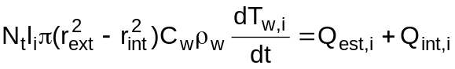
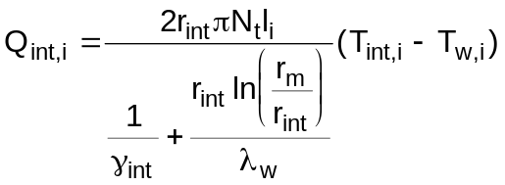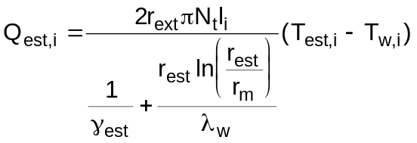
where the heat transfer coefficients are computed by means of empirical correlations, depending on the local conditions.
The shell side fluid undergoes the following transformations:
∗ desuperheating
∗ condensation
∗ subcooling
As a rule the shell side volume is split in three zones, the desuperheating zone, the condensation zone and the subcooling zone. On each of them the continuity and energy equations are integrated:
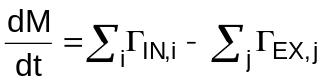
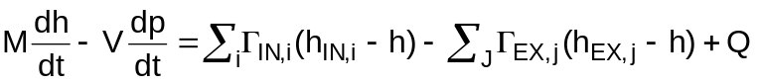
Once the fluid mass in the subcooling zone is known, the zone volume and the liquid level can be computed.
The momentum equation takes the form:
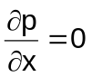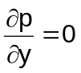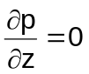
for heat exchangers, and the form:
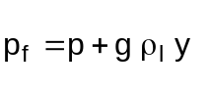
for condensers (that is to say p is the same for all zones but in the condensers the bottom pressure is computed).
The total volume is constant:
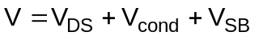
The heat transfer between the shell side fluid and the casing is always neglected.

#$K+!Steam condensers and feedwater heaters: steam condensers
Modules referred to: CNDN.
The following hypotheses are made for the shell side fluid model:
∗ desuperheating zone:
∗ since the condenser is fed with the turbine exhaust steam, which is already wet, the desuperheating zone is not modelled
∗ condensation and subcooling zones:
∗ instantaneous and complete separation between gas and liquid phases
∗ thermal equilibrium everywhere between gas and liquid phases (that is to say the liquid zone is really not a subcooling zone)
∗ the non-condensable gas is not considered in the model
The continuity and energy equations of the two zones can be summed, resulting in:
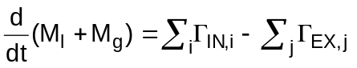
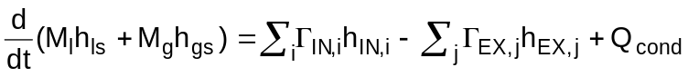
where it is:
hEX,j = hls if the flow ΓEX,j exits the liquid zone
hEX,j = hgs if the flow ΓEX,j exits the gas zone
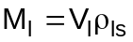
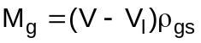
In the tube side fluid model and the tube wall model the equations are referred to five cells and it is:
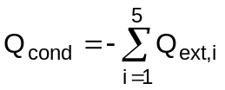
Because the shell side fluid temperature Text,i is always the saturation temperature at the condenser pressure and the external heat transfer coefficient γext,i is considered as a constant, it doesn’t matter which external zone the tube cells face.

#$K+!Steam condensers and feedwater heaters: horizontal feedwater heaters
Some additional hypotheses are made for the shell side fluid model:
∗ the heat transfer among the fluid in the zones is negligible with respect to the heat transfer among the fluid and the tube bundle
∗ the evaporation mass flow rate Γev between the subcooling zone and the evaporation zone is negligible
∗ desuperheating zone:
∗ since the horizontal feedwater heaters are fed with the lowest pressure steam extractions, where the steam is already wet, the desuperheating zone is not modelled
∗ condensation zone:
∗ no heat storage
∗ the drainage inlet flow immediately separates in a steam flow ΓDRg, which enters the condensation zone, and a liquid flow ΓDRl which enters straight the subcooling zone
∗ the fluid inside the zone is dry saturated steam, because the condensate immediately separates
so the equations for the condensation zone are:
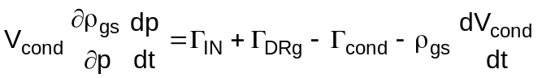
∗ subcooling zone:
∗ the term (∂ρ/∂p)(dp/dt) is negligible in the continuity equation
therefore:
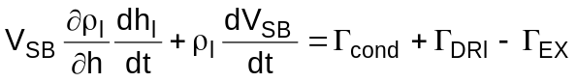
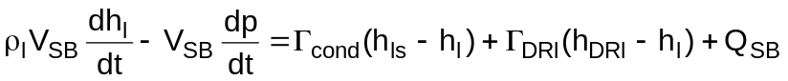
and:
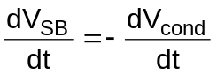
In the tube side fluid model and the tube wall model the aforesaid equations are referred to two cells, corresponding to the two zones of the shell side fluid model. The first tube cell faces the subcooling zone and the second one the condensation zone.

#$K+!Steam condensers and feedwater heaters: vertical feedwater heaters
Some additional hypotheses are made for the shell side fluid model:
∗ the heat transfer among the fluid in the zones is negligible with respect to the heat transfer among the fluid and the tube bundle
∗ desuperheating zone:
∗ no mass storage
∗ no thermal storage
∗ the volume of the zone is very small with respect to the volume of the condensation zone, that is
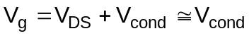
∗ the fluid leaving the zone is dry saturated steam, that is:
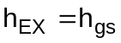
since there are one inlet flow and one outlet flow the equations become:
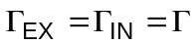
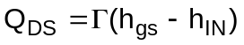
∗ condensation zone:
∗ no heat storage
∗ the drainage inlet flow immediately separates in a steam flow ΓDRg, which enters the condensation zone, and a liquid flow ΓDRl which enters straight the subcooling zone
∗ the fluid inside the zone is dry saturated steam, because the condensate immediately separates
so the equations are for the condensating zone are:
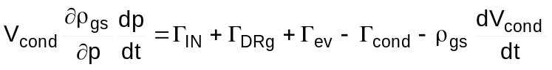
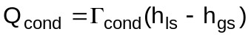
∗ subcooling zone:
∗ the fluid density derivatives are null
therefore:
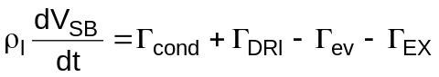
and:
The evaporation mass flow rate Γev is
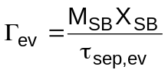
based on the same considerations as for the cavities models.
In the tube side fluid model and the tube wall model the aforesaid equations are referred to three cells, corresponding to the three zones of the shell side fluid model. The first tube cell faces the subcooling zone, the second one the condensation zone and the third one the desuperheating zone.
It obviously is:
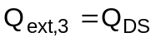
whereas the other heat transfer powers, namely Qext,2, Qext,1, Qcond and QSB are computed by means of the customary relationships.

# lg_lptheo_conds
$ Steam condensers and feedwater heaters
K steam condensers and feedwater heaters
+ LEGOCAD_LPtheory_mod:000
! EnableButton("button_up");ChangeButtonBinding("button_up", "JumpId(`lglptheo.hlp',`lg_lptheo_main')")
# lg_lptheo_condgen
$ Steam condensers and feedwater heaters: generalities
K steam condensers and feedwater heaters: generalities
+ LEGOCAD_LPtheory_cnd:000
! EnableButton("button_up");ChangeButtonBinding("button_up", "JumpId(`lglptheo.hlp',`lg_lptheo_conds')")
# lg_lptheo_condcond
$ Steam condensers and feedwater heaters: steam condensers
K steam condensers and feedwater heaters: steam condensers
+ LEGOCAD_LPtheory_cnd:000
! EnableButton("button_up");ChangeButtonBinding("button_up", "JumpId(`lglptheo.hlp',`lg_lptheo_conds')")
# lg_lptheo_condhori
$ Steam condensers and feedwater heaters: horizontal feedwater heaters
K steam condensers and feedwater heaters: horizontal feedwater heaters
+ LEGOCAD_LPtheory_cnd:000
! EnableButton("button_up");ChangeButtonBinding("button_up", "JumpId(`lglptheo.hlp',`lg_lptheo_conds')")
# lg_lptheo_condvert
$ Steam condensers and feedwater heaters: vertical feedwater heaters
K steam condensers and feedwater heaters: vertical feedwater heaters
+ LEGOCAD_LPtheory_cnd:000
! EnableButton("button_up");ChangeButtonBinding("button_up", "JumpId(`lglptheo.hlp',`lg_lptheo_conds')")

