#$K+!Combustion chambers for steam generators
{bmc help.bmp} Abstracts of the user documentation of these modules
∗ Generalities (on these modules)
∗ Furnace fluid-dynamic model
∗ Furnace thermal balance model:
∗ fluid mass conservation
∗ fluid energy conservation
∗ radiative heat transfer
∗ convective heat transfer
∗ combustion chemical reactions
∗ burners tilt effect
∗ coal combustion

#$K+!Combustion chambers for steam generators: generalities
The model of the furnace is split in two partial models; one of them deals with the thermal balance of the fluid passing through the chamber, the other one is the fluid-dynamic model.
The module EXCH can be used to build a model of the furnace walls.

#$K+!Combustion chambers for steam generators: furnace fluid-dynamic model
The internal differences of pressure in the furnace are very small with respect to those along the air-gas path from air intake to the chimney. The internal pressure in the furnace can be therefore considered as spatially constant.
The furnace is modelled as a volume in which the gas has uniform pressure. The volume is split in so many cells as those of the thermal model of the furnace. For each cell the gas temperature Ti is:
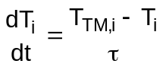
where TTM,i is the gas temperature in the corresponding cell of the thermal model.
Assuming the gas follows the perfect gas law it is for each cell:
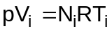
and the volume mean gas temperature T is:
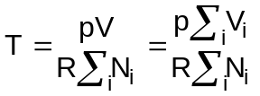
Assuming the molar mass m = 28.725 kg/kmole it is:
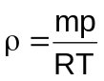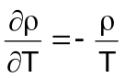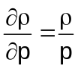
the continuity equation is:
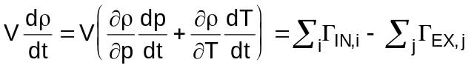
The temperature changes are much slower than pressure changes and the term V(∂r/∂p)(dT/dt) can be dropped. It results:
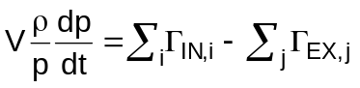
where ΓIN,i and ΓEX,j are the mass flow rates entering and leaving the furnace.

#$K+!Combustion chambers for steam generators: furnace thermal balance model
The goal is the evaluation of radiation heat transfer as well as temperature and radiating species concentration distributions in the furnace. The furnace walls temperatures, the inlet and outlet flow rates are boundary conditions.
The models for analysing heat transfer in industrial furnaces are of three types:
∗ the “stirred vessel” (zero-dimensional) model, which yields only the total heat transfer rate without providing information on the local heat flux distribution;
∗ the “plug-flow” (one-dimensional) model, which is capable of predicting the local heat flux in the furnace along the flow direction;
∗ the multidimensional model which can predict two-dimensional heat flux distribution at the load surface.
The first two models are being used routinely in engineering design calculations, and the one-dimensional model has been adopted as standard model in the LEGOCAD modules library and will be discussed in greater detail.
Various kinds of fuel are considered, such as natural gas, fuel oil and coal.
The burners tilting is taken into account.
The furnace is divided in control volumes, called cells, along the main gas path.
The simulated phenomena are:
∗ fluid mass conservation
∗ fluid energy conservation
∗ radiative and convective heat transfer
∗ combustion chemical reactions
The main hypotheses are:
∗ no mass storage
∗ no heat storage

#$K+!Combustion chambers for steam generators: fluid mass conservation
For each cell the continuity equation is:
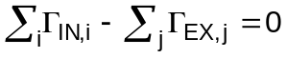
The inlet flow rates ΓIN,i are comprised of fuel and comburent air from the cell burners, the exhaust gas, unburnt fuel and air from the preceding cell. The outlet flow rates ΓEX,j are comprised of exhaust gas, unburnt fuel and air.
The evaluation of the unburnt fuel Γubf and air Γuba mass flow rates is based on the stoichiometric air-fuel ratio. When the actual ratio of the total entering air and the total entering fuel is greater than the stoichiometric ratio, the fuel entirely burns and an excess air flow rate Γuba leaves the cell; when the actual ratio is less than the stoichiometric one, an unburnt fuel flow rate Γubf exits the cell. If the furnace is fed with a mixture of fuels, the assumption is that as first natural gas burns, as second fuel oil and finally coal.

#$K+!Combustion chambers for steam generators: fluid energy conservation
For each cell the fluid energy equation is:
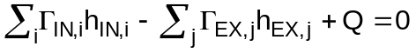
The power Q is the algebraical sum of all powers entering or leaving the cell without mass transfer. It includes the power Qcomb released by combustion of fuel, the radiative power Qrad,w and the convective power Qconv,w from furnace walls, the radiative power Qrad,i-1,i and Qrad,i+1,i from adjoining cells.
All other power sources, that is to say the conduction heat transfer with the adjoining cells and the radiative heat transfer with the non-adjoining cells, are neglected.
It is:
Of course, if a mixture of fuels is used, this relationship is repeated for each fuel.

#$K+!Combustion chambers for steam generators: radiative heat transfer
In industrial furnaces convective heat transfer usually accounts for a very small fraction of the total heat transfer to the load; therefore, more emphasis has been given to radiation in the model.
Two kinds of radiative heat transfer must be considered:
∗ heat transfer among gas and furnace walls
∗ heat transfer among gas and gas in the adjoining cells
The heat transfer among furnace walls and internal gas Qrad,w is:
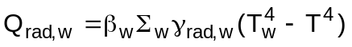
where βw is the flat surface / real surface ratio and the radiative heat transfer coefficient γrad,w is:
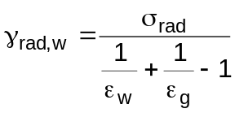
The wall emissivity εw value must be assigned. The gas emissivity εg is:
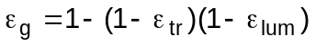
The transparent emissivity εtr is a function of the gas temperature, the partial pressures of the gas components, mainly triatomic components such as steam and carbon dioxide, and the optical path length and it is usually obtained by means of tables.
The luminous emissivity εlum is a function of the gas temperature, the optical path length and the presence of soot, solid and liquid particles and their diameter and it is strongly dependent on the kind of fuel. It is usually obtained by means of tables.
The heat transfer among gas and gas in the adjoining cells is for the preceding cell:
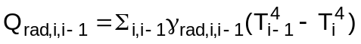
An analogous relationship holds for the following cell.
The radiative heat transfer coefficient γrad,i,i-1 is:
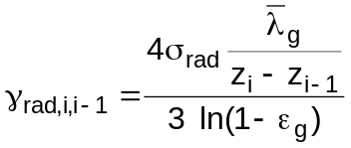
and the gas emissivity εg is:
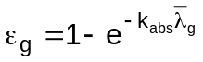
where kabs is the absorption coefficient.

#$K+!Combustion chambers for steam generators: convective heat transfer
The heat transfer among gas and furnace walls Qconv,w is:
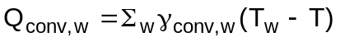
where the convective heat transfer coefficient γconv,w is:
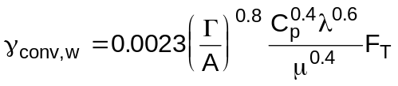
The term:
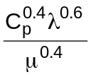
is approximated as a quadratic function of the boundary layer temperature TFILM, defined as:
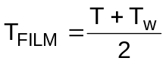
and the temperature factor FT is:
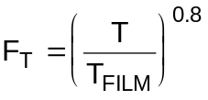

#$K+!Combustion chambers for steam generators: combustion chemical reactions
The considered chemical reactions are:
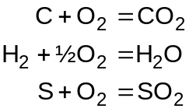
The stoichiometric oxygen mass for a unit fuel mass can be computed:
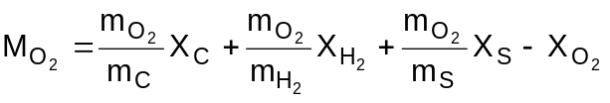
from which the stoichiometric air / fuel mass ratio can be determined.
The combustion products masses are:
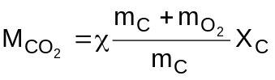
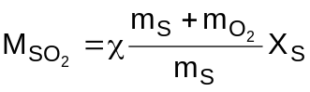
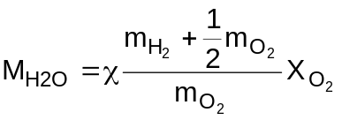
where is:
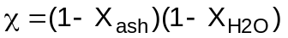
Xash is the ash / dry fuel ratio and XH2O is the fuel humidity.
When the excess air is known, the concentrations Xi, the molar fractions Ni and the partial pressure pi of each species can be computed:
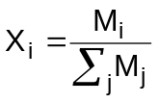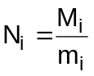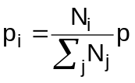

#$K+!Combustion chambers for steam generators: burners tilt effect
The burners tilt shifts the flame upwards or downwards in the furnace. The effect rises when the fuel flow rate increases, because the flame length grows. The tilt effect is taken into account by partly shifting the inlet fuel flow rate upwards or downwards in proportion to the tilt angle.

#$K+!Combustion chambers for steam generators: coal combustion
The coal combustion has three main phases:
∗ volatile matter release
∗ volatile matter combustion
∗ solid particles combustion
The volatile matter release and combustion is nearly instantaneous, whereas the solid particles combustion takes some time, that is to say solid particles do not completely burn in the same cell where they are injected.
Radiation heat transfer is due to gaseous contributions, mainly due to CO2 and H2O, and particulate contributions, which usually result from coal (char), soot and fly-ash. Radiation from fly-ash particles exceeds substantially the contribution of both triatomic combustion gases, as well as char and soot particles.

# lg_lptheo_ccsteam
$ Combustion chambers for steam generators
K combustion chambers for steam generators
+ LEGOCAD_LPtheory_mod:000
! EnableButton("button_up");ChangeButtonBinding("button_up", "JumpId(`lglptheo.hlp',`lg_lptheo_main')")
# lg_lptheo_ccsggen
$ Combustion chambers for steam generators: generalities
K combustion chambers for steam generators: generalities
+ LEGOCAD_LPtheory_ccs:000
! EnableButton("button_up");ChangeButtonBinding("button_up", "JumpId(`lglptheo.hlp',`lg_lptheo_ccsteam')")
# lg_lptheo_ccsghydr
$ Combustion chambers for steam generators: furnace fluid-dynamic model
K combustion chambers for steam generators: furnace fluid-dynamic model
+ LEGOCAD_LPtheory_ccs:000
! EnableButton("button_up");ChangeButtonBinding("button_up", "JumpId(`lglptheo.hlp',`lg_lptheo_ccsteam')")
# lg_lptheo_ccsgterm
$ Combustion chambers for steam generators: furnace thermal balance model
K combustion chambers for steam generators: furnace thermal balance model
+ LEGOCAD_LPtheory_ccs:000
! EnableButton("button_up");ChangeButtonBinding("button_up", "JumpId(`lglptheo.hlp',`lg_lptheo_ccsteam')")
# lg_lptheo_ccsgmass
$ Combustion chambers for steam generators: fluid mass conservation
K combustion chambers for steam generators: fluid mass conservation
+ LEGOCAD_LPtheory_ccs:000
! EnableButton("button_up");ChangeButtonBinding("button_up", "JumpId(`lglptheo.hlp',`lg_lptheo_ccsteam')")
# lg_lptheo_ccsgener
$ Combustion chambers for steam generators: fluid energy conservation
K combustion chambers for steam generators: fluid energy conservation
+ LEGOCAD_LPtheory_ccs:000
! EnableButton("button_up");ChangeButtonBinding("button_up", "JumpId(`lglptheo.hlp',`lg_lptheo_ccsteam')")
# lg_lptheo_ccsgradi
$ Combustion chambers for steam generators: radiative heat transfer
K combustion chambers for steam generators: radiative heat transfer
+ LEGOCAD_LPtheory_ccs:000
! EnableButton("button_up");ChangeButtonBinding("button_up", "JumpId(`lglptheo.hlp',`lg_lptheo_ccsteam')")
# lg_lptheo_ccsgconv
$ Combustion chambers for steam generators: convective heat transfer
K combustion chambers for steam generators: convective heat transfer
+ LEGOCAD_LPtheory_ccs:000
! EnableButton("button_up");ChangeButtonBinding("button_up", "JumpId(`lglptheo.hlp',`lg_lptheo_ccsteam')")
# lg_lptheo_ccsgcomb
$ Combustion chambers for steam generators: combustion chemical reactions
K combustion chambers for steam generators: combustion chemical reactions
+ LEGOCAD_LPtheory_ccs:000
! EnableButton("button_up");ChangeButtonBinding("button_up", "JumpId(`lglptheo.hlp',`lg_lptheo_ccsteam')")
# lg_lptheo_ccsgtilt
$ Combustion chambers for steam generators: burners tilt effect
K combustion chambers for steam generators: burners tilt effect
+ LEGOCAD_LPtheory_ccs:000
! EnableButton("button_up");ChangeButtonBinding("button_up", "JumpId(`lglptheo.hlp',`lg_lptheo_ccsteam')")
# lg_lptheo_ccsgcoal
$ Combustion chambers for steam generators: coal combustion
K combustion chambers for steam generators: coal combustion
+ LEGOCAD_LPtheory_ccs:000
! EnableButton("button_up");ChangeButtonBinding("button_up", "JumpId(`lglptheo.hlp',`lg_lptheo_ccsteam')")

