#$K+!Flue gas side and metal wall of pipes and exchangers
{bmc help.bmp} Abstracts of the user documentation of these modules
∗ Gas duct exchangers
∗ Component walls:
∗ pipe walls
∗ flat slabs
∗ steam turbine rotors, shells and casing

#$K+!Flue gas side and metal wall of pipes and exchangers: gas duct exchangers
Modules referred to: FUMN.
The thermal exchange among the exhaust gas flowing through a duct and the duct walls is computed. The momentum equation is not considered in the model.
The main hypotheses are:
∗ no mass storage
∗ no energy storage
∗ kinetic and gravitational terms are neglected in the energy conservation equation
A one-dimensional approximation is adopted.
The duct is axially split in cells.
The conservation equations for each cell are:
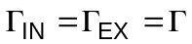
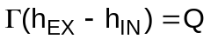
Q is the power entering the gas and it is sum of two contributions, the convective one Qconv and the radiative one Qrad, expressed as:
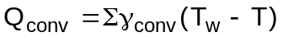
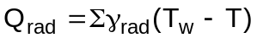
The expressions of the convective heat transfer coefficient γconv and the radiative heat transfer coefficient γrad are explained in the section "pressure drop and heat transfer correlations".
The radiative power only takes into account the intertube radiation, whereas the cavity radiation is neglected.
It often happens the duct walls of the same cell, belonging to different boiler sections, have different temperatures Tw,i. The following approximations are made:
∗ the mean wall temperature Tw is defined as:
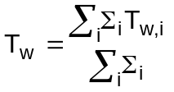
∗ the heat transfer coefficients and powers, both convective and radiative, are evaluated using the mean wall temperature Tw.

#$K+!Flue gas side and metal wall of pipes and exchangers: component walls
The energy conservation equation in local form for a solid body is
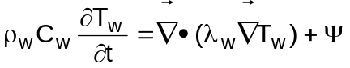
where • indicates the inner product between vectors and Ψ is the internal power for unit volume. If it is:
Ψ = 0
the equation becomes in rectangular coordinates:
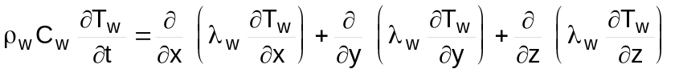
and in cylindrical coordinates:
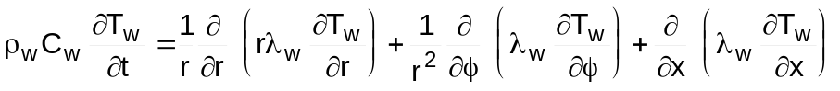

#$K+!Flue gas side and metal wall of pipes and exchangers: pipe walls
The thermal field in a thin hollow cylindrical body, such as a pipe wall, must be determined.
The pipe is modelled as a series of control volumes, called cells, in the axial direction.
The following assumptions are made:
∗ the wall thickness is small with respect to the diameter
∗ Tw doesn’ t depend on φ
∗ Tw, Tint and Test are constant in the axial direction along the cell
∗ the axial thermal conduction term can be neglected
∗ the wall thermal conductivity λw is constant
Referring to the wall energy equation in cylindrical coordinates:
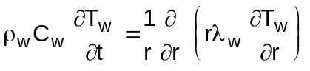
the equation is integrated on a control volume of length li spanning from rint to rext, that is the whole wall is lumped in only one cell in the radial direction, with the boundary conditions:
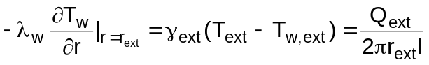
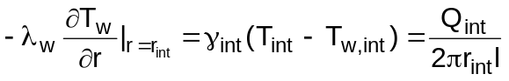
It is:
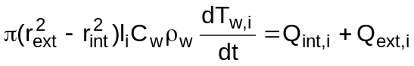
where:
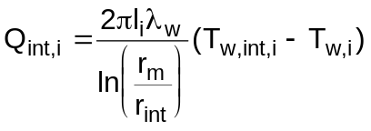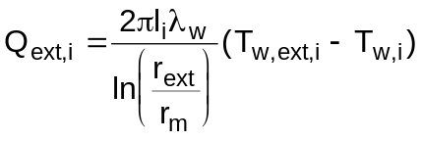
To obtain the definition of mean radius rm the mean temperature Tw in steady state conditions is computed.
It is:
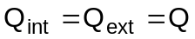
and:
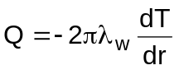
for rint ≤ r ≤ rext.
Integrating two times it is obtained:
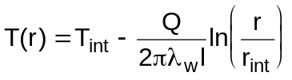
and the mean temperature:
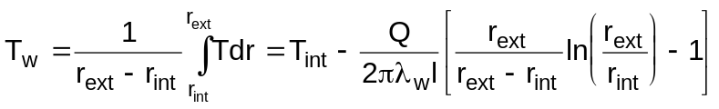
Imposing T(rm) = Tw it is:
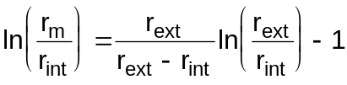
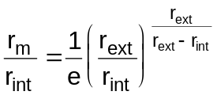
and, if it is:
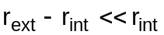
it can be taken:
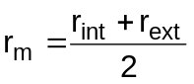

#$K+!Flue gas side and metal wall of pipes and exchangers: flat slab
The thermal field in a flat slab must be determined.
The following assumptions are made:
∗ the wall thermal conductivity λw is constant
Referring to the wall energy equation in rectangular coordinates:
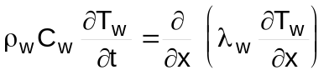
integrating on a control volume of length li spanning from xint to xext, that is the whole wall is lumped in only one cell in the x direction, with the boundary conditions:
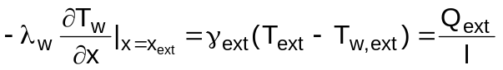
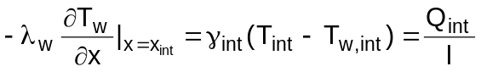
and assuming the whole wall heat capacity is lumped on the mean wall abscissa, defined as:
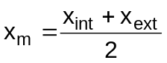
the energy equation becomes for each cell:
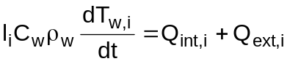
where:
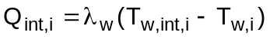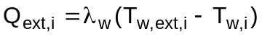

#$K+!Flue gas side and metal wall of pipes and exchangers: steam turbine rotor, shells and casing
The thermal field in a thick cylindrical body, such as steam turbine rotors, shells and casings, must be determined.
The body is divided in axial cells, each one consisting of radial layers.
The following assumptions are made:
∗ the body has an axial-symmetric geometry
∗ Tw doesn’ t depend on φ
∗ Tw, Tint and Test are constant in the axial direction along the cell
∗ the axial thermal conduction term can be neglected
Referring to the energy equation in cylindrical coordinates:
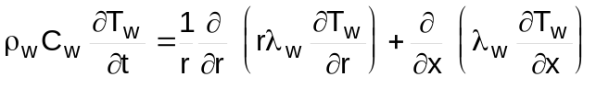
and integrating it on each layer an equations set is obtained. The generical i-th equation is:
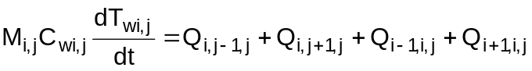
where i is the cell index, j is the layer index and imax and jmax are the top values of the indexes.
Moreover it is:
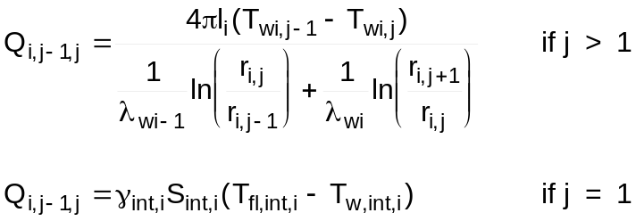
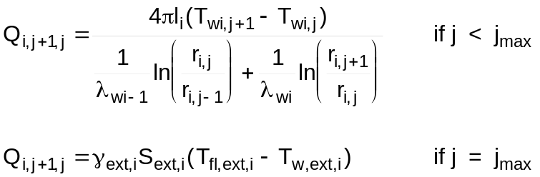
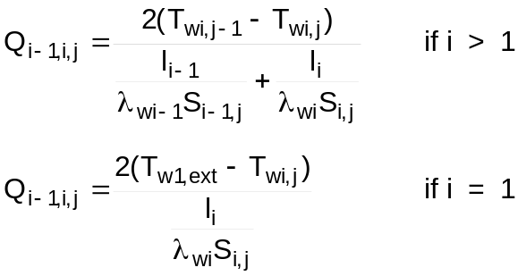
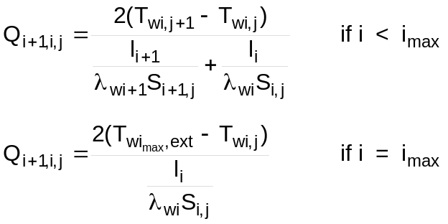
Right and left extensions with respect to a fixed point are calculated as sum of the partial dilatation on each cell. The thermal dilatation and the contraction due to the spin for rotating parts are taken into account. The linear dilatation for unit length εz is:
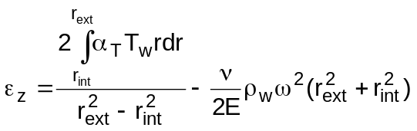

# lg_lptheo_metals
$ Flue gas side and metal wall of pipes and exchangers
K flue gas side and metal wall of pipes and exchangers
+ LEGOCAD_LPtheory_mod:000
! EnableButton("button_up");ChangeButtonBinding("button_up", "JumpId(`lglptheo.hlp',`lg_lptheo_main')")
# lg_lptheo_metaduct
$ Flue gas side and metal wall of pipes and exchangers: gas duct exchangers
K flue gas side and metal wall of pipes and exchangers: gas duct exchangers
+ LEGOCAD_LPtheory_met:000
! EnableButton("button_up");ChangeButtonBinding("button_up", "JumpId(`lglptheo.hlp',`lg_lptheo_metals')")
# lg_lptheo_metawall
$ Flue gas side and metal wall of pipes and exchangers: component walls
K flue gas side and metal wall of pipes and exchangers: component walls
+ LEGOCAD_LPtheory_met:000
! EnableButton("button_up");ChangeButtonBinding("button_up", "JumpId(`lglptheo.hlp',`lg_lptheo_metals')")
# lg_lptheo_metapipe
$ Flue gas side and metal wall of pipes and exchangers: pipe walls
K flue gas side and metal wall of pipes and exchangers: pipe walls
+ LEGOCAD_LPtheory_met:000
! EnableButton("button_up");ChangeButtonBinding("button_up", "JumpId(`lglptheo.hlp',`lg_lptheo_metals')")
# lg_lptheo_metaslab
$ Flue gas side and metal wall of pipes and exchangers: flat slab
K flue gas side and metal wall of pipes and exchangers: flat slab
+ LEGOCAD_LPtheory_met:000
! EnableButton("button_up");ChangeButtonBinding("button_up", "JumpId(`lglptheo.hlp',`lg_lptheo_metals')")
# lg_lptheo_metacase
$ Flue gas side and metal wall of pipes and exchangers: steam turbine rotor, shells and casing
K flue gas side and metal wall of pipes and exchangers: steam turbine rotor, shells and casing
+ LEGOCAD_LPtheory_met:000
! EnableButton("button_up");ChangeButtonBinding("button_up", "JumpId(`lglptheo.hlp',`lg_lptheo_metals')")

