#$K+!Turbogas plants and related modules
{bmc help.bmp} Abstracts of the user documentation of these modules
∗ The air compressor
∗ The combustion chamber
∗ The gas turbine

#$K+!Turbogas plants and related modules: the air compressor
The model simulates a gas turbine axial compressor with the following features:
∗ the "choke flow" phenomenon is taken into account;
∗ the "surge" conditions are identified;
∗ the isentropic efficiency is depending on the compression ratio;
∗ the model of a bypass valve is included to be used during the start up to reduce the delivery air flow rate and consequently keep lower the pressure inside the furnace.
The following three dimensionless quantities must be defined:
∗ flow number:
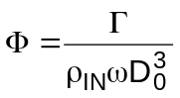
∗ compression ratio:
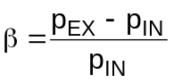
∗ blade Mach number:
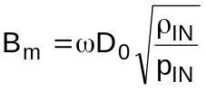
The equations are:
1. total mass flow rate can be calculated from the following formula:
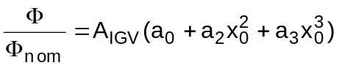
where:
a) x0 measures how much the value of x=β/βnom is greater than the choke flow value
b) AIGV is the inlet guide vanes cross-section area (function of servomotor position or of the inlet guide vanes rotation angle, depending on the compressor type)
2. the air entering the compressor Γair is the total mass flow rate Γair,IN minus the bypass mass flow rate Γbyp:
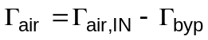
where the bypass mass flow rate is calculated using the Stodola law:
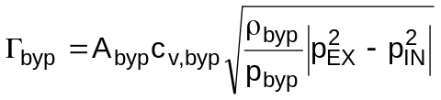
3. the outlet temperature is function of the outlet enthalpy, which is, in turn, calculated from the isentropic efficiency parameter:
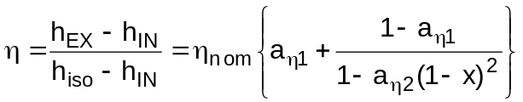
relation depending on nominal efficiency and on two coefficients which depend on the characteristics of the used compressor
4. pressure and enthalpy of the bypass valve are calculated using simplified linear relationships:
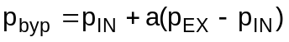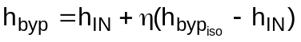
the latter equation supposes that the isentropic efficiency of the first compressor stages (up to the bypass valve) is the same as the one of the entire compressor
5. mechanical absorbed power is:

#$K+!Turbogas plants and related modules: the combustion chamber
The main features of the model are:
∗ two control volumes, related to the cold chamber and the combustion hot chamber, in which the energy and mass accumulation phenomena are neglected;
∗ two pressure nodes corresponding to the control volumes;
∗ the fuel feed system dynamics is represented through a zero / pole transfer function;
∗ the combustion delay is taken into account by means of a first order transfer function;
∗ the thermal exchange between the hot chamber walls and the internal flue gas, as well as that one with the external environment are represented.
The combustion chamber is constituted by two control volumes: a cold chamber receiving the compressor air and a hot chamber in which the combustion takes place. The compressed air flows from the former to the latter through a grid, modelled as a pressure drop.
The model equations are the following:
1. metal energy conservation
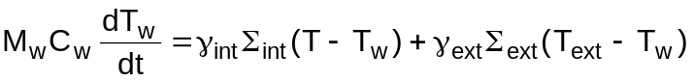
2. pressure drop through the grid (Stodola’s law):
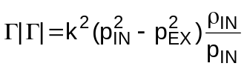
where pIN is the cold chamber pressure and pEX the hot chamber pressure
3. energy balance in the hot chamber:
where:
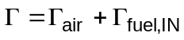
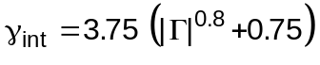
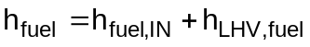
4. a delay time between fuel inlet and burning fuel is taken into account as a first order transfer function:
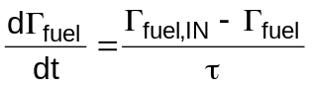
Moreover a combustion efficiency is considered. Finally, the effective burning fuel mass flow rate is obtained as the minimum between the so obtained mass flow rate and the stoichiometric flow rate.

#$K+!Turbogas plants and related modules: the gas turbine
The main features of the model are:
∗ the flow is evaluated by Stodola's law;
∗ the isentropic efficiency is depending on the expansion ratio;
∗ the thermal exchange between flue gas and metal of blades, rotor, stator and casing is supposed to be concentrated at the turbine inlet.
∗ the thermal storage in the mechanical parts is not taken into account.
The equations are the following ones:
1. Stodola’s efflux law to calculate inlet pressure:
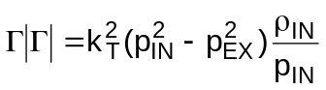
where in case of sonic conditions, pEX is substituted by the value provided by the sonic ratio
2. the thermal exchange between flue gas and casing (supposed to occur at turbine inlet for simplicity):
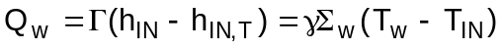
the thermal exchange coefficient between walls and flue gas is calculated by means of the following formula:
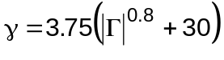
3. calculation of the turbine efficiency ratio:
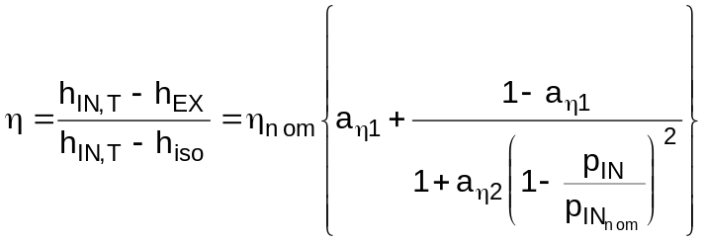
4. the generated mechanical power is calculated as:
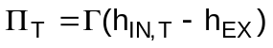

# lg_lptheo_tg
$ Turbogas plants and related modules
K turbogas plants and related modules
+ LEGOCAD_LPtheory_mod:000
! EnableButton("button_up");ChangeButtonBinding("button_up", "JumpId(`lglptheo.hlp',`lg_lptheo_main')")
# lg_lptheo_tgascoaf
$ Turbogas plants and related modules: the air compressor
K turbogas plants and related modules: the air compressor
+ LEGOCAD_LPtheory_tga:000
! EnableButton("button_up");ChangeButtonBinding("button_up", "JumpId(`lglptheo.hlp',`lg_lptheo_tg')")
# lg_lptheo_tgascpaf
$ Turbogas plants and related modules: the combustion chamber
K turbogas plants and related modules: the combustion chamber
+ LEGOCAD_LPtheory_tga:000
! EnableButton("button_up");ChangeButtonBinding("button_up", "JumpId(`lglptheo.hlp',`lg_lptheo_tg')")
# lg_lptheo_tgastpaf
$ Turbogas plants and related modules: the gas turbine
K turbogas plants and related modules: the gas turbine
+ LEGOCAD_LPtheory_tga:000
! EnableButton("button_up");ChangeButtonBinding("button_up", "JumpId(`lglptheo.hlp',`lg_lptheo_tg')")

