#$K+!Compressed air and natural gas treatment
{bmc help.bmp} Abstracts of the user documentation of these modules
∗ Compressors
∗ Gas tanks
∗ Air valves
∗ Compressors

#$K+!Compressed air and natural gas treatment: compressors
Modules referred to: CMSC.
The model simulates the operation of an industrial compressor with an internal recirculation line.
The main hypotheses are:
∗ no mass storage
∗ no heat storage
∗ no flow inertia
The compressor characteristic curve is described by means of the following relationship:
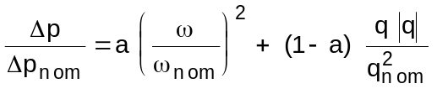
The mass flow rate through the compressor is:
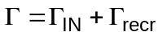
and the mass flow rate Γrecr through the recirculation line is:
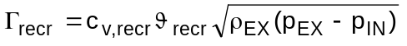
The power balance equation of fluid flowing through the fan is:
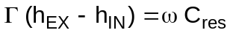
and the inlet enthalpy hmix to the compressor stages is:
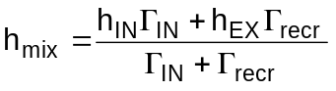
The isentropic efficiency ηiso and the mechanical efficiency ηmec are defined as:
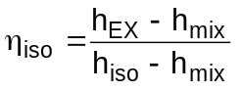
where hiso is the enthalpy obtained with an isentropic compression between pIN and pEX, and:
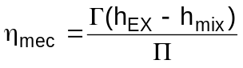
and of course:
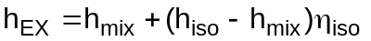
At the outlet of the compressor a cooling device is modelled.
The fluid energy conservation equation is:
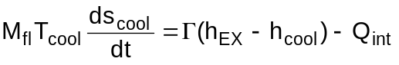
and the wall energy conservation equation is:
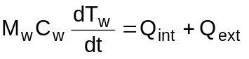
where:
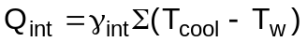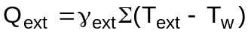

#$K+!Compressed air and natural gas treatment: gas tanks
Modules referred to: SERA.
Main hypotheses:
∗ constant cavity volume
∗ perfect mixing of the fluid in the cavity
∗ fluid properties are computed at the mean fluid pressure value
∗ fluid follows the perfect gas law
∗ no friction losses are taken into account
The momentum equation takes the form:
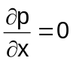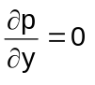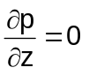
The continuity equation is:
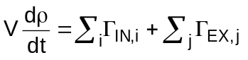
which becomes, assuming T and p as state variables:
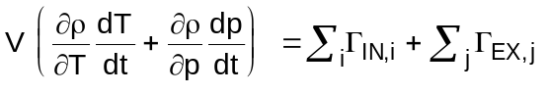
where:
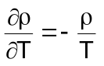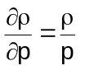
and the fluid energy conservation equation is:
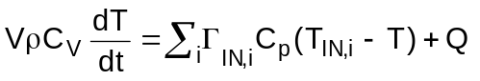
where T is the internal fluid temperature and Q is the heat transfer between the internal fluid and the wall:
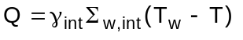
The wall energy conservation equation is
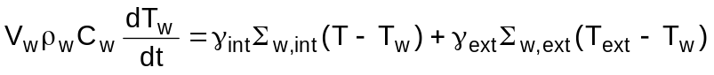
where Text is the temperature of the external fluid or the ambient temperature.

#$K+!Compressed air and natural gas treatment: air valves
Modules referred to: VAIN.
Main hypotheses:
∗ no mass storage
∗ no heat storage
∗ no inertia
∗ no heat transfer between fluid and component casing and internals
The following relationship, which strictly is only valid for incompressible fluids, is used:
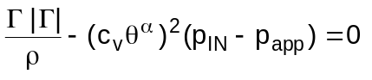
Remembering that:
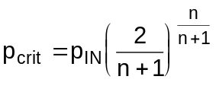
where:
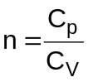
the term papp is defined:
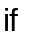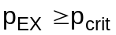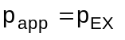
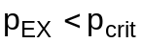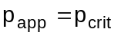
The outlet temperature TEX is computed as
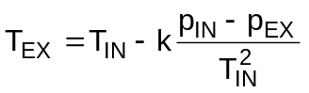
where k is an assigned coefficient.

# lg_lptheo_air
$ Compressed air and natural gas treatment
K compressed air and natural gas treatment
+ LEGOCAD_LPtheory_mod:000
! EnableButton("button_up");ChangeButtonBinding("button_up", "JumpId(`lglptheo.hlp',`lg_lptheo_main')")
# lg_lptheo_airgcomp
$ Compressed air and natural gas treatment: compressors
K compressed air and natural gas treatment: compressors
+ LEGOCAD_LPtheory_air:000
! EnableButton("button_up");ChangeButtonBinding("button_up", "JumpId(`lglptheo.hlp',`lg_lptheo_air')")
# lg_lptheo_airgserb
$ Compressed air and natural gas treatment: gas tanks
K compressed air and natural gas treatment: gas tanks
+ LEGOCAD_LPtheory_air:000
! EnableButton("button_up");ChangeButtonBinding("button_up", "JumpId(`lglptheo.hlp',`lg_lptheo_air')")
# lg_lptheo_airgvalv
$ Compressed air and natural gas treatment: air valves
K compressed air and natural gas treatment: air valves
+ LEGOCAD_LPtheory_air:000
! EnableButton("button_up");ChangeButtonBinding("button_up", "JumpId(`lglptheo.hlp',`lg_lptheo_air')")

