#$K+!Fossil fuel supply systems for steam generators
{bmc help.bmp} Abstracts of the user documentation of these modules
∗ Fuel oil manifold
∗ Fuel oil manifold with damper
∗ Fuel oil valve
∗ Fuel oil volumetric pump

#$K+!Fossil fuel supply system for steam generators: fuel oil manifold
The model computes the fuel oil conditions in a tank or manifold into which a few pipes converge.
The main hypotheses are:
∗ perfect mixing of the fuel oil in the tank;
∗ constant fuel oil compressibility;
∗ constant specific heat and thermal conductivity of the tank wall material;
∗ flat slab approximation for heat conduction in the tank walls;
∗ constant heat transfer coefficients.
The continuity equation and the energy conservation equation for the fuel oil are:
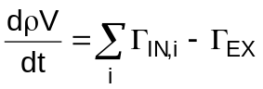
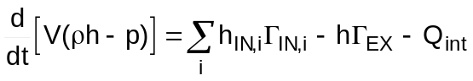
Developing the equations and dropping the term dp/dt in the energy conservation equation it is obtained:
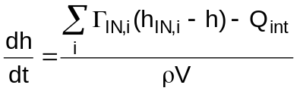
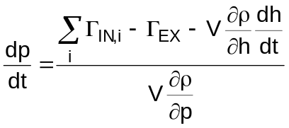
The wall energy conservation equation is:
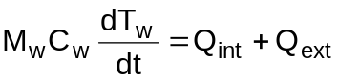
where the heat transfer power Qint with the fuel oil and Qext with the ambient air are:
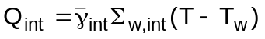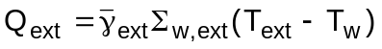
T is the internal fuel oil temperature and the termal exchanange coefficients are defined as:
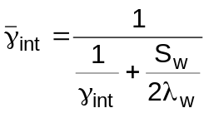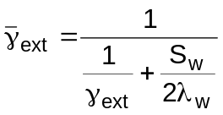

#$K+!Fossil fuel supply system for steam generators: fuel oil manifold with damper
The model computes the fuel oil conditions in a tank into which a few pipes converge. The tank is equipped with a volume (damper) filled with nitrogen.
The main hypotheses are:
∗ perfect mixing of the fuel oil in the tank;
∗ the fuel oil is an incompressible and thermally expandable fluid;
∗ constant specific heat and thermal conductivity of the tank wall material;
∗ flat slab approximation for heat conduction in the tank walls;
∗ constant heat transfer coefficients;
∗ constant gas mass in the damper;
∗ gas in the damper behaves as a perfect gas.
The total volume, comprised of gas and damper, is:
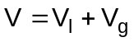
where Vl is the volume of the oil and Vg is the volume of the gas.
It is of course:
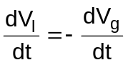
The continuity equation for the fuel oil is:
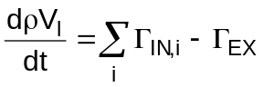
which becomes:
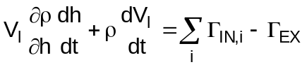
the energy conservation equation for the fuel oil:
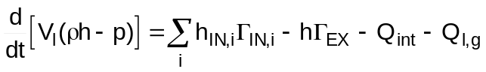
where Ql,g is the heat transfer power between fuel oil and gas.
Developing the equation, substituting in it the continuity equation and dropping the term dp/dt in the energy conservation equation it is obtained:
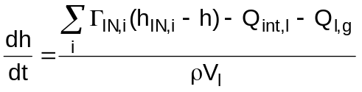
The perfect gas law states:
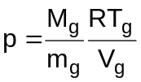
and the gas energy conservation equation is:
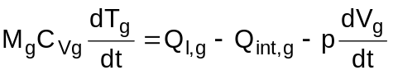
from which:
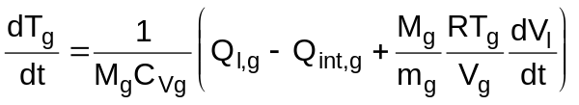
The wall energy conservation equation is:
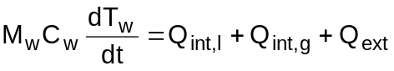
where the heat transfer power Qint,l with the fuel oil, Qint,g with the gas and Qext with the ambient air are:
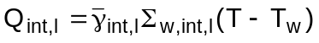
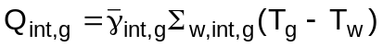
T is the internal fuel oil temperature and the termal exchanange coefficients are defined as:
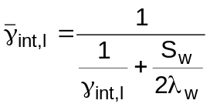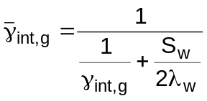
The internal heat transfer surfaces Σint,l and Σint,g depend on the fractions of the total volume occupied by oil and gas.

#$K+!Fossil fuel supply system for steam generators: fuel oil valve
The model simulates the operation of a valve and of a piping where it is installed on, when the process fluid is fuel oil.
The main hypotheses are:
∗ no mass storage;
∗ no inertia;
∗ no heat storage;
∗ the oil density is the same everywhere in the pipe;
∗ the oil undergoes an isenthalpic transformation.
The continuity equation and the energy conservation equation are
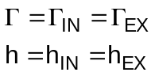
The momentum equation is:
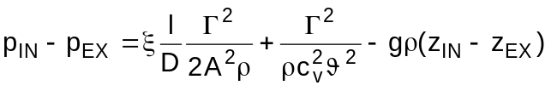
where the distributed head loss coefficient ξ is computed by means of the Blasius correlation for laminar flow:
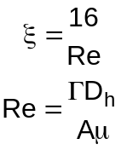
The first term is due to the distributed losses, the second one to the valve loss and the third one is the gravitational term.
Due to the hypotheses, the valve location in the pipe is not relevant.

#$K+!Fossil fuel supply system for steam generators: fuel oil volumetric pump
The model simulates the operation of a volumetric pump, when the process fluid is fuel oil.
The main hypotheses are:
∗ no mass storage;
∗ no inertia;
∗ no heat storage.
∗ the fluid is incompressible;
∗ no fluid leakage inside the pump.
The pump mass flow rate Γ is:
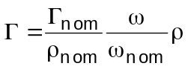
and the mechanical power Π is:
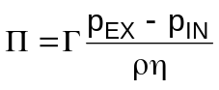

# lg_lptheo_fuelsupp
$ Fossil fuel supply systems for steam generators
K fossil fuel supply systems for steam generators
+ LEGOCAD_LPtheory_mod:000
! EnableButton("button_up");ChangeButtonBinding("button_up", "JumpId(`lglptheo.hlp',`lg_lptheo_main')")
# lg_lptheo_fuelmani
$ Fossil fuel supply system for steam generators: fuel oil manifold
K fossil fuel supply system for steam generators: fuel oil manifold
+ LEGOCAD_LPtheory_fue:000
! EnableButton("button_up");ChangeButtonBinding("button_up", "JumpId(`lglptheo.hlp',`lg_lptheo_fuelsupp')")
# lg_lptheo_fuelmnda
$ Fossil fuel supply system for steam generators: fuel oil manifold with damper
K fossil fuel supply system for steam generators: fuel oil manifold with damper
+ LEGOCAD_LPtheory_fue:000
! EnableButton("button_up");ChangeButtonBinding("button_up", "JumpId(`lglptheo.hlp',`lg_lptheo_fuelsupp')")
# lg_lptheo_fuelvalv
$ Fossil fuel supply system for steam generators: fuel oil valve
K fossil fuel supply system for steam generators: fuel oil valve
+ LEGOCAD_LPtheory_fue:000
! EnableButton("button_up");ChangeButtonBinding("button_up", "JumpId(`lglptheo.hlp',`lg_lptheo_fuelsupp')")
# lg_lptheo_fuelpump
$ Fossil fuel supply system for steam generators: fuel oil volumetric pump
K fossil fuel supply system for steam generators: fuel oil volumetric pump
+ LEGOCAD_LPtheory_fue:000
! EnableButton("button_up");ChangeButtonBinding("button_up", "JumpId(`lglptheo.hlp',`lg_lptheo_fuelsupp')")

