#$K+!Implicit regulators
{bmc help.bmp} Abstracts of the user documentation of these modules
The theoretical documentation of these modules is not yet ready.

#$K+!Auxiliary modules (used to connect other modules)
{bmc help.bmp} Abstracts of the user documentation of these modules
∗ Air ejector or vacuum pump
∗ Thermocouple wit heat exchange and thermal inertia

#$K+!Auxiliary modules: air ejector or vacuum pump
Modules referred to: AEXT.
The model deals with the problem of calculating the mass flow rate in a plant component such as an air ejector or a vacuum pump.
The reference component for modelling is the air ejector.
The working fluid is air.
The mathematical model is a semi-empirical one.
It is based on a simplified momentum equation in which the inertial term, the flux term and the gravitational term are neglected.
The downstream pressure is reduced depending on the value of a control parameter, the driving flow for an air ejector, in order to have the right pressure difference between the inlet of the driven flow and the mixing chamber.
If the downstream pressure changes, the reduced pressure too varies affecting the driven mass flow rate.
Data of a working point allow to determine the internal data, namely the driven flow pressure loss coefficient and the downstream pressure reduction coefficient, to match the component performances.
The main simplifications are:
∗ no mass storage in the component is considered;
∗ the drive flow is not taken into account in the computation of the mass flow rate, that is the outlet mass flow is equal to the driven mass flow;
∗ no heat balance is performed, therefore the outlet flow temperature is not calculated.
The basic relationship is:
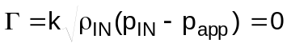
where k is a coefficient and papp is the reduced downstream pressure, both dependent on the nominal working point. Also papp depends on the actual drive flow rate and downstream pressure too.
The module can simulate a vacuum pump, making use of the rotational speed as control parameter.
Of course, in this case the reduced downstream pressure has no physical meaning.

#$K+!Auxiliary modules: thermocouple wit heat exchange and thermal inertia
The model simulates the behaviour of a thermocouple for steam temperature measurement, influenced by all the real conditionings on its measurement, beyond the thermal exchange with the fluid, it measures the temperature of.
So it takes into account:
∗ effects of thermal inertia due to the thermal capacity of the protection sheath: in facts the hot junction “feels” fluid temperature variations only through the sheath and a time of response to fluid temperature variations must be considered;
∗ thermal exchange coefficient between sheath and fluid is not infinite.
So, sheath and fluid are not at the same temperature. Between thermocouple and metal basis there is a conduction thermal exchange . Finally there is a radiative exchange between the thermocouple itself and the metal walls of the enclosure.
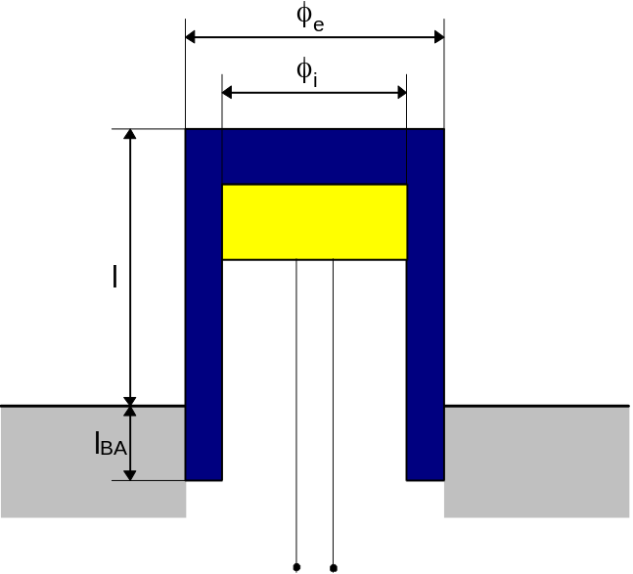
As the figure shows the thermocouple is constituted by a protection sheath, coming out of the mounting surface for a length l and inserted in such surface for a length lBA.
The sheath has circular shape, having external diameter Dext and inner diameter Dint. Inside it, there is the hot junction, from which the electrical contacts come out.
The measured temperature is the one of sheath tip and is determined on the basis of a balance equation considering:
1. convection thermal exchange with steam along the sheath portion that is not sunk down;
2. conduction exchange along the basis adjoining the bulk;
3. radiative exchange with the portion of the enclosure “seeing” the thermocouple walls (schematised as an equivalent wall having an average temperature between all the surfaces faced to the thermocouple).
The thermal balance can be written:
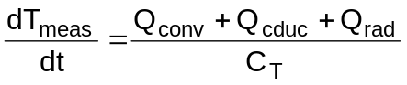
where Qconv, Qcduc, Qrad are exchanged powers for convection, conduction and radiation:
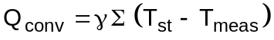
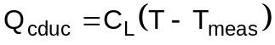
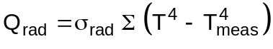
where Tst is the steam temperature, T is the wall temperature, CT the thermocouple thermal capacity, CL the thermocouple longitudinal conductance and Tmeas the measured temperature.
Convection exchange coefficient with the fluid is supposed zero if the fluid flow rate is zero, but rapidly tending to an asintotical value when fluid flow rate Γ grows, with an exponential law:
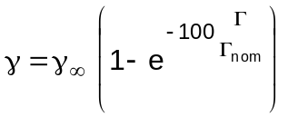

# lg_lptheo_impreg
$ Implicit regulators
K implicit regulators
+ LEGOCAD_LPtheory_mod:000
! EnableButton("button_up");ChangeButtonBinding("button_up", "JumpId(`lglptheo.hlp',`lg_lptheo_main')")
# lg_lptheo_auxmod
$ Auxiliary modules (used to connect other modules)
K auxiliary modules (used to connect other modules)
+ LEGOCAD_LPtheory_mod:000
! EnableButton("button_up");ChangeButtonBinding("button_up", "JumpId(`lglptheo.hlp',`lg_lptheo_main')")
# lg_lptheo_auxmejec
$ Auxiliary modules: air ejector or vacuum pump
K auxiliary modules: air ejector or vacuum pump
+ LEGOCAD_LPtheory_aux:000
! EnableButton("button_up");ChangeButtonBinding("button_up", "JumpId(`lglptheo.hlp',`lg_lptheo_auxmod')")
# lg_lptheo_auxmther
$ Auxiliary modules: thermocouple wit heat exchange and thermal inertia
K auxiliary modules: thermocouple wit heat exchange and thermal inertia
+ LEGOCAD_LPtheory_aux:000
! EnableButton("button_up");ChangeButtonBinding("button_up", "JumpId(`lglptheo.hlp',`lg_lptheo_auxmod')")

