#$K+!Numerical methods
The mathematical models developed to characterise various physical processes such as transient fluid flow, heat conduction and component models are comprised of a coupled set of partial differential equations, ordinary differential equations and algebraical equations.
An analytical solution does not exist for this equation set and the use of a numerical solution method is required.
The main topics of numerical solution methods and attendant assumption are shortly presented.
The differential equations must be replaced by "finite difference" equations with respect to the time and to the space, which are algebraical equations.
The algebraical equations may be obtained by two different routes:
∗ the first method uses finite difference representations of the partial differential equations (distributed parameters equations);
∗ the second method derives the equations by integrating the differential equation terms on a finite number of control volumes, called cells (lumped parameters equations).
The resultant equations can be identical in both cases if conservation-law-form differential equations are used with the first method.
The independent variables, namely "time" and "space", can assume only a discrete and finite sequence of values, that is to say a calculation grid must be set.
The dependent variables will be computed only for these points and for these instants, which can be equally spaced (constant time step) or unequally spaced (variable time step).
When the first method is used, the finite difference approximation of the space derivatives (backward, forward or central difference) must be chosen.
When the second method is used, a "staggered mesh" computation grid for the control volumes is often adopted.
Two finite difference approximation for the time derivatives (backward or forward difference) are possible.
With the forward difference approximation the solution method is explicit, that is to say the solution at every point of the given time depends on the values of the solution at several points of the preceding time step.
A stability condition (Courant's condition) must be respected:
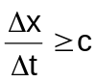
where:
c = sound speed
Δx = space step
Δt = time step
with the backward difference approximation the solution method is implicit, that is to say the solution at every point of the given time depends on the values of the solution at several close points of the same time step.
A simultaneous solution of the equation set is needed, but the stability of the method is always assured.
The solution method is generally a recursive method: for an explicit method the variables values at time ti+1 are computed using the values at the preceding time steps (ti, ti-1, etc., multi-step methods) or at time ti (single-step method). The multi-step methods are not popular because they are not self-starting.
Once that a system involving only ODE and algebraical equations is obtained, that system can, at least logically, be written in normal form:
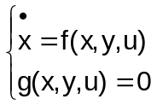
where:
∗ x is the vector of state variables
∗ y is the vector of algebraic output variables
∗ u is the vector of input variables
Given a generical ODE:
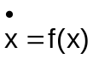
a choosing a one-step method, it can be written as:
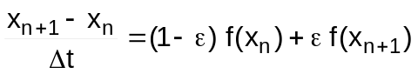
If ε = 0 we have an explicit method, while for 0 < ε ≤ 1 the method is implicit.
The convergence condition for the generic one-step method applied to a linear Cauchy problem:
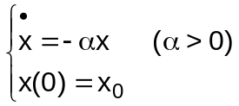
is:
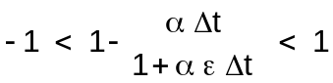
It’s easy to observe that if ε ≥ 0.5 the method is A-stable (that is: it converges for any value of Δt).
So, the standard LEGO discretization method is the trapezoidal rule:
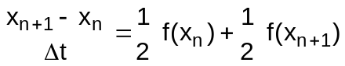
By applying the trapezoidal rule to the algebraic-differential system as above described, one gets:
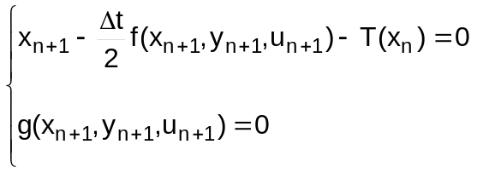
which is a (non linear) system in the unknowns xn+1 and yn+1:
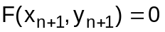
that will be solved with the Newton-Raphson method.
This one is an iterative method that consists of a Taylor series development to the first order around the point calculated at the previous k-th iteration:
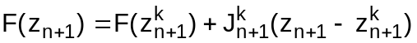
where zn+1 is the unknowns vector at the n+1-th time step (union of the vectors xn+1 and yn+1) and J is the jacobian matrix (the one of the first derivatives) calculated with the values of the previous (k-th) iteration. Calculating that formula k+1 and remembering that it must be:
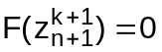
one gets:
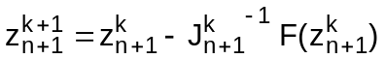
A stop rule for the iterations is set by fixing a tolerance. This tolerance can be one only for the whole system of equations as all the equations are normalised. Default value for the tolerance is 1e-6.
As the calculation of the jacobian matrix (which should occur at each iteration) is very time expensive, one calculation of J is kept valid for more iterations insofar as convergence is guaranteed.

#$K+!Two-phase flow models
The following descriptions of two-phase flow are widely used:
∗ thermodynamic equilibrium models (the phases are always in thermodynamic equilibrium conditions), then:
∗ liquid is always saturated,
∗ vapour is always saturated.
∗ non-equilibrium models (the phases can be, during the transients, in non-equilibrium conditions), then:
∗ liquid can be saturated, non saturated or with bubbles;
∗ vapour can be saturated or superheated.
Various two-phase flow models can be distinguished:
∗ the two-fluid models
∗ models based on imposed velocity profiles, depending on the choice of kinematic properties; there are:
∗ no local relative velocity (homogeneous model, Bankoff model),
∗ correlation for the relative velocity given by means of a slip ratio vg/vl (as a function of pressure and equilibrium quality), a weighted drift velocity Ugj and a distribution coefficient C0 (as a function of pressure and of the physical properties of the fluid, drift-flux or Zuber and Findlay model), and a void fraction (as a function of pressure and equilibrium quality, Martinelli and Nelson).
For applications in the industrial processes the more used two-phase models are:
∗ homogeneous equilibrium model (HEM)
∗ thermal equilibrium slip or Drift flux models (natural circulation and low pressure)
∗ thermal non-equilibrium models with interaction between the phases given by empirical correlations.

#$K+!Two-phase flow: homogeneous equilibrium model (HEM)
The assumptions are made:
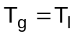
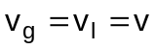
The conservation equations have the same form as in the single phase flow models, provided the mixture density, the mixture specific enthalpy and the void fraction are defined as
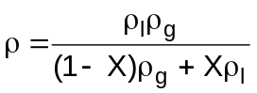
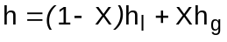
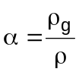

#$K+!Two-phase flow: drift flux model
This is the classical formulation of Zuber and Findlay for the representation of a non-homogeneous two-phase flow.
This representation gives sufficient accuracy for moderate transients in which the mixture evolves in a quasi-steady-state fashion and even during fast transients it has not been shown to lead to great inaccuracies.
As well known, the drift between the phases causes energy and momentum to cross the mixture centre-of-mass plane and generates in the corresponding conservation equations additional terms depending both on the average void fraction a and the so-called "total drift velocity" Ugj.
Therefore a relationship between the void fraction and the drift velocity is necessary as well as the determination of the last one by means of adequate correlations. In the basic drift-flux approach a linkage is established between the average void fraction of the mixture and the two typical average parameters accounting for the local drift (Vgj) and the non-uniformity of the velocity and void fraction profiles across the duct cross-section (C0):
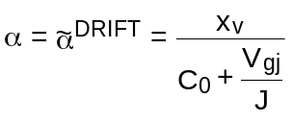
where (ñ means cross-sectional average of property n) XV is the average volumetric quality:
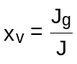
J is the cross-sectional averaged total volumetric flux (or velocity of the centre of volume)
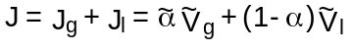
C0 is the distribution coefficient
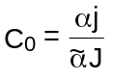
and Vgj is the average local drift velocity of the gas
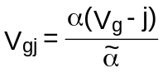
Finally
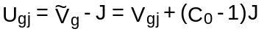
is the average total drift velocity of the gas, appearing in the "drift" terms of the conservation equations.
One remarks that the "total drift" Ugj includes contributions due to both the average local drift Vgj and the velocity profile (the (C0 − 1)J term).
It is evident that a proper evaluation of the two drift parameters C0 and Vgj becomes essential to obtain a realistic determination of the void fraction (i.e. of the density) of the two-phase flow.
To this aim several correlations are available, generally developed for specific applications and then strongly dependent on the considered geometrical and thermal-hydraulic conditions. But if the "drift-flux" model must be used in the simulation of the whole working situations of a plant system, considerable difficulties from the computational view-point could arise utilising different specifically flow-regime dependent correlations. To avoid this problem two empirical flow-regime independent "drift- flux" correlations have been considered and implemented in LEGOCAD models:
∗ the Zuber-Dix correlation
∗ the Chexall-Lellouche correlation
covering the full range of pressures, flows and void fractions and qualified against several sets of steady-state test data coming from a wide range of initial conditions and geometries.
Of course for homogeneous mixtures, being identical the velocities of the two phases:
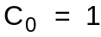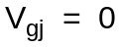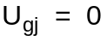
and the drift flux model turns into the HEM.

#Zuber-Dix correlation
The distribution coefficient C0 and the average local drift velocity Vgj are given by the following relations:
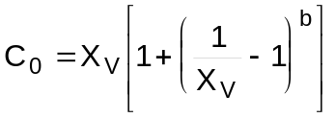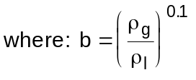
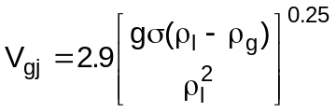
The Mc Coy’s correction is:
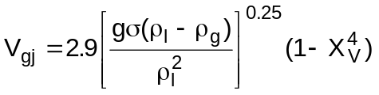

#Chexall-Lellouche correlation
This correlation covers a full range of pressures, diameters, flows, flow orientation and void fractions.
The evaluation of the distribution coefficient C0 and the average local drift velocity Vgj requires a lot of additional parameters to be determined. Their analytical formulations are not reported here.

#$K+!Water-steam and other fluids properties
The thermodynamic state of a fluid is completely determined by two independent intensive properties (for instance specific enthalpy and pressure). The dependent properties can be calculated by means of tables or by an analytical formulation.
It is worthwhile to note that the various thermodynamic properties are not independent of each other. For example, when the pressure p and the temperature T are chosen as the independent variables of the formulation, then expressions, called derived function, for the specific volume, entropy, enthalpy and all other thermodynamic properties may be derived directly by partial differentiation of the so-called canonical function g = g(p;T), where g is the specific free enthalpy (Gibbs function). If the analytical formulation is presented in terms of these canonical functions, the thermodynamic consistency is maintained.
The most useful properties of a fluid are:
∗ density (ρ)
∗ specific enthalpy (h)
∗ specific entropy (s)
∗ temperature (T)
∗ viscosity (μ)
∗ thermal conductivity (λ)
∗ specific heat at constant pressure (Cp)
∗ the partial derivative of density with respect to pressure (at constant entropy)
∗ the partial derivative of density with respect to entropy (at constant pressure)
{bmc help.bmp} Water-steam tables
{bmc help.bmp} Other fluids properties

#$K+!Water-steam tables
The subprograms now available in the LEGOCAD environment are valid in a range of pressures between 0.006108 bar and 400 bar in a region limited by the isothermal curves of 0 °C and 800 °C.
The couple of independent variables is constituted by pressure p and entropy s, but entropy is in turn calculable as a function of pressure and enthalpy. So, all properties are calculable from the couples p-s, p-h, p-T.
For two-phase mixtures the steam mass quality X is also available.
Moreover, saturation values are also available for temperature, enthalpy, entropy and density (the last three both for liquid and steam phase).
The calculation is accomplished by dividing the thermodynamical plane in a certain number of regions, limited by isobaric curves. Each region was in turn subdivided in regions delimited by isentropic curves. In each so delimited region, fluid properties are obtained with a parabolic interpolation method based on a network of precalculated values.

#$K+!Other fluids properties
A great deal of fluids must be considered, such as air, oxygen, hydrogen, nitrogen, methane and other hydrocarbons, fuel oil, combustion products, etc...

Density determination
For real gases and vapours the perfect gas law:
pV = RT
is often used.
This equation, which applies to both pure components and mixtures, is reasonably accurate, when the temperature is clearly higher than the critical temperature, up to a pressure of about 2 bar for most compounds and even higher for small, nonassociating molecules.
Leaving this zone this equation is no longer valid and other state equations with two parameters, such as the Van Der Walls equation and the often used Redlich and Kwong equation
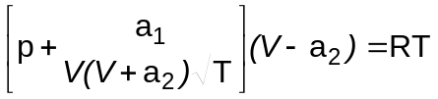
have been proposed.
The equation with two parameters have the advantage that the parameters can be expressed in terms of the critical coordinates pcrit, Tcrit and Vcrit imposing that for the critical point two conditions are fulfilled:
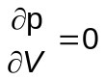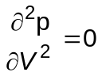
which determine a1 and a2 as a function of pcrit, Tcrit and Vcrit.
These equations moreover can be expressed in terms of reduced variables
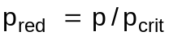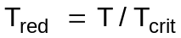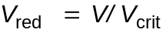
It results that if two reduced variables are known, the third one is defined whatever the fluid may be.
From these statements the law of corresponding states arises.
If there were equations of state with two parameters representing the behaviour of real fluids, it would be possible, even without knowing this law, to predict the properties of any fluid based on those of a known fluid, on condition that the critical state be known. Such an universal law does not exist, but there are equations of state which are somehow valid for groups of equivalent bodies, for instance series of hydrocarbons.
Another method of approach is the so-called virial method; it is based on the fact that at a given temperature the product pV tends toward RT when p tends toward zero. Therefore
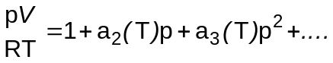
The virial coefficients a2, a3, etc. are functions of T only.
For liquids empirical correlations are used.

Specific heat capacity determination
For gases the ideal gas heat capacity is computed, which is a function of temperature but not of pressure. The most common analytical equation relating the heat capacity to the temperature is a simple polynomial.
For liquids empirical correlations are used.

Other properties determination
All the other properties are estimated by empirical correlations.

#$K+!Pressure drop and heat transfer correlations
The two main fields requiring the usage of empirical correlations are friction coefficient and heat transfer coefficient calculation:
{bmc help.bmp} Correlations on friction pressure drops for single-phase fluids
{bmc help.bmp} Correlations on friction pressure drops for two-phase flow
{bmc help.bmp} Heat transfer correlations for water-steam
{bmc help.bmp} Heat transfer regions for water-steam
{bmc help.bmp} Heat transfer correlations for flue gas

#$K+!Correlations on friction pressure drops for single-phase fluids
By applying Buckingham theorem on a straight circular tube, having diameter D and length l >> D, in which a single-phase fluid flows, one can get the following formula:
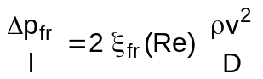
where the dependency of friction coefficient ξfr from the Reynolds number has been highlighted.
That very dependency may be written in many ways originating a great deal of correlations. Some of these are valid in laminar conditions. Other correlations are valid for turbulent motion, like Colburn’s, Drew’s, Blasius’s, Nikuradse’s or von Karman’s, which are valid in case of smooth tubes. If roughness becomes important, the ratio e/D, being e the average height of protuberances is introduced and two correlations (Nikuradse’s in the region of complete turbulence and Colebrook in the transition region) are currently used.

#$K+!Correlations on friction pressure drops for two-phase flow
In the case of two-phase flow many correlations are based on the friction multiplier ΦLO² as defined by the relationship:
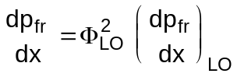
where the derivative at the right side represents the pressure drop that there would be if only liquid flowed in the duct with a flow rate equal to the total mixture flow rate.
In some cases a different friction multiplier is used Φl²:
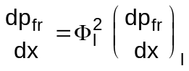
where the derivative at the right side represents the pressure drop that there would be if only liquid flowed in the duct with its own flow rate.
Martinelli-Nelson’s correlation is based on ΦLO² that can be practically expressed in function of quality and pressure. That correlation has the practical drawback not to consider dependency of the multiplier from specific flow rate. Jones corrects the correlation in:
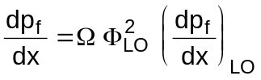
where Ω is a function of pressure and specific flow rate.
Analogous to Jones’s correlation is Baroczy’s, while Chisolm’s utilises the parameter ΦLO². Becker’s correlation is simpler but doesn’t consider specific flow rate and has a more limited application range.

#$K+!Heat transfer correlations for water-steam
As far as the calculation of the convection heat transfer coefficient γ is concerned, describing heat transfer between fluid and duct wall, by means of Buckingham theorem one can obtain:
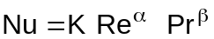
which ties the dimensionless numbers of Reynolds, Nusselt and Prandtl and is the base of a family of correlations whose most famous example is Dittus-Boelter’s.
A wide spectrum of correlations able to calculate γ in forced convection conditions is exploited by many LEGO modules. Those correlations consider ducts of whatsoever section (characterised by its hydraulic diameter) and for any given inclination with respect to the horizontal plane.
Those correlations don’t cover natural convection and pool boiling conditions.

#$K+!Heat transfer regions for water-steam
The following table shows all the regions that were considered (on account of fluid status), their definition and the correspondent correlation. Great attention was also paid to interface regions so that when fluid conditions change, correlations change automatically.

REGION NAME THERMAL CONDITIONS CORRELATION
forced convection with water pressures greater than 221.2 bar Swenson
in supercritical conditions
forced convection with water with quality Dittus-Boelter
subcooled liquid less than zero
subcooled boiling bulk fluid is subcooled but Chen (modified
wall temperature is above the by Butterworth)
saturation temperature and
vapour formation takes place
saturated boiling and forced two different regions: the first one Chen
convection with liquid film with boiling and creation of bubbles
migrating toward the duct centre,
the second one referred to
wall-liquid film heat transmission
transition boiling after thermal crisis Bjonard-Griffith
the wall is only partially wet
forced convection with there is no more wall liquid film: Groeneveld-Delorme
dispersed two-phases only liquid drops remain; they
evaporate because of heat
received by steam
forced convection with having quality more than one: Hadaller
superheated steam the steam flux drags liquid drops

#$K+!Heat transfer correlations for flue gas
The thermal power exchanged by flue gas along the boiler backpass is mainly yielded to the exchanger tubes by several banks of heaters. In consideration of their geometrical disposition, one can suppose that the heat transfer between water and flue gas is of crossflow type.
For convective heat transfer coefficient calculation one of the most complete correlations in literature, proposed by Babcock & Wilcox Co, can be used:
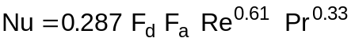
where
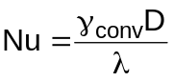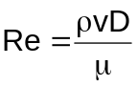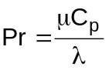
being Fd (depth factor) depending on the number of ranks of exchanging tubes and Fa (arrangement factor) depending on gas motion and their geometrical disposition.
Still following a Babcock & Wilcox metodology also radiative heat transfer coefficient γrad can be taken into account.
It can be expressed as a product of two terms, the first one depending on the temperature difference between walls and gas and the wall temperature, the second one depending on the partial pressure of triatomic gases (only CO2 and H2O are considered) and the radiating thickness, which on its turn depends on the tubes arrangement. The two terms are reported as charts and are not shown here.

#$K+!LEGO mathematical models symbology

Symbols:
a coefficient in pump, fan and compressor momentum equation
aη i coefficients in turbine stage efficiency equation
A cross-section flow area
b coefficient in fan momentum equation
B body force
Bm blade Mach number
cv valve flow coefficient
C torque
C specific heat
CL longitudinal conductance
Cp specific heat at constant pressure
CT thermal capacity
CV specific heat at constant volume
C0 distribution coefficient (drift flux two-phase flow model)
D diameter
E Young module
Eb Total blackbody emitted flux
Fa arrangement factor
Fd depth factor
FT temperature factor
Fv view factor
g gravity acceleration
g specific free enthalpy
G specific mass flow rate
h specific enthalpy
hLHV lower heating value of fuel
H head
i index of cells or flows
j index of cells or flows
j velocity of the centre of volume (drift flux two-phase flow model)
k coefficient
kabs absorption coefficient (radiative heat transfer model)
l length
L latent heat of vaporisation
m molar mass
M mass
n exponent of isentropic expansion
N number of cells or flows
N molar fraction
Nt number of parallel tubes
Nu Nusselt number
p pressure
P perimeter
Pr Prandtl number
q volumetric flow rate
Q thermal power
Q Imposed heat flux
r radial coordinate
R universal gas constant
Re Reynolds number
Rx fractional reaction of a turbine stage
s specific entropy
S thickness
S radiative heat transfer area
Sd direct exchange area
SiSj total exchange area
t time
T temperature
Ugj total drift velocity (drift flux two-phase flow model)
v speed
V molar volume
V volume
Vgj local drift velocity (drift flux two-phase flow model)
x axial abscissa
x coordinate in a rectangular coordinates system
X steam mass quality
X mass fraction
XV volumetric quality
y water level
y coordinate in a rectangular coordinates system
z elevation
z coordinate in a rectangular coordinates system

Greek letters:
α void fraction
α exponent in the relationship flow area vs. lift in the valve model
αT thermal dilatation coefficient
β compression ratio
βw flat surface - real surface ratio
γ heat transfer coefficient
Γ mass flow rate
ε emissivity
εz axial dilatation for unit length
η efficiency
ϑ valve lift (fraction of maximum lift)
λ thermal conductivity
λopt optical path length
μ dynamic viscosity
ν transverse contraction module
ξ head loss coefficient
Π power
ρ density
σ surface tension
σrad Stefan-Boltzmann constant
Σ heat transfer surface area
τ time constant
τsep separation time
φ angular coordinate
Φ compressor flow number
Ψ internal power for unit volume
ω rotational speed

Subscripts:
a air
byp bypass
comb combustion
cond condensation
cund conduction
conv convective
cool cooling
csup surface condensation
crit critical
damp damper
duct duct
DR drainage
DS desuperheating
ext external
EX outlet
ev evaporation
f bottom
FILM boundary layer
fl fluid
frict frictional
fr friction
fuel fuel
FW feedwater
g gas
h hydraulic
IGV inlet guide vanes
int internal
IN inlet
irr irreversible
isl steam-liquid interface
iso isentropic
l liquid
LO liquid only
loss local momentum losses
lum luminous
m mean
meas measured
mec mechanical
mix mixing
mot motive
nom nominal working point
p pump
r reduced
rad radiative
rec recovery
recr recirculation
res resistance
rev reversible
s saturated
SB subcooling
st steam
sup superheated
T turbine
Tb turbine stage bucket
Tn turbine stage nozzle
th throat
tr transparent
uba unburnt air
ubf unburnt fuel
v volumetric
w wall

# lg_lptheo_methods
$ Numerical methods
K numerical methods
+ LEGOCAD_LPtheory_gen:000
! EnableButton("button_up");ChangeButtonBinding("button_up", "JumpId(`lglptheo.hlp',`lg_lptheo_general')")
# lg_lptheo_twophase
$ Two-phase flow models
K two-phase flow models
+ LEGOCAD_LPtheory_gen:000
! EnableButton("button_up");ChangeButtonBinding("button_up", "JumpId(`lglptheo.hlp',`lg_lptheo_general')")
# lg_lptheo_hem
$ Two-phase flow: homogeneous equilibrium model (HEM)
K two-phase flow: homogeneous equilibrium model (HEM)
+ LEGOCAD_LPtheory_two:000
! EnableButton("button_up");ChangeButtonBinding("button_up", "JumpId(`lglptheo.hlp',`lg_lptheo_twophase')")
# lg_lptheo_drift
$ Two-phase flow: drift flux model
K two-phase flow: drift flux model
+ LEGOCAD_LPtheory_two:000
! EnableButton("button_up");ChangeButtonBinding("button_up", "JumpId(`lglptheo.hlp',`lg_lptheo_twophase')")
# lg_lptheo_zuberdix
# lg_lptheo_chexall
# lg_lptheo_fluidprop
$ Water-steam and other fluids properties
K water-steam and other fluids properties
+ LEGOCAD_LPtheory_gen:000
! EnableButton("button_up");ChangeButtonBinding("button_up", "JumpId(`lglptheo.hlp',`lg_lptheo_general')")
# lg_lptheo_tables
$ Water-steam tables
K water-steam tables
+ LEGOCAD_LPtheory_flu:000
! EnableButton("button_up");ChangeButtonBinding("button_up", "JumpId(`lglptheo.hlp',`lg_lptheo_fluidprop')")
# lg_lptheo_otherfluid
$ Other fluids properties
K other fluids properties
+ LEGOCAD_LPtheory_flu:000
! EnableButton("button_up");ChangeButtonBinding("button_up", "JumpId(`lglptheo.hlp',`lg_lptheo_fluidprop')")
# lg_lptheo_dphtcorr
$ Pressure drop and heat transfer correlations
K pressure drop and heat transfer correlations
+ LEGOCAD_LPtheory_gen:000
! EnableButton("button_up");ChangeButtonBinding("button_up", "JumpId(`lglptheo.hlp',`lg_lptheo_general')")
# lg_lptheo_onefrict
$ Correlations on friction pressure drops for single-phase fluids
K correlations on friction pressure drops for single-phase fluids
+ LEGOCAD_LPtheory_dpht:000
! EnableButton("button_up");ChangeButtonBinding("button_up", "JumpId(`lglptheo.hlp',`lg_lptheo_dphtcorr')")
# lg_lptheo_twofrict
$ Correlations on friction pressure drops for two-phase flow
K correlations on friction pressure drops for two-phase flow
+ LEGOCAD_LPtheory_dpht:000
! EnableButton("button_up");ChangeButtonBinding("button_up", "JumpId(`lglptheo.hlp',`lg_lptheo_dphtcorr')")
# lg_lptheo_heatws
$ Heat transfer correlations for water-steam
K heat transfer correlations for water-steam
+ LEGOCAD_LPtheory_dpht:000
! EnableButton("button_up");ChangeButtonBinding("button_up", "JumpId(`lglptheo.hlp',`lg_lptheo_dphtcorr')")
# lg_lptheo_regions
$ Heat transfer regions for water-steam
K heat transfer regions for water-steam
+ LEGOCAD_LPtheory_dpht:000
! EnableButton("button_up");ChangeButtonBinding("button_up", "JumpId(`lglptheo.hlp',`lg_lptheo_dphtcorr')")
# lg_lptheo_heatfg
$ Heat transfer correlations for flue gas
K heat transfer correlations for flue gas
+ LEGOCAD_LPtheory_dpht:000
! EnableButton("button_up");ChangeButtonBinding("button_up", "JumpId(`lglptheo.hlp',`lg_lptheo_dphtcorr')")
# lg_lptheo_symbols
$ LEGO mathematical models symbology
K LEGO mathematical models symbology
+ LEGOCAD_LPtheory_gen:000
! EnableButton("button_up");ChangeButtonBinding("button_up", "JumpId(`lglptheo.hlp',`lg_lptheo_general')")

