SCADA-OSF1
Scada “Help on line”

TABLE OF CONTENTS

1. SCADA INTERFACE
1.1 CHARACTER INTERFACE
1.2 GRAPHIC INTERFACE
1.2.1 MANDB WINDOW
1.2.2 DEBUG WINDOW
1.2.3 LOG WINDOW
2. ENVIRONMENT
3. HOW TO EXECUTE SCADA
4. CONFIGURATION FILES

SCADA interface

SCADA is designed to work in two different ways:
With a graphic interface
Without a graphic interface (character interface)
To have SCADA running with the graphic interface it’s necessary to compile it having configured X_USR_INTERFACE environment variable to 1, while to have SCADA running with the character interface X_USR_INTERFACE must be set to 0.

Character interface

Character interface allows machine maximum resource saving and it is very rudimentary.
On the display it appears:
- SCADA -
Q) Quit
By pressing ‘Q’ the program ends.

Graphic interface

Graphic interface is made up by a set of windows, which allow the user to interact with the system. After the system has started the main window, see , is shown.

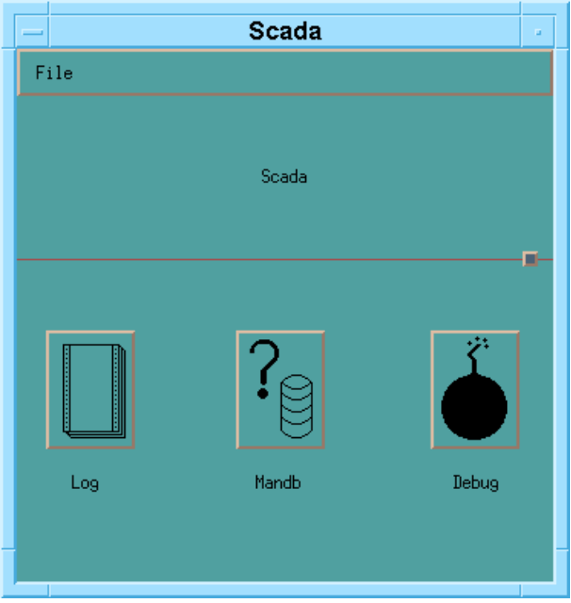

Figure 1 Main window

The Main window is made up by three push buttons that allow opening three more windows.
By selecting “Exit” in the “File” menu SCADA ends

Mandb window

Click “Mandb” push button to open the window, shown in : this window is divided into five areas that allow managing up to five measures. To view and to modify measures value and flags perform the following steps:

Type the measure tag into the editing window () and then press the button with the three dots. If the measure does not exist an error message appears otherwise its value and flags are presented:
Click “Set mode”;
Type in the new value;
Modify flags;
Press “Apply” to accept modification or press “Vis.mode” to cancel and to go back to normal monitoring.
Press “Quit” to close the Mandb window.

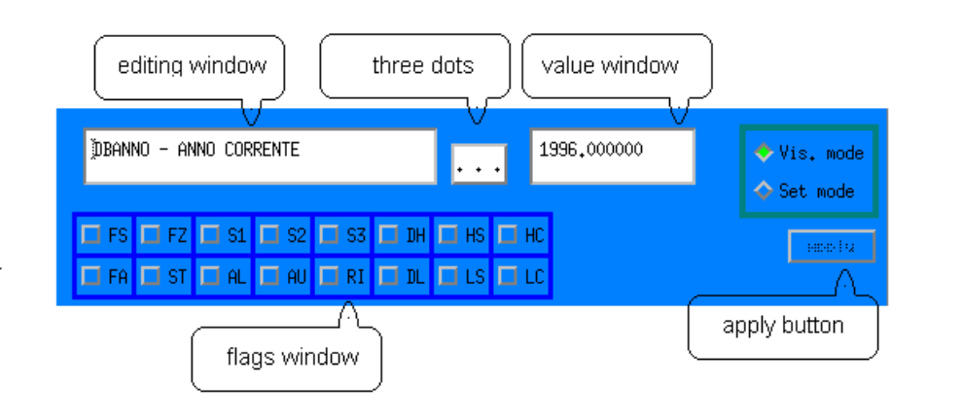

Figure 2 Mandb areas

Debug window

Click the “Debug” push button to open the window shown in . It shows the status and the priority index of each SCADA thread.
Press “Quit” to close the Debug window.

Log window

Click “Log” to open the window shown in . The Log window displays SCADA possible messages.
Press “Quit” to close the Log window.

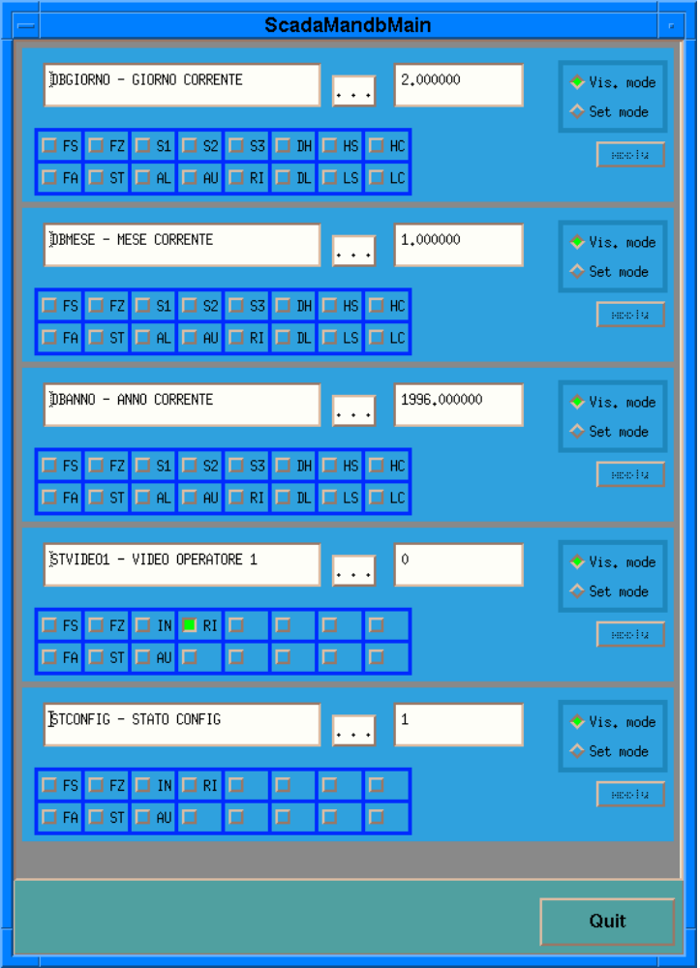

Figure 3 Mandb window
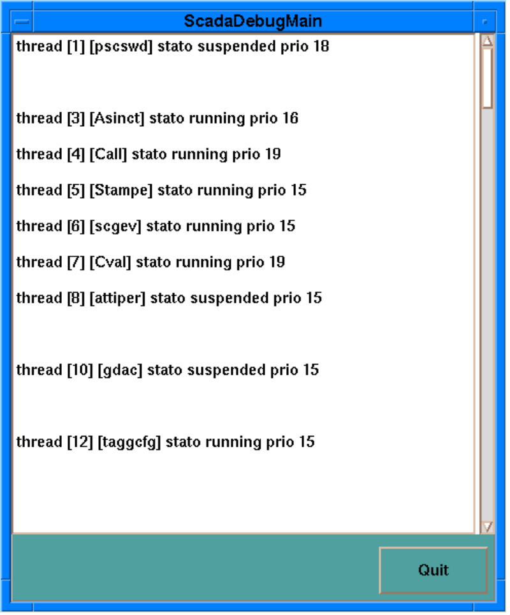

Figure 4 Debug window
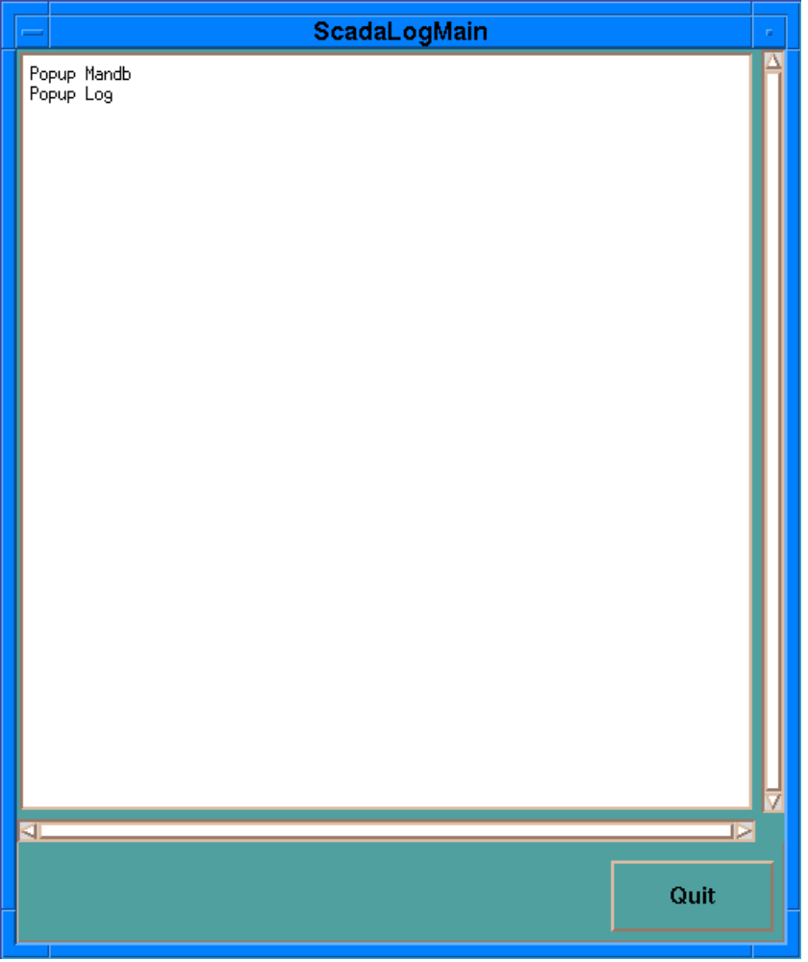

Figure 5 Log window

Environment

In order to activate SCADA you have to define the following environment variables:

DISPLAY (if the SCADA was generated with the <XUSR_INTERFACE> flag OFFSET_SCADA_PORT: this variable defines the offset added by SCADA to assigned port numbers for its services (connection with MMI stations, connection with the simulator [data and command] and with the configuration station).

shows the algorithm with which SCADA builds connection ports values.

Service | Port
MMIxx | OFFSET_SCADA_PORT+1900+xx-1
Config | OFFSET_SCADA_PORT+2000
Simulator (command) | OFFSET_SCADA_PORT+2050
Simulator(data) | OFFSET_SCADA_PORT+3000

Table 1 Net ports

How to execute SCADA

In order to start the SCADA process you have to type <scada> at the prompt command line.
SCADA has several starting flags: Type <scada /h> to have more information about the starting flags; on the terminal this message will appear:

SCADA
Use: SCADA [/Ffunction] [/Alarm_option] (/F function - /A allarm options)
[/Tcycle] ( /T time of one cycle)
[/Vlowest_rate] [/Mmmi_number] (/V the lowest refresh rate of MMI’s page
/M how many MMI you can connect to the SCADA system) function:
T logs enabled
A archive enabled
alarm options: R single alarm acknowledge enabled
S alarm acknowledge log enabled
V alarm browsing enabled
C alarm account for database and zone enabled
W closing weekly logs
F alarm string format: HH/MM/SS.
Lowest_rate: the lowest refresh rate of MMI’s page (the default is 1 Hz the max is 2 Hz)
Mmi_number: how many MMI you can connect to the SCADA system (a number between 1 and 16, the default is 1)

A possible starting macro is:
scada /FAT /ARV /M2
In this way logs and archives are enabled with /FAT, single alarm acknowledge and alarm browsing are enabled with /ARV and it is possible to connect to two mmi.
It is recommended, for two reasons, to activate SCADA via the starter process as you can see in the following command line:
starter /usr/users/scada/pscs32/bin scada /FAT /ARV /M2
<process path> <process name> <process flags>

The starter process is able to rerun SCADA if it has an abnormal termination. Furthermore starter is owned by root (having the "s" flag set and its children (like SCADA) inherit this feature.
In this way the SCADA process is allowed to alter its user-id (in order to gain root authority) to manage its threads priority index.

Configuration files

It is possible to configure SCADA via a set of files that are read by SCADA at start-up time.
lists configuration file names and it gives a brief description of their utility and meaning.

name | description
arcfile.rtf | used by SCADA during run-time
conf.cfg | SCADA working directory
de_arcXX.rtf | archive XX descriptor
fdarc.rtf | archives descriptor
fdbdp.hea | database size
fdbdp.rtf | system database
fdcom.rtf | digital outputs descriptor
fdde.rtf | measures tags and descriptions
fdeacq.rtf | acquisition settings
fdeao.rtf | analogic outputs descriptor
fdesal.rtf | strings and colour setting descriptor
fdizst.rtf | devices status descriptor
fdiztab.rtf | logs list
fgerarch.rtf | measures hierarchy descriptor
fnomi.rtf | measures list
fstato.rtf | devices types and status
fsvinana.rtf | relationship between SCADA and simulator analog inputs
fsvindig.rtf | relationship between SCADA and simulator digital inputs
ftab.rtf | logs scripts
fvirtprn.rtf | virtual printers descriptor

Table 2 Configuration file list

