THE MODEL BUILDER “LEGOPC”

The mathematical models for simulation constitute nowadays an important tool for analysis and design of thermal power plants and turn up to be useful to study how to obtain either fuel sparing or production efficiency or to better understand how to comply with new rules as those imposed by new environmental laws.
In this context, the model builder “LegoPC” has been conceived as a modern tool for the construction and the testing of mathematical models, in order to get as easy as possible the implementation of these on personal computer.
The main assets of LegoPC are the following:
- It is a modular system: a model is obtained by assembling instances of general purpose models taken from libraries. The system is open: a user is free to expand the default libraries with its own models. The default libraries include the models of many typical components to be found in thermoelectrical power plants. Some examples:
- steam/water base library (valves, charge losses, centrifugal pumps, volumes with mass storage)
- heat exchangers library (flue gas ducts and water/steam exchanging pipelines with metal wall)
- cavities library (deaerators, condensers, mono and two-phase cavities, heaters)
- turbines library (turbogas combustors, compressors and turbines, steam turbine impulse and
reaction stages)
- air/gas path models (valves, fans, variable loss of charge, compressibility volumes)
- electrical library (synchronous machines, motors, lines, busses, static loads, ballast loads)
- control library (regulators and algebraic signals manipulators).
- It is actually available on PC for systems Windows NT;
- It is structured as a windows-style graphical interface totally written using Tcl/Tk-Tix language. It covers and sequences all the phases of construction and testing of a simulation model: from equations writing to models topology build-up, to the insertion of geometrical-physical data and trial values for any variable, to steady state calculation, to transient calculations with perturbations on one or more input variables. All this set of activities has been organized in one only interface (see fig. 1), designed to maximize ergonomics and improve usage intuitivity.

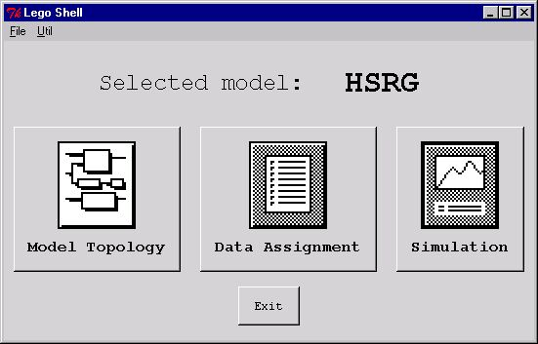

Fig. 1 – main window of LegoPC

- The system to be simulated is built by creating instances of physical components (the so-called modules). Such an instantiation is performed in a “CAD-like” fashion, building a drawing on which the components are “dragged” from different graphical libraries (see fig. 2).

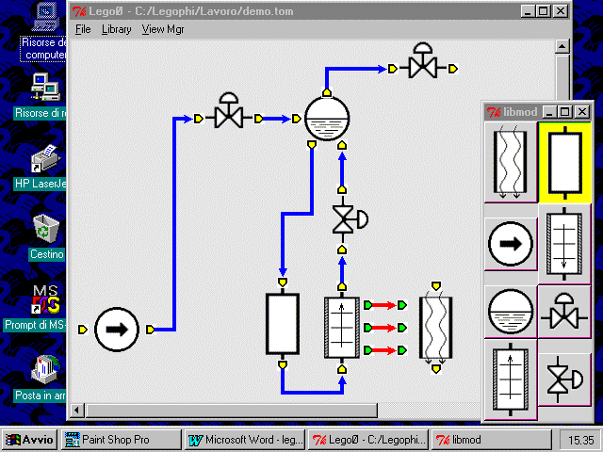

Fig. 2 – The topology constructor of LEGOPC

- Components are connected in a “CAD-like” fashion too, drawing lines connecting their physical terminals. A group of variables is associated to each terminal. Connecting terminals of two modules is automatically translated by LegoPC into a connection between corresponding mathematical variables, position by position, of the two connected terminals. In this way who creates the model is no more compelled to connect model components variable by variable: this operation is automatically performed by a translator, generating the model topological file based on model drawing. Such an approach not only spares a long and ripetitive work to the model constructor, but eliminate an easy source of errors that are, moreover, difficult to be traced in later phases of a model testing.

- Data and variables trial values are inserted by means of a easy-to-use windows interface (fig. 3).

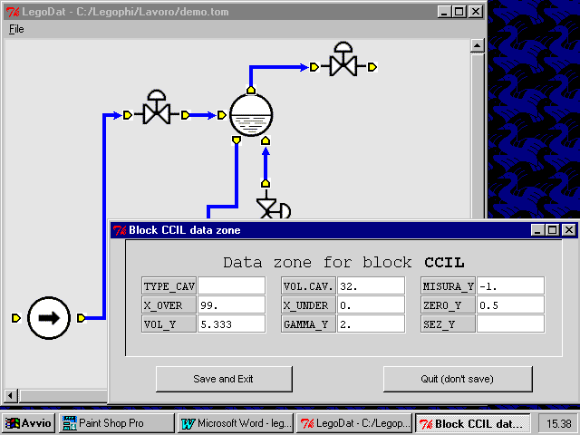

Fig. 3 – The data editor of LEGOPC

- Steam-water properties are easily consulted on-line.
- Steady state can be found (fig. 4) both using a classical MA28-based algorithm and with a new algorithm based on weighed Gram-Schmidt, allowing a higher flexibility and an approach closer to the mentality of simulation experts. In facts, the algorithm is able to find, among the infinite number of solutions of a non-linear system, the one minimizing a weighed norm of the differences between the values obtained by the calculation and the desired ones for the most important system variables. Both MA28-based and Gram-Schmidt-based algorithms have shown a reliable and robust behavior in all the tests we have performed up to now. Furthermore, the graphical interface allows to monitor easily the calculated values of the main variables in subsequent calculations (fig.5).

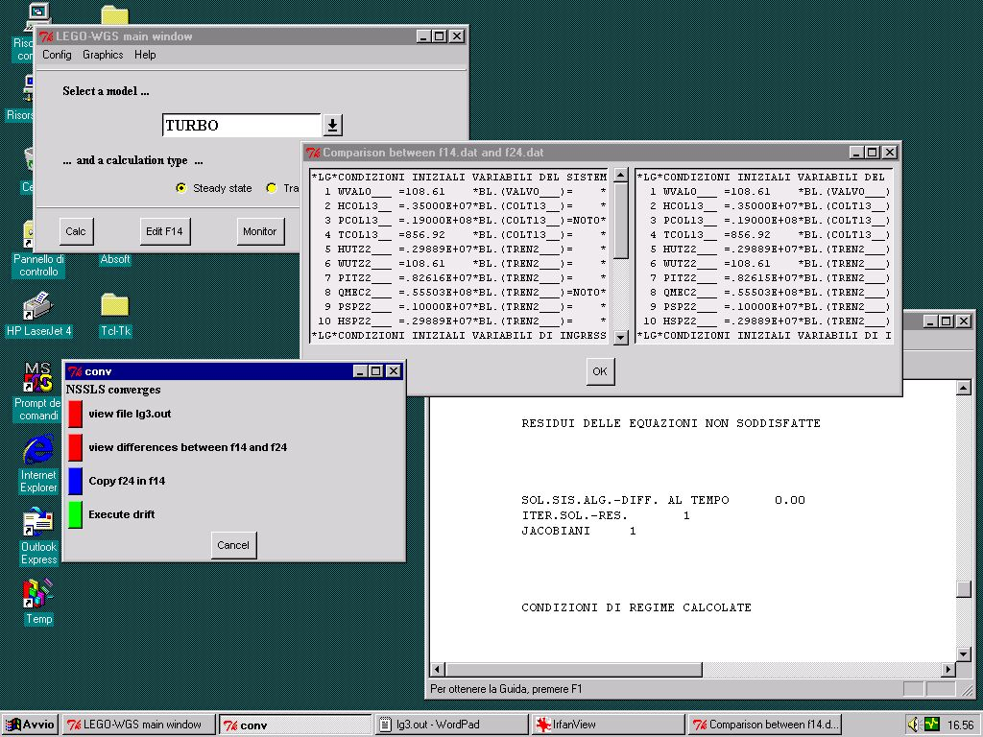

Fig. 4 – Steady state calculation with LEGOPC

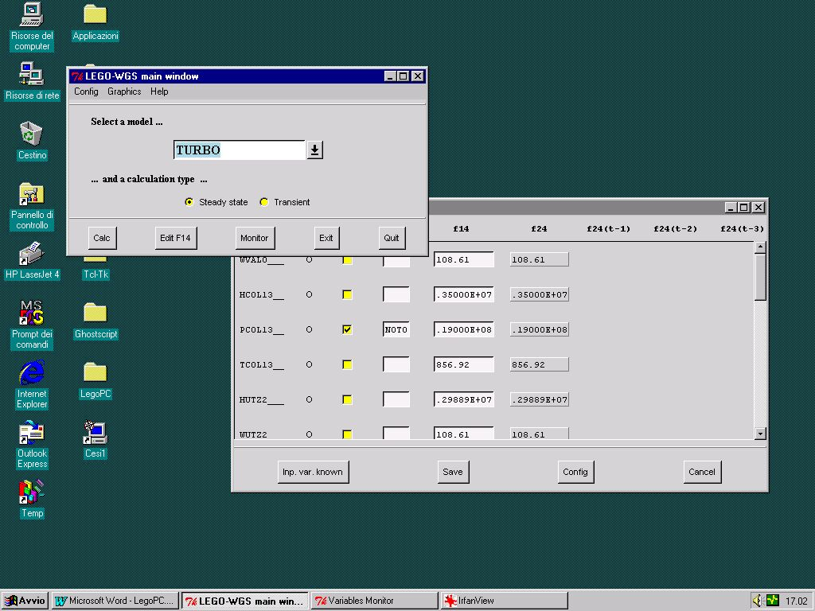
Fig. 5 – The interface monitoring variables during subsequent steady state calculations

- Also transient calculations can be performed both choosing a classical method using trapezoidal rule and Newton-Raphson method, and with a Quasi-Newton variation using the “good” Broyden algorithm. The latter allows an economical refresh of the jacobian matrix at each step, avoiding its aging and assuring, thus, uniform convergence properties at each time step.

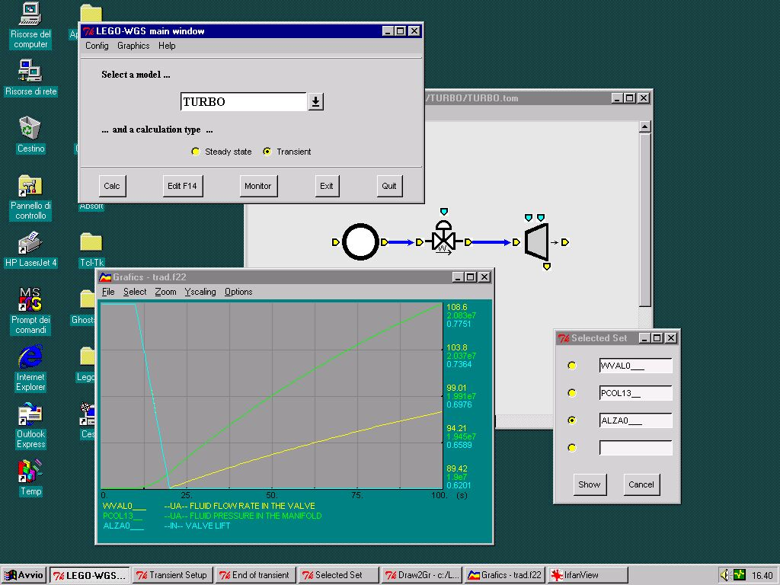

Fig. 6 – Transient calculations and graphical capabilities of LEGOPC
For all the abovementioned reasons LegoPC is a quite different tool with respect to similar ones on the market, the main distiguishing characteristics being:

- Flexibility and “user friendliness” in building new models
- Expansibility of the modules library, allowing to cope with all modeling needs of the user
- Modernity and effectiveness of the calculation algorithm.

Utilities developed for LEGOPC

LegoPC boasts a rich set of embedded utilities facilitating all building and managing operations on mathematical models. These tools have been developed for Windows 95 and subsequently implemented for Windows NT.
The utilities set comprises:

- TABLES: to consult water/steam thermodynamic properties.
- NEWMOD: to develop new library modules using a modern windows-based interface.
It’s possible, in this way, to widen the mathematical models library
without writting any programming line.
- LIBRARIAN: to manage the modules library and their preinstantiation procedure.
- EDI14: to transfer data from a model to another.
- FORAUS: to write user subprograms customizing modules behavior.
- INHOUD: to assemble automatically several models in one only.

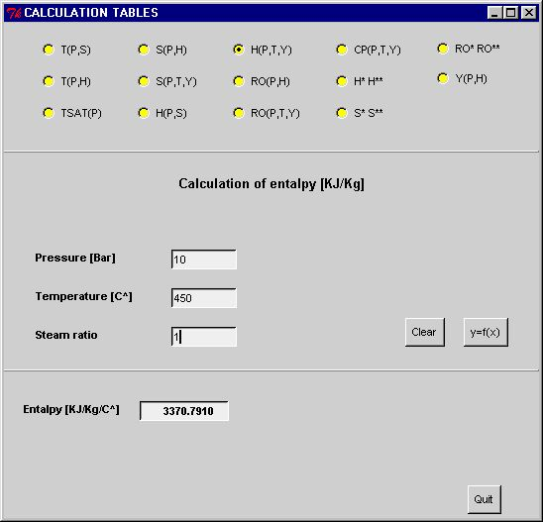

Fig. 7 – TABLES: consulting on-line water-steam properties

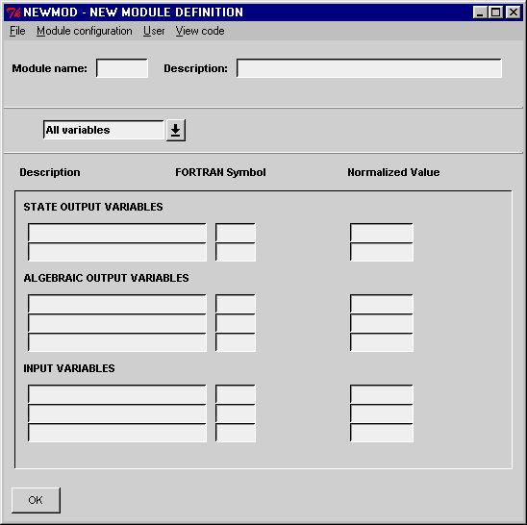
Fig. 8 – NEWMOD: making a new modul

