THE PROGRAM “LegoSim”

LegoSim is a useful complement of the package LegoPC. It allows to “see” a LegoPC model as a Simulink block. Several LegoPC models can be included in a Simulink model and freely connected with other Simulink blocks. The anvantage is to be able to combine the flexibility and the great power of Simulink with the reliability provided by the solver of LegoPC to solve large systems of non-linear algebraic-differential equations typical of complex industrial processes.

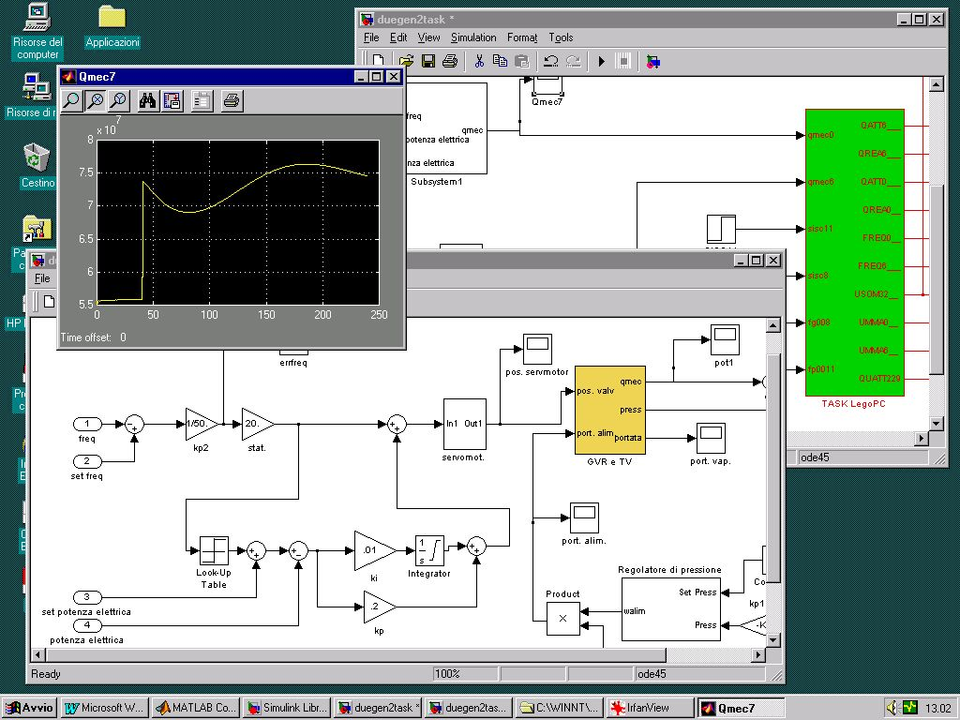

Fig. 1 – an application LegoSim
LegoPC models are called by the solver of Simulink at due time during the simulation, in dependency from their own integration step.
As far as the code organization is concerned every LegoPC model is managed as an independent process, a server to which a client made up of a level 2 Simulink S-function is associated. The dialogue between client and server is assured by the synchronization mechanisms of Windows NT.

Hardware characteristics needed to install LegoSim:
- PC with OS Windows-NT; 64Mbyte RAM (for very complex models we recommend 128Mbyte),
- compiler Fortran 77 Absoft (version 6.0 or higher);
- Matlab/Simulink release 11 or subsequent (Matlab versione 5.3 or higher)

