Puertollano Dynamic Simulator Project

Document code:

Document type: INSTRUCTOR STATION FUNCTIONAL SPECIFICATION

DISTRIBUTION RESERVED
PROPRIETARY

1 | 1 /2/1995
Rev | Date | Page | ENEL  CRA | ENEL  CRT | ELM | EDF |  | ENEL  CRA | ENEL  CRT | ELM | EDF |  | Project Manager
 |  | changed | Prepared by |  |  |  | Checked by |  |  |  |  | Approval

TABLE OF CONTENTS

1. OVERVIEW
2. REFERENCES
2.1. APPLICABLE TECHNICAL SPECIFICATION PARAGRAPHS
3. GENERALITIES
3.1. ENVIRONMENT
4. GRAPHIC PAGES LAYOUT
4.1. STATES OF THE SIMULATOR
4.1.1 STOP
4.1.2 FREEZE
4.1.3 RUN
4.1.4 BACKTRACK
4.1.5 REPLAY
5. CAPABILITIES
5.1. SIMULATOR START-UP AND SHUTDOWN
5.2. CHANGE OF THE SIMULATOR STATE
5.3. SNAPSHOT MANAGEMENT
5.4. BACKTRACK MANAGEMENT
5.5. RECORD AND REPLAY
5.6. TIME SCALING
5.7. CONTINUOS RECORDING
5.8. MALFUNCTION CONFIGURATION AND MANAGEMENT
5.9. REMOTE FUNCTION CONFIGURATION AND MANAGEMENT
5.10. PRE-PROGRAMMED SCENARIOS
5.11. INSTRUCTOR AND TRAINEE ACTION LOG
5.12. INSTRUCTOR-LESS TRAINING SESSION CAPABILITY
5.13. TRAINEE PERFORMANCE REVIEW CAPABILITY
5.14. FILES MANAGEMENT
5.15. ON-LINE HELP
5.16. ERROR LOGGING AND TROUBLESHOOTING
6. SOFTWARE ARCHITECTURE

OVERVIEW
This document contains the functional specification for the design and the development of the Instructor station software, through which the instructor can control the simulator.
It contains a brief description of the behaviour of the simulator in the different states, the list of the functionalities and their description.

REFERENCES

APPLICABLE TECHNICAL SPECIFICATION PARAGRAPHS

ELCOGAS, S.A.
COOPERATION AGREEMENT BETWEEN ENEL, EDF and ELCOGAS FOR THE DEVELOPMENT, INSTALLATION and TUNING OF A PLANT DYNAMIC SIMULATOR
ANEXO TECNICO
MADRID, November 1994

List of paragraphs:

- 3.6 Malfunction analysis
- 3.7 Training features
- Annex V - Malfunction analysis

GENERALITIES

ENVIRONMENT

The simulator system consist of three DEC alpha workstations running DEC OSF/1, interconnected via an ethernet network; one monitor will be selected to be available for the instructor.
All the functionalities provided to the instructor are achievable by using the mouse, the keyboard and the graphical interface.
The next figure shows the general hardware architecture.
TWO WORKSTATIONS
RUNNING MODELS
AND
OPERATOR
INTERFACE
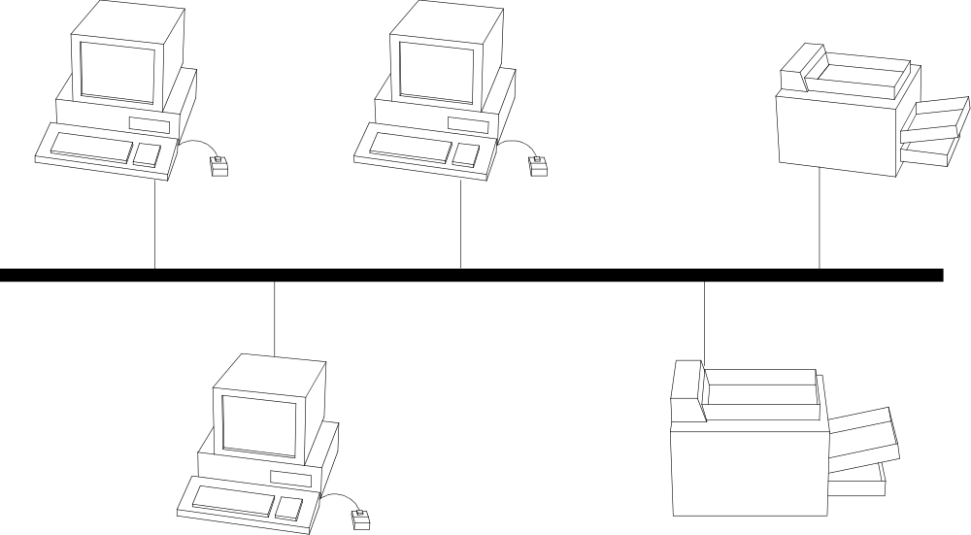 Figure 3-1 - Hardware architecture
LASER
PRINTER
INSTRUCTOR
STATION
HARD-COPY
PRINTER
LAN ETHERNET (TCP/IP)

The Instructor station software is installed on the Instructor station machine and is integrated and interacts with the local graphic system, the same used for the operator interface; it interacts with the simulator scheduler, in order to perform those functions that affect the simulation, and with a local database, for the functions related to the malfunctions and the remote functions. Has also access to the disk files necessary to the recording and viewing functions.
Following is provided a block diagram of the software.

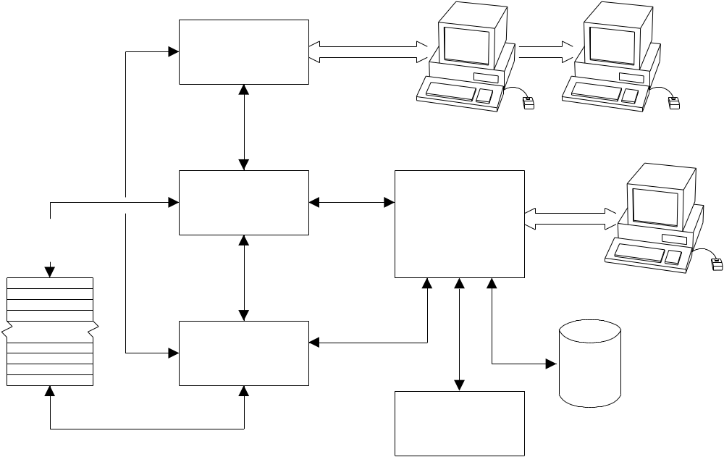
GRaphic
interface

master
scheduler

instructor
station

simulator
database

instructor
station
database
recorded
files
simulation
models
instructor
interface
operator interface
Figure 3-2 - Software block diagram

Graphic pages layout
All the graphic pages the instructor can display may be the same used for the operator’s interface system. In addition, these pages display, in an apposite area, the simulation and the real time clock, the simulator state, the time scale and the title the instructor gave to the running session. An alarm signals the presence of non acknowledged simulator system alarms (task aborted, fault during the execution of an automatic function, interrupted communications, and so on). Functional push buttons are also provided to switch the selection mode while selecting a graphical icon (selection of malfunctions and remote functions associated with the icon, rather then display the generic information or the associated plot).
All the functions of the Instructor Station are quickly accessible through a menu bar.

STATES OF THE SIMULATOR
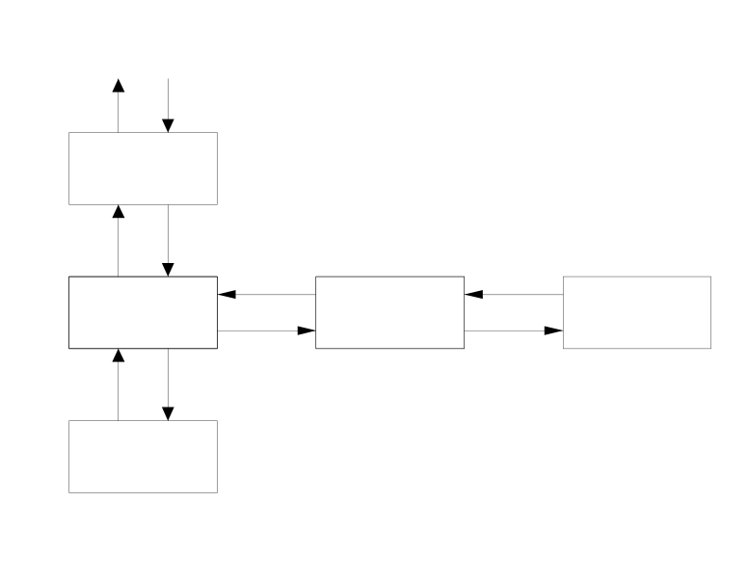
Figure 4-1 - States of simulator
stop
freeze
run
backtrack
replay
system not initialized

STOP
In this state the simulator is ready for the initialization procedure and all the off line configurators are accessible.

FREEZE
In this state the simulator tasks are active but not running. The simulation time is not incremented and the automatic functions of the Instructor Station are not executed. It is possible to switch to a different state (but REPLAY), load an initial condition, operate with the configurators and view recorded data.

RUN
The simulator tasks are running and the Instructor Station executes the automatic functions: backtrack snapshots, continuos recording, trainee’s performance monitoring, instructor and trainee’s actions recording.

BACKTRACK
The simulator tasks are not running and the Instructor Station does not execute the automatic functions.
From BACKTRACK state it is possible to sweep, automatically or manually, backward or forward, through the snapshots automatically recorded, if any. The mentioned snapshots are available for loading as initial condition.

REPLAY
In this state, reached from the BACKTRACK state, it’s possible to “replay” one of the recorded sessions or part of that. The models run like in the RUN state but the inputs coming from the control system are inhibited. Starting from the loaded backtrack snapshot, all of the actions (of both the instructor and the operator, previously recorded) are proposed to the simulator at the appropriate time.

CAPABILITIES
The following is the list of the Instructor Station software capabilities:

- Simulator start-up and shutdown
- Change of the simulator state
- Snapshot management
- Backtrack management
- Record and replay
- Time scaling
- Continuos recording
- Malfunctions management
- Remote functions management
- Pre-programmed scenarios
- Instructor and trainee’s action log
- Instructor-less training session capability
- Trainee performance review capability
- Files management
- On-line help
- Error logging and troubleshooting

Simulator start-up and shutdown
In the simulator configuration, based on three workstations, one will be used as master system and the others as slaves.
The simulator is activated at the master machine with a single shell command; all the commands and functions needed to initialize, configure and use the simulator are available from the graphical interface of the Instructor Station console.
The instructor is required to type a simple command at the keyboard of the Instructor station machine. All the software will be initialized, the simulator will come up in the STOP state, and the graphical system will display a default mimics page on all the monitors.
The Instructor Station machine will have the necessary graphical interfaces and capabilities.
Before the initialization of the simulator, the instructor can choose among the default set of recorded files and an alternative set previously saved.
The initialization procedure restores the simulator situation left before the last simulator shutdown: simulation time and simulator database are recovered from the recorded files.

Change of the simulator state
All the permitted transitions between the states of the simulator are manually driven by the instructor.
Through the selection of a push-button available from all the graphical pages, the list of the selectable states is displayed. The transition is achieved by selecting the desired state from the list.
While the RUN state is selected, the instructor is prompted to enter a “title” of the session that will start from this moment on, if the selection comes after a database replacement (initial condition or backtrack snapshot loading).

Snapshot management
The instructor has the possibility to record, load and maintain up to 64 initial conditions. An appropriate interface is provided from all the graphical pages that make possible to:
- save a snapshot of the simulator database as an initial condition specified by the instructor or directly as the default initial condition, along with an instructor’s comment. This functionality is available from all the simulator states.
- load the simulator database from a selected initial condition. This functionality is available from the FREEZE state.
- delete, move and copy initial conditions, as well as modify the comments associated to the initial conditions. This functionality is available from all the simulator states.
- preview the initial conditions database on the graphic displayed at the Instructor Station. This functionality is available from all the simulator states.

Backtrack management
An automatic function is provided that, at the time interval specified by the instructor, records the simulator database into a file in circular fashion. The file is sized for 120 records.
An interface is provided from all the graphical pages that make possible to:
- preview the existent backtrack records on the graphic displayed at the Instructor Station. This functionality is available from all the simulator states.
- manually select a backtrack record for loading into the simulator database. It is also possible to sweep the file in automatic mode (with selectable interval time between one load to the next), backward and forward. The automatic mode stops at the session limits. This functionality is available from the BACKTRACK state.
- switch from the BACKTRACK state to the REPLAY state, and back to BACKTRACK state. The REPLAY state stops automatically at the session limit.
- switch from the BACKTRACK state to the FREEZE state in two possible ways:
- by validating the database substitution made while in BACKTRACK state
- recovering the situation left while entering in BACKTRACK state

The backtrack snapshot list is displayed by record time order, and are clearly pointed out the start and the end of the sessions.
The file can be cleared by using the appropriate function.

Record and replay
All the events coming from outside the models that affect the simulation (generally: modification of input variables of the models, such as activation of malfunctions and trainee actions) are automatically recorded. In REPLAY mode these “perturbations” are submitted to the models at the appropriate time, so producing an effective “replay” of a previous session. The REPLAY mode stops automatically at the session limit on instructor’s request.
The instructor can follow the replayed simulation looking at the backtrack summary list and at the instructor and trainee’s actions log. The lists are automatically scrolled during the evolution of the simulation, pointing out the events and the backtrack snapshot recorded at the present simulation time.

Time scaling
An interface is provided from all the graphical pages that make possible to modify the “speed” of the simulator by introducing a multiplier of the system clock. Requesting the “maximum speed” of the simulator, the effective speed reached is displayed.
This feature is available from all the simulator states.

Continuos recording
An interface is provided from all the graphical pages that make possible to select from the simulator database up to 256 variables that will be recorded, at an instructor selectable frequency, on an apposite file in circular fashion.
A trend function is available to display the recorded values; an interface permit the configuration of up to 50 trends. The instructor has the possibility to modify on line the preassigned parameters that define the trends (time scale, engineering units and scale of the displayed variables and the variables themselves). All these functions are available from all the simulator states.

Malfunction CONFIGURATION AND management
Each type of plant component has a set of possible associated malfunctions. The Instructor station software does not limit the number of malfunctions, except that due to storage requirements.
An off-line configurator is provided that permit to associate the modelled malfunctions to the simulated components and to the plant systems or to the plant functional areas. Furthermore, a configurator is provided to define (using simple relational operators and the values of simulated variables or constants) up to 20 trigger events.

An interface is provided from all the graphical pages to manage the simulator malfunctions.

For each malfunction it is possible to define the following parameters:

- the activation delay
- the duration of the active malfunction before its deactivation
- the target value (for variable malfunctions only)
- the ramp time (for variable malfunctions only)
- the event that will trigger the activation or deactivation

Each one of these parameters has a software default value that may be replaced run-time by the instructor.

The malfunctions are modifiable in three different ways:

- step change, by entering the target value that will be reached instantaneously
- automatic ramping, by entering the rate and the target value to be reached
- manual ramping, at fast and slow rate, using an appropriate graphical interface

The malfunctions are selectable from any mimic in three ways:

- from a list grouped by system or plant areas
- selecting a component or a flag on the mimics
- from the summary page

- The first manner implies that the instructor knows the system or plant area where the malfunction variable is simulated, and the variable name itself; the browsing of the variable descriptions is however possible. Once selected, the instructor can insert or remove the malfunction from the summary table, accept or modify the default values of the parameters and get it ready for activation or deactivation. Short cuts are provided for fast operation.
All these operations are available from the list and from all the simulator states, though the evolution of the malfunctions are possible in the RUN state only.

- The second manner allows the instructor to select malfunctions by symbol: the selection of an icon, for instance a valve, opens a window with the list of the associated simulated malfunctions, expressed with the description that the modelist entered during the off-line configuration. The selection of an item of the list initiate a procedure that permits to operate the malfunction as described before. In this way, the instructor does not need knowledge about models: only plant information are required.
Moreover, flags are available allowing to associate to them up to 10 malfunctions: this feature permits to connect to the graphical system the malfunctions not associated to displayed components.
All these operations are available from all the simulator states, though the evolution of the malfunctions are possible in the RUN state only.

- The third manner permit to operate directly from the summary tableau. The malfunctions contained herein, showed by state and time-to-activation order, are available for all the functionality previously described. All the information related with the variables are displayed or quickly accessible. From the summary tableau the instructor can activate all the functions previously described, as well as those functions that suppose the use of multiple selection (total clear, contemporary activation, deactivation or deletion of two or more malfunctions).

The malfunctions summary is sized to manage up to 300 entries and is saved as part of the snapshot.
The evolution of a malfunction variable is visible at the summary as well as at any menu that permits to select it; the state of the malfunction is also displayed, along with the time remaining to the expiration of the timers and the indication of the associated trigger.
During the preview function of the snapshot and backtrack, the summary is updated to show the malfunctions as they were snapped.

Following is provided the block diagram of the states of the malfunctions.

manual activation
timer exhausted
trigger event

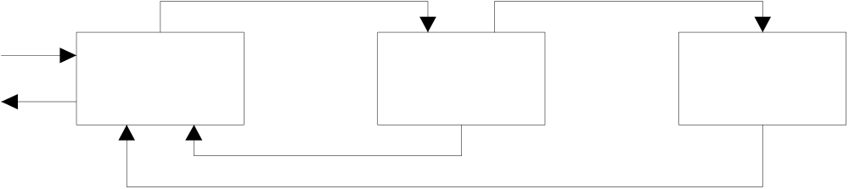
SELECTED
ARMED
ACTIVATED
selection
deletion
manual deactivation
timer exhausted
manual deactivation
out
of
summary

interacting
with
simulation
in the summary list

Figure 5-1
After the selection, the malfunction is inserted in the summary list in the SELECTED state. Once the instructor activate it, the state of the malfunction switch to ARMED: the expiration of the delay time or the selected trigger event will switch the state to ACTIVE. At any time it is possible to manually deactivate a malfunction (even if it is in the ARMED state) switching the state back to SELECTED. A deletion of a SELECTED malfunction causes the variable to be removed from the summary.

Remote function COnfiguration and management
All the plant components that do not have an associated command in the real control room but are simulated, are associated to remote functions. The Instructor station software does not limit the number of remote functions, except that due to storage requirements.
An off-line configurator is provided to associate the modelled remote functions to the simulated components and to the plant systems or the plant functional areas.

An interface is provided from all the graphical pages to manage the simulator remote functions.
For each remote function is possible to define the following parameters:

- the activation delay
- the target value (for variable remote functions only)
- the ramp time (for variable remote functions only)

Each one of these parameters has a software default value that may be replaced run-time by the instructor.

The remote functions are modifiable in three different ways:

- step change, by entering the target value that will be reached instantaneously
- automatic ramping, by entering the rate and the target value to be reached
- manual ramping, at fast and slow rate, using an appropriate graphical interface

The remote functions are selectable from any graphic display in three ways:

- from a list grouped by system or plant areas
- selecting a component or a flag on the mimics
- from the summary page

- The first manner implies that the instructor knows the system or plant area where the remote function variable is simulated, and the variable name itself; the browsing of the variable descriptions is however possible. Once selected, the instructor can insert or remove the remote function from the summary table, accept or modify the default values of the parameters and get it ready for activation or deactivation. Short cuts are provided for fast operation.
All these operations are available from the list and from all the simulator states, though the evolution of the remote functions are possible in the RUN state only.

- The second manner permits the instructor to select remote functions by symbol: the selection of an icon, for instance a valve, opens a window with the list of the associated simulated remote functions, expressed with the description that the modelist entered during the off-line configuration. The selection of an item of the list initiate a procedure that permit to operate the remote function as described before. In this way, the instructor does not need knowledge about models: only plant information are required.
Moreover, flags are available allowing to associate to them up to 10 remote functions: this permits to connect to the graphical system the remote functions not associated to displayed components.
All these operations are available from all the simulator states, though the evolution of the remote functions are possible in the RUN state only.

- The third manner permits to operate directly from the summary tableau. The remote functions contained herein, showed by state and time-to-activation order, are available for all the functionality previously described. All the informations related with the variables are displayed or quickly accessible. From the summary tableau the instructor can activate all the functions previously described, as well as those functions that suppose the use of multiple selection (total clear, contemporary activation, deactivation or deletion of two or more remote functions).

The remote functions summary is sized to manage up to 300 entries and is saved as part of the snapshot.
The evolution of a malfunction variable is visible at the summary as well as at any menu that permits to select it; the state of the malfunction is also displayed, along with the time remaining to the expiration of the timers and the indication of the associated trigger.
During the preview function of the snapshot and backtrack, the summary is updated to show the remote functions as they were snapped.

Following is provided the block diagram of the states of the remote functions.

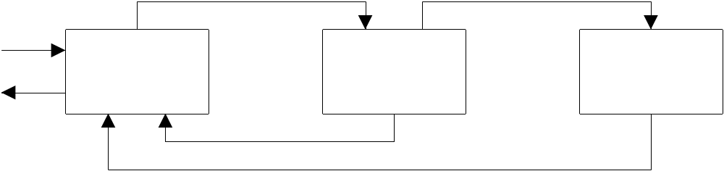
interacting
with
simulation
in the summary list
out
of
summary
deletion
timer exhausted
manual deactivation

manual deactivation
timer exhausted
manual activation
selection
ACTIVATED
ARMED
SELECTED

Figure 5-2
After the selection, the remote function is inserted in the summary list in the SELECTED state. Once the instructor activate it, the state of the remote function switch to ARMED: the expiration of the delay time will switch the state to ACTIVE. At any time it is possible to manually deactivate a remote function(even if it is in the ARMED state) switching the state back to SELECTED. A deletion of a SELECTED remote function causes the variable to be removed from the summary.

Pre-programmed scenarios
An interface is provided from all the graphical pages that make possible to define up to 20 different sequences of up to 15 malfunctions and remote functions, along with their parameters. Once a sequence is activated, the variables are automatically managed.
All the variables included in the selected sequence are appended to the malfunction and remote function summaries.
If one or more variables are already included in a summary, a warning is emitted and the instructor is prompted in order to correct the sequence.
Would the maximum limit be exceeded (for either malfunctions or remote functions), the instructor will be prompted to choose which variable is to be used or eliminated.

Instructor and trainee action log
All the actions made by both the instructor and the trainee that affect the simulation, are recorded in a textual description manner. It is possible to log and print all these data along with the associated simulation date and time; furthermore, it is possible to relate the single action with the continuos recording trends and with a particular instant during a “replay” session.

Instructor-less training session capability
An interface is provided from all the graphical pages that make possible to program a complete training session using a symbolic language.
All the possible commands that could be made by both the instructor or the trainee are available. Initial conditions load, change of simulator state, timescaling variations, malfunctions and remote functions activation are clearly stated; actions that affect plant components are explicitly referenced as the kind of action (OPEN, CLOSE, START, SET_POINT etc.), the reference to the plant component as it is established in the plant flow diagram, and the parameters needed to fully specify the command.
A “compiler” is moreover supplied to convert the log of the trainee and instructor’s actions to an executable training program.
Up to 10 instructor-less training programs can be written and maintained.

Trainee performance review capability
An interface is provided from all the graphical pages that make possible to select from the simulator database up to 300 variables that will be recorded at an instructor selectable frequency, and to pre-define up to 20 trends. For each one of the variables the instructor can specify the upper and lower limits, and the action the simulator will take once the limit will be exceeded. The limits may be fixed (values) or variables (the value of referenced variables).
If during the session, one or more limits should be exceeded, the simulator will take the action the indicated by the instructor during the configuration (typically change of state or warning messages).
The variables selected for this functionality are recorded in addition to the ones recorded for the Continuos recording function.
The recorded data are displayable using the pre-defined trends and the points where the limits have been exceeded are graphically pointed out.
Statistical information are generated to summarize the number of variables the value of whose exceeded the limits, the number of time the limits have been exceeded, etc. Such information may be printed by an apposite command.

Files management
All the files recorded during a session are seen as a unique set of data. The files that recorded :

- the backtrack snapshots
- the recording for the replay function
- the values of the continuos recording function
- the trainee and instructor’s actions
- the trainee performance

are aligned to the simulation time.
The limits of the sessions are individuated through graphical marks and through the comments inserted by the instructor.
An utility is provided that permit to backup the entire set of data or part of that, as well as to load a backup into the simulation system.
The functions that display recordings can be addressed to get data from alternate set of files, rather from the one actually selected.
The visualizations of the recorded data can interact one each other.
The instructor can view all the recordings correlated to an unique time scale. By moving a time reference point on a trend or on a list, all the trends and lists displayed will scroll.
While in the FREEZE state, it is possible to clear all the recordings and the simulation time, using the apposite function.

ON-LINE help
All the actions the instructor can do by means of the Instructor Station software are assisted by an on-line, context sensitive help function.

Error logging and troubleshooting
Software errors as well as the incapability by the software to execute specific instructor’s requests are logged to the error log file and displayed to the instructor, along with, possibly, an explanation of the error condition and the corrective actions the instructor should take.
Unavailability of machines included on the configuration are clearly indicated.

Software architecture
Mainly, the software can be divided in two parts: the Graphic interface (the same used for the operator interface) and the Instructor Station Software.
The Graphic Interface is connected to the rest of the system through the Graphic System Interface. From this channel it receives the data for the Local Graphic Database and communicate to the master scheduler the commands that the instructor can activate using the same possibility the operator has. It interacts with the Instructor Station Software through the Instructor Interface, that interpretates the requests of the instructor.
The Instructor Station Scheduler, that receives the inputs from the Instructor Interface, controls all the functions the Instructor Station can perform: periodically activate the backtrack recordings, the instructor and trainee’s action recordings, the continuos recordings and the recordings for replay (Automatic Functions), controls the malfunctions and remote functions management, the snapshot and backtrack management and the preview logic. It also interfaces the Session Interpreter, that translates the instructor-less training session files into standard Instructor Station commands. Through the Master Scheduler Interface it communicate to the rest of the system the change of state of the simulator, receives the simulator database to perform the snapshots and transmits the data to replace the simulator database after a snapshot loading.
On-line and off-line configurators complete the Instructor Station Software.
The following is the simplified block diagram of the modules that form the Instructor Station Software.

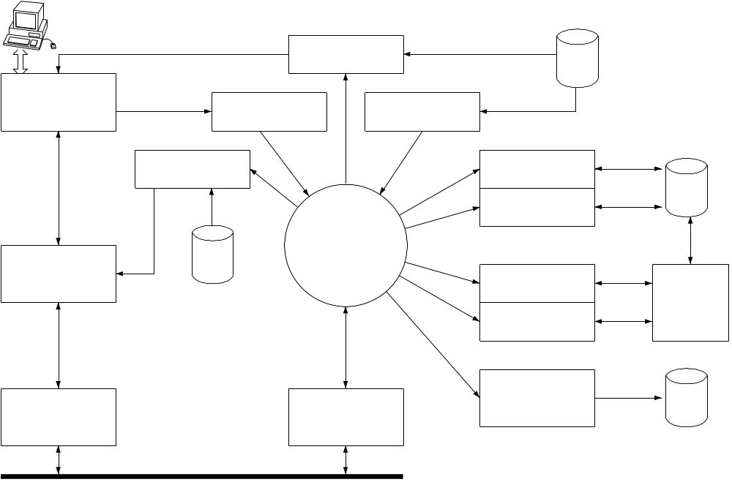
Instructor
Station
Scheduler
Graphic
System

Local
Graphic
Database
Preview
Logic
Display of
Recordings
Instructor
Interface
Session
Interpreter
Snapshot
Management
Backtrack
Management
Malfunctions
Management
Remote Func.
Management
Instr.
Station
Database
Automatic
Functions
Master
Scheduler
Interface
Graphic
System
Interface
Ethernet (TCP/IP)
Figure 6-1 - Instructor Station Software block diagram

