Research Software Engineer for Composites Simulations  Ref XXXXXXXX (5315) |  |  |  |  | 

JOB DESCRIPTION
School or Division/ Address: |  | Bristol Composites Institute (ACCIS)
Academic Faculty / Support Services Division: |  |  |  | Engineering
(Supplementary information for recruitment only)
Job Family / Grade: | Grade I |  |  | Salary range: |  | £32,004-£36,001 per annum
Hours of work: | 35 hours |  |  | Work pattern: |  | 1.0FTE
Contract type: | Open-Ended with Fixed Term Funding for 24 months

Main Job Purpose
The post holder will be a Research Software Engineer (RSE) employed as partnership between the Bristol Composites Institute (ACCIS) and the Advanced Computing Research Centre’s Research Software Engineering Group (ACRC RSE Group). The post holder will work with the ACRC RSE Group to provide RSE support to researchers working in the Bristol Composites Institute.

The Bristol Composites Institute was established in March 2017, building on the extensive previous work of ACCIS, the Advanced Composites Collaboration for Innovation and Science. It brings together composites activities across the University of Bristol, based in the Faculty of Engineering and linking to the Science and Medical Faculties. Its vision is to be a world-leading institute for composites research and education, combining cutting-edge science with strong industrial links for exploitation and technology transfer.

The ACRC RSE Group was established in July 2016, and comprises RSEs who work in partnership with researchers across a range of academic departments. RSEs support academics in the design, implementation, documentation and testing of research software, thereby ensuring that such software provides a strong foundation for future development and future exploitation and technology transfer.

The post holder will both be a member of the Bristol Composites Institute, under the direct supervision of Prof Stephen Hallett (Professor in Composite Structures), and a member of the ACRC Research Software Engineering Group, under the mentorship of Dr Christopher Woods (EPSRC RSE Fellow). The post holder will work as part of large team, led by Prof Hallett, to develop and deploy software for the analysis of composite materials and structures. A significant part of the role will be focussed on the EPSRC platform grant, SIMPROCS. The focus of this project is to develop a robust and efficient simulation toolbox for prediction of manufacturing processes, in support of design concepts utilising new composite material formats. The post holder will be employed as part of Prof. Hallett’s team of researchers and software developers, supporting them in their objective to develop new finite element modelling approaches that speed up the design and development of composite structures and improve manufacturing processes. In this role, the post holder will work to ensure that software developed is produced to a high standard, e.g. including robust testing, complete documentation, utilising a clean and modular design, and is packable into easy-to-distribute and easy-to-install applications to support dissemination and technology transfer. To facilitate this, the post holder will be responsible for developing and maintaining services necessary for robust software development (e.g. a version control and continuous integration platform). They will additionally optimise software for performance, which might include parallelisation and vectorisation of codes. They will take the lead in providing training in software engineering best practice to researchers in the Bristol Composites Institute and where appropriate, contribute to academic publications. In addition, the post holder will develop and present training materials to help support the dissemination and use of software produced. They will liaise with external stakeholders to ensure efficient and timely delivery of software that is robustly tested and meets required coding standards. Going forward the role holder will also contribute to the preparation of research grant proposals, identifying and supporting the needs for software development.

Statement of Responsibilities
Analysis, Reporting and Documentation

An RSE needs to be able to productively collaborate with researchers in a given field. In order to do so the post holder must be able to quickly build an understanding of key principles at play in that field and also the challenges presented by a particular project.

To discuss and understand the computational and storage needs of researchers and to advise on the ways in which best practice meets those needs.

Create or modify existing documentation, keeping up to date records of work, progress and outputs, and to coordinate with the other members of the team to ensure that progress towards completion of goals remains on track. They may also contribute to academic publications. This includes regularly attending project meetings, maintaining an open dialog with team members both at Bristol and outside Bristol, contributing to problem solving within a group setting, and ensuring that documentation of produced software is developed to a high standard.

Customer Services & Support

Work within the Bristol Composites Institute, with regular hot-desking within ACRC.

Provide specialised and in-depth support and guidance to researchers in several areas;

To work as part of the project team to develop and deploy software internally within the university. To liaise and coordinate with external academic and industrial collaborators, to ensure robust, usable code is made available, to meet their requirements. The software is currently written in a combination of Fortran and Matlab, with scope available to develop in C++ and Python where this improves the design, robustness or ease of distribution of the code. RSE support will be provided with mentoring and support of Dr Woods.

Planning & Organising

The post holder will be expected to prioritise work across a range of requirements from different stakeholders, ensuring optimum delivery of support. They will contribute to all required outputs for the project, e.g. including research papers, research talks, conference presentations and posters, and research visits, for which support and credit/authorship will be provided.

To deliver the software and associated outputs required. This will involve adapting existing software and developing new software in partnership with researchers employed on the SIMPROCS grant and other projects, under the close supervision and guidance of Prof Hallett and Dr Woods, together with associated tests, documentation and training materials

To deliver outputs required, which includes developing research papers, training material, workshops, talks, benchmark tests, examples and documentation that will ensure that the software will be well-known, sustainable, and readily transferable to the wider academic and industrial composites community.

The post holder will help develop and deliver training workshops both in academia and in industry, and will work with the project team to ensure that the developed software is robust, trustable and correct, reproducible and performance portable. This will be achieved by developing software following current software engineering best practice (i.e. using version control, continuous integration, source-level documentation, issue-tracking and collaborative software development via code-review). Support and training will be provided as necessary.

Liaison

To establish and build relationships with members of external companies, peer institutions and national bodies (such as, e.g., industrial partners like Rolls Royce, or research organisations such as the National Composites Centre), as appropriate.

Work closely with Prof Hallett, Dr Woods and the research team to develop and test the software tool set, together with associated documentation and tests. In addition, the post-holder will collaborate in the development of training material, which they will help deliver to academic and industrial groups.

Continuous Improvement

The post holder will be provided with training in packages and programming, software engineering best practice and composites modelling, and will be supported via regular meetings, co-coding sessions, mentoring and provision of training materials and workshops.

The post holder will ensure they keep abreast of updates in the field, including all aspects of the field of composites modelling and high performance computing required for the project.

People Management

To advise and gain the support of research groups, so that project objectives are met.

Relationships and Contacts
Line manager: |  |  | Stephen Hallett (Professor in Composite Structures)
Line manager to (where appropriate): |  |  | N/A
Internal Contacts
SIMPROCS Project Team (Academics and Researchers)

Christopher Woods (EPSRC RSE Fellow)

Bristol Composites Institute (Academics, Researchers and Students)

Advanced Computing Research Centre staff, in particular the ACRC Research Software Engineering Group

External Contacts
Other partners involved in the SIMPROCS Platform Grant.

Industrial and academic collaborators of the Bristol Composites Institute.

Membership of the UK Research Software Engineering Association (rse.ac.uk), a national body of research software engineers, which acts as a forum for discussion of all aspects of research software engineering, and for the establishment of best practice.

Organisation Charts

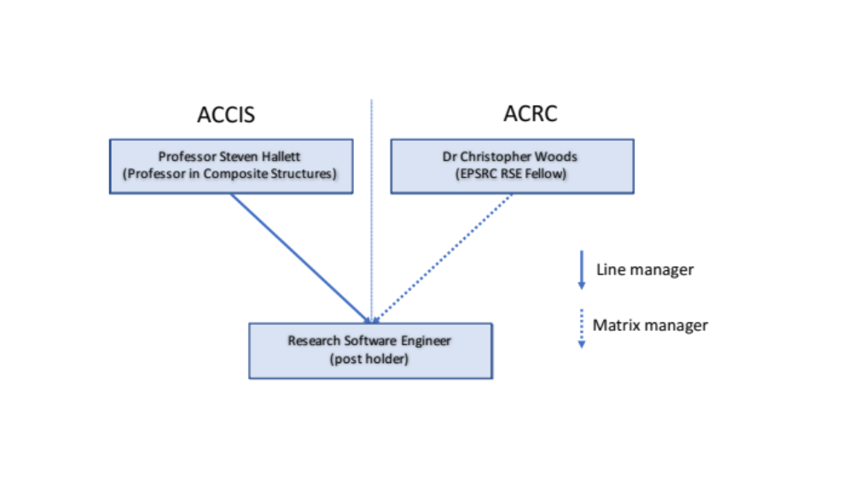

Job Hazards/Safety Critical Duties (Pre-employment health screening)
(Please refer to guidance notes at http://www.bristol.ac.uk/hr/resourcing/practicalguidance/appointment/checks.html)

Not applicable

PERSON SPECIFICATION

Relevant Experience, Skills and Knowledge
Essential | Desirable
- Significant experience of a range of programming languages, including Fortran, particularly Fortran 77, modern object orientated / functional programming languages, specifically Python and C++.  - Experience as a researcher or of working closely with researchers and contributing to research through software development  - Significant experience of software development best practice, including issue tracking, testing, documentation, version control, and/or continuous integration.  - Experience contributing to collaborative software projects, or delivering software used by other people  - The ability to assimilate complex information, about a wide range of topics both technical and those relating to the areas of research being undertaken by researchers, and to use this to independently develop and implement solutions, and communicate this back to stakeholders  - The ability to organise and prioritise tasks; possession of first class organisation skills and the ability to manage workload independently.  - Track record of delivering well-tested, documented and sustainable software  - Experience of analysing, researching and solving complex programming problems. | - Experience of composite materials modelling software and/or algorithms  - Experience in scientific software code development, optimisation, debugging and maintenance using Fortran  - Experience in scientific software code development, optimisation, debugging and maintenance using modern object orientated / functional programming languages, specifically Python and C++  - Experience of teaching or mentoring researchers and/or scientific software developers, e.g. via workshops or code study groups  - Track-record of delivering well-tested, documented and sustainable software, utilising software development best practice (e.g. using issue tracking, testing, producing documentation, continuous integration and version control using a multi-site platform such as GitHub or BitBucket)  - Some knowledge of parallel programming techniques in multicore and manycore hardware environments  - Track record of successfully working in a team and delivering outputs from collaborative projects

Relevant Qualifications
Essential | Desirable
- A degree or equivalent in Science, Engineering, Maths or Computer Science or a discipline which employs an amount of Computational Science. | - Postgraduate degree in an appropriate subject which provides experience in Scientific Computing

Communication and Interpersonal Skills
Essential | Desirable
- Excellent interpersonal, and planning skills.  - Good presentation skills to present complex ideas to both technical and non-technical audiences  - Experience of working successfully in a team  - Experience of developing training material and presenting this via talks or workshops | - Excellent communication skills and a track record in working with researchers across a wide range of different disciplines  - Experience of working with academics together with a good knowledge of the working practices of professional researchers.  - Experience of working with collaborators across a range of geographically distributed sites

Additional Criteria
Essential | Desirable

BACKGROUND INFORMATION

The School/Division
Bristol Composites Institute

The Bristol Composites Institute – the Advanced Composites Collaboration for Innovation and Science (ACCIS) has recently attained institute status at the University of Bristol in recognition of its internationally leading research profile. It is one of the UK’s foremost academic teams in the area of composite materials, based in outstanding laboratories and office space. Within ACCIS there are over 120 people working on composites, with twenty one members of academic staff and current research funding in excess of £18M. For further details, please visit: http://www.bris.ac.uk/composites.

Advanced Computing Research Centre (ACRC)

The University of Bristol's mission is 'to pursue and share knowledge and understanding, both for their own sake and to help individuals and society fulfil their potential'. This is underpinned by a vision where the University of Bristol is an international powerhouse of learning, discovery and enterprise, whose excellence is acknowledged locally, nationally and globally.

The University has recognised that computationally driven science and technology are the future both for University research and for the industry sectors that derive benefits from University research, for example high value manufacturing, creative, aerospace, automotive, renewable energy, nuclear and pharmaceutical industries to name but a few. It has also recognised the need for people and ideas to flow between the two sectors, and as such the University has, and is continuing to develop, links in this arena across both HE and industry.

The University has for a number of years invested significant capital resource - some £16M since 2006 - into developing a world class advanced computing facility - the Advanced Computing Research Centre (ACRC). We use the term "advanced computing" so as to include not only high-performance computing, but also data storage and the associated long term data curation, research software engineering, staff and student teaching and learning, and critical supporting infrastructure such as high speed networks and advanced, energy efficient data centres.

The University now has one of the best advanced computing facilities of its kind in the UK, putting us amongst the leaders in the UK in terms of capacity, capability and best practice. This enables us to exploit the maximum return from our investments.

Since its creation in 2007 the ACRC has overseen the installation of four large HPC systems, BlueCrystal, the most recent of which was ranked number 397 in the June 2017 Top500 list. This cluster offers the latest generation of powerful GPU processors, innovative ‘burst buffer’ storage and powerful remote visualization technology. The ACRC is also key in procuring and supporting other compute resources which are vital to research at the University. This includes exciting developments in area of low temperature microscopy, where very high-resolution images need to be processed and analysed using powerful compute clusters.

In 2011 we added a resilient, expandable Petascale Research Data Storage Facility (RDSF), which is continually being improved and updated. The RDSF is a multi-site, high resilience, high availability storage system based on the enterprise grade IBM Spectrum Scale file system. It has over 2PetaByte of real usable disk capacity which will soon be expanded into the range of tens of petabytes through the addition of a tape tier coupled via a hierarchical storage management system.

In 2016 the ACRC expanded to include one of the UK’s first Research Software Engineering Groups, making advanced programming and software engineering expertise available to researchers across the University and beyond.

The University and the City of Bristol
The University of Bristol's roots date back to 1876. Since its formation it has become one of the leading institutions among the UK's Russell Group of universities and operates globally, where it is recognised for its research and academic excellence.

The University has a strong interdisciplinary approach and regularly features among the top ranking institutions in global league tables.
The University of Bristol’s mission is 'to pursue and share knowledge and understanding, both for their own sake and to help individuals and society fulfil their potential'. This is underpinned by a vision where the University of Bristol is an international powerhouse of learning, discovery and enterprise, whose excellence is acknowledged locally, nationally and globally, and that is:
- dedicated to academic achievement across a broad range of disciplines, and to continuous innovation and improvement
- research-intensive, supporting both individual scholarship and interdisciplinary or thematic research of the highest quality
- a centre for intellectually demanding, research-informed education that nurtures independence of mind and helps students achieve their personal goals and serve society’s needs, both during and after their time here
- an inclusive and collaborative community of scholarship that attracts and retains people with outstanding talent and potential from all walks of life and all parts of the world
- a stimulating and supportive environment for all students and staff, distinguished by a commitment to high standards, respect for the individual and a strong sense of collegiality
- committed to operating in a sustainable manner
- engaged with society’s interests, concerns, priorities and aspirations
- a major contributor culturally, environmentally and economically to Bristol and the South West
- well led and responsibly run, with an emphasis on consultative decision-making and open communication as well as personal responsibility and accountability

Key to Bristol’s vision is a clear and consistent articulation of and dialogue with its many stakeholder and publics about the wide range of research carried out at the Institution and hence is often featured in many national and international media. It has a proud history of two way dialogue as part of its research activities and addresses the world’s key challenges through an interdisciplinary approach.

The University also plays a lead role in the city of Bristol’s cultural and economic well being and carries out an extensive programme of events and activities on behalf of the city, as well as being a keen supporter of partner organisations’ activities.

For more information, please see http://www.bris.ac.uk/university/

The University’s Positive Working Environment
As a leading global institution we are keen to attract the most highly talented individuals from a diverse range of backgrounds. Further information on our commitment to equality and diversity can be found at:
http://www.bris.ac.uk/jobs/diversity.html

The University’s Positive Working Environment (PWE) agenda is an ongoing process with the aim of making working life at the University of Bristol productive, rewarding, enjoyable and healthy for all colleagues. To find out more about PWE please visit http://www.bristol.ac.uk/pwe/

APPLICATION PROCESS
Please visit our web site at www.bris.ac.uk/jobs, enter the vacancy number XXX into the job search and follow the link to the on line application process.

The closing date for applications is midnight on Sunday the 10th September 2017.

Further information on the University’s application process can be found at: http://www.bristol.ac.uk/jobs/application-process.html

SELECTION PROCESS
The selection process will take place as soon as possible after the closing date. Shortlisted candidates will be invited to attend an interview (11th October currently reserved) that will include a tour of the University, including the Bristol Composites Institute and ACRC. If you are unable to attend an in-person interview and tour then please get in touch, as mitigating circumstances will be considered.

