**Grade 11 Computer Science ISP**

Overall expectations being assessed in this independent study project:

• A1. demonstrate the ability to use different data types, including one-dimensional arrays, in computer programs;

• A2. demonstrate the ability to use control structures and simple algorithms in computer programs;

• A3. demonstrate the ability to use subprograms within computer programs;

• A4. use proper code maintenance techniques when creating computer programs.

• B1. use a variety of problem-solving strategies to solve different types of problems independently…;

• B2. design software solutions to meet a variety of challenges;

• B4. apply a software development life-cycle model to a software development project;

In all phases of this ISP, you will be guided by an exemplar produced by Mr. Gordon.

The emphasis in this ISP is on understanding and applying the process of software development. The greatest success has historically come to students who plan their deliverables according to a manageable schedule and stick to their plan.

**Scope**

Aim to create a modest application that solves a problem you care about. If you solve the problem well, it is highly likely that others will find your application useful as well. Challenge yourself with something new, but avoid overreaching.

**Due dates**

The proposal is due on Tuesday, February 28, 2017, at the start of class.

The first checkpoint (prototype) is due on Wednesday, March 8, 2017.

The second checkpoint (second prototype) is due on Tuesday, April 4, 2017.

The final submission (completed product) is due on Monday, April 10, 2017.

Note that you will be granted significant opportunities to work in class, but that there is, like any Grade 11 university preparation course, an expectation that work be completed outside of class time as well.

**Proposal**

Modify this document and add your responses to the following prompts below.

**What problem will your application solve?**

*Write a paragraph to describe the utility of your application. This applies equally for games. When would someone use your application? Why would they use your application?*

**My application does not as of yet have a final name, but for now I will just call it fighter. It’s called fighter because it’s just that, a fighting game about a man who fights. It will be a 3d beat-em-up style game, where the player will move along the screen and advance, as waves of enemy’s are trying to stop him. There will be different levels as the player advances, with a boss at the end of certain ones.**

**The better question is when would someone not be using my application. They will be playing it 24/7 due to its addictiveness and fun factor. All jokes aside, someone would be using my game whenever they need a little entertainment. The gameplay will be relatively easy making it playable for all skill levels, however still make it enjoyable for the more seasoned player with harder levels as the game progresses**

**What is your inspiration for this project?**

*Have you seen another application that you wish to improve on? Has someone asked you to create this?*

**My inspiration comes from both my overall love of all things video games, as well as my life growing up, and to a certain limited extent, my current life of playing these types of games. Every time I play new game, I like to think about what the developer(s) were thinking when they were making the game, and what it really means to them. Although no one has asked me to make a game like this, I’ve always asked myself why I couldn’t be the one behind the game.**

**What is your prior experience in this area?**

*Have you written an application like this before? Have you made use of any required APIs (for example, SpriteKit) before?*

**I have made a game that is kind of similar before last year, however, other than them both being games with enemies, they don’t have very much in common. This means that I will be starting with little more than the basic skills that we’ve been taught in class, so I will have a lot of learning and skill building to do along the way.**

**What are skills do you hope to acquire by completing this project?**

*For example, you might be writing a networked application for the first time. Or, you may be writing an application that requires a particularly well designed user interface. Describe what you expect to learn by writing this application.*

**From this ISP, I hope to further my knowledge of basic game development. This includes, well designed controls, user interface and heads-up display, good looking sprites and backgrounds. I also hope to work on taking feedback from my peers, and using that feedback to work on the game. After all, what goods a game if the players aren’t having fun.**

**Rate the personal difficulty level of this project.**

**This is gonna be a pretty difficult project for me, as I’ve never really made a project on the same scale that I want to make this one. The overall turnout quality of this project will be a direct correlation to how much time I put into it, as the more time I put in, the more levels and features that I’m gonna be able to put in.**

**Identify what you think your biggest challenge for successfully completing this ISP will be.**

**Time management. Very often on big project such as this one, my biggest problem is procrastination, as I always think that I have way more time than I do. Recently I’ve gotten much better with my time management, however every once in a while, I still can find myself very distracted.**

**Make storyboards to indicate the user interface and/or functionality of your application.**

*In the section below, sketch out a plan for your application. This is where you will spend the majority of your time in completing the ISP proposal. Think through what you hope to create and as needed, adjust your responses to the questions above.*

Storyboard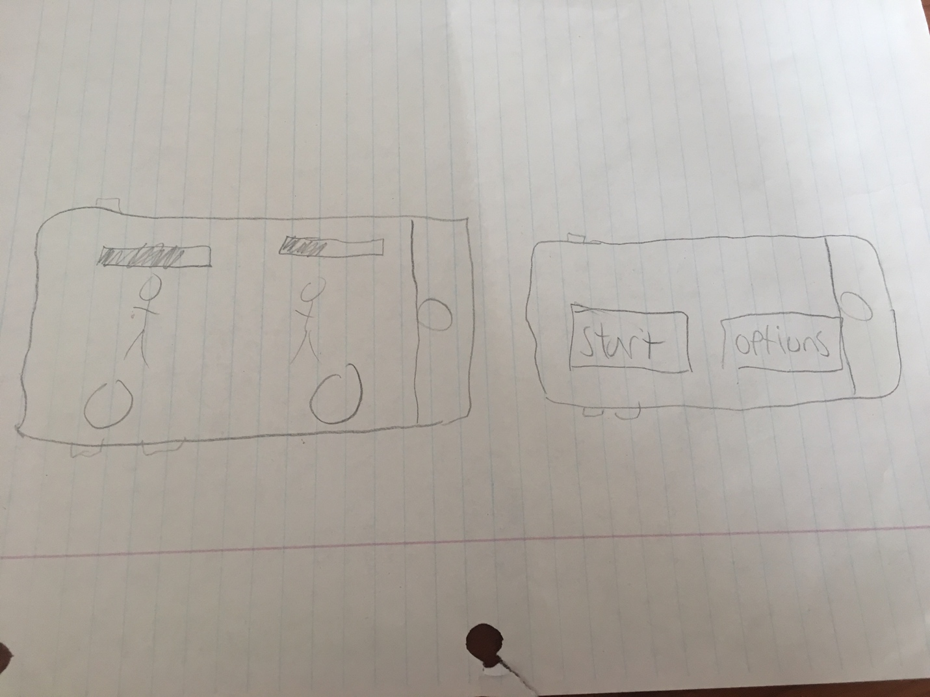

**Basic Design of what the gameplay, and what the starting screen will look like**