STATE OF OREGON INTEROFFICE MEMO

Department of Transportation
Transportation Development Division
Mill Creek Office Park
555 13th Street NE Suite 2
Salem, Oregon 97301-4178
(503) 986-4104 or (503) 986-4120 Date: 3/18/19

TO: Oregon Modeling Steering Committee (OMSC) - Technical Tools Subcommittee – Southern Oregon Activity Based Model (SOABM) Peer Review Team

FROM: Alex Bettinardi, P.E., Senior Integrated Analysis Engineer
Jin Ren, P.E., Senior Travel Demand Modeler / Analyst
Transportation Planning Analysis Unit

SUBJECT: Final SOABM 2010 Documentation and Findings

Executive Summary
The project team finalize third round of the Southern Oregon Activity Based Model (SOABM) calibration after the third round SOABM peer review meeting held on August 7th, 2018. The calibration result from that third round was arguably complete, however the peer review and the project team had a series of questions and potential changes to be explored. Over the several months following August 2018, the project team found a handful of issues and worked on the SOABM implementation to better represent the comments of the third round peer review meeting. The result is the current SOABM implementation available and documented on the github code repository - https://github.com/RSGInc/SOABM,
documentation - https://github.com/RSGInc/SOABM/tree/master/documentation.

The documentation github location linked above contains the original round three final documentation, as well as the notes from the third round meeting, this memo and five html visualizations for the update SOABM 2010 calibrated model (compared to both the round three work and the target calibration data) and the three sensitivity scenarios.

Introduction
This technical memorandum documents the final revisions that were made to the Southern Oregon Activity Based Model (SOABM) 2010 calibration year to finalize the build and calibration effort in preparation for use of the SOABM. A more extensive, but incomplete, calibration document was completed in August of 2018. That document is referenced in the following background section. This memo builds off of that work and captures all the changes that were made beyond that document to finalize the SOABM calibration effort.

The purpose of this memo is to capture those final changes and the final results so that the final implemented state of the SOABM is captured to build off of for future analysis and transportation modeling. The calibration work focused on a 2010 model year out of necessity (based on the data available to calibrate to). This memo captures the 2010 calibration and steps taken to achieve the final level of calibration. The SOABM model then ultimately uses a 2017 base year and 2045 future year (along with interim years in-between). The calibration efforts completed, reviewed, and finalized in the 2010 model are then taken forward in the other SOABM years.

This memo has the following sections to cover the 2010 calibration elements and finalize the foundation that the SOABM modeling work and analysis builds on:
- Background,
- Final Revisions,
- Final Results and Findings, and
- Conclusions.

Background
The development of the SOABM model started in conception between 2010 and 2012. Starting around 2010 many questions were beginning to be elevated that ODOT’s traditional modeling tools were not fully equipped to address. Questions around;
- greenhouse gas emissions,
- a more comprehensive evaluation of project performance measures (Least Cost Planning),
- new vehicle technologies and modes to travel, and
- increasing levels of projects and analysis around transit service and active modes of transportation.

After a through internal and external discussion, ODOT-TPAU determined that the best path forward in transportation model development was using the Activity Based Model (ABM) approach to best address these new questions of increasing interest to Oregon planners and decision makers.

In 2013, ODOT-TPAU made the determination (with external consultation) that the best course of action in ABM development and deployment would be to build off a previously estimated model and then calibrated to deploy in an Oregon region. It was determined that the Coordinated Travel – Regional Activity Modeling Platform (CT-RAMP) would be used as the basis for Oregon’s ABM platform.

In 2014, ODOT-TPAU entered a phased contract approach with Parsons Brinckerhoff. The first phase ended up taking two years and successfully implemented an uncalibrated version of CT-RAMP in the Southern Oregon area (covering both the Middle Rogue and Rogue Valley MPOs, MRMPO and RVMPO). The purpose of the first phase was to determine how transferable CT-RAMP was to Oregon and to allow for better scoping of how large of a calibration effort would be needed. The first phase provided evidence that estimated behavior in CT-RAMP was largely transferable and only minor re-calibration would be needed throughout the ABM modules.

In 2017, ODOT-TPAU started the second phase of the SOABM deployment in contract with RSG. The purpose of the second phase was to complete the calibration of the 2010 model year. That final calibrated model and instruction set (user guide) can be found in the following github code repository - https://github.com/RSGInc/SOABM. The contract with RSG included an integrated peer review process, bring the reviews through the calibration throughout the full process. Knowing that these efforts are iterative; the contract laid out three discrete calibration phases, where the SOABM calibration would be further refined at each step or phase. The third phase of calibration was shared with the peer review team on August 7th, 2018. The final state of the model after that meeting was captured in the final calibration document as a formal deliverable as part of the agreement with RSG. That final calibration document is available here - https://github.com/RSGInc/SOABM/tree/master/documentation FinalDraft_SOABM_Calibration_Validation_TechMemo3.pdf

However, there were remaining issues that existed after the third calibration phase that the peer review had discussed and that ODOT desired to incorporate into the final release of SOABM. That work was completed by the SOABM project team throughout the remainder of 2018 and through February 2019. It’s also worth stating that the SOABM project team worked in finalizing the 2017 and 2045 SOABM scenario years as well, with the intent of having SOABM be ready for use shortly after the 2010 calibration work becomes finalized.

Therefore, this memo builds off of the delivered “FinalDraft_SOABM_Calibration_Validation_TechMemo3.pdf” document. This memo captures the final changes that were made beyond the documented results of the third phase of calibration. It also highlights the final results that were achieved; the end result of all the work that went into the calibration of the 2010 SOABM. Full summary results can be reviewed in the html files provided in the documentation folder of the SOABM code repository - https://github.com/RSGInc/SOABM/tree/master/documentation.

Final Revisions
Beyond the work documented in the third phase calibration document (referenced in the background section), the SOABM project team worked to address the outstanding comments from the peer review team at the August 7th, 2018 SOABM peer review meeting. The full notes from that meeting can be found in the SOABM repository - https://github.com/RSGInc/SOABM/tree/master/documentation 20180808_SOABM_Round_3_Peer_Review_Meeting_Notes.docx. However, here is a summary of some of the items discussed that the project team worked to address as the 2010 SOABM was finalized:
- Testing the model with employment shadow pricing turned off, to allow for easier use of the model with scenarios that involved testing changes in employment.
- There was discussion around representing visitors in SOABM and the challenges that existed related to representing visitors.
- There was discussion around ways to review and improve the models performance related to traffic counts.
- ODOT had a desire to remove the approach of applying ramp meters to the network to achieve better interstate assignment.
- A handful of requests for additional information and summarizes related to the sensitivity scenarios.

Along with desiring to address the Peer Reviews’ comments, the SOABM project team also identified a number of other setup and input issues over the multiple months of review that required a handful of treatments and revisions. The following is the list of all the changes that were made to the SOABM setup and repository after the third round calibration meeting to finalize the 2010 SOABM:
- Made a series of changes and additions to the html Visualizer.
- Corrected a small inaccuracy in the code that calculated intersection capacity, correcting travel time calculations and travel time skim matrices.
- Updated global capacity assumptions for through and turn lanes by functional class to better align with current understanding and expectations.
- Updated global assumptions on cycle lengths (using a flat 60 seconds).
- Prior code had assumed certain functional classes for bike and walk travel. The update allowed bike and walk travel to occur on any link the user had coded as available to bike and walk regardless of functional class.
- Updated the SWIM external model code to the latest version, which addressed a number of known errors and bugs, it also allowed for more recent SWIM data to be used, which then was used to improve the background trends that are used to distribute the external traffic. It should also be mentioned that in replacing the code an incorrect module parameter was identified, and that also was corrected.
- Removed the process and code of factoring up (changing) the external demand prior to traffic assignment. Now the external model treatment is consistent with the inputs and settings; meaning no other factoring is applied.
- Removed factoring of the Commercial Vehicle Model (CVM); meaning the CVM production was returned back to the original state.
- The UEC (Utility Expression Calculator) files were reverted back to the set of UECs with not special district level treatment for the Ashland area (increasing attraction for trips to/from Ashland).
- Revisited and updated University enrollment inputs (mostly left as-is after testing several different ways to approach enrollment; only ended up removing a few small (<50 student) trade schools).
- It was determined that the synthetic population was not generating enough college students, so a control was added to the population synthesis process that ensure that there were enough students in the model area to satisfy the known college demand.
- Added terminal time treatment at the MAZ level (2 minutes for MAZs with parking restrictions, 1 minute all other zones).
- Updated the Districting labels of a handful of MAZs based on local review.
- Updated household, group quarters and employment by MAZ based on local review.
- Transit headways were revisited by time period and corrected to bring in better alignment with 2010 transit schedules.
- The ramp metering treatment that had been applied in the late stages of the round 3 calibration work to achieve better interstate assignment was removed. Bringing the ramp representation in the model inputs back to 2010 conditions (no ramp meters).
- The network and related inputs were extensively reviewed and revised, including corrections and changes such as:
  - Reviewing and correcting improperly coded counts.
  - Revising TAZ connector placement.
  - Revising the active transportation network to better account for neighborhood connections to those paths and roads by active modes.
  - Correcting speed and lane coding along select links
- A representation of visitors was added to the synthetic population. It was noted that the project team had gone through the effort of inventorying hotels (rooms) and recreational vehicle (RV) parks (vehicle units), but that there was no functionality in the SOABM to model visitors. No data or scope existed to develop a formal visitor model, so the project team opted to test adding visitors with household locations at hotels and RV parks to allow for those zones (locations) to generate trips and to be able to do some work to model hotels and RV park expansion in future scenarios. A method to develop a visitor population was developed with the limited information available:
  - PUMS records for all areas in Oregon outside of the SOABM PUMAs were used as the seed to the visitor synthetic population.
  - Travel Oregon surveys provided some information on the approximate percentage of business versus pleasure travelers. In addition, some information on approximate average party size by traveler type was obtained from Travel Oregon information.
  - Local inventory work was used to develop the hotel rooms and RV units by MAZ, a 70% occupancy rate was assumed across all units.
  - A monte carlo draw process was used to pull weighted PUMS records from the seed to achieve the Travel Oregon average household sizes by traveler type; hotel business, hotel pleasure, recreational vehicle.
While the project team acknowledged that there are more travelers (visitors) in the region than just hotels and RV parks, this level of approach and representation helped to address two issues;
  - Adding these visitors allowed for the model to better match traffic counts, removing the need to factor up the commercial vehicle model or use other treatments, and
  - It allowed for future uses of the model to represent changes in hotel rooms or RV parks by zone; a feature that may be requested in SOABM application work.

This list of changes captures all the changes that were made between the August 7th, 2018 version of SOABM, and then final peer reviewed and calibrated 2010 model. The following section covers the results that were achieved with these changes.

Final Results and Findings
This section reviews the final calibration results for SOABM. There are hundreds of different calibration elements that are reviewed. This document does not include discussion of all of those elements. Access to all of the different comparison can be found in the several html calibration and sensitivity test html files that were created to assess the final calibration. Those htmls can be found in the code repository at: https://github.com/RSGInc/SOABM/tree/master/documentation.

This section focuses on key areas of change in the calibration comparisons from the 3rd round calibration document, sections 5.2 and 6.0, which can also be found at - https://github.com/RSGInc/SOABM/tree/master/documentation FinalDraft_SOABM_Calibration_Validation_TechMemo3.pdf

Similar to the 3rd round document, this section largely pulls from the html files linked above and is broken into review sections that follow the flow of the html files which follow the module flow of the ABM:
- Overall Results,
- Long Term Model Results,
- Tour Level Results,
- Trip Level Results,
- Assignment Validation, and
- Sensitivity Test Results.

SOABM Overview Results
Figure 1 provides an overview of how the synthetic population result compares to OHAS data and to the calibrated input from the round 3 work. In Figure 1 one can see that the largest change between the round 3 work and the final synthetic population is the increase in university students. As was described in the Final Revisions section, one of the significant issues identified in the final calibration was the university student population was significantly lower than the college enrollment totals for the region (which were approximately 20,000). While the final university student totals are significantly higher than OHAS data, the final now aligns with college enrollment totals which the project team has more trust in than OHAS. This finding helps further justify deviating from OHAS trends across other calibration measures, given that OHAS does not represent university students very well.

Figure 1. Person Type Distributions
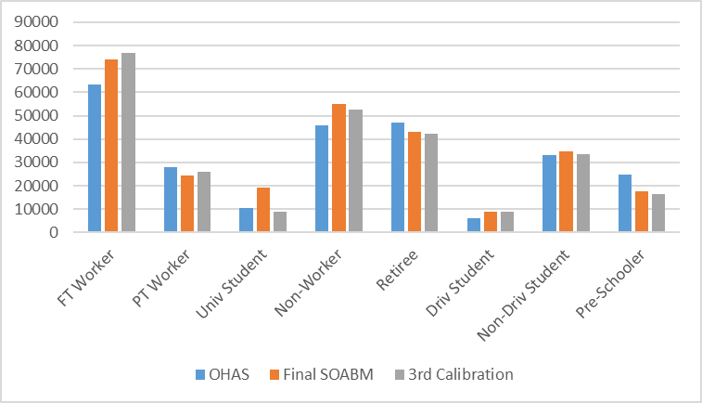

The other major finding of Figure 1 is that most populations have increased, with the exception of workers. This is because a non-working visitor population was added to the final synthetic population which is being displayed. Removing occupations was specifically completed in the visitor population, so that visitors would not be traveling to work. Therefore, increasing the student population decreased all other populations, however all non-working populations were increased due to the visitor population.

From an overview perspective, all the other global changes are essentially the same between the calibration round three work and the final state. The increase in university students and the subsequent decrease in the worker population likely results the general decrease in tours and trips per person, as seen in Figure 2. However, the addition of the visitor population increases overall region trips, tours, and stops. The increase in overall trip activity is desired as the round three calibration version had modules factors up to attempt to achieve total link count validation. Those factors have been replaced in this final version with a correction to the external model, which had a significant impact, and the addition of the visitor population.

Figure 2 Overview of Aggregate Summaries
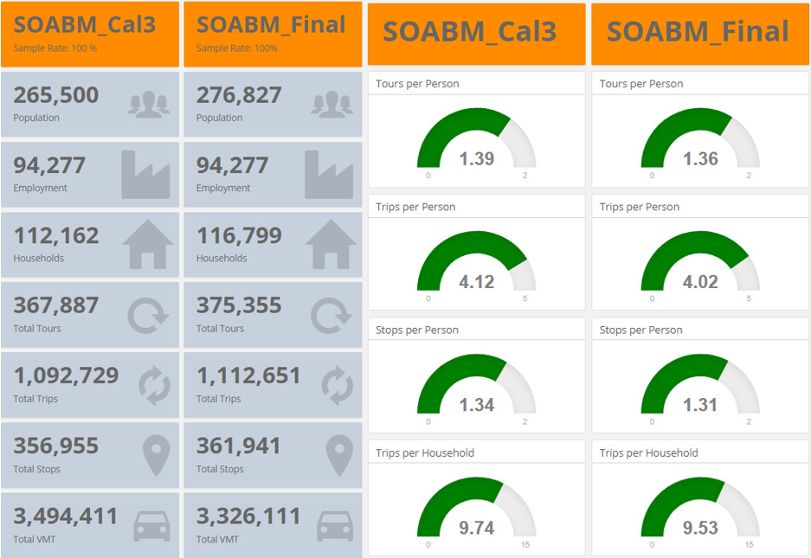

Long Term Model Results
The changes that were made since August 2018 did not significantly impact the auto ownership or working from home percentage. However it is important to note that in the final SOABM 2010 calibration the number of households with 1 vehicle did get slightly higher (from 33.7% to 36.1%) and households with 2 vehicles became slightly lower (from 37.0% to 34.9%). This is due to the addition of visitors with a lower number of average vehicles, as opposed to a change in the characteristics of the general population.

The percentage working at home improved very slightly from 6.8% to 7.0% which now perfectly matches the 2010 ACS comparison.

Overall the changes did impact the average trip distance by slightly decreasing the distance to work (~8.5% reduction) and slightly increasing the distance for university travel (~7.7%). Figure 3 shows those changes in trip length frequency distribution plots. A lot of changes have been made, but it’s likely that the removal of shadow pricing on employment had a specific impact on the trip lengths to work, and that the review and refinement of university enrollment numbers by MAZ impacted the trip lengths for university trips.

Figure 3. Work, University, School Trip Length Frequency Distributions
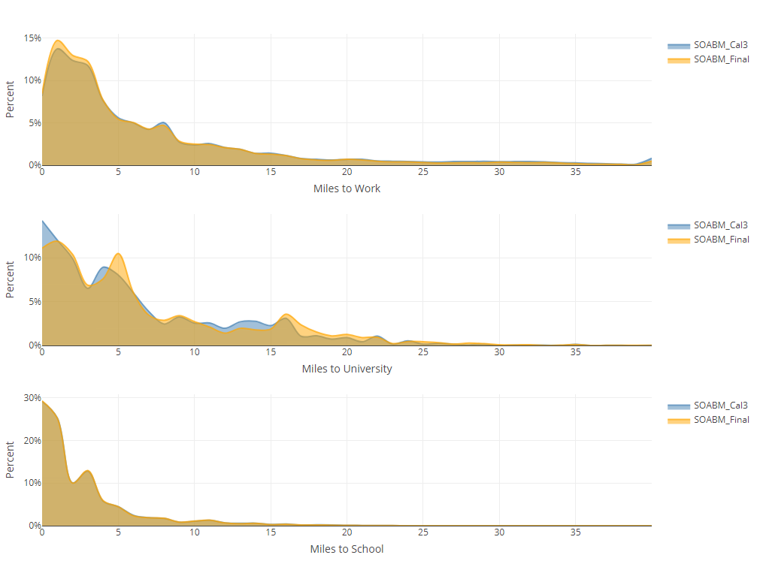
While there has been a shift in the work and university trips length distributions, it does not necessarily require additional calibration efforts. As can be viewed in Table 1, the overall average trips lengths are still within a reasonable range of the OHAS target data. The round three average work trip length was 4.5% higher than OHAS. After the revisions discussed in this document the average work trip length is now 4.5% lower than OHAS, so the results are within the same level of error that they were in August. Average university trip lengths did get worse overall, from 0.7% high in August to 8.5% too high as of this document. Being 8.5% too high might justify additional calibration work, however it’s important to remember that the university data from OHAS is very sparse. In this case the quality of the target data might allow for the 8.5% difference to be deemed acceptable.

Table 1. Average Mandatory Trip Lengths

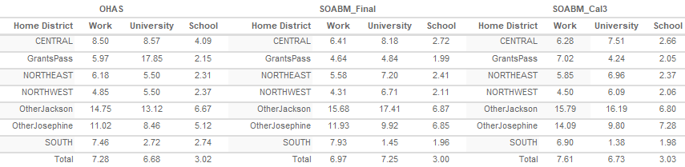

At the calibration round 3 meeting in August 2018, one of the key discussion items was on checking whether the employment shadow pricing could be turned off to speed up the model for basic runs and to simplify use the ABM for application that varried employment (if shadow pricing was used, special attention would need to be made to ABM scenarios that altered land use to ensure that the shadow pricing was properly working under those new land uses. Figure 4 helps to provide evidence that the model still matches workers to employment fairly well without utilizing shadow pricing.

Figure 4. Reference Employment Shadow Pricing Comparison
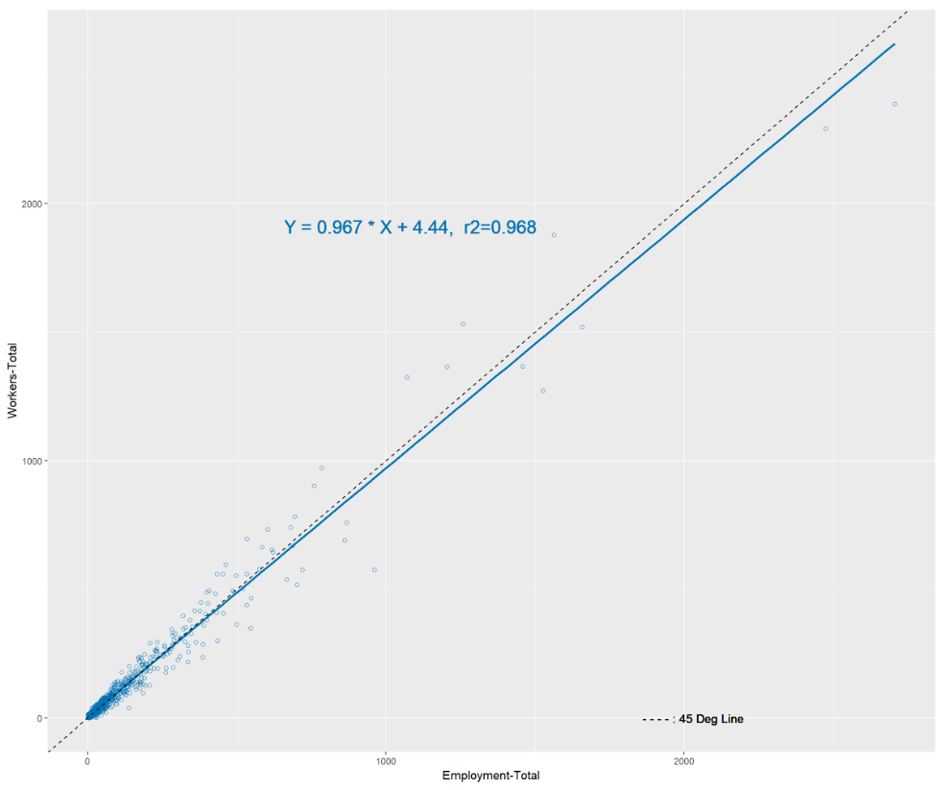

The results of the three senstivity tests that were run to more completely test the calibratoin are discussed in greater detail later in this results discussion. However, the results of the worker to employment comparison for the senstivity tests are specifically highlighted here as it helps to document whether the appraoch of removing the shadow pricing works across ABM applications.

The first comparison (Figure 5) is with the Increased Transit Serivce scenario. In that ABM scenario, neither employment placement nor workers was impacted and so the worker to employment placement is almost identical to what is seen in Figure 4.

Figure 5. Transit Increase Scenario Employment Shadow Pricing Comparison
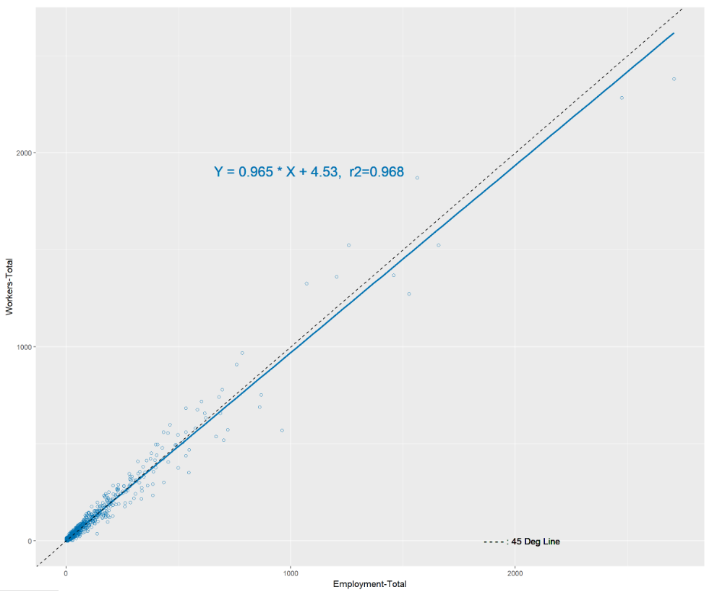

In the sensitivity scenario where a new employment center was added, 4760 new employees across 12 employment categories were coded at the MAZ level. This was the only change from the reference condition, meaning that the number of workers by occupation was not adjusted for the region. Figure 6 shows that the additional employees creates an overall trend where there are more jobs (employment) than workers creating an overall slope of 0.921 (where the reference was closer to 1.0 at 0.967). The r-squared value between the Employment Center Scenario and the reference is still identical at 0.968, indicating that the ABM’s ability to place workers in employment zones without shadow pricing is working reasonability well, even with an increase in overall employment without increasing the workforce.

Figure 6. Employment Center Scenario Employment Shadow Pricing Comparison
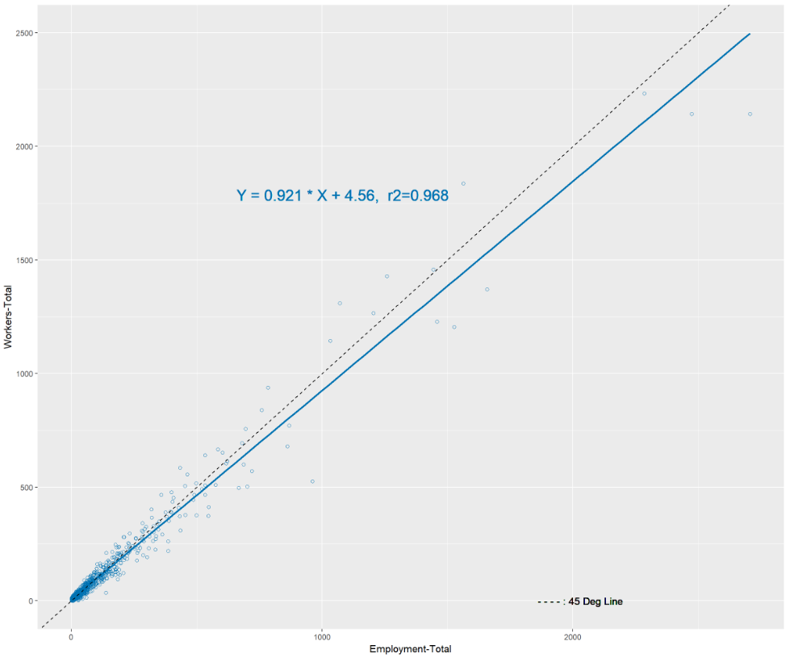

The third senstivity test was the Aged Population Scenario. In this scenario the transportaion network and the MAZ level inputs (like employement) were left unaltered. This scenario the sythetic population input to the ABM was changed, aging the demographics while keep the popualtion total the same. The purpose was to do an apples-to-apples comparison with the 2010 calibration year, but with a 2010 population that was aged to what the year 2045 is anticipted to look like from an age perspecitve for the Southern Oregon area. Aging the population while keeping the population constant results in many additioanl retirees and much fewer full-time workers. If 2010 employment (job) totals are held constant (which they were) the result is many more jobs than workers.

The result (see Figure 7) is a much lower slope (0.822) indicating that there were much fewer workers than jobs (employment). The r-squared was still bascially the same as the reference sceanrio with a value of 0.965. This indicates that even with the imbalance the ABM is still doing a reasonable job placing workers in zones by employment even with a fairly large workers to employment imbalance.

Figure 7. Aged Population Scenario Employment Shadow Pricing Comparison
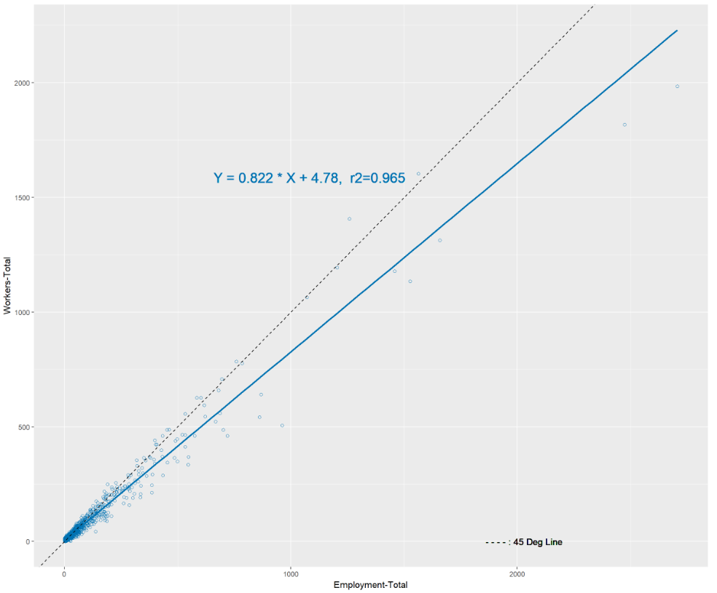

The overall finding from removing the shadow pricing is that the ABM appears to be able to successfully place workers in reasonable employment zones (MAZs) without using shadow pricing. Turning shadow pricing off is desirable as it reduces run times and having shadow pricing off simplifies the instructions for running new ABM scenarios. The ABM appears to be able to do a reasonable job even with fairly large employment to worker imbalances. Therefore, the result is that shadow pricing can be left turned off for the use of SOABM, however, best practice should be to review the balance of workers to employment and work to keep these values reasonably close to equal to one-another across scenarios. Meaning that if there is going to be a scenario with significantly more employment, considerations should be made on increasing the number of workers. Similarly, if employment or workers are decreasing in a given scenario; the both should be decreased.

Additionally, the “Employment vs Workers” comparison in the html dashboard visualizer (used in this report) should always be reviewed for ABM scenarios, and specifically scenarios were the total employment or workers (synthetic population) has been altered.

Tour Level Results
Tour level results between the third round of calibration and this document were highly similar. One area of more significant difference was on the worker and university average tour rates by person type, see Figure 8. Figure 8 helps to show that an increase on full-time workers with zero non-mandatory tours is working to pull the total tour rate down (similar for part-time workers). The university student increase in total tour rate is due to more students working and going to school. While these are changes from the original calibration work, it’s important to highlight that there is no consistent or significant deviation from the comparison to OHAS data across these trends so there is no reason to attempt to correct for the changes.

Figure 8. Tour Rates by Each Person Type and Number of Non-Mandatory Tours for Full-Time Workers
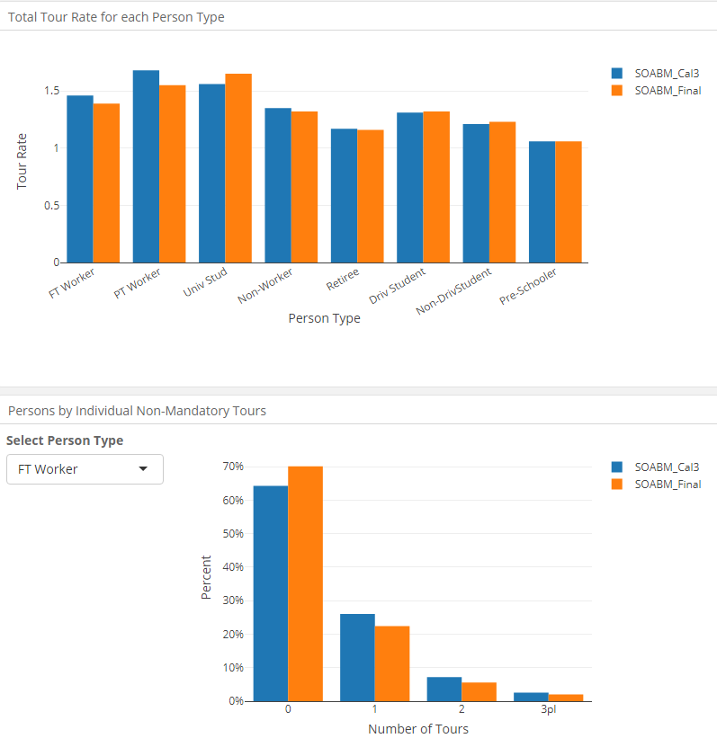
One area of clear improvement over the round three calibration work is on non-mandatory tour length compairson to the OHAS target data. Figure 9 shows that overall this latest round of documentation matched much closer with OHAS data than the previous round three calibration work. Specifically for the individual and joint discretionary tour types. While the chages that were made weren’t specifically targeting this improvement, it is encouraging to see this improvement in performance.

Figure 9. Average Non-Mandatory Tour Lengths (Miles)
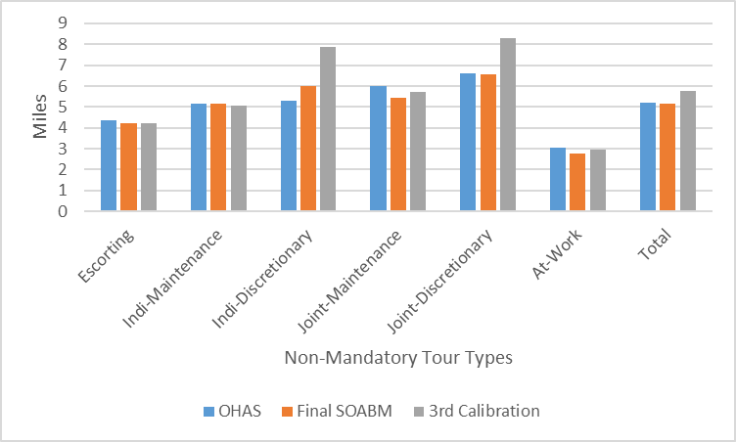

Tour time-of-day saw no signficant change, but there was a noticable change in tour mode. The change was to an increase in walk tours, which can be seen in Figure 10. It’s assumed that this change is primarly due to the extra university students.

Figure 10. Tour Mode Choice Summary
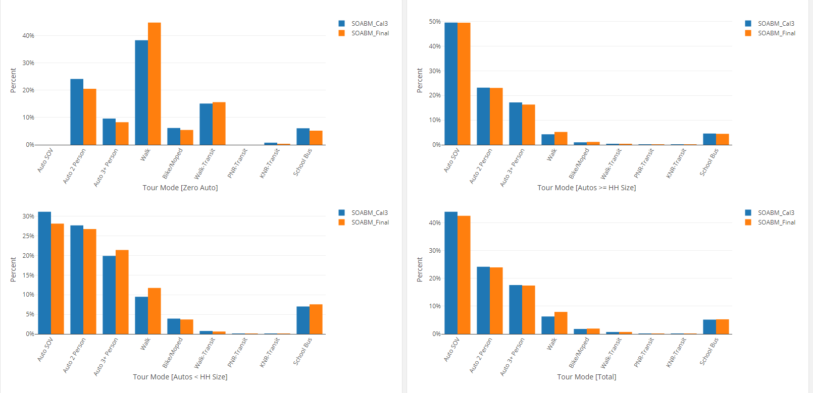

Trip Level Results
Similar to the improvement in non-mandatory tour lengths, average out of direction distances by non-mandatory tour purposes improved in this latest round of calibration. Figure 11 shows an overall improvement in out of direction distance across purposes.

Figure 11. Average Out of Direction Distance (Miles)
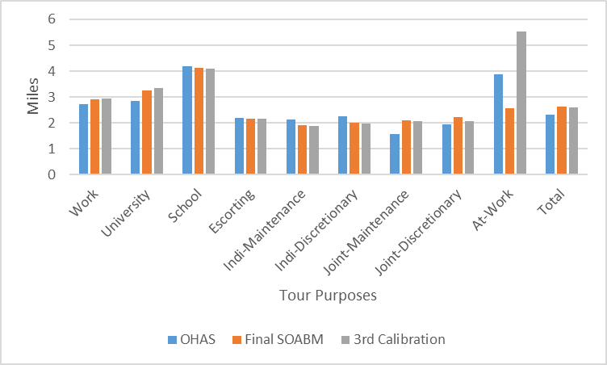

While the trip level results show no noteworthy change in stop frequency or time-of-day trends, there is a specific improvement in the trip mode split. Figure 12 shows the latest round of calibration matching the overall walk share found in OHAS (likely because of the increase in univiersity students) and an improvement in the Auto SOV mode percentage.

Figure 12. Total Trip Mode Percentages
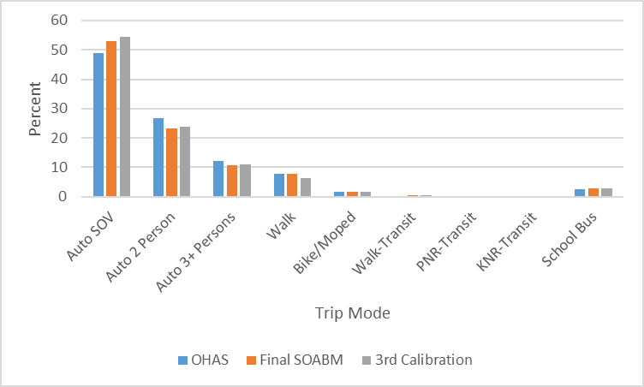

Assignment Validation
When comparing the assignment validation of the current work versus the round three calibration work, it’s critical to highlight a fundamental change between the two reports. After the August peer review it was learned that the R-square values reported by the html visualizer did not match the R-squared values returned from excel calculations, Visum, or similar software that could report an R-squared value from a set of scatter plot data. In tracing the difference it was learned that the html visualizer assumed a zero intercept in the scattered data, and that R (the programming language used to develop the html visuals) had a different methodology in determining the R-squared value give the zero intercept assumption. After review and internal discussion, the decision was made to change the zero intercept assumption, which allowed for the reported R-square values to produce identical results to those obtained from excel, Visum, and similar.

This change is covered in the blanket statement, “Made a series of changes and additions to the html Visualizer”, in the Final Revisions section of this memo. It’s important to understand this, as the value produced in the previous work looked significantly better than the R-squared methodology (calculations) where a zero-intercept assumption is not made. Therefore, the round three calibration report appears to have a much better comparison to counts based on the slope and R-Squared value, when in reality the later work compares to counts much better. Figure 13 shows at a high (daily) level how the SOABM compares to counts overall.

Figure 13. Daily Volume versus Count Comparison
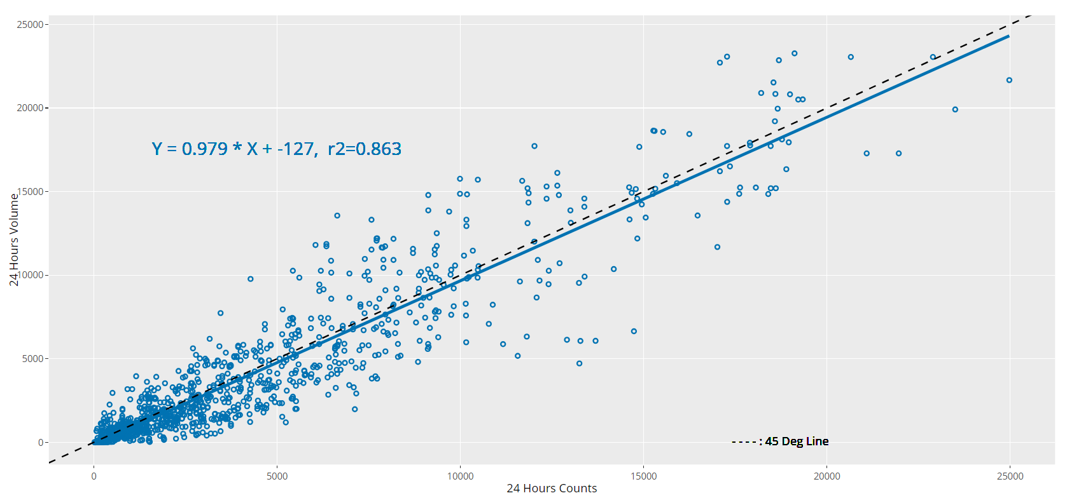

Table 2 seeks to duplicate the information provided in table 24 in the round 3 calibration document. Overall the slopes and the R-squared values look worse, but this is a factor of additional calibration factors and adjustments being made that were removed in this iteration, and the artifically high R-squared values from the original work due to the different R-squared methodlogy used previously.

Table 2. Volume versus Count Analysis by Time-of-Day
Facility Type | AM |  | MD |  | PM |  | Daily
 | Slope | R-2 | Slope | R-2 | Slope | R-2 | Slope | R-2
Interstate | 0.784 | 0.626 | 0.822 | 0.766 | 0.847 | 0.684 | 0.848 | 0.804
Principal Arterial | 1.120 | 0.756 | 1.020 | 0.807 | 0.997 | 0.760 | 1.010 | 0.825
Minor Arterial | 0.817 | 0.669 | 0.863 | 0.734 | 0.807 | 0.691 | 0.789 | 0.714
Major Collector | 0.087 | 0.566 | 0.759 | 0.528 | 0.729 | 0.554 | 0.753 | 0.572
Minor Collector | 0.542 | 0.013 | 1.420 | 0.015 | 0.144 | 0.002 | 0.817 | 0.046
Local Road | 0.348 | 0.093 | 0.531 | 0.203 | 0.472 | 0.167 | 0.466 | 0.189
Ramp | 0.944 | 0.662 | 0.998 | 0.700 | 0.983 | 0.659 | 0.961 | 0.668
Total | 1.060 | 0.797 | 1.000 | 0.857 | 0.983 | 0.824 | 0.979 | 0.863

The “Gap Statistics” report from the original work is a true apples-to-apples comparison between the round three and the current calibration work. Table 3 below can be directly compared to Figure 92 from the round three calibration report. A side-by-side comparison is difficult with so many numbers but the main take-away is that they are largely the same. There was no significant improvement or loss in model volume representation due to the changes. While ideally the recent work would have improved these gap statistics, there is a positive outcome here in that many special factoring techniques that were applied under round three (like ramp metering treatment to improve interstate and ramp assignment) have been removed. This produces the end result of an ABM that is much easier to use in model applications due to the more simplistic approach in the calibration; and a calibration process that is easier to justify, as no custom treatments were applied to achieve improved assignment results.

Table 3. Daily Gap Statistics
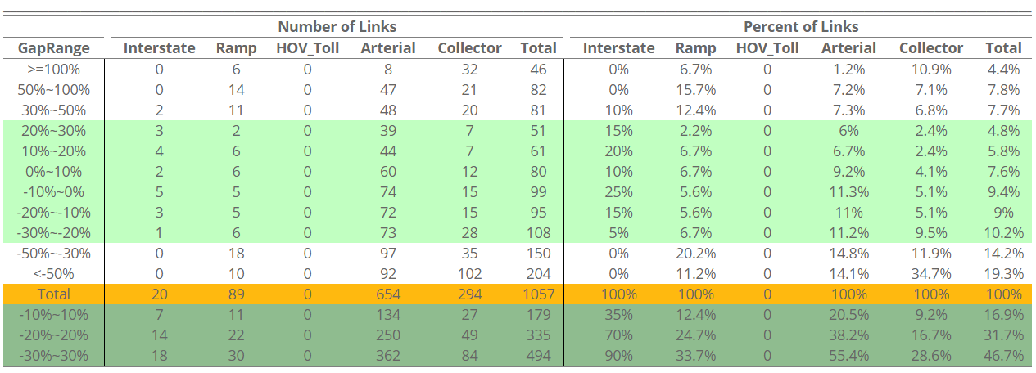

It is important to note in this assignment discussion that while the project team seaks to finalize this calibration with this document covering the end state of that calibration. There is still desire from the project team to further improve the overall assignment results and some assignment results on specific cooridors of interest. The intent is to continue to review the network and look for coding errors or count inconsistencies that may be causing worse than expected assignment results. It is the project teams intent to finalize this current iteration of the calibration and to follow-up with any changes that might end up being applied to improve assignment that are outside of the approchase discussed in this memo.

Sensitivity Test Results
[Working on text]

Conclusion
The project team finalize third round of the SOABM calibration after the third round SOABM peer review meeting held on August 7th, 2018. The calibration result from that third round was arguably complete, however the peer review and the project team had a series of questions and potential changes to be explored. Over the several months following August 2018, the project team found a handful of issues and worked on the SOABM implementation to better represent the comments of the third round peer review meeting. The result is the current SOABM implementation available and documented on the github code repository - https://github.com/RSGInc/SOABM, documentation - https://github.com/RSGInc/SOABM/tree/master/documentation.

The documentation github location linked above contains the original round three final documentation, as well as the notes from the third round meeting, this memo and five html visualizations for the update SOABM 2010 calibrated model (compared to both the round three work and the target calibration data) and the three sensitivity scenarios.

For any questions on this work beyond what is covered on the documentation github page or in this memo, please contact:
- Alex Bettinardi, P.E. ODOT-TPAU, on questions related to the overall ABM program implementation and development, or
- Jin Ren, P.E. ODOT-TPAU, on questions specific to Southern Oregon use and design.

