Checking Traffic Count Consistency – Count Checker Tool

March 2018

**

**Table of Contents**

1.0 Open the Tool 2

2.0 Run the Tool 4

3.0 Inputs 6

4.0 Outputs 8

**List of Figures**

Figure 1. Add GIS Developer’s Kit 2

Figure 2. Compile Icon 2

Figure 3. Test Icon 2

Figure 4. Run the Tool 3

Figure 5. TransCAD with Tool GUI 3

Figure 6. Count Checker Tool GUI 4

Figure 7. Count Coverage Report Format 8

Figure 8. Link Capacity Based Checks Output Format 9

Figure 9. Intersection Flow Conservation Output Format 9

Figure 10. Intersection Turning Movements Output Format 10

Figure 11. Intersection AADT Calculations Output Format 10

Figure 12. Intersection Missing Counts Output Format 11

Figure 13. TMIP Count Checker GUI – View and Display Results 12

# Open the Tool

The count checker is a TransCAD[1] based tool. The tool was originally developed for TransCAD 6 in Caliper’s GISDK programming language. The tool has since been applied in TransCAD 7.

The tool can be accessed here

This document provides instructions and screenshots for running the tool in TranCAD 6. To open the tool and launch its graphic user interface (GUI), users should:

1. *Open TransCAD*
2. *Add the GIS Developer’s Kit tool*

In the menu bar, click on “GIS developer’s Kit” under “Tools,”

Figure . Add GIS Developer’s Kit

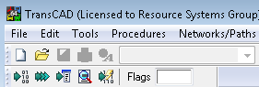

1. *Compile the Count Checker script*

Click “compile” (first icon) in the “GIS Developer’s Kit” toolbar. This will open a window asking for a resource file. Navigate to the directory of the count checker tool GISDK script (* .rsc) and select the script.

Figure . Compile Icon



1. *Run the Count Checker script*

After the script is verified by TransCAD, click on “Test” (second icon) in GIS Developer’s Kit. This will open a window asking for an add-in name. Select “Macro” as type of add-in and enter “run” as name.

Figure . Test Icon



Figure . Run the Tool

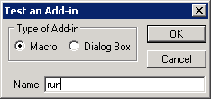

1. *Confirm the Count Checker GUI appeared*

After hitting “OK”, the tool GUI will appear on the TransCAD background.

Figure . TransCAD with Tool GUI

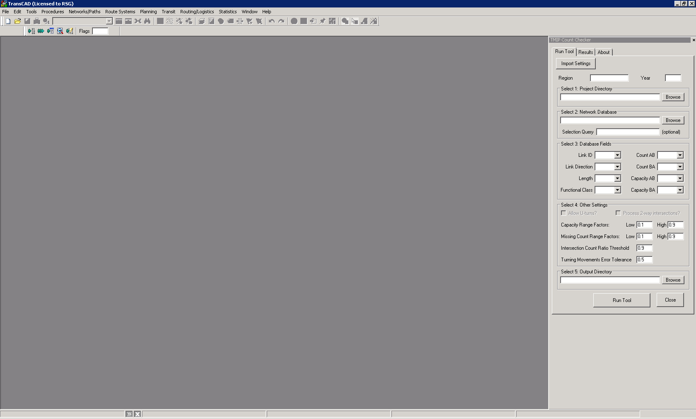

# Run the Tool

To specify inputs, users can either choose a progenerated inputs text file (using “Import Settings”) or enter the inputs manually. The tool is then run using “Run Tool.”

Under the tab “Results,” user can either view reports or display them on a map. The tab “About” contains information about the authors of the tool. The tool can also be run for a selected part of the network by providing a selection query. If a query is not provided, the tool performs checks for all links (linked>0) in the network database.

Figure . Count Checker Tool GUI

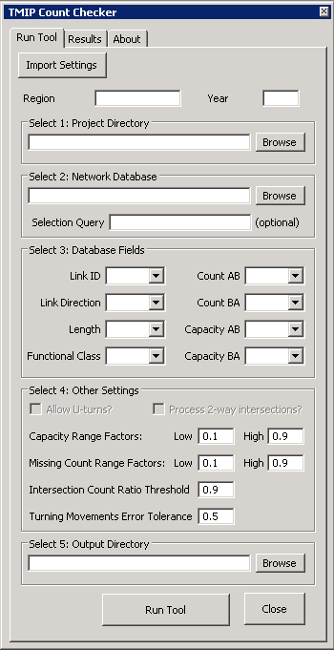

The required inputs are described in Table 1.

Table 1. Tool GUI Inputs

|  |  |  |
| --- | --- | --- |
| **Input** | **Description** | **Example Inputs (TNDOT)** |
| Region | Analysis region name | Tennessee |
| Year | Analysis year. | 2010 |
| Select 1: Project Directory | Project directory where all inputs and outputs are stored | E:\Projects\Clients\TMIP_IP_2C-010 |
| Select 2: Network Database | Network database file path | E:\Projects\Clients\TMIP_IP_2C-010\_Data\LoadedNet\Network_Base.dbd |
| Selection Query (optional) | A query to select an analysis region in the network | STATE="TN" |
| Select 3: Database Fields | Select following fields in network database |  |
| Link ID | Field for link id | ID |
| Link Direction | Field for link direction | Dir |
| Functional Class | Field for functional classification | FUNCCLASS |
| Length | Field for link length | Length |
| Count AB | Field for count in AB direction | AB_AADT |
| Count BA | Field for count in BA direction | BA_AADT |
| Capacity AB | Field for capacity in AB direction | AB_DLYCAP |
| Capacity BA | Field for capacity in BA direction | BA_DLYCAP |
| Select 4: Other Settings | Select other settings |  |
| Allow U-turns?  (disabled) | Allow u-turns at an intersection? (set to NO, for now user cannot change this) | No |
| Process 2-way Intersections?  (disabled) | Process 2-way intersections too? (set to No, for now user cannot change this) | No |
| Capacity Range Factors | Factors used to calculate a range of capacity to compare with count | Low: 0.1, High:0.9 |
| Missing Count Range Factors | Factors used to calculate a range of AADT count on an approach | Low: 0.1, High:0.9 |
| Intersection Count Ratio Threshold | Threshold on the ratio of an inbound flow and total outbound from other legs | 0.9 |
| Turning Movements Error Tolerance | Acceptable gap in turning movements calculations | 0.5 |
| Select 5: Output Directory | Directory path to store outputs | E:\Projects\Clients\TMIP_IP_2C-010\_Testing\outputs |

The tool writes out user entered settings into a text file (“inputs_[region][year].txt”) to use in subsequent runs. The text file is “=” delimited and can be edited using a text file editor. This file can be imported to populate inputs in the tool.

# Outputs

The tool produces CSV files to report the results of count checks and calculations. Table 2 lists the reports generated by the tool. The reports are discussed in the model documentation.

Table 2. Tool Output Files

|  |  |
| --- | --- |
| **Component** | **Output** |
| List of reports | ReportSmmary.txt |
| Count coverage | CountCoverage.txt |
| Link capacity based checks | LinkCapacityBasedChecks.csv |
| Count propagation | LinksWithPropagatedCounts.csv |
| Intersection flow conservation checks | IntersectionFlowConsCheck.csv |
| Intersection turn movements calculations | IntersectionTurnMovements.csv |
| Intersection AADT calculations | IntersectionCalculatedCount.csv |
| Intersections with missing counts | IntersectionMissingCount.csv |

Example reports are shown in Figure 7 through Figure 12.

Figure . Count Coverage Report Form

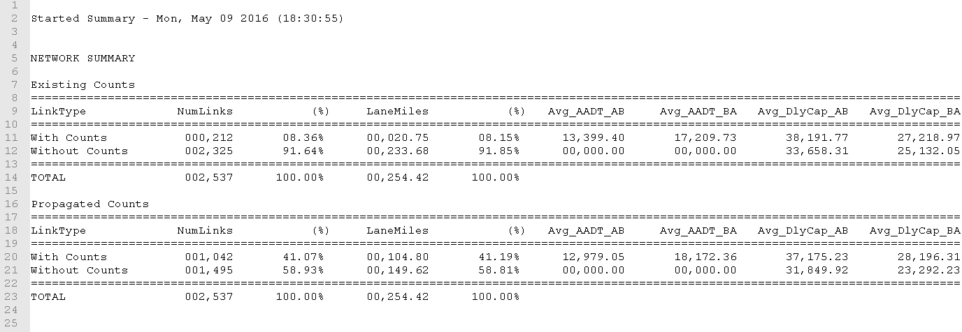

Figure . Link Capacity Based Checks Output Format

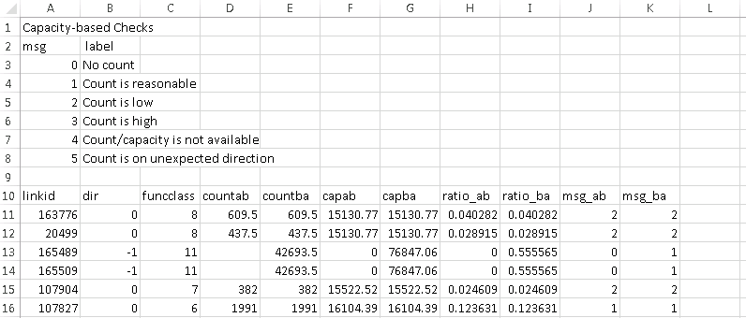

Figure . Intersection Flow Conservation Output Format

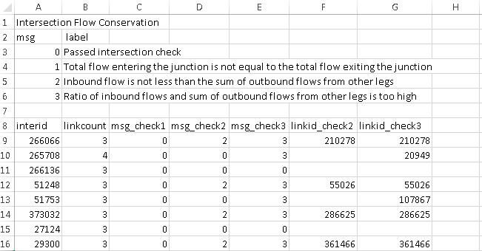

Figure . Intersection Turning Movements Output Format

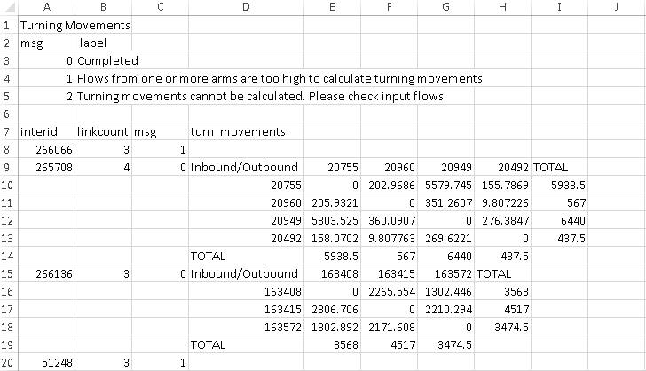

Figure . Intersection AADT Calculations Output Format

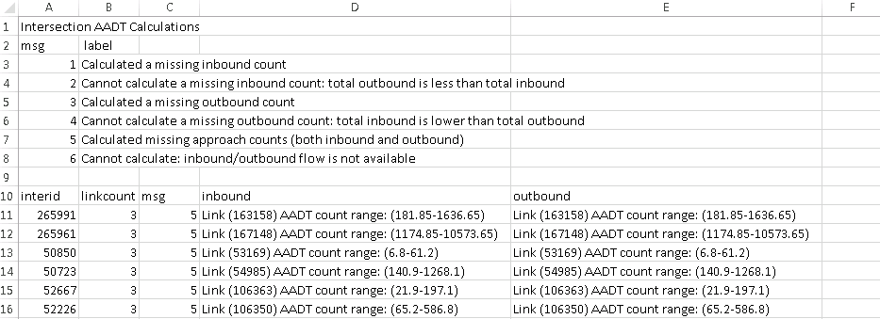

Figure . Intersection Missing Counts Output Format

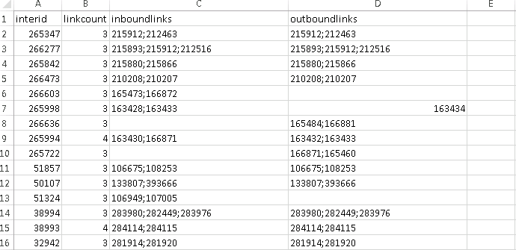

The outputs generated by the tool can be viewed and displayed on map from within the tool using the options under “Results” tab. The command button “View Report” opens the selected report with an appropriate program. The command button “Display” creates a theme map in TransCAD.

Figure . TMIP Count Checker GUI – View and Display Results

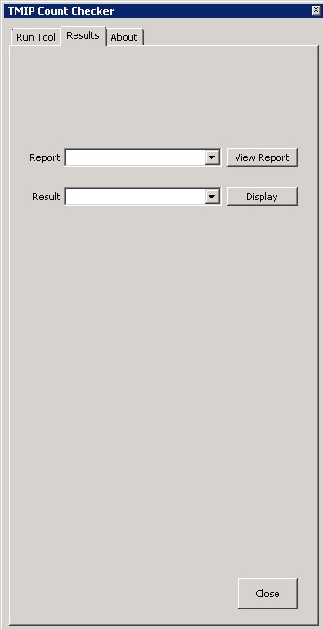

|  |
| --- |
| **NOTICE** |
| This document is disseminated under the sponsorship of the U.S. Department of Transportation in the interest of information exchange. The United State Government assumes no liability for its contents or use thereof.  The United States Government does not endorse manufacturers or products. Trade names appear in the document only because they are essential to the content of the report.  The opinions expressed in this report belong to the authors and do not constitute an endorsement or recommendation by FHWA.  This report is being distributed through the Travel Model Improvement Program (TMIP). |

1. TransCAD is Caliper Corporation’s proprietary transportation planning software. A TransCAD license is required to run the tool.