01.

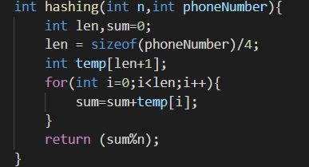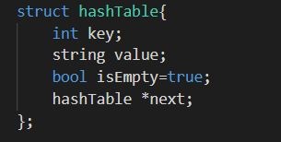Here we have implemented hash table to create "Phone book" program that takes user Name of the Phone Number and the Number as inputs. And this take number inputs that you are entering and searching. Here Phone Number is considered as the Key and corresponding user name is the Value. Here we test sot is empty or not. And first have to enter the number of entries.

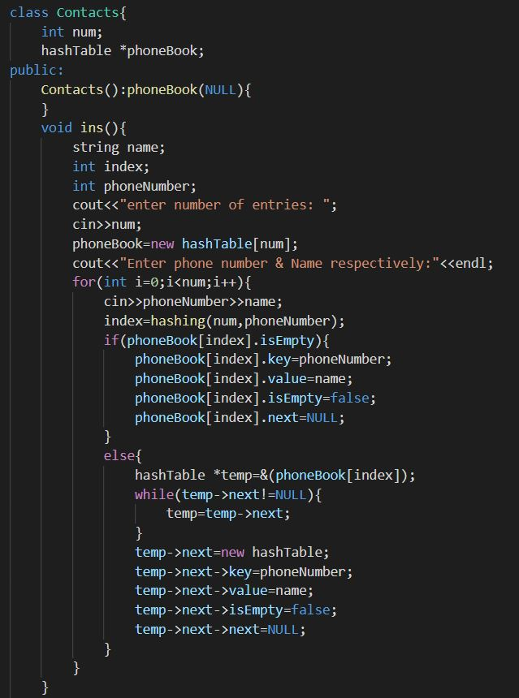Given below is the inserting function and here check whether having any collision or not. Here enterd Number assign as the Key and user’s name assign as Value of the corresponding key. If there is free slot then **phoneBook[index].key=phoneNumber;** and **phoneBook[index].Value=name;** enterd data assign like this to the phoneBook hashtable.

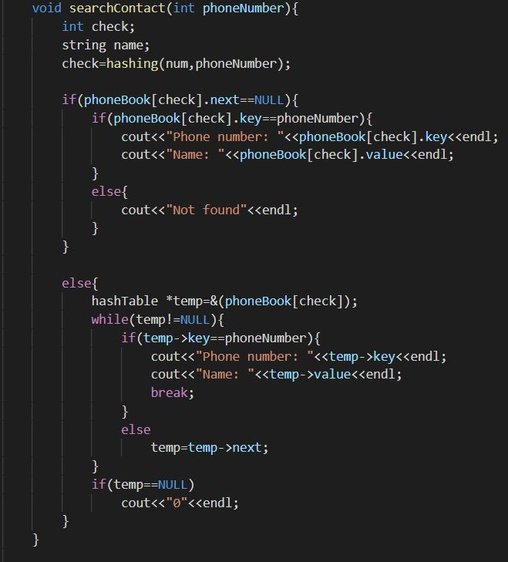Here is the Searching function. Entering key value can srach the number and relevant name of the user. It search using **phoneBook[check].key==phoneNumber** if it is equal then give the key and the value.if not print the **“0".**

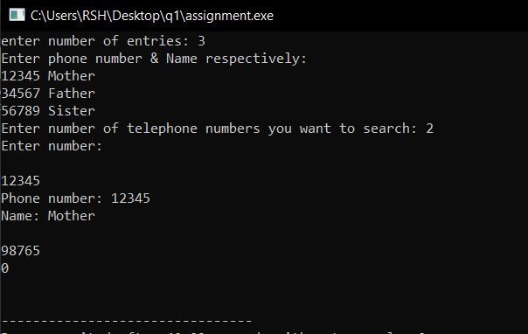**Test cases:**