01.

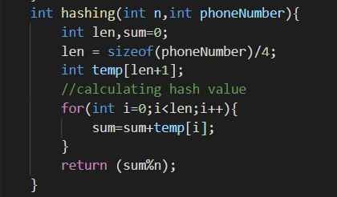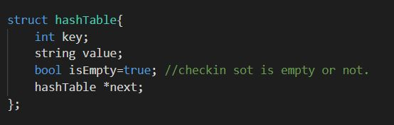Here we have implemented hash table to create "Phone book" program that takes user Name of the Phone Number and the Number as inputs. And this take number inputs that you are entering and searching. Here Phone Number is considered as the Key and corresponding user name is the Value. Here we test sot is empty or not.

* Given below is the inserting function and here check whether having any collision or not.

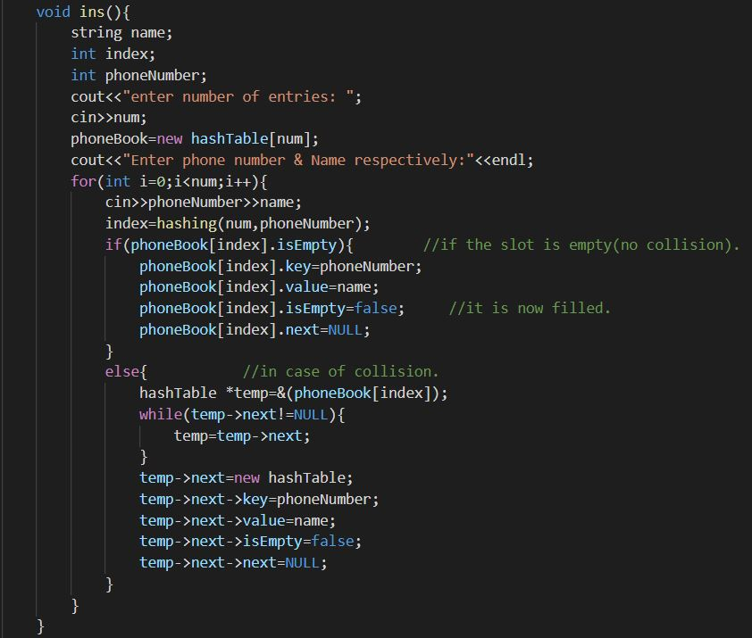

* 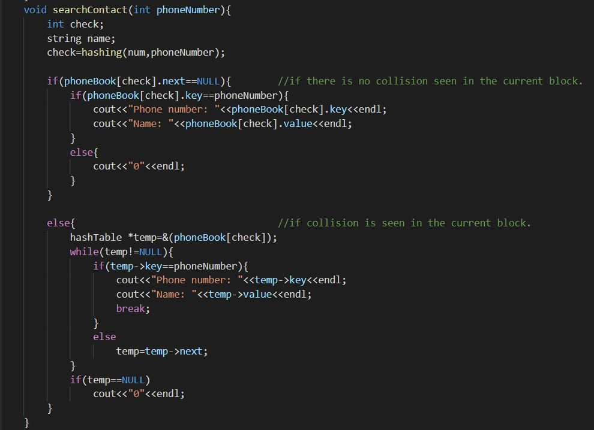Here is the Searching function. Entering Number can search the hashtable because it is the Key. If number Exit then it give the Name, if not 0 will returned.

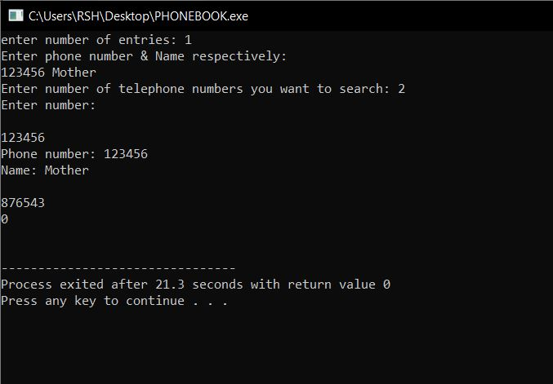Test Cases: