

Product Documentation and Setup

Frontend (Angular)

Ramzan Kadar

+91 7028375058

Table of Contents

* Project Overview
* Description
* Features
* Technologies
* Installation Guide
* Prerequisites
* Repository
* Project Structure
* Setup and Configuration
* Environment Setup
* Production Setup
* Code Architecture
* Modular Structure
* Components and Templates
* Services and Dependency Injection
* Routing
* Reusable Components and Shared Module
* Testing

3

3

3

3

3

3

3

3

5

5

5

6

6

6

7

7

7

7

7

8

8

8

9

* Testing Frameworks
* Writing Tests
* Running Tests
* Test Coverage
* API Documentation
* Screenshots 10

JK-TECH

* Project Overview
* Description

An Angular-based frontend application to handle user interactions with the backend services (mock server) and document management.

* Features

The application includes key features as follows

* Login
* Sign Up
* Logout
* User Management
* Document Management
* Profile
* Technologies

The application is developed on Angular CLI version 17.0.4 along with additional libraries such as RxJS, Bootstrap, Chart.js, and prime ng

* Installation Guide
* Prerequisites

To run the application, ensure the Node.js and Angular CLI are installed prior.

* Repository

The project can be downloaded from the link

* Project Structure

The Angular project follows a modular structure that supports scalability and maintainability. Below is an overview of the folder structure:

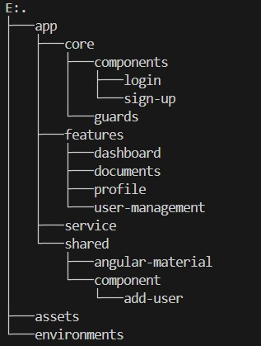

Figure: Tree Structure

# Setup and Configuration

This section explains the setup process for local and production environments, the configuration files required for Angular to run correctly, and any API/database configuration settings.

* Environment Setup
* Clone the Repository: Clone the project

from the Git repository: git clone

* Install Dependencies: Navigate to the project directory and run the following command to install the necessary dependencies:

## npm install

• Run the Development Server: To run the application locally, use the Angular CLI command:

## ng serve

By default, the application will run on [http://localhost:4200.](http://localhost:4200/)

* Local Environment Configuration: The local environment is configured using src/environments/environment.ts. This file typically contains configuration settings specific to the local setup, such as API endpoints for development.
* Code Architecture

The architecture of this Angular application follows best practices for modularity, scalability, and maintainability. The project is organized using Angular's standard module, component, service, routing concepts and reusable components, and optimization.

* Modular Structure

The application is divided into multiple modules to encapsulate features and functionality. Each feature of the app is represented by a dedicated Angular module (also known as feature module), which organizes the related components, services, and other code into

a cohesive unit. The goal is to create a maintainable and scalable project by organizing features into separate modules.

* App Module (app.module.ts): This is the root module that bootstraps the application and imports other essential modules (e.g., routing module, core module).
* Feature Modules: These represent different sections or features of the app (e.g., CoreModule). They help in lazy loading and reducing the initial bundle size.
* Shared Module: This module holds reusable components, pipes, directives, and services that can be used throughout the application.
* Components and Templates

Components are the building blocks of an Angular application. Each feature module contains one or more components, which are responsible for rendering the user interface and handling user interactions.

* Services and Dependency Injection

Angular’s services handle logic and business rules that are not directly related to UI rendering. Services are typically used for data handling, interacting with APIs, or managing application state. Angular uses dependency injection (DI) to provide instances of services to components, which makes the app more testable and modular.

* Core Services: These services manage critical application-wide functionality, like authentication, API communication, and user settings.
* Feature Services: Each feature module may have its own set of services for handling domain-specific logic.
* Routing

Angular uses the Router to navigate between different views or pages within the application. The routing configuration is typically handled by a dedicated module, often named AppRoutingModule, which defines the routes and links them to corresponding components.

* Reusable Components and Shared Module

Common components (add user form) are placed in the Shared Module to promote reusability and maintainability. This module is imported by feature modules to avoid duplicating code and ensure that all reusable components are available throughout the app.

* Testing

This section outlines the Angular application's testing strategy, the tools and libraries employed, and guidelines for writing and running tests.

* Testing Frameworks

Angular provides built-in support for unit and end-to-end testing using the following tools:

* Unit Testing:
* Jasmine: The testing framework used for writing unit tests in Angular. Jasmine provides a syntax for defining tests and assertions.
* Karma: The test runner used to execute Jasmine tests in a real browser environment.
* TestBed: Angular's testing utility that allows you to configure and initialize an Angular environment for unit testing.
* Writing Tests

Tests in Angular are typically organized into the following categories:

* Unit Tests: Unit tests verify individual components, services, and other logic in isolation. These tests are written using Jasmine and executed with Karma.
* Component Tests: Components are tested to ensure they correctly render templates, handle events, and manage input/output properties.
* Running Tests
* Run Unit Tests with Karma: The ng test command runs unit tests in the browser using Karma and Jasmine.

## ng test

This command will open a browser window and execute all unit tests defined in the project. Once the tests are complete, the results will be displayed in the terminal.

* Continuous Testing: During development, Karma watches for file changes and reruns the tests automatically. It allows developers to get instant feedback on code changes.
* Test Coverage

Testing coverage ensures that all parts of the code are being tested adequately. The following tools can be used for measuring and ensuring code coverage:

* Code Coverage with Karma: To enable code coverage reporting, run,

## ng test --code-coverage

This command will generate a code coverage report in the /coverage folder in your project. The report includes detailed information on which lines of code have been executed and which haven’t.

To install karma and jasmine and show the coverage, run,

*npm install karma karma-chrome-launcher karma-jasmin*

## npm install karma-coverage --save-dev

Once the command is successful, browse the index.html to view the code coverage which is available at the following path, project-name/coverage/index.html

Unit testing has been done and the current code coverage is shown in the picture below,

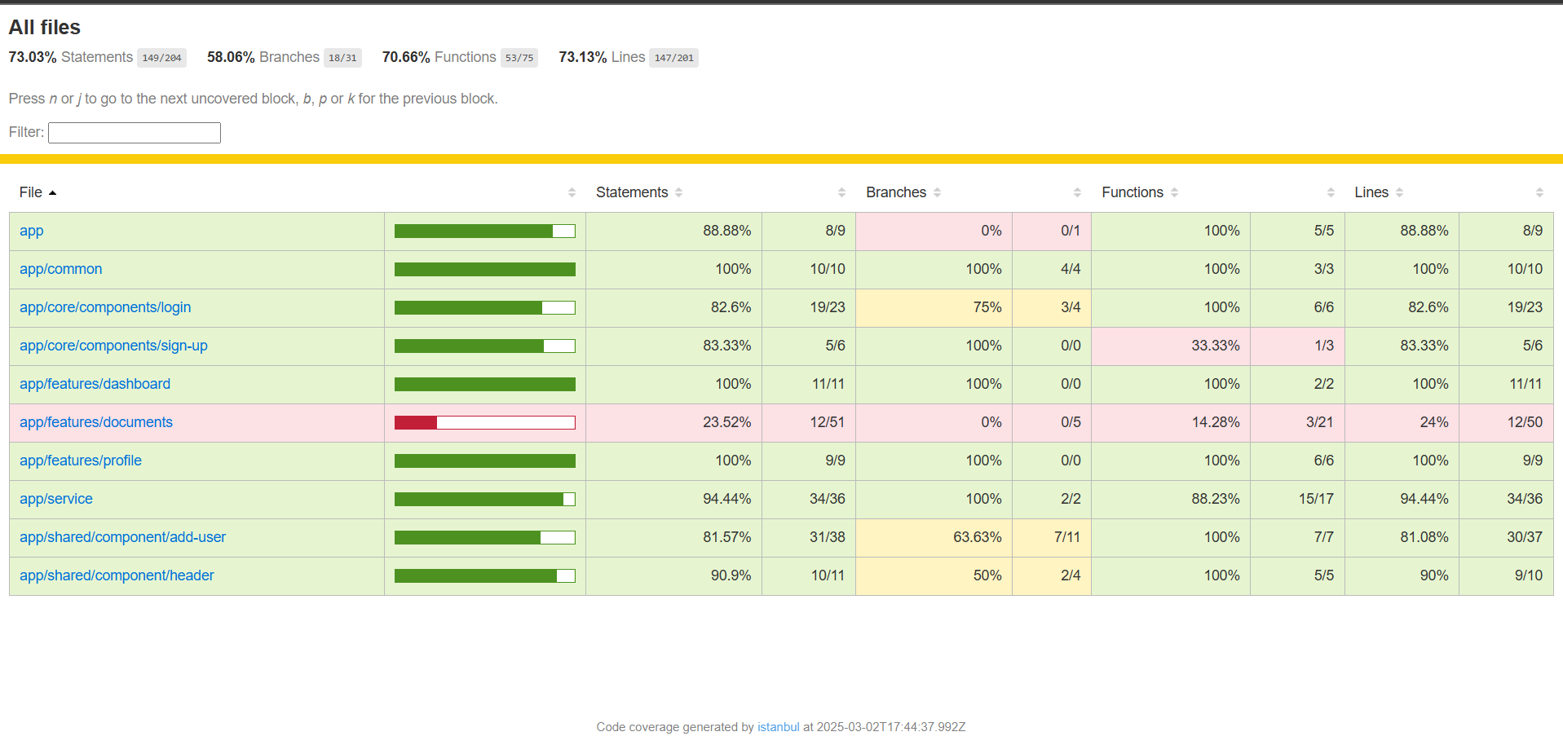

Figure: Code coverage

* API Documentation

As we are not directly dealing with the backend or REST APIs, we use JSON

Server for mocking the API methods.

To install the JSON Server use the following command, *npm run json-server*

This should enable the server to run at [http://localhost:3000](http://localhost:3000/)

* Screenshots

This section provides some of the screenshots of the application.



Figure 1: Login Screen

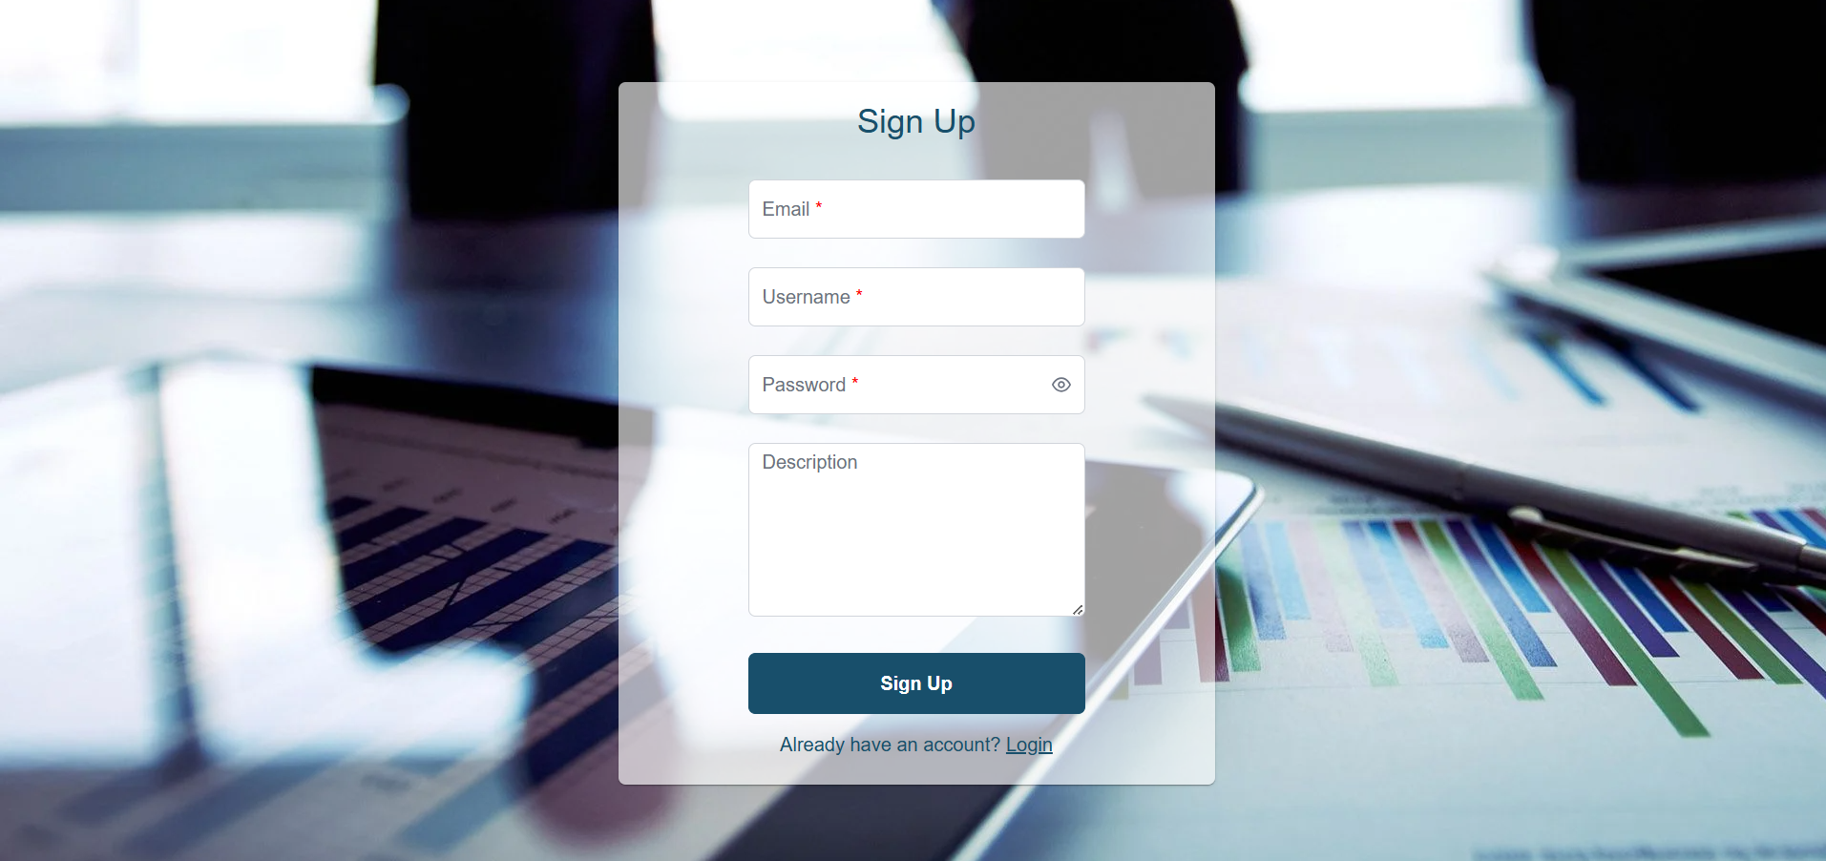

Figure 2: Sign Up Screen

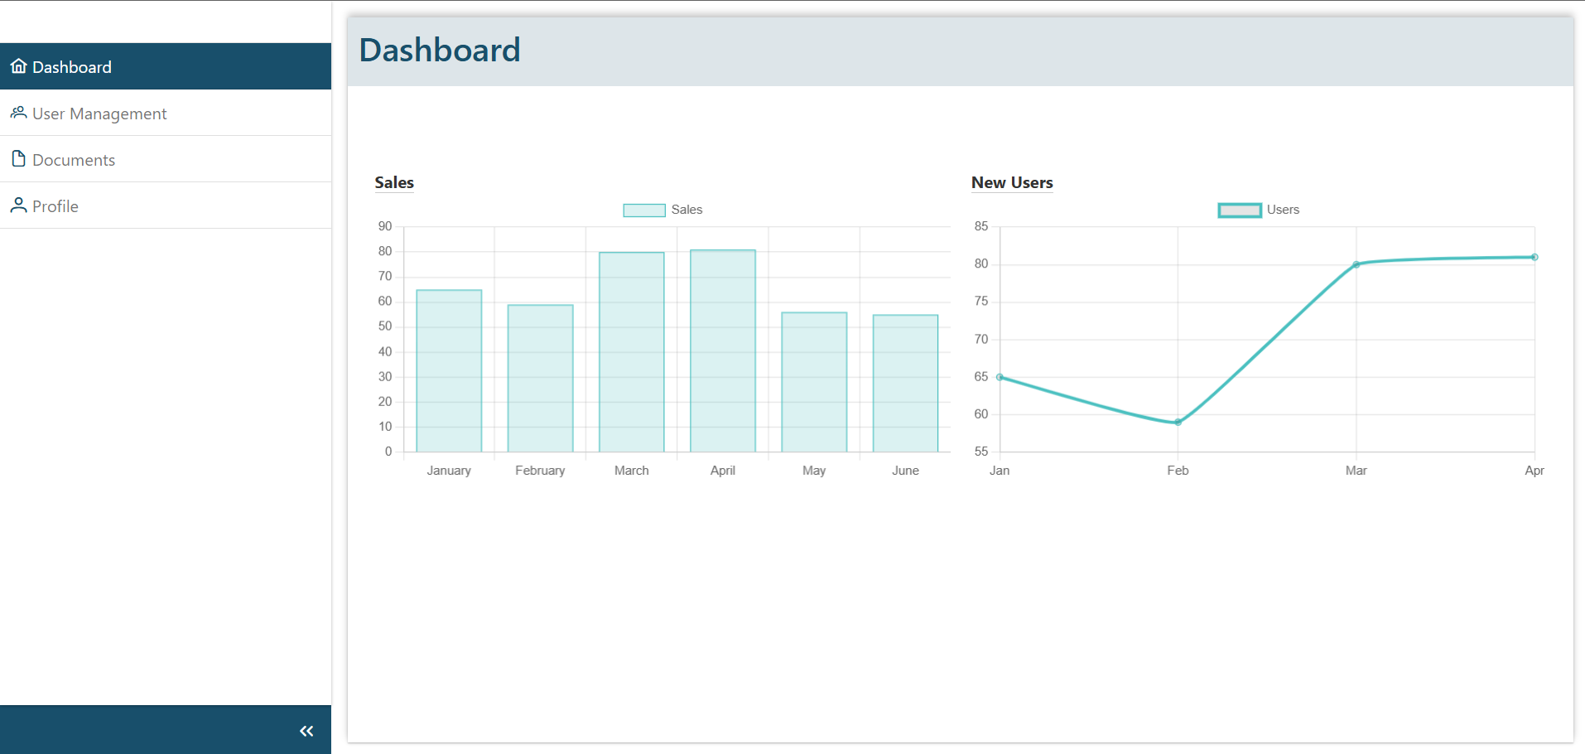

Figure 3: Dashboard Screen

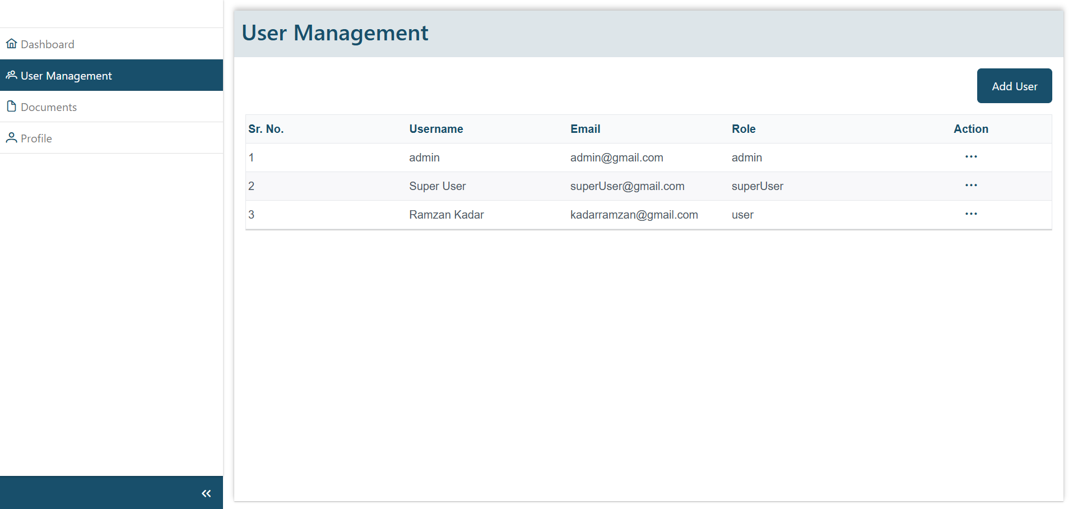

Figure 4: User Management Screen

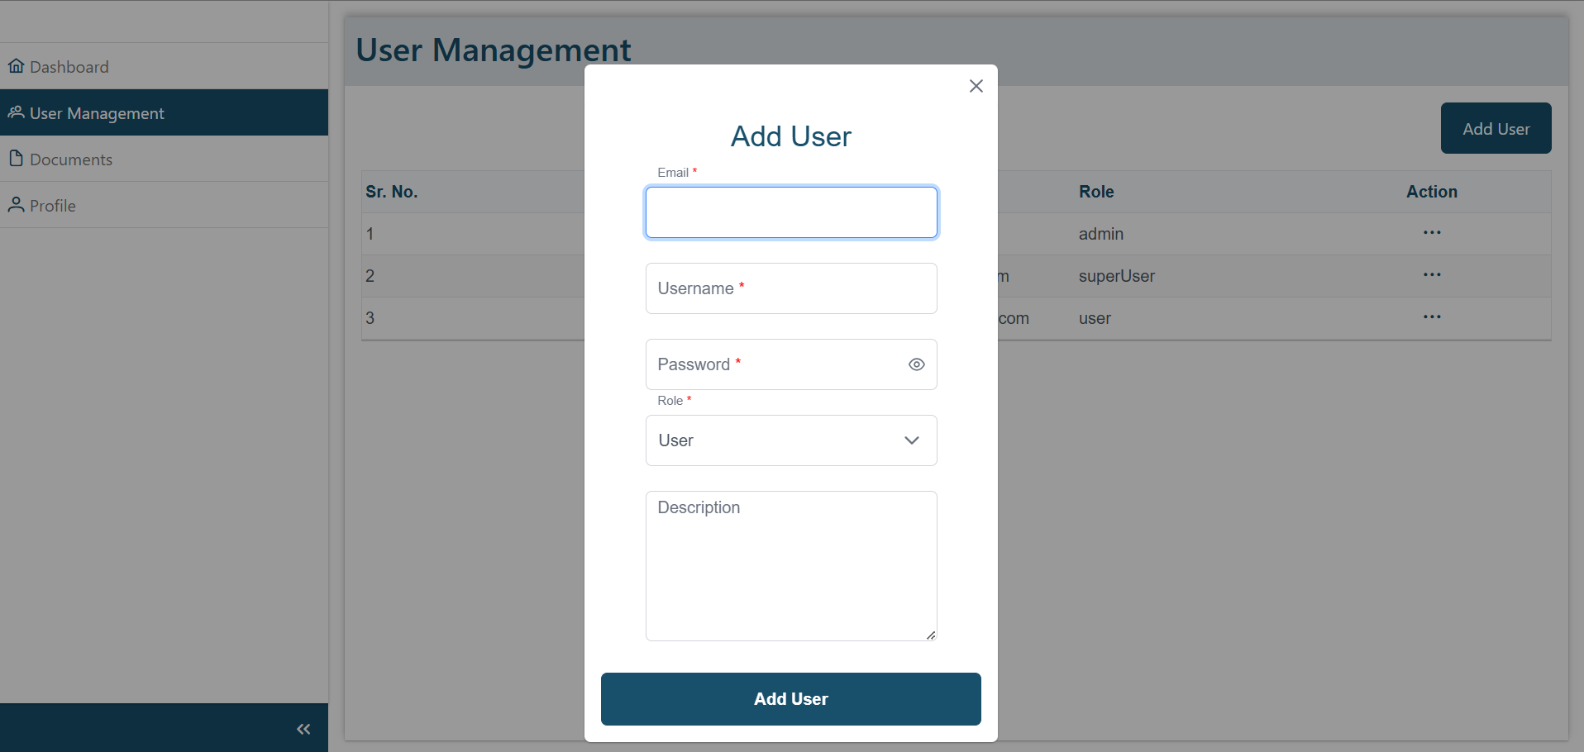

Figure 4.1: Popup to add new user

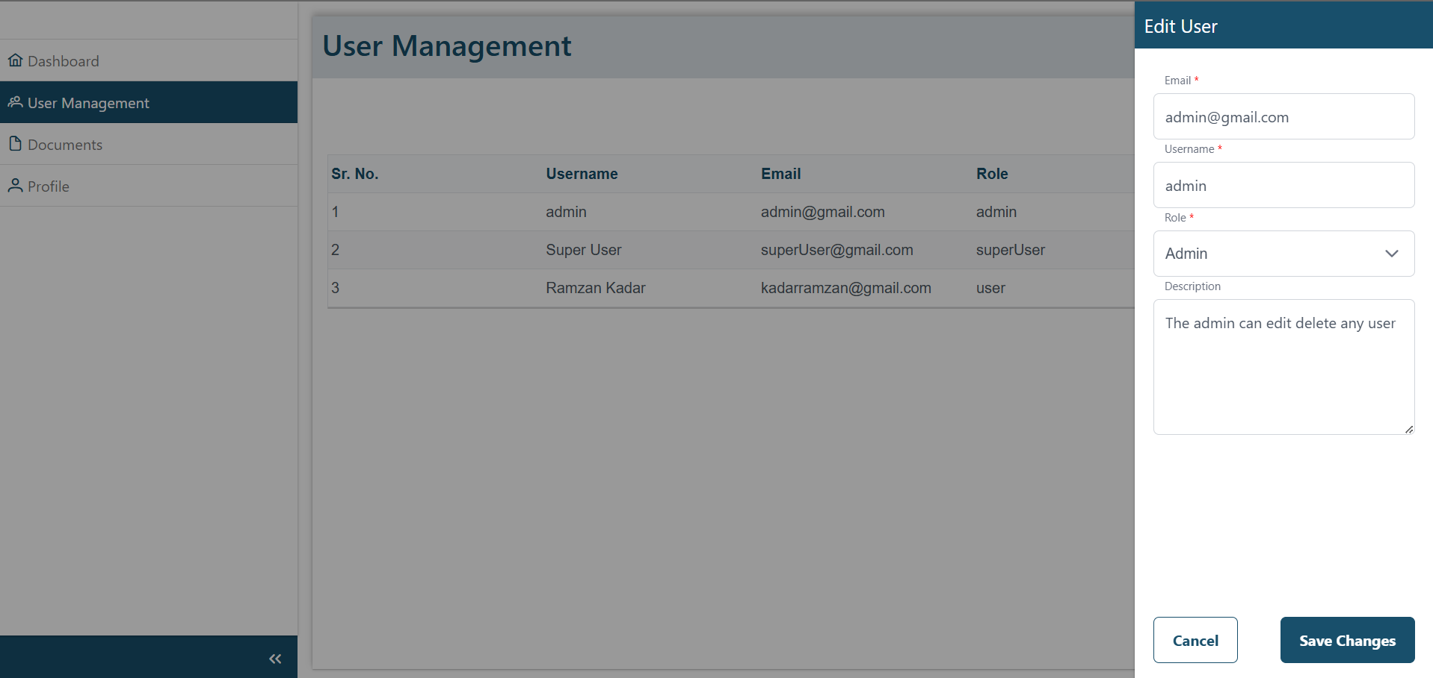

Figure 4.2: Edit existing user screen

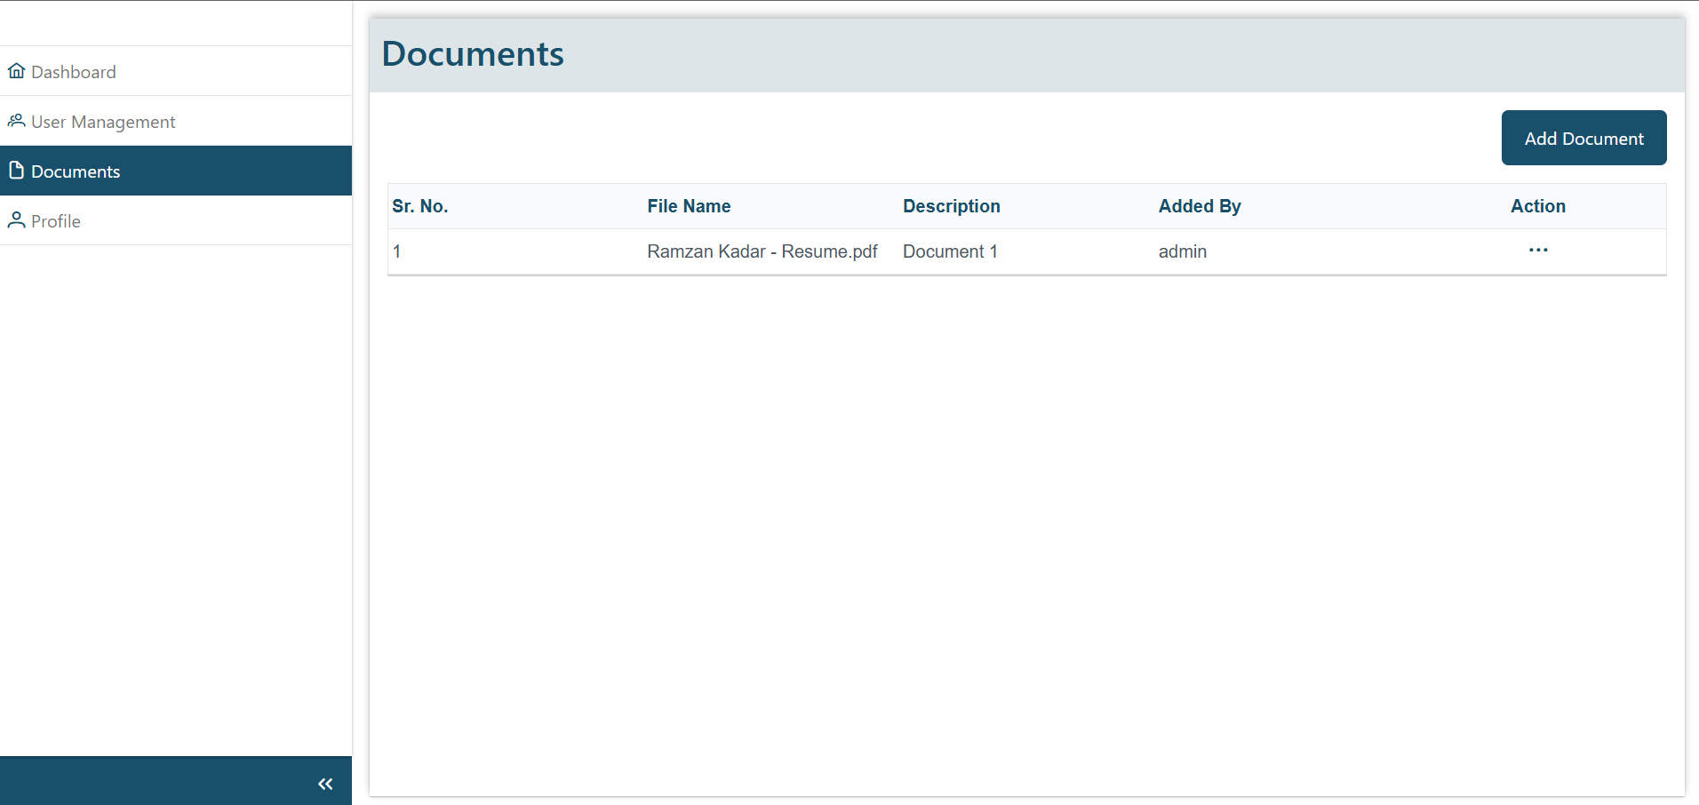

Figure 5: Documents screen

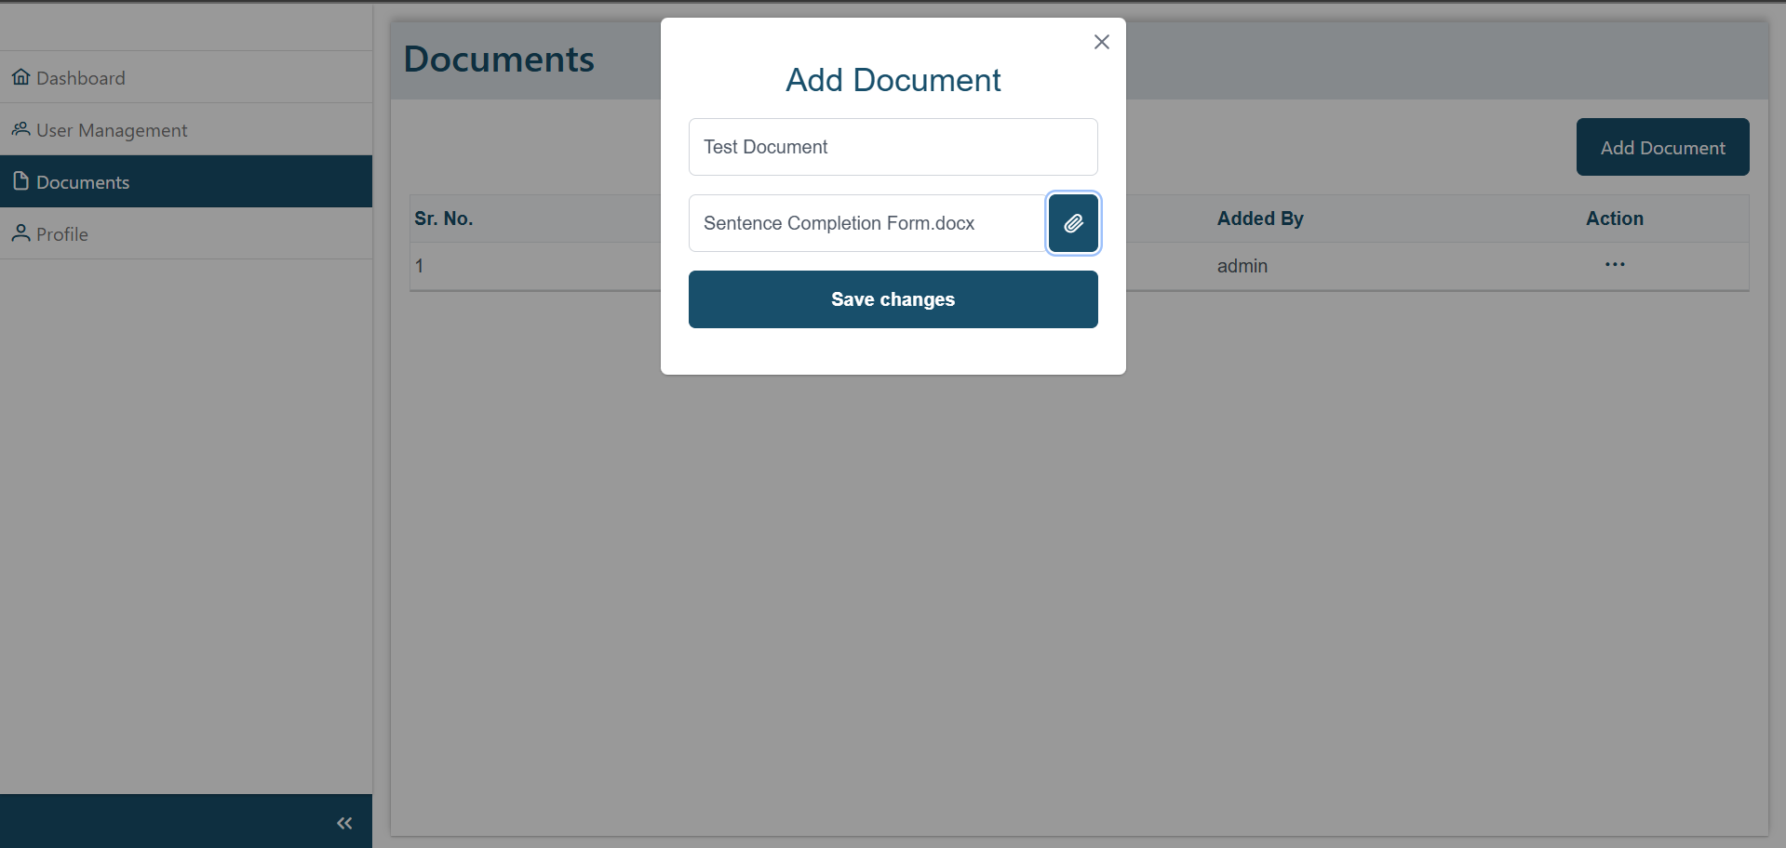

Figure 5.1: Add document popup

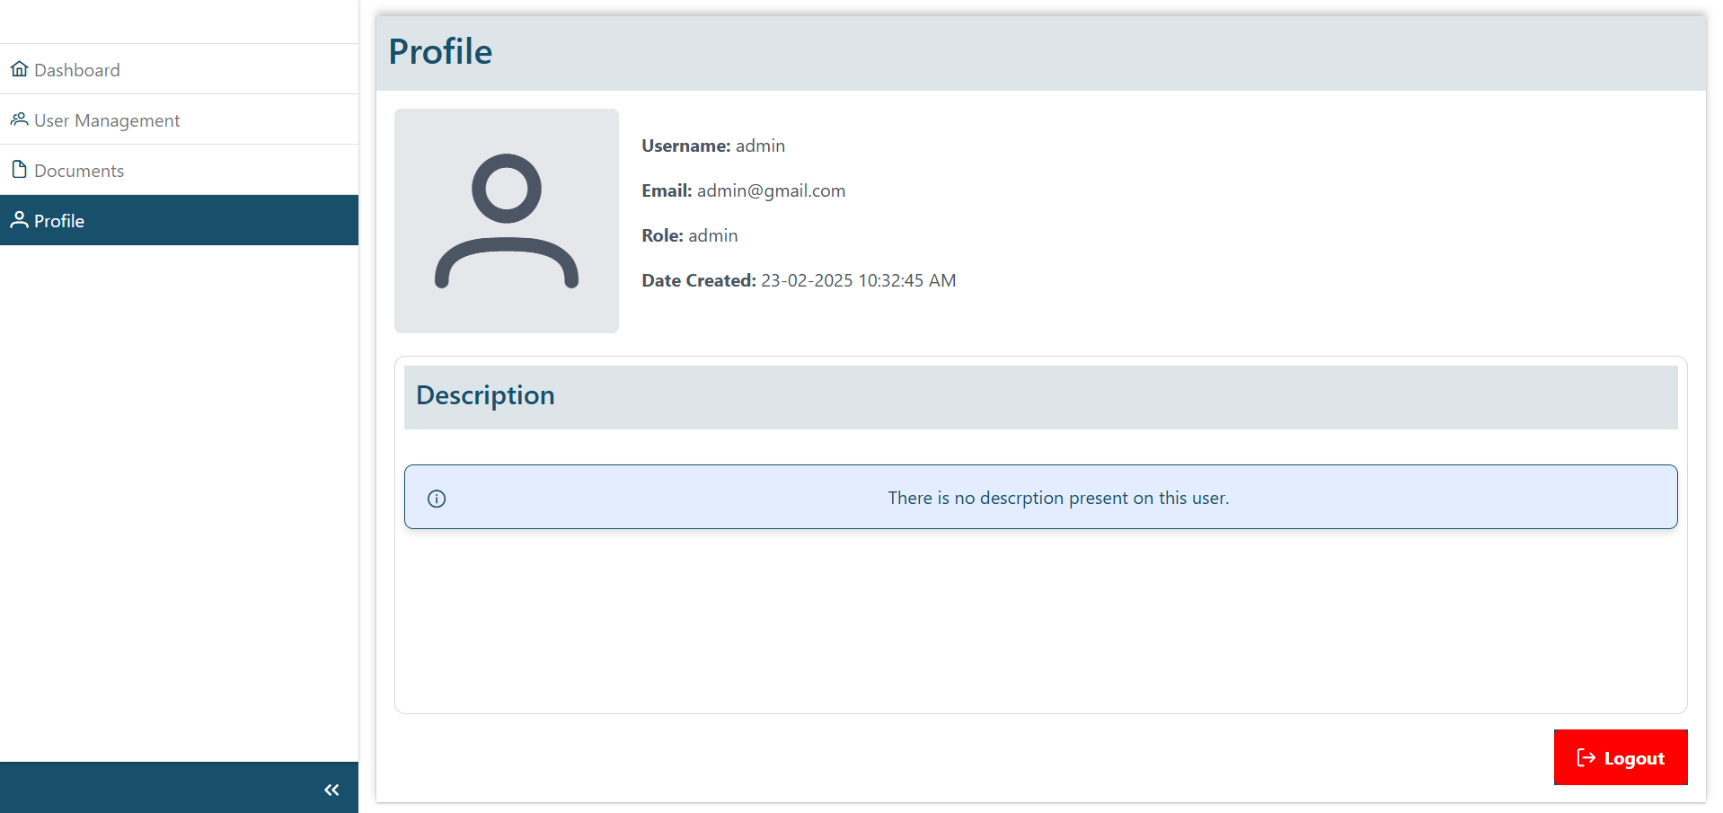

Figure 6: Profile Screen