|  |
| --- |
| TEAM KKB |
| **Documentation**  **Date : 11.02.2021**  **School project** |

Team Members:

Raya Lilova – Scrum Trainer

Valentin Petrov – Frontend Developer

Teachers:

Dimitrina Todorova

Petar Georgiev

Bozhidar Dimitrov- Backend Developer

Georgi N. Georgiev – Quality Engineer

Danaila Stamatova

## Table of Contents

Introduction 3

Purpose 3

Short description of the program 3

About the site 4

Diagram of the program 5

Table with the most important functions 6

Used programs 7

Learned lessons 7

Future goals 8

Conclusion 8

## Introduction

We know that the documentation needs to be done carefully so the idea of our project needs to be clearly expressed to the ones who read it. Our project is a result of all the ideas we’ve discussed and decided to make. We believe that the documentation can help and make the project more effective as it contains various information such as objectives, future goals, details about the project, purpose etc.

## Purpose

The purpose of this document is to present our project and our aim as clear as possible. Our aim was to create a program which represents a school system where the students are grouped in teams in order to work on projects with one teacher in each team.

## Short description of the program

Our program represent an information about the students and their teachers in a school. The main idea of the program is to group each student in team where together with his teammates and their teacher-instructor have to work together in order to create projects. We have site where you can find the software you need to group your students with their teachers.

## About the site

• Main reason

The main reason about our decision of making a site even if it isn’t necessary is that we want our project to be not just a task performance. We wanted our project to be fill with the ideas we have and a site was part of our list.

• More popularity

We thought it would be a good idea to make a site where the users could easily work with our software and we are sure that would increase more popularity of the software.

• Design

The design has a big influence on the opinion that users have about the sites so that is the reason our site is as interesting as possible. The colors which are used don’t irritate the eyes. The text contrasts with the background for easier reading.

## Diagram of the files

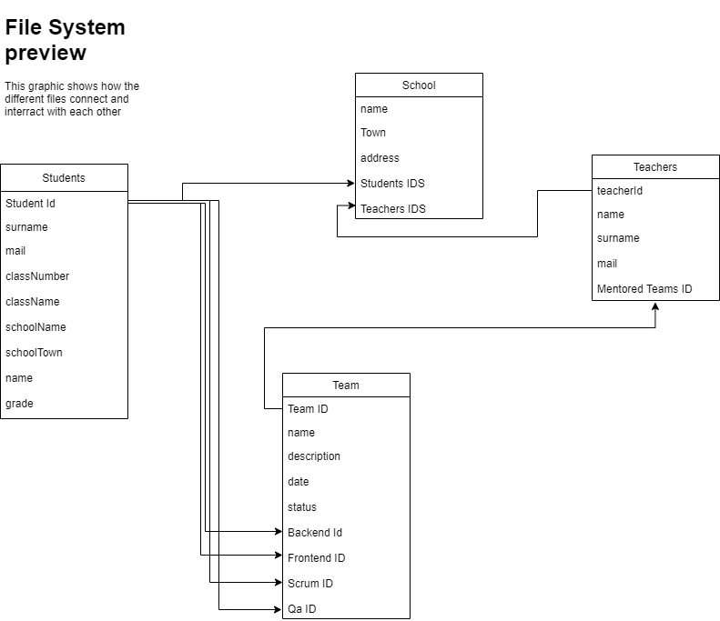

## Table with the most important functions

|  |  |  |  |
| --- | --- | --- | --- |
| Name (+ type) | Use | Arguments (+ type) | Returned value |
| bool menu | Functions for showing the main menu with all the options of the program | fstream& studsFile, fstream& teachersFile, fstream& teamsFile,fstream& schoolFile | return true |
| Int main | Function for calling fails and the main menu | - | - |
| SCHOOL enterSchoolData | Function for entering school data | - | return school |
| vector<STUDENT>enterStudents | Function for entering students | int numberOfStudents | return students |
| vector<TEAM>enterTeams | Function for entering teams | int numberOfTeams, vector<STUDENT> students | return teams |
| vector<TEACHER>enterTeachers | Function for entering teachers | int numberOfTeachers, vector<TEAM> teams | return teachers |
| vector<STUDENT>getStudentsFromFile | Function for getting students from file | fstream& studentsList | return students |
| vector<TEAM>getTeamsFromFile | Function for getting teams from file | fstream& teamsList, vector<STUDENT> students | return teams |
| vector<TEACHER>getTeachersFromFile | Function for getting teachers from file | fstream& file,vector<TEAM> teams | return teachers |
| int readInt | Function for checking the value (int) and loops until the user enters an integer. | - | return a |

## Used programs

* The programs that we used for our project are:

1. Visual Studio – for writing the code.
2. Github – for storing the project.
3. Word, Excel and PowerPoint – for the documentation, QA document and Presentation.
4. Discord/Messenger/Teams – for communications and discussions.

* The program languages used for the project:

1. C++, C - to develop the game.
2. HTML, CSS, JavaScript – for the site and the program.

## Learned lessons

As a young programmers we are still learning on our skills and how to give our best in every project. The lessons we learnt during this project are: To be more patient with each other, more hard-working, more empathetic, more enthusiastic and to plan our time. We have so much more to learn step by step but we believe that we are becoming better and better every time. We are fill with ideas and excitement and we are ready to learn more new things.

## Future goals

If we had the time to make all the ideas in our heads, then they’d all include every feature in our list. But we don’t have it so that’s this paragraph for. The goal of our team was not just to spot how things flow, but also how they can be improved. So what are our future goals? Firstly we want to expand our project in order to help with grouping students and their teachers in real life. We want to upgrade our site and add more and more features.

## Conclusion

To sum up we didn’t face with many obstacles because of the organization we had and we did all of the things we had set as a goal. We are thankful to be part of this project because with every project we make, we get better and learn new things every time.