Appendix A: The Billing System[1]

1

Alberto rodrigues da silva, Instituto Superior Técnico, alberto.silva@tecnico.ulisboa.pt

Daniel Serrão, Instituto Superior Técnico, daniel.serrao@tecnico.ulisboa.pt

Tiago Catarino, Instituto Superior Técnico, tiagomcatarino@tecnico.ulisboa.pt

# RSL-IL Excel Template

## Configuration and Home Sheets

### home Sheet

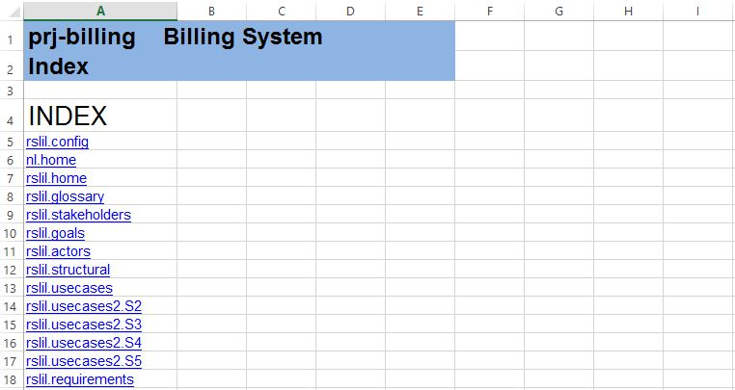

### rslil.config Sheet

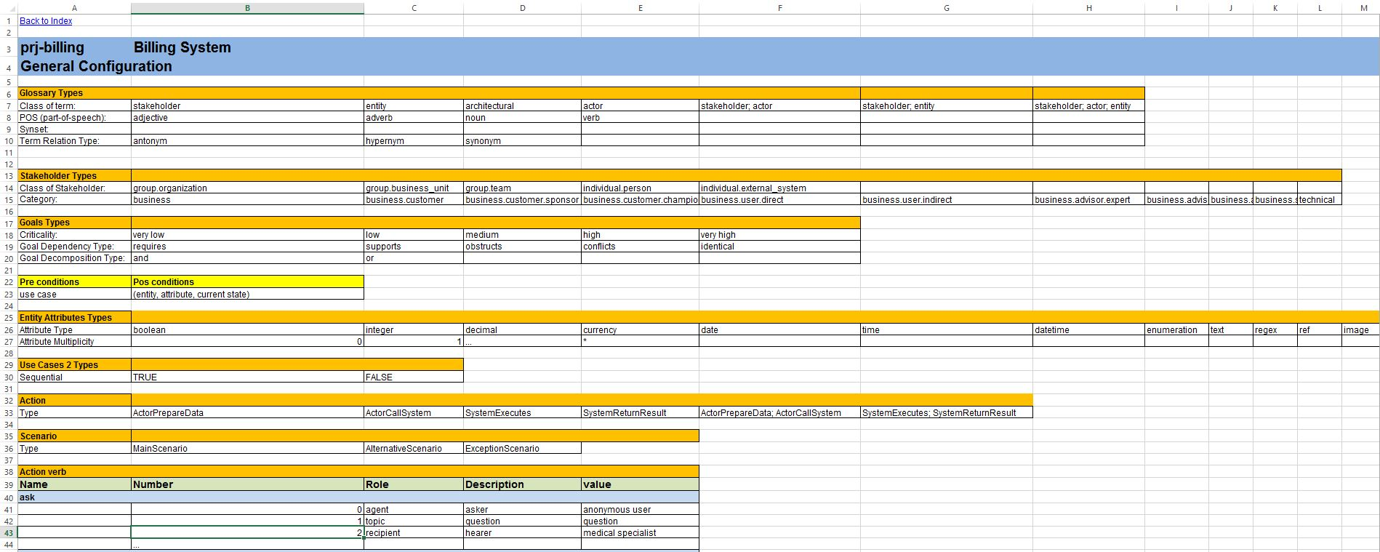

### rslil.home Sheet

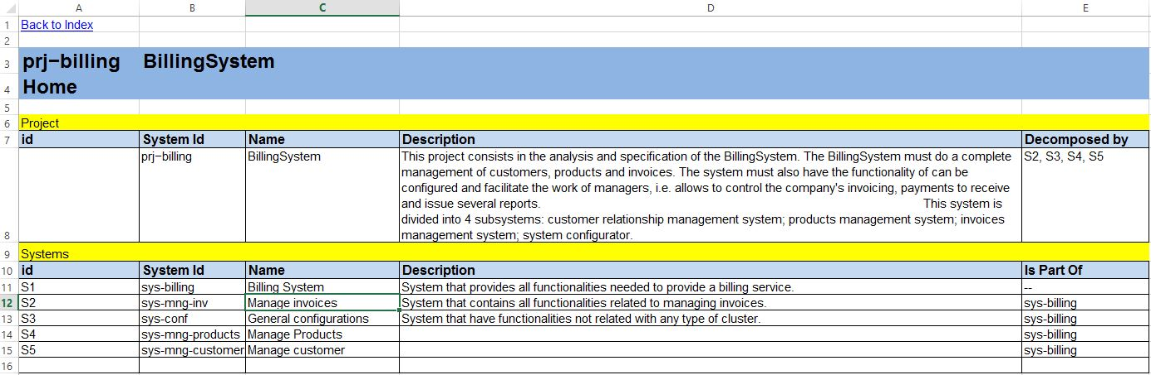

## Business Level Sheets

### Glossary View (rslil.glossary sheet)

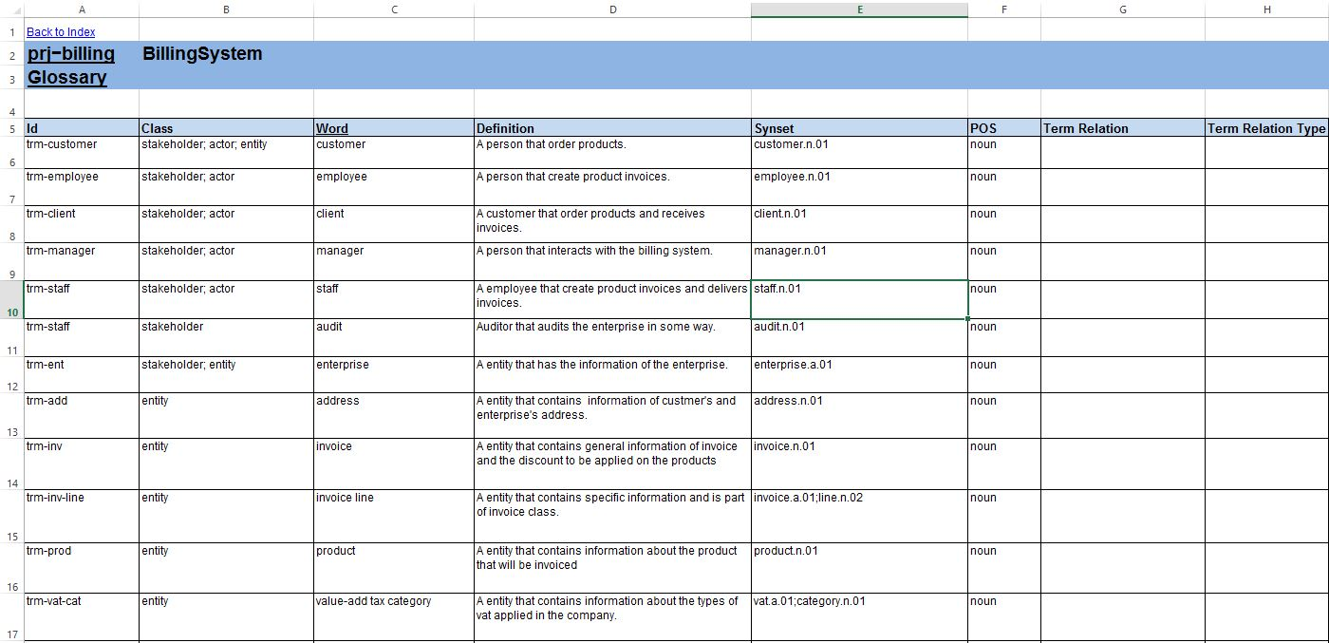

### Stakeholders View (rslil.stakeholders sheet)

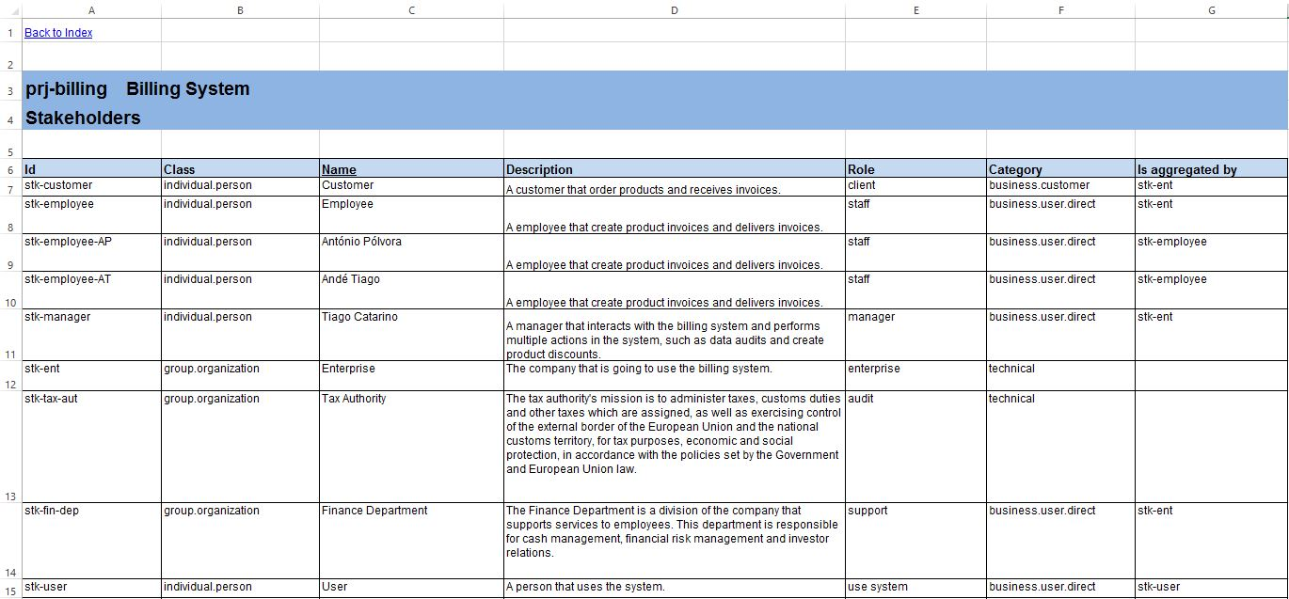

### Goals View (rslil.goals sheet)

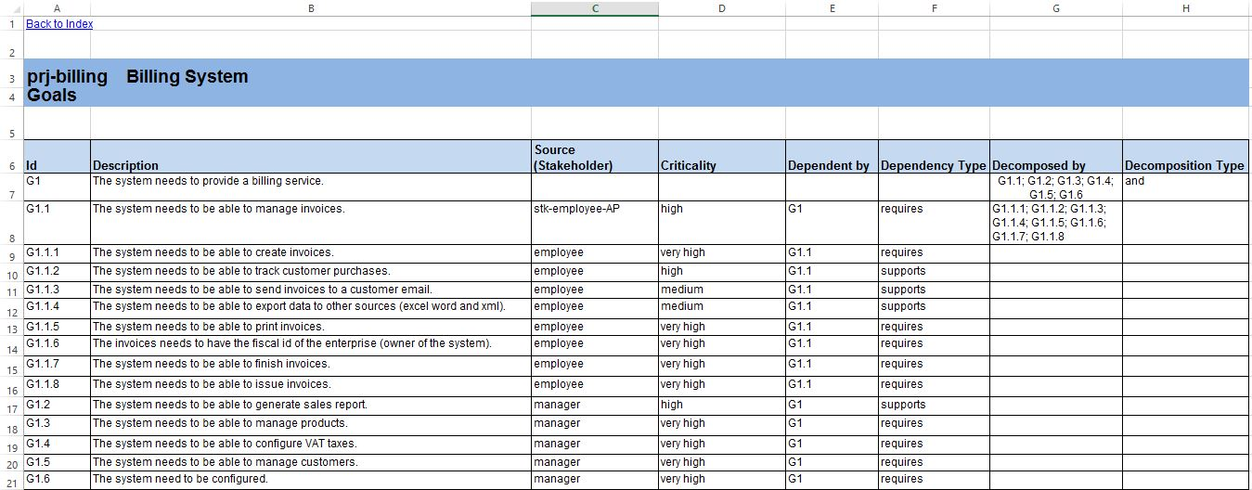

## System Level Sheets

### Actors View (rslil.actors sheet)

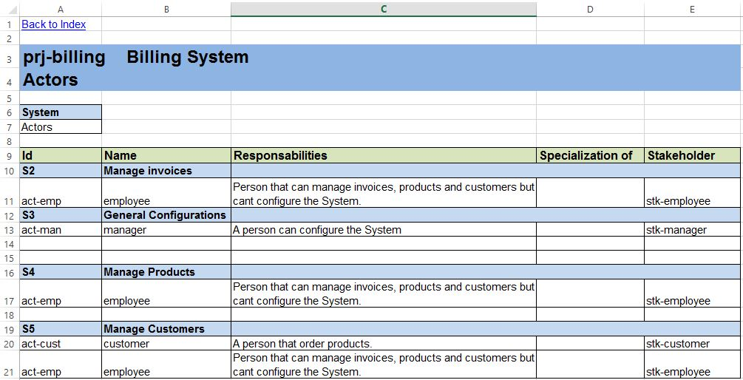

### Structural View (rslil.structural sheet)

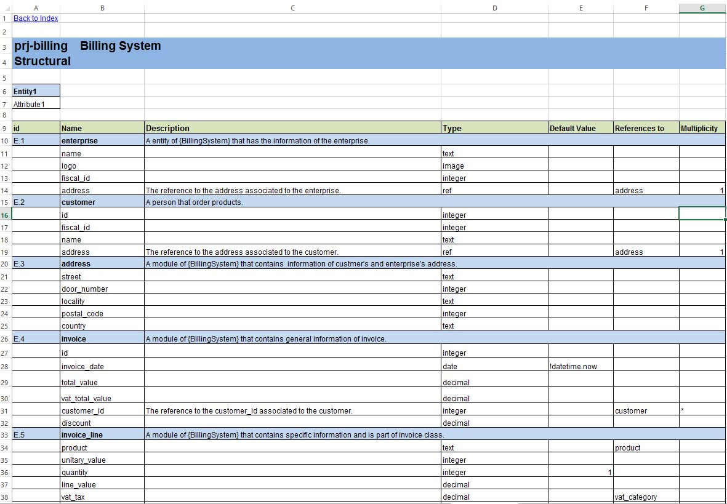

### Use Cases View (rslil.usecases sheet)

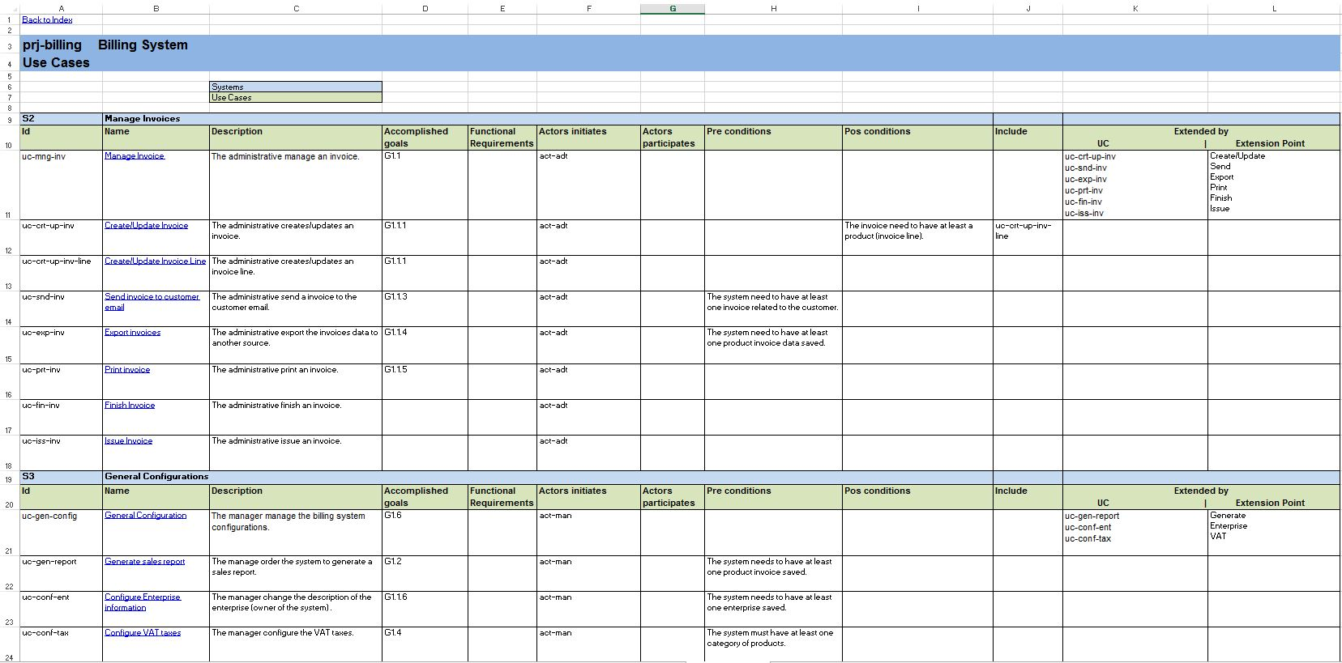

### Scenarios View (rslil.usecases2.Sn sheet)

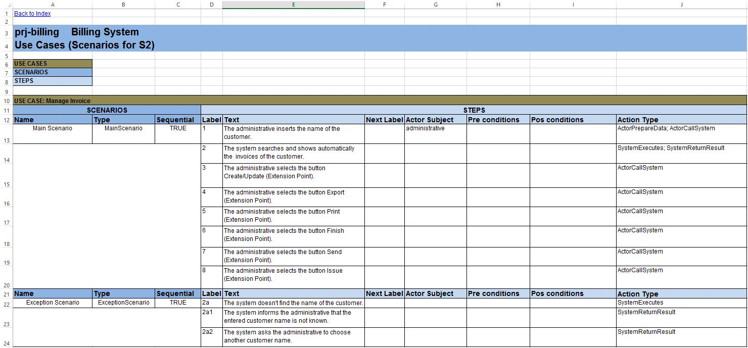

1. This work is supported by the Instituto Superior Técnico.

   Author's address: A. Silva, email: alberto.silva@tecnico.ulisboa.pt; D. Serrão, email: daniel.serrao@tecnico.ulisboa.pt; T. Catarino, email: tiagomcatarino@tecnico.ulisboa.pt

   Permission to make digital or hardcopies of part or all of this work for personal or classroom use is granted without fee provided that copies are not made or distributed for profit or commercial advantage and that copies show this notice on the first page or initial screen of a display along with the full citation. Copyrights for components of this work owned by others than IST must be honored. Abstracting with credits permitted. To copy otherwise, to republish, to post on servers, to redistribute to lists, or to use any component of this work in other works requires prior specific permission and/or a fee.

   © 2015 IST