KT-0905-5 -- Ethanol, 100%
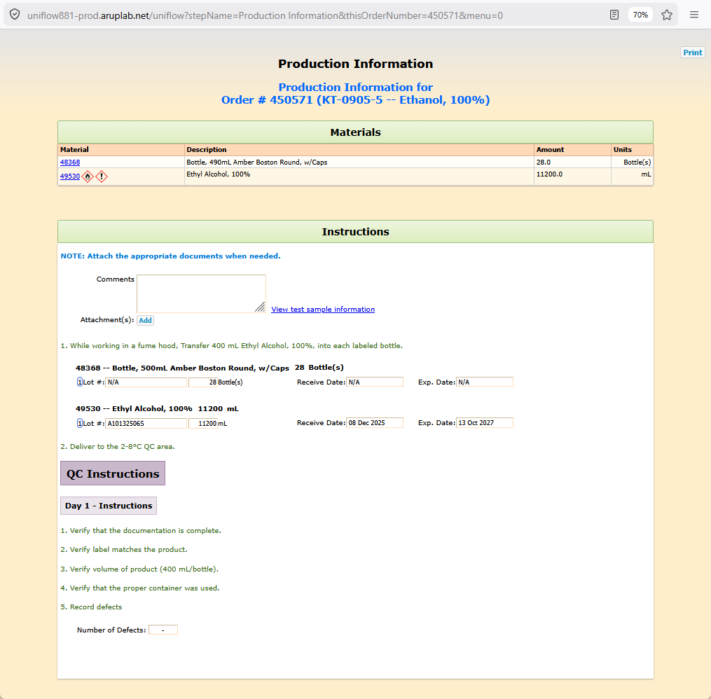
FormPlan for KT-0905-5 -- Ethanol, 100%
formPartValues
part formParts_text_0
parameter formParts_instructions_0
value= <b><span style='color:rgb(0,120,215);'>NOTE: Attach the appropriate documents when needed.</span></b>
part formParts_attachments_1
parameter formParts_Add_1
value= Add
part formParts_text_2
parameter formParts_instructions_2
value= 1. While working in a fume hood, Transfer 400 mL Ethyl Alcohol, 100%, into each labeled bottle.
part formParts_materialNotWeighed_3
parameter formParts_selectedItem_3
value= 48368 -- Bottle, 500mL Amber Boston Round, w/Caps
parameter formParts_reqAmount_3
value= 28
parameter formParts_reqAmountUnits_3
value= Bottle(s)
parameter formParts_reqItem_3
value= 48368
parameter formParts_usedAmountUnits_3
value= Bottle(s)
part formParts_materialNotWeighed_4
parameter formParts_selectedItem_4
value= 49530 -- Ethyl Alcohol, 100%
parameter formParts_reqAmount_4
value= 11200
parameter formParts_reqAmountUnits_4
value= mL
parameter formParts_reqItem_4
value= 49530
parameter formParts_usedAmountUnits_4
value= mL
part formParts_text_5
parameter formParts_instructions_5
value= 2. Deliver to the 2-8°C QC area.
part formParts_separator_6
part formParts_separatorDay1_7
part formParts_text_8
parameter formParts_instructions_8
value= 1. Verify that the documentation is complete.
part formParts_text_9
parameter formParts_instructions_9
value= 2. Verify label matches the product.
part formParts_text_10
parameter formParts_instructions_10
value= 3. Verify volume of product (400 mL/bottle).
part formParts_text_11
parameter formParts_instructions_11
value= 4. Verify that the proper container was used.
part formParts_text_12
parameter formParts_instructions_12
value= 5. Record defects
part formParts_defectRate_13

