N-13200-6 -- NSE Muscles Phosphate Buffer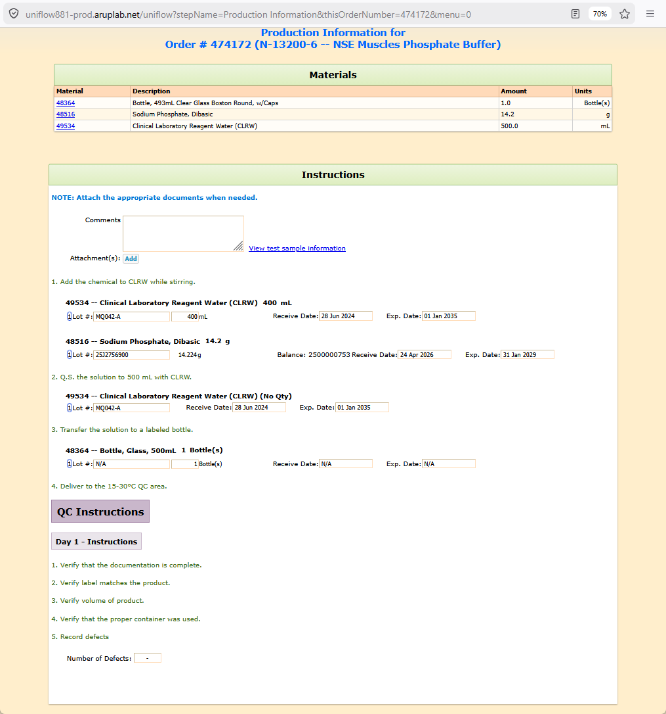
FormPlan for N-13200-6 -- NSE Muscles Phosphate Buffer
formPartValues
part formParts_text_0
parameter formParts_instructions_0
value= <b><span style='color:rgb(0,120,215);'>NOTE: Attach the appropriate documents when needed.</span></b>
part formParts_attachments_1
parameter formParts_Add_1
value= Add
part formParts_text_2
parameter formParts_instructions_2
value= 1. Add the chemical to CLRW while stirring.
part formParts_materialNotWeighed_3
parameter formParts_selectedItem_3
value= 49534 -- Clinical Laboratory Reagent Water (CLRW)
parameter formParts_reqAmount_3
value= 400
parameter formParts_reqAmountUnits_3
value= mL
parameter formParts_reqItem_3
value= 49534
parameter formParts_usedAmountUnits_3
value= mL
part formParts_materialWeighed_4
parameter formParts_selectedItem_4
value= 48516 -- Sodium Phosphate, Dibasic
parameter formParts_reqAmount_4
value= 14.2
parameter formParts_reqAmountUnits_4
value= g
parameter formParts_getWeightButton_4
value= Get weight
parameter formParts_reqItem_4
value= 48516
parameter formParts_usedAmountUnits_4
value= g
part formParts_text_5
parameter formParts_instructions_5
value= 2. Q.S. the solution to 500 mL with CLRW.
part formParts_materialNoQty_6
parameter formParts_selectedItem_6
value= 49534 -- Clinical Laboratory Reagent Water (CLRW)
parameter formParts_reqItem_6
value= 49534
part formParts_text_7
parameter formParts_instructions_7
value= 3. Transfer the solution to a labeled bottle.
part formParts_materialNotWeighed_8
parameter formParts_selectedItem_8
value= 48364 -- Bottle, Glass, 500mL
parameter formParts_reqAmount_8
value= 1
parameter formParts_reqAmountUnits_8
value= Bottle(s)
parameter formParts_reqItem_8
value= 48364
parameter formParts_usedAmountUnits_8
value= Bottle(s)
part formParts_text_9
parameter formParts_instructions_9
value= 4. Deliver to the 15-30°C QC area.
part formParts_separator_10
part formParts_separatorDay1_11
part formParts_text_12
parameter formParts_instructions_12
value= 1. Verify that the documentation is complete.
part formParts_text_13
parameter formParts_instructions_13
value= 2. Verify label matches the product.
part formParts_text_14
parameter formParts_instructions_14
value= 3. Verify volume of product.
part formParts_text_15
parameter formParts_instructions_15
value= 4. Verify that the proper container was used.
part formParts_text_16
parameter formParts_instructions_16
value= 5. Record defects
part formParts_defectRate_17

