**Hands on 1**

Create a new React Application with the name “myfirstreact”, Run the application to print “welcome to the first session of React” as heading of that page.

**Code:**

import'./App.css';

functionApp() {

  return (

    <h1> Welcome the first session of React </h1>

  );

}

exportdefaultApp;

**Output:**

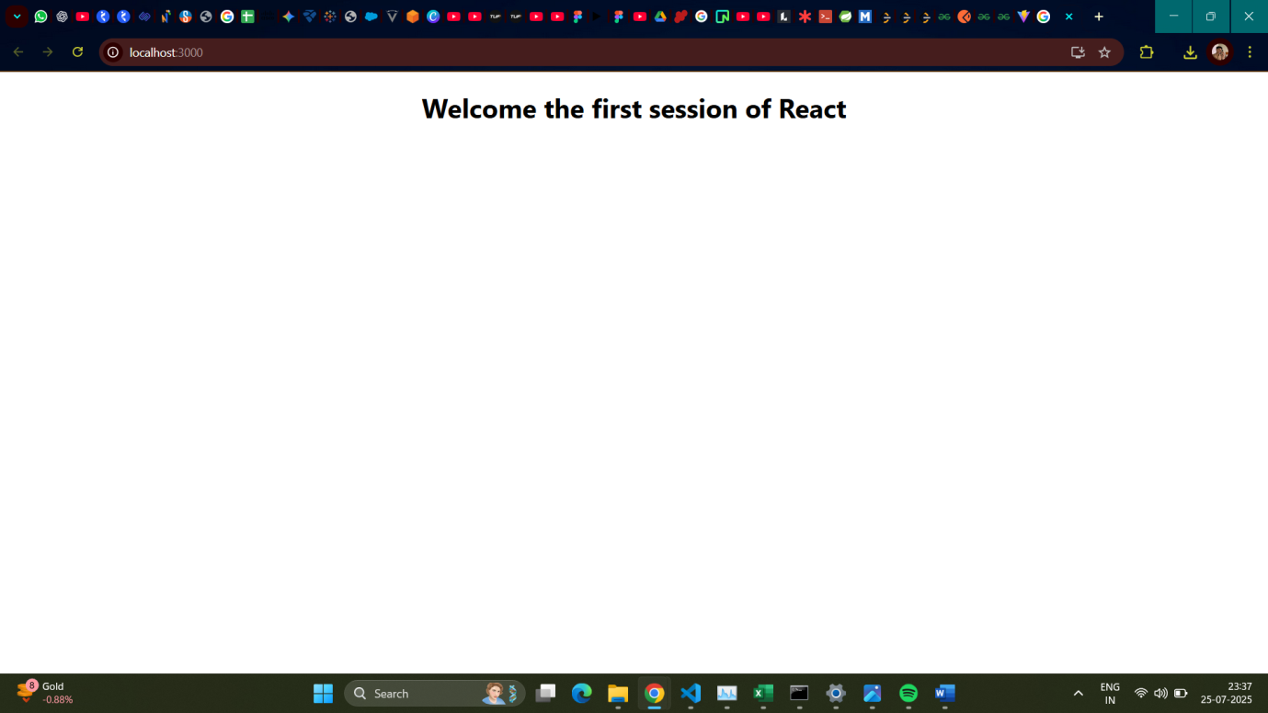

**Hands on 2**

Create a react app for Student Management Portal named StudentApp and create a component named Home which will display the Message “Welcome to the Home page of Student Management Portal”. Create another component named About and display the Message “Welcome to the About page of the Student Management Portal”. Create a third component named Contact and display the Message “Welcome to the Contact page of the Student Management Portal”. Call all the three components.

**Code:**

App.js

import'./App.css';

import {Home} from'./Components/Home';

import {About} from'./Components/About';

import {Contact} from'./Components/Contact';

functionApp() {

  return (

    <div*className*="container">

      <*Home*/>

      <*About*/>

      <*Contact*/>

    </div>

  );

}

exportdefaultApp;

Home.js

import React, {Component} from'react';

classHomeextendsComponent{

    render(){

        return(

            <div>

                <h3> Welcome to the Home Page of Student Management Portal </h3>

            </div>

        );

    };

};

export { Home };

Contact.js

import React, {Component} from'react';

classContactextendsComponent{

    render(){

        return(

            <div>

                <h3> Welcome to the Contact Page of Student Management Portal </h3>

            </div>

        );

    };

};

export { Contact };

About.js

import React, {Component} from'react';

classAboutextendsComponent{

    render(){

        return(

            <div>

                <h3> Welcome to the About Page of Student Management Portal </h3>

            </div>

        );

    };

};

export { About };

**Output:**

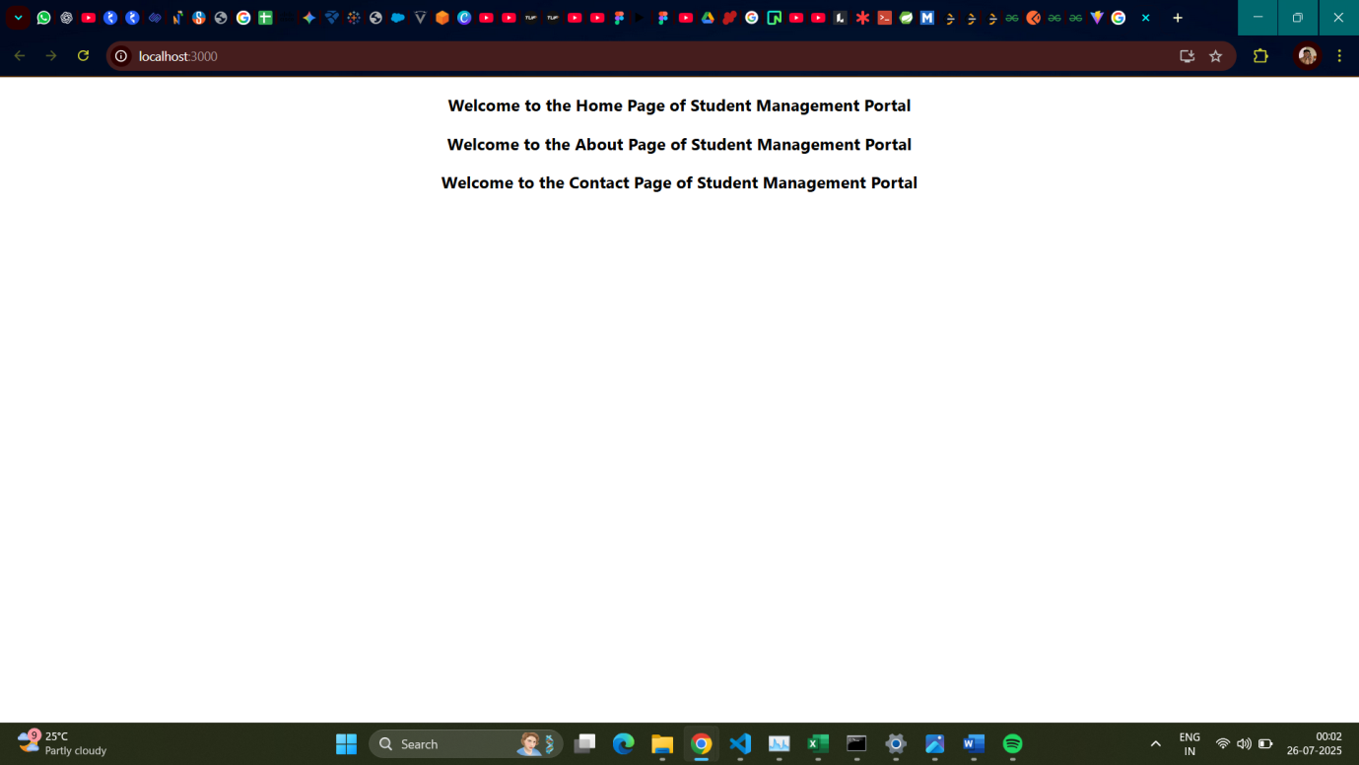

**Hands on 3**

Create a react app for Student Management Portal named scorecalculatorapp and create a function component named “CalculateScore” which will accept Name, School, Total and goal in order to calculate the average score of a student and display the same.

**Code:**

App.js

import React from'react';

import { CalculateScore } from'./Components/CalculateScore';

functionApp() {

  return (

    <div*className*="App">

      <*CalculateScoreName*={"Steeve"}*School*={"DNV Public School"}*total*={284}*goal*={300} />

    </div>

  );

};

exportdefaultApp;

CalculateScore.js

import React from'react';

import'../StyleSheets/mystyle.css';

constpercentToDecimal= (*decimal*) => {

    return (*decimal*.toFixed(2) *100) +'%';

};

constcalcScore= (*total*, *goal*) => {

    if (*goal*===0) return"N/A";

    returnpercentToDecimal(*total*/*goal*);

};

exportconstCalculateScore= ({ *Name*, *School*, *total*, *goal* }) => (

    <div*className*="formatstyle">

        <h1*style*={{ color:"brown" }}>Student Details:</h1>

        <div*className*="Name">

            <b><span>Name:</span></b>

            <span>{*Name*}</span>

        </div>

        <div*className*="School">

            <b><span>School:</span></b>

            <span>{*School*}</span>

        </div>

        <div*className*="Total">

            <b><span>Total:</span></b>

            <span>{*total*}</span>

            <span>Marks</span>

        </div>

        <div*className*="Score">

            <b><span>Score:</span></b>

            <span>

                {calcScore(*total*, *goal*)}

            </span>

        </div>

    </div>

);

mystyle.css

*.Name* {

    font-weight:300;

    color:blue;

}

*.School* {

    color:crimson;

}

*.Total* {

    color:darkmagenta;

}

*.formatstyle* {

    text-align:center;

    font-size:large;

}

*.Score* {

    color:forestgreen;

}

**Output:**

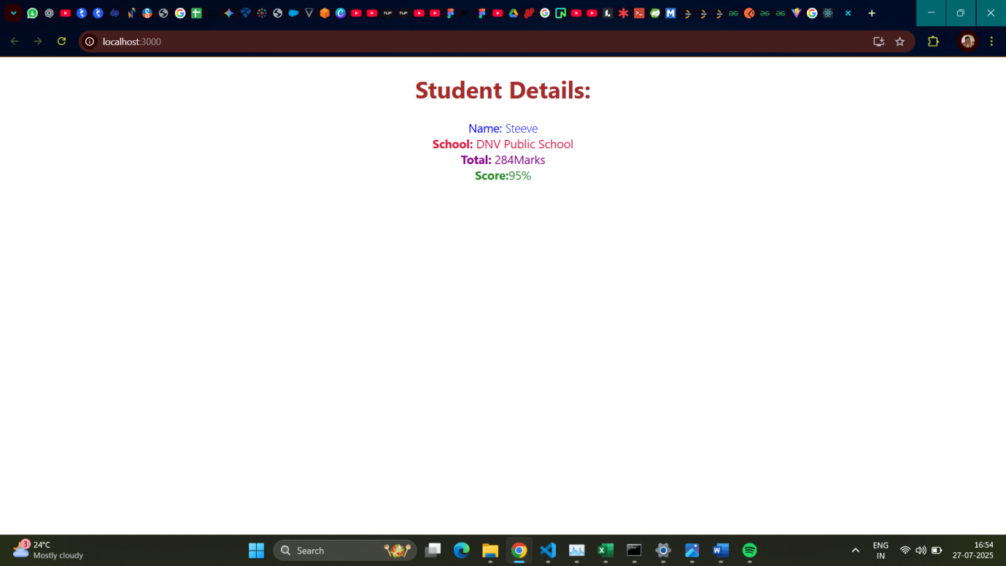

**Hands on 4**

Create a new react application using *create-react-app* tool with the name as “blogapp”.

**Code:**

App.js

import React from'react';

import Posts from'./Posts';

functionApp() {

  return (

    <div*className*="App">

      <*Posts* />

    </div>

  );

}

exportdefaultApp;

Post.js

classPost {

    constructor(*id*, *title*, *body*) {

*this*.id =*id*;

*this*.title=*title*;

*this*.body=*body*;

    }

}

exportdefaultPost;

Posts.js

import React from'react';

classPostsextends*React*.Component {

    constructor(*props*) {

*super*(*props*);

*this*.state= {

            posts: [],

            hasError:false,

            error:null,

            errorInfo:null,

        };

    }

    loadPosts=async () => {

        try {

            constresponse=awaitfetch('https://jsonplaceholder.typicode.com/posts');

            if (!response.ok) {

                throw**new***Error*(`HTTP error! status: ${response.status}`);

            }

            constdata=awaitresponse.json();

*this*.setState({ posts:data });

        } catch (error) {

            console.error("Failed to fetch posts:", error);

*this*.setState({ hasError:true, error: error });

        }

    };

    componentDidMount() {

*this*.loadPosts();

    }

    componentDidCatch(*error*, *errorInfo*) {

        console.error("Caught an error:", *error*, *errorInfo*);

*this*.setState({

            hasError:true,

            error:*error*,

            errorInfo:*errorInfo*,

        });

        alert("An error occurred in the component! Check console for details.");

    }

    render() {

        if (*this*.state.hasError) {

            return (

                <div*style*={{ color:'red', textAlign:'center', padding:'20px' }}>

                <h2>Something went wrong.</h2>

                <p>{*this*.state.error&&*this*.state.error.toString()}</p>

                </div>

            );

        }

        if (*this*.state.posts.length===0) {

          return<div*style*={{ textAlign:'center', padding:'20px' }}>Loading posts...</div>;

        }

        return (

            <div*style*={{ padding:'20px', maxWidth:'800px', margin:'0 auto' }}>

                <h1*style*={{ textAlign:'center', marginBottom:'30px', color:'#333' }}>Blog Posts</h1>

                {*this*.state.posts.map((*post*) => (

                    <div*key*={*post*.id}*style*={{ border:'1px solid #eee', borderRadius:'8px', padding:'15px', marginBottom:'20px', backgroundColor:'#fff', boxShadow:'0 2px 5px rgba(0,0,0,0.05)' }}>

                        <h2*style*={{ color:'#0056b3', fontSize:'1.5rem', marginBottom:'10px' }}>{*post*.title}</h2>

                        <p*style*={{ color:'#555', lineHeight:'1.6' }}>{*post*.body}</p>

                    </div>

                ))}

            </div>

        );

    }

}

exportdefaultPosts;

**Output:**

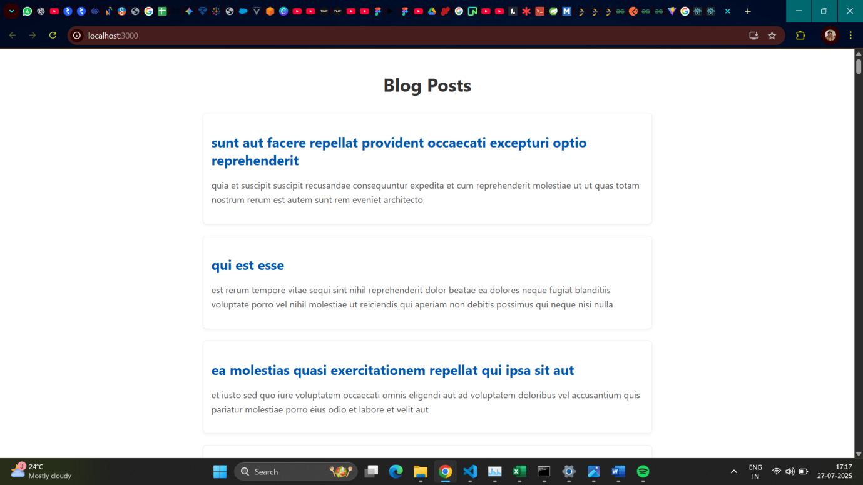

**Hands on 5**

My Academy team at Cognizant want to create a dashboard containing the details of ongoing and completed cohorts. A react application is created which displays the detail of the cohorts using react component. You are assigned the task of styling these react components.

**Code:**

CohortDetails.module.css

*.box* {

    width:300px;

    display:inline-block;

    margin:10px;

    padding-top:10px;

    padding-bottom:10px;

    padding-left:20px;

    padding-right:20px;

    border:1pxsolidblack;

    border-radius:10px;

    box-sizing:border-box;

}

dt {

    font-weight:500;

}

CohortDetails.js

import React from'react';

import styles from'./CohortDetails.module.css';

functionCohortDetails(*props*) {

    constheadingStyle= {

        color:*props*.cohort.currentStatus==='Ongoing'?'green':'blue'

    };

    return (

        <div*className*={styles.box}>

            <h3*style*={headingStyle}>

                {*props*.cohort.cohortCode} -

                <span>{*props*.cohort.technology}</span>

            </h3>

            <dl>

                <dt>Started On</dt>

                <dd>{*props*.cohort.startDate}</dd>

                <dt>Current Status</dt>

                <dd>{*props*.cohort.currentStatus}</dd>

                <dt>Coach</dt>

                <dd>{*props*.cohort.coachName}</dd>

                <dt>Trainer</dt>

                <dd>{*props*.cohort.trainerName}</dd>

            </dl>

        </div>

    );

}

exportdefaultCohortDetails;

**Output:**

