**50-100 words brief about business**

Product Video: <https://www.youtube.com/watch?v=fIjWcbhvIrc>

Integerspin has indigenously developed India’s first Vacuum Truck, capable of handling Wet and Dry Waste. Its is the World's most advance, smart and Green Vacuum Technology based Waste Management Solution. Additionally, we have developed Vacuum based products like Vacuum Toilets, Road sweepers, Vacuum Trailor and Vacuum Skids.

**Product / Service Description**

**Range of VAC-SPIN**

1. Combi VAC-SPIN

2. FLUID VAC-SPIN

3. SOLID VAC-SPIN

OUR Vaccum trucks are capable to Handle Liquid, Solid, Hazardous, Non Hazardous, Municipal and Industrial waste

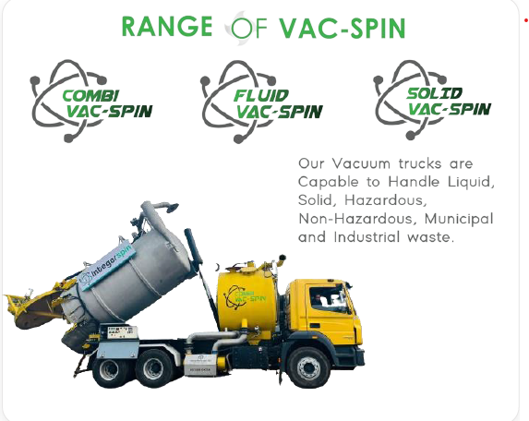

Vacuum Toliets by Integerspin: Indian & Western Design

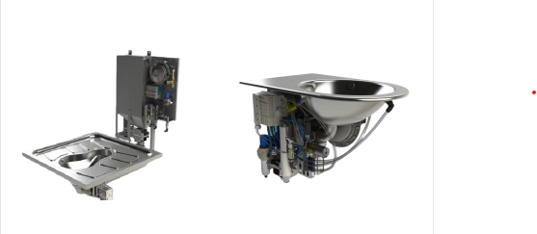

**More than 80% Saving of Water**

Each flush in a normal toilet takes 5-6 liters of water per flush and a vacuum toilet takes only 500 ml to 1 liter of water per flush

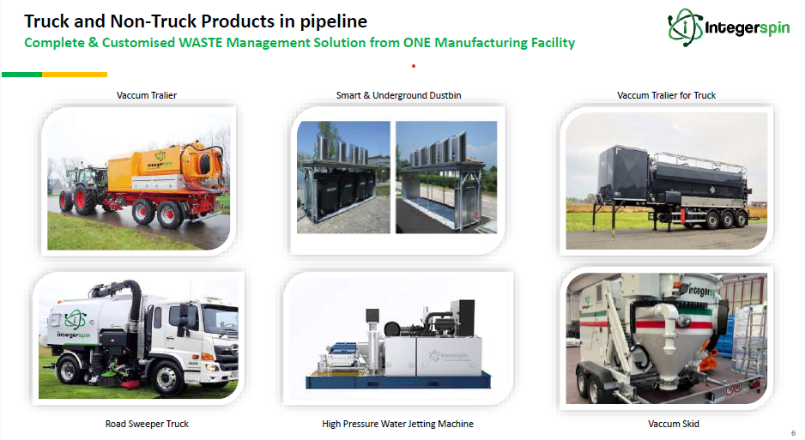

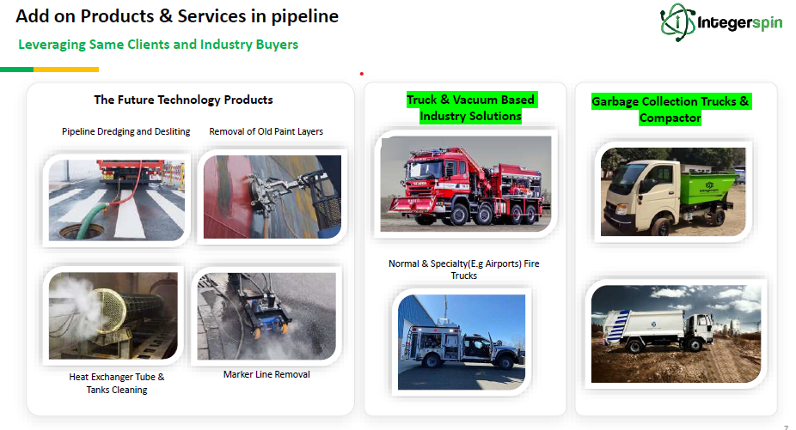

**Current Clients served:**

* CR3 Group
* Tata
* Kalzip
* Innovatiview

**Clients in Pipeline:**

* Kanooz
* BFG
* Reliance Industries Ltd
* Bayariq Al Sharqiyah company Ltd

**Supported By**

* DPIIT
* MSME chambers of commerce
* People of Indian orgin chamber of commerce & Industry
* Startup India Iniatives

**Early Traction:**

FY23-24 Revenues: INR 1.82 Crore

FY23-24 Gross Margins – 45%

Bootstrapped & Profitable from day one

• Order booked for FY24-25 : INR 10 Crore and more POs in hand

• Overall Opportunity Pipeline stands at : INR 43 Crore

• Patent: Applied for CombiVac Spin (Vacuum Truck for Dry and Wet) & To be applied for Vacuum Toilet

**Brief background about the founders.**

**Gaurav Tyagi (Co-Founder & CEO)**

B.Tech (Mechanical Engineering), P.G.D.M

11 Year of Experience in Sales | Festo and Forbes

**Anupam Gangwar (Co-founder & CTO)**

M.Tech (Mechatronics & Advance Robotics)

13 years of experience in Application, R&D | Festo

**Vijendra Yadav (Co-founder & Design & Project Execution)**

B.Tech (Mechanical Engineering)

14 years Experience of Design & NPD | Forbes | KOKS Group

**Vikrant Chaudhary (Co-founder & Operations & Automation)**

B.Tech (Electrical & Electronics Engineering)

11 Years Experience in Programming & Control | PG | Forbes

**Future Projections:**

Revenue Generated Post-Funding is:

|  |  |  |
| --- | --- | --- |
| **Year** | **Revenue (INR)** | **YoY Growth (%)** |
| **1** | 10 CR | 441% |
| **2** | 100 CR | 900% |
| **3** | 180 CR | 80% |

**USP:**

**BOTH DRY & WET Dust & Water Free:** INDIA’s first Indigenously Developed Dry and Wet Vacuum Suction Truck

**Handle Hazardous INDIA’s FIRST Materials:** INDIA’s first Vacuum Suction Truck which can handle Hazardous Materials i.e. Catalyst & Ammonia

**Patented Nitrogen Recycling:** INDIA’s first Vacuum Suction Truck Nitrogen recycling Technology (Patented).

**Unique Super Sucker Trucks** without external Engine (Powered with Trucks Engine)

**Automation, Capacity, Power, Reduced Ops Cost, Environment Friendly: Advanced** Automation reducing Fuel, reduced Manpower, over 1200 Ltr of suction Tank Capacity along with 200 litre of jetting & pumping, Offer Vacuum upto 5 meter dept and over pressure of 900 mbar, Sustainable materials and Environment friendly principles

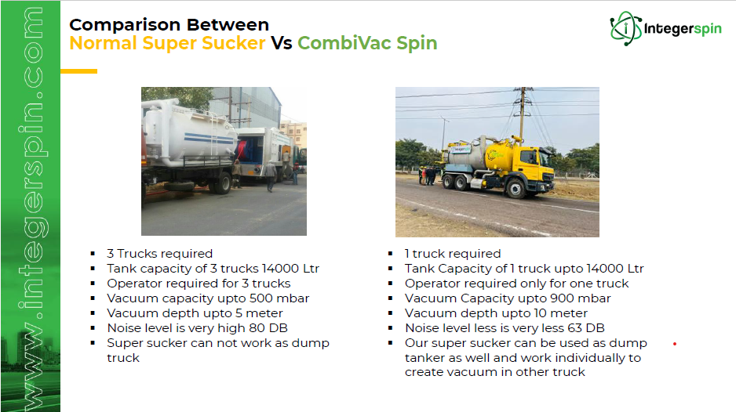

**Ask:**

INR 4CR at 30 CR pre-money valuation. (2CR committed by Angel Investor)