AI ASSISTED CODING
ASSIGNMENT – 3.4
Hallticket No: 2303A51586
Batch – 09
Task-01:
Prompt:
# Write a Python function that prints the first N numbers in the Fibonacci series.Dynamic input n
Code:
def fibonacci_series(n):
a, b = 0, 1
for _ in range(n):
print(a, end=' ')
a, b = b, a + b
# Example usage:
n = int(input("Enter the number of terms in the Fibonacci series: "))
fibonacci_series(n)
Output:
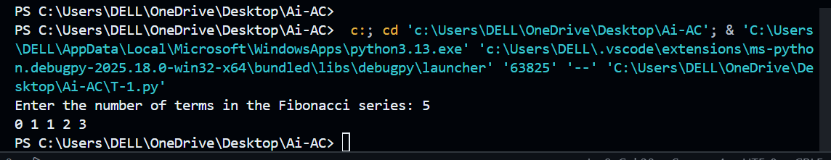
Explanation:
This function generates the Fibonacci series by starting with 0 and 1. In each loop, it prints the current number and updates the values by adding the previous two numbers. The number of terms is taken dynamically from the user.

Task-02:
Prompt:
# Write a Python function to reverse a list.Dynamic input list
# Example: Input: [1, 2, 3] → Output: [3, 2, 1]
Code:
def reverse_list(lst):
return lst[::-1]
# Example usage:
input_list = list(map(int, input("Enter numbers separated by spaces: ").split()))
reversed_list = reverse_list(input_list)
print("Reversed list:", reversed_list)
Output:
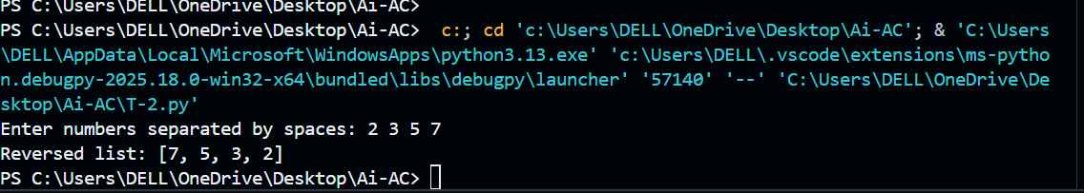
Explanation:
The function reverses a list using Python slicing ([::-1]). The user enters numbers dynamically, which are stored in a list and then reversed easily.
Task-03:
Prompt:
# Write a Python function is_valid() that checks if a string starts with a capital letter and ends with a period.
# Examples: "Hello." → True ; "hello." → False ;"Hello" → False
Code:
def is_valid(s):
return s[0].isupper() and s.endswith('.')
# Example usage:
input_string = input("Enter a string: ")
result = is_valid(input_string)
print("Is the string valid?", result)
Output:
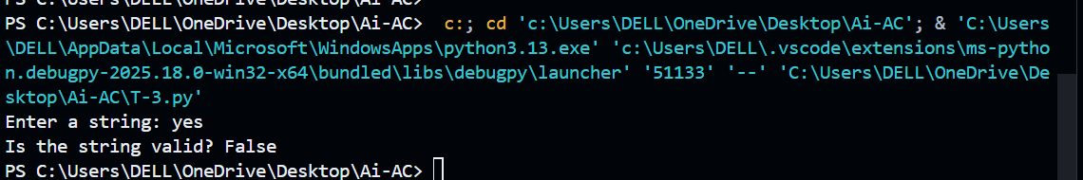
Explanation:
The function checks if the first character of the string is uppercase and if the string ends with a period. If both conditions are true, it returns True; otherwise, False.
Task-04:
Zero-Shot Prompt:
# Write a Python function to validate an email address.
Code:
import re
def is_valid_email(email):
"""
Validates an email address using a regular expression.

Parameters:
email (str): The email address to validate.

Returns:
bool: True if the email address is valid, False otherwise.
"""
pattern = r'^[a-zA-Z0-9._%+-]+@[a-zA-Z0-9.-]+\.[a-zA-Z]{2,}$'
return re.match(pattern, email) is not None
# Example usage
if __name__ == "__main__":
email_input = input("Enter an email address: ")
if is_valid_email(email_input):
print("The email address is valid.")
else:
print("The email address is invalid.")
Output:
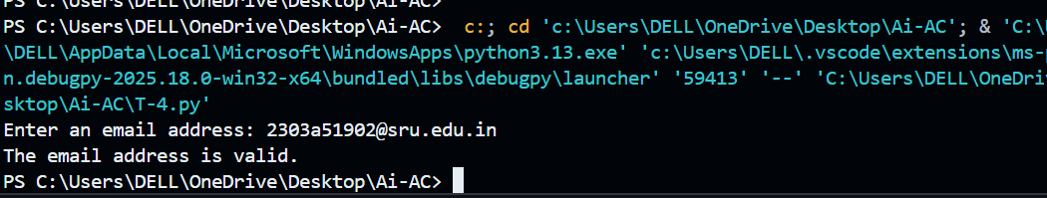
Few-Shot prompt:
# Write a Python function to validate an email address.
# Examples: "user@gmail.com" → True ; "user@gmail" → False ; "user@.com" → False
Code:
import re
def is_valid_email(email):
pattern = r'^[a-zA-Z0-9._%+-]+@[a-zA-Z0-9.-]+\.[a-zA-Z]{2,}$'
return re.match(pattern, email) is not None
# Example usage:
input_email = input("Enter an email address: ")
result = is_valid_email(input_email)
print("Is the email address valid?", result)
Output:
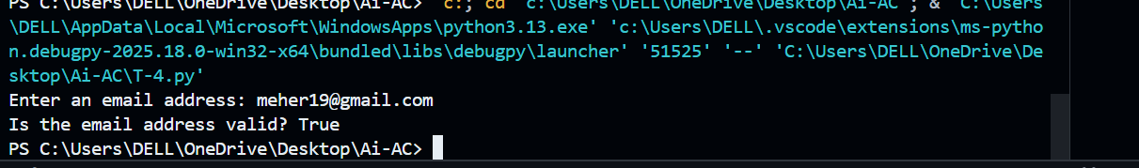
Explanation:
Both functions use regular expressions to check valid email formats. The few-shot prompt improves accuracy by providing examples, helping the AI generate better validation logic.
Task-05:
Generic Prompt
# Write a Python function to return the sum of digits of a number. Number is user inout.
Code:
def sum_of_digits(number):
return sum(int(digit) for digit in str(number) if digit.isdigit())
# Example usage:
user_input = input("Enter a number: ")
result = sum_of_digits(user_input)
print(f"The sum of digits in {user_input} is {result}.")
Output: 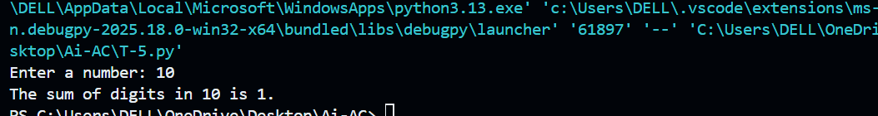
Prompt + Example:
# Write a Python function to return the sum of digits of a number. Number is User input
# Example: sum_of_digits(123) → 6
Code:
def sum_of_digits(number):
return sum(int(digit) for digit in str(number) if digit.isdigit())
# Example usage:
user_input = input("Enter a number: ")
result = sum_of_digits(user_input)
print(f"The sum of digits in {user_input} is {result}.")

Output:
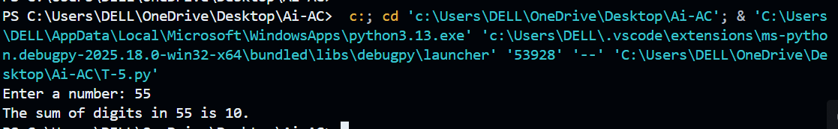
Explanation:
The function converts the number into a string and adds each digit using a loop. The example-based prompt helps generate cleaner and more understandable code.

