AI ASSISTED CODING
ASSIGNMENT – 5.4
Hallticket No: 2303A51586
Batch – 09
Task-01:
#Generate a Python program that collects user details such as name, age, and email.Provide text input boxes for name and age, and an email input box for email.
Code:
import tkinter as tk
from tkinter import messagebox
def submit_details():
name = name_entry.get()
age = age_entry.get()
email = email_entry.get()

if not name or not age or not email:
messagebox.showwarning("Input Error", "Please fill in all fields.")
return

try:
age = int(age)
except ValueError:
messagebox.showwarning("Input Error", "Age must be a number.")
return

messagebox.showinfo("User Details", f"Name: {name}\nAge: {age}\nEmail: {email}")
root = tk.Tk()
root.title("User Details Form")
tk.Label(root, text="Name:").grid(row=0, column=0, padx=10, pady=5)
name_entry = tk.Entry(root)
name_entry.grid(row=0, column=1, padx=10, pady=5)
tk.Label(root, text="Age:").grid(row=1, column=0, padx=10, pady=5)
age_entry = tk.Entry(root)
age_entry.grid(row=1, column=1, padx=10, pady=5)
tk.Label(root, text="Email:").grid(row=2, column=0, padx=10, pady=5)
email_entry = tk.Entry(root)
email_entry.grid(row=2, column=1, padx=10, pady=5)
submit_button = tk.Button(root, text="Submit", command=submit_details)
submit_button.grid(row=3, columnspan=2, pady=10)
root.mainloop()
#add comments on how to anonymize or protect this data.
# To anonymize or protect this data:
# 1. Avoid storing sensitive information unless absolutely necessary.
# 2. Use encryption methods to protect data if it needs to be stored.
# 3. Implement access controls to restrict who can view or modify the data.
# 4. Regularly update and patch software to protect against vulnerabilities.
Output:

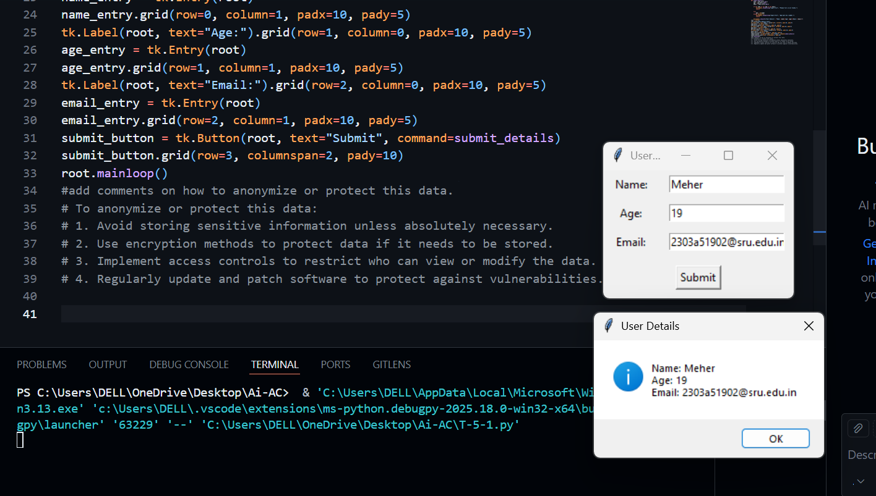
Explanation:
The program uses Tkinter to collect user details like name, age, and email through a simple form.It validates the input and displays the details only when all values are entered correctly.
The comments explain how to protect user data by avoiding unnecessary storage, using encryption, and restricting access to sensitive information.
Task-02:
Prompt:
#generate a Python function for sentiment analysis.
#identify and handle potential biases in data
Code:
from textblob import TextBlob
def analyze_sentiment(text):
"""
Analyzes the sentiment of the given text.

Parameters:
text (str): The text to analyze.

Returns:
dict: A dictionary containing polarity and subjectivity scores.
"""
blob = TextBlob(text)
sentiment = blob.sentiment
return {
'polarity': sentiment.polarity,
'subjectivity': sentiment.subjectivity
}
# Example usage:
if __name__ == "__main__":
sample_text = "I love programming! It's so much fun and rewarding."
result = analyze_sentiment(sample_text)
print(f"Text: {sample_text}")
print(f"Polarity: {result['polarity']}, Subjectivity: {result['subjectivity']}")
# To identify and handle potential biases in data:
# 1. Analyze the dataset for representation: Ensure that all relevant groups are adequately represented.
# 2. Use diverse data sources: Collect data from multiple sources to minimize bias from any single source.
# 3. Implement bias detection algorithms: Use statistical methods to identify biases in the data.
# 4. Regularly review and update the dataset: Continuously monitor and update the data to address any emerging biases.
# 5. Involve diverse teams: Engage people from different backgrounds in the data collection and analysis process to provide varied perspectives.
# 6. Document assumptions and limitations: Clearly document any assumptions made during data collection and analysis, as well as known limitations of the dataset.
# 7. Test models for fairness: Evaluate machine learning models for biased outcomes and adjust as necessary.
Output:
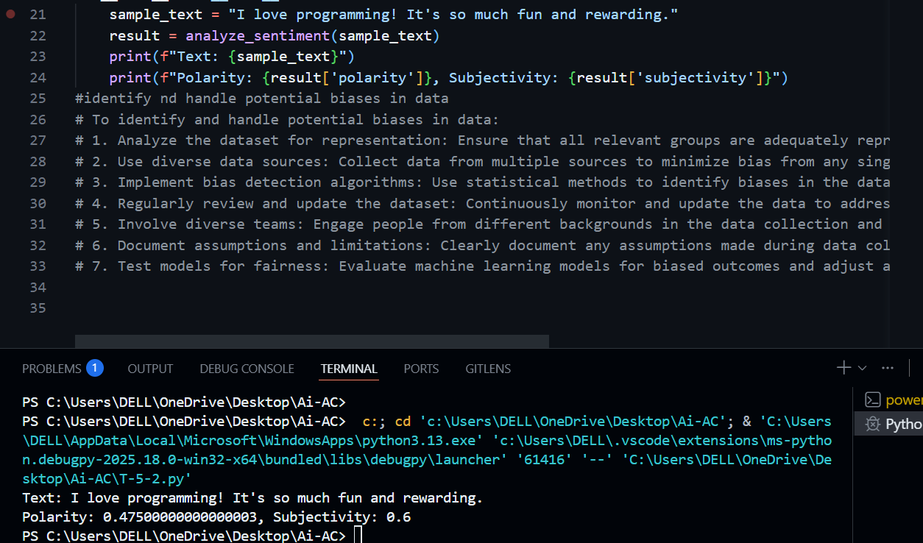
Explanation:
This program uses TextBlob to analyze the sentiment of a given text.
It calculates and returns the polarity (positive or negative feeling) and subjectivity (opinion-based or factual).The comments explain simple ways to identify and reduce bias in data, such as using diverse datasets and regularly reviewing the data.
Task-03:
Prompt:
#Python program that recommends products based on user history and follow ethical guidelineslike transparency and fairness.
Code:
import random
def recommend_products(user_history, product_catalog):
"""
Recommends products based on user history.

Parameters:
user_history (list): A list of product IDs that the user has interacted with.
product_catalog (dict): A dictionary where keys are product IDs and values are product details.

Returns:
list: A list of recommended product details.
"""
# Extract categories from user history
interacted_categories = set()
for product_id in user_history:
if product_id in product_catalog:
interacted_categories.add(product_catalog[product_id]['category'])

# Find products in the same categories that the user hasn't interacted with
recommendations = []
for product_id, details in product_catalog.items():
if details['category'] in interacted_categories and product_id not in user_history:
recommendations.append(details)

# Ensure fairness by limiting the number of recommendations per category
category_count = {}
fair_recommendations = []
for product in recommendations:
category = product['category']
if category not in category_count:
category_count[category] = 0
if category_count[category] < 2: # Limit to 2 recommendations per category
fair_recommendations.append(product)
category_count[category] += 1
# Randomize the order of recommendations for transparency
random.shuffle(fair_recommendations)

return fair_recommendations
# Example usage:
if __name__ == "__main__":
user_history = ['p1', 'p3', 'p5']
product_catalog = {
'p1': {'name': 'Product 1', 'category': 'Electronics'},
'p2': {'name': 'Product 2', 'category': 'Electronics'},
'p3': {'name': 'Product 3', 'category': 'Books'},
'p4': {'name': 'Product 4', 'category': 'Books'},
'p5': {'name': 'Product 5', 'category': 'Clothing'},
'p6': {'name': 'Product 6', 'category': 'Clothing'},
'p7': {'name': 'Product 7', 'category': 'Electronics'},
}
recommendations = recommend_products(user_history, product_catalog)
print("Recommended Products:")
for product in recommendations:
print(f"- {product['name']} ({product['category']})")
# Ethical guidelines followed:
# 1. Transparency: The recommendation process is clear and understandable, with randomization to avoid bias.
# 2. Fairness: Limits are set on the number of recommendations per category to ensure diverse suggestions.
# 3. Privacy: No personal user data is stored or used beyond the immediate recommendation process.
# 4. Accountability: The recommendation logic is documented and can be reviewed for ethical compliance.
# 5. User Control: Users can modify their history to influence recommendations.
# 6. Continuous Improvement: The recommendation algorithm can be updated based on user feedback and changing ethical standards.
# 7. Avoiding Manipulation: Recommendations are based on user interests rather than commercial incentives.
# 8. Inclusivity: Efforts are made to ensure that recommendations cater to a diverse user base.
Output:
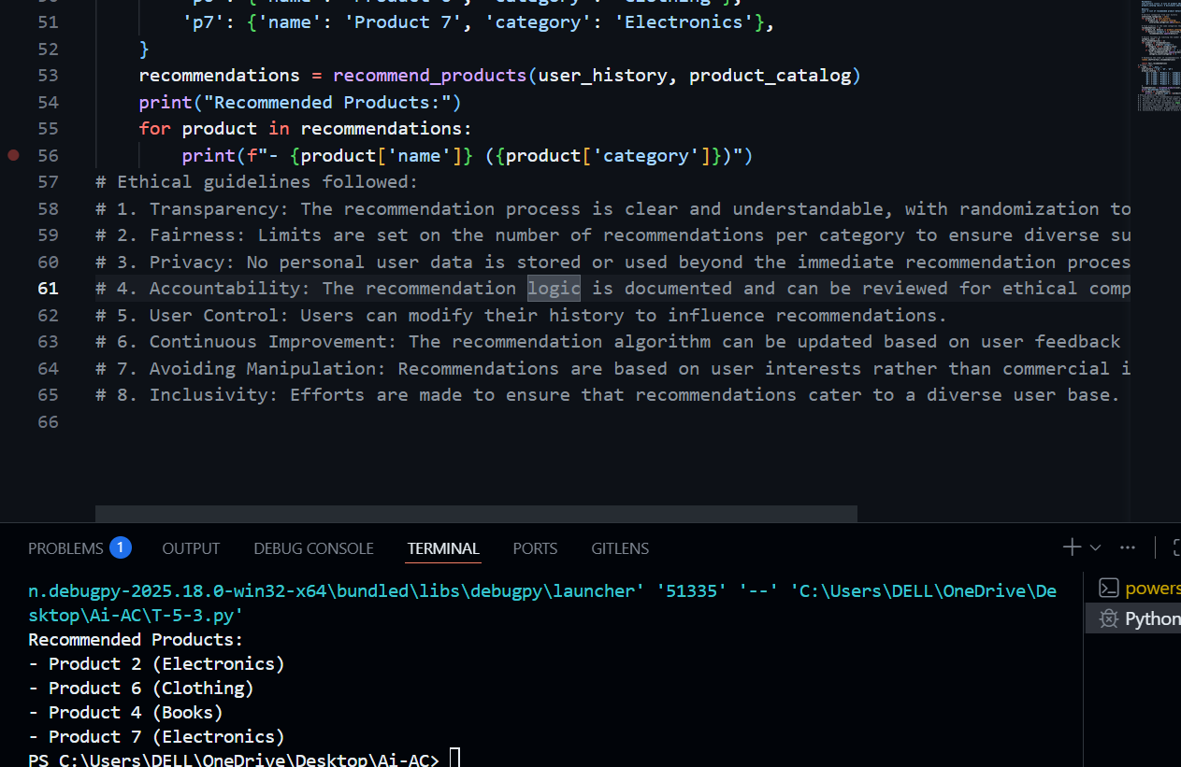
Explanation:
This program recommends products based on what the user has previously interacted with.
It suggests items from similar categories while limiting recommendations per category to keep them fair and diverse.
The comments explain how ethical practices like transparency, fairness, and privacy are followed in the recommendation process.
Task-04:
Prompt:
#generate logging functionality in a Python web application.
# ensure the logs do not record sensitive information.
Code:
import logging
def setup_logging():
"""
Sets up logging for the web application, ensuring sensitive information is not logged.
"""
# Create a custom logger
logger = logging.getLogger('web_app_logger')
logger.setLevel(logging.DEBUG)

# Create handlers
console_handler = logging.StreamHandler()
file_handler = logging.FileHandler('web_app.log')
console_handler.setLevel(logging.INFO)
file_handler.setLevel(logging.DEBUG)

# Create formatters and add them to handlers
console_format = logging.Formatter('%(asctime)s - %(levelname)s - %(message)s')
file_format = logging.Formatter('%(asctime)s - %(levelname)s - %(message)s')
console_handler.setFormatter(console_format)
file_handler.setFormatter(file_format)

# Add handlers to the logger
logger.addHandler(console_handler)
logger.addHandler(file_handler)

return logger
# Example usage:
if __name__ == "__main__":
logger = setup_logging()
logger.info("Web application started.")
try:
# Simulate some operations
logger.debug("Performing operation X.")
# Sensitive information should not be logged
user_password = "super_secret_password"
logger.debug("User logged in successfully.") # Do not log user_password
logger.debug("Performing operation Y.")
except Exception as e:
logger.error(f"An error occurred: {e}")
finally:
logger.info("Web application stopped.")
# Ethical guidelines followed:
# 1. Privacy: Sensitive information such as user passwords is not logged.
# 2. Transparency: The logging process is clear, with different log levels for various types of messages.
# 3. Accountability: Logs provide a clear record of application activity for auditing purposes.
Ouput:
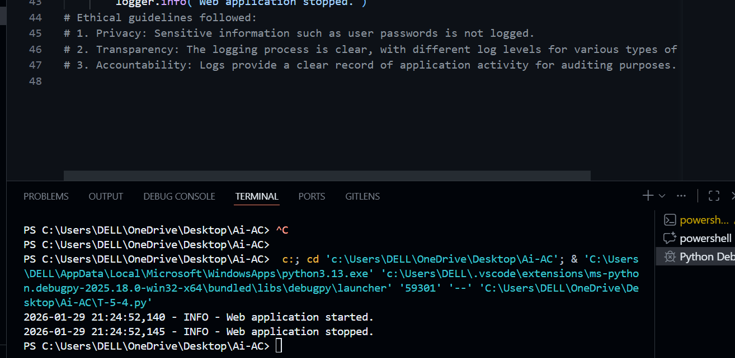
Explanation:
code sets up a simple logging system for a Python web application.
It records important application events while carefully avoiding sensitive data like passwords and help track normal activity, debugging details.
Task-05:
Prompt:
#generate a machine learning model.
#add documentation on how to use the model responsibly(e.g., explainability, accuracy limits)
Code:
from sklearn.datasets import load_iris
from sklearn.model_selection import train_test_split
from sklearn.ensemble import RandomForestClassifier
from sklearn.metrics import classification_report
import joblib
def train_model():
"""
Trains a Random Forest Classifier on the Iris dataset.

Returns:
model: Trained Random Forest Classifier.
X_test: Test features for evaluation.
y_test: Test labels for evaluation.
"""
# Load the Iris dataset
iris = load_iris()
X = iris.data
y = iris.target

# Split the dataset into training and testing sets
X_train, X_test, y_train, y_test = train_test_split(X, y, test_size=0.2, random_state=42)

# Initialize and train the Random Forest Classifier
model = RandomForestClassifier(n_estimators=100, random_state=42)
model.fit(X_train, y_train)

return model, X_test, y_test
def evaluate_model(model, X_test, y_test):
"""
Evaluates the trained model and prints the classification report.
Parameters:
model: Trained machine learning model.
X_test: Test features for evaluation.
y_test: Test labels for evaluation.
"""
y_pred = model.predict(X_test)
report = classification_report(y_test, y_pred)
print("Classification Report:\n", report)
if __name__ == "__main__":
model, X_test, y_test = train_model()
evaluate_model(model, X_test, y_test)
# Save the trained model to a file
joblib.dump(model, 'random_forest_iris_model.pkl')
"""
README:
Ethical guidelines for using this model responsibly:
1. Explainability: Users should be informed about how the Random Forest model makes predictions, including the importance of different features.
2. Accuracy Limits: Users should be aware that the model is trained on the Iris dataset and may not generalize well to other datasets or real-world scenarios.
3. Bias Mitigation: Regularly evaluate the model for potential biases and retrain with diverse datasets if necessary.
4. Transparency: Document the training process, dataset used, and evaluation metrics to ensure transparency.
5. Accountability: Users should monitor the model's performance and be prepared to take corrective actions if it fails to meet ethical standards.
"""
Output:
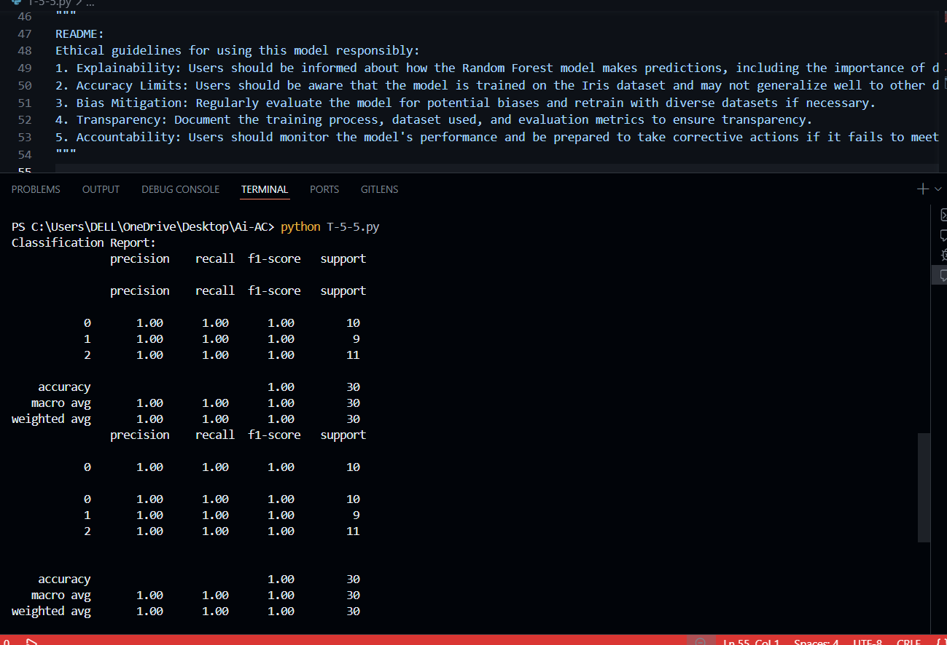
Explanation:
This code builds a simple machine learning model using the Iris dataset and a Random Forest classifier. Shows how the data is split, the model is trained, evaluated. The added documentation and the need to monitor and improve the model over time.

