How to flash the TTGO with the .bin file.

First download:
Flashtool:
https://www.espressif.com/sites/default/files/tools/flash_download_tool_v3.8.8_0.zip

Then:
https://github.com/Xinyuan-LilyGO/TTGO-T-Display/blob/master/firmware/LilyGo_T_Display_20200414.bin
And my .bin file:
https://github.com/RSZ-Nld/TTGO/raw/main/Si4735_Radio_TTGO.zip

The install Flashtools and open it with Esp32 > Dev and open it:
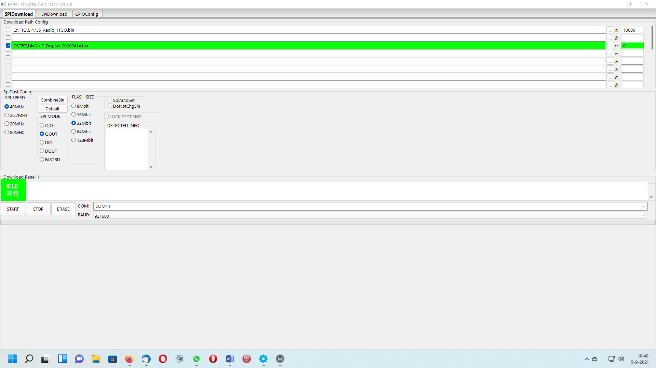

You see that i first flash the demo file, at adres : 0

After flash that push the button on the side of the TTGO.
You see the demo then

After that flash my bin file like this, at adres 10000:
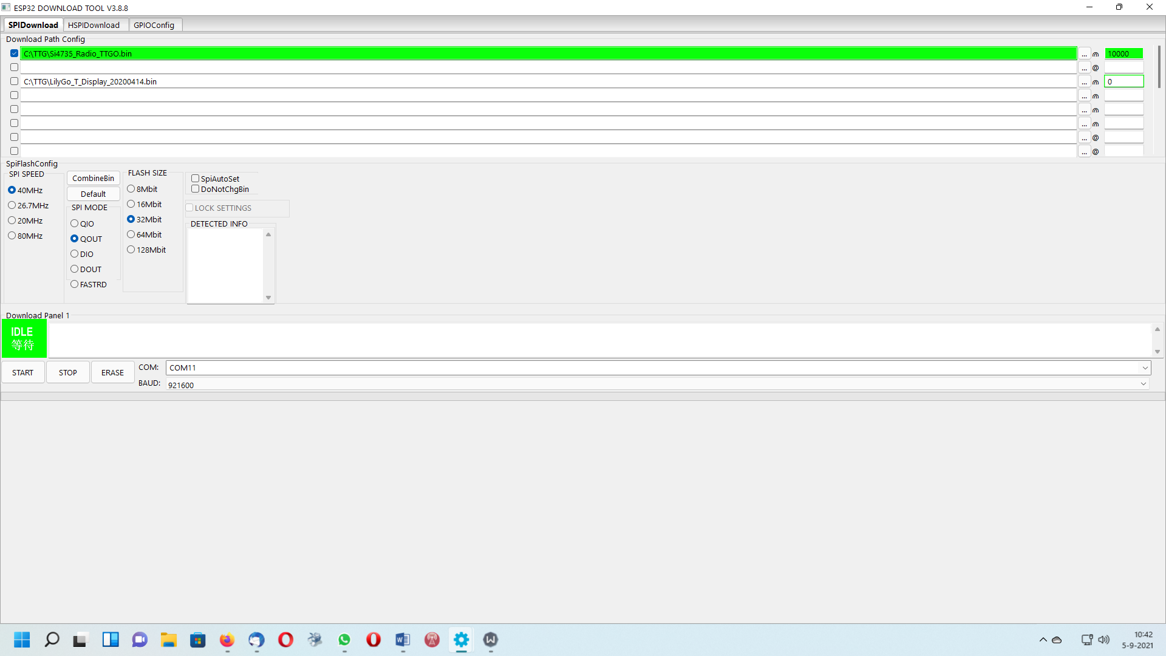

After flashed, push the button on the side of the TTGO and you got a working TTGO now!

