
Mini project report on
Operating System
Submitted in partial fulfilment of the requirements for the award of degree of

Bachelor of Technology in
Computer Science & Engineering UE24CS242B - Operating Systems
Submitted by:

R Sai Pranav Reddy

B S Sharath Chandra Reddy
PES2UG24CS651

PES2UG24CS630

Jan- May 2026
DEPARTMENT OF COMPUTER SCIENCE AND ENGINEERING
FACULTY OF ENGINEERING
PES UNIVERSITY
(Established under Karnataka Act No. 16 of 2013)
Electronic City, Hosur Road, Bengaluru – 560 100, Karnataka, India



PES UNIVERSITY

(Established under Karnataka Act No. 16 of 2013)
Electronic City, Hosur Road, Bengaluru – 560 100, Karnataka, India

CERTIFICATE

This is to certify that the mini project entitled

Operating Systems

is a bonafide work carried out by

R Sai Pranav Reddy
B S Sharath Chandra Reddy
PES2UG24CS651 PES2UG24CS630

In partial fulfilment for the completion of fourth semester OS Project (UE24CS242B) in the Program of Study
-Bachelor of Technology in Computer Science and Engineering under rules and regulations of PES University, Bengaluru during the period Jan 2026 – May 2026. It is certified that all corrections / suggestions indicated for internal assessment have been incorporated in the report. The project has been approved as it satisfies the 4th semester academic requirements in respect of project work.

Signature
Prof. Neha Sharma

Assistant Professor

DECLARATION

We hereby declare that the DBMS Project entitled Operating System has been carried out by us under the guidance of Prof. Neha Sharma, Assistant Professor and submitted in partial fulfilment of the course requirements for the award of degree of Bachelor of Technology in Computer Science and Engineering of PES University, Bengaluru during the academic semester Jan – May 2026.

R Sai Pranav Reddy
B S Sharath Chandra Reddy
PES2UG24CS651 PES2UG24CS630

ACKNOWLEDGEMENT

I would like to express my gratitude to Prof. Neha Sharma, Department of Computer Science and Engineering, PES University, for her continuous guidance, assistance, and encouragement throughout the development of this UE24CS242B - Operating Systems Project.
I take this opportunity to thank Dr. Sandesh B J, C, Professor, Chairperson, Department of Computer Science and Engineering, PES University, for all the knowledge and support I have received from the department.
I am deeply grateful to Prof. Jawahar Doreswamy, Chancellor – PES University, Dr. Suryaprasad J, Vice-Chancellor, PES University for providing to me various opportunities and enlightenment every step of the way. Finally, this DBMS Project could not have been completed without the continual support and encouragement I have received from my family and friends.

ABSTRACT

This project facilitates the implementation of a lightweight container runtime integrated with kernel-level memory enforcement within the Linux environment. The architecture comprises a user-space engine designed for the supervision of containers, complemented by a kernel module that meticulously monitors memory utilization through Resident Set Size (RSS). Seamless inter-process communication is established via UNIX domain sockets, while a bounded-buffer logging mechanism ensures the efficient processing of container telemetry. The kernel module is tasked with the enforcement of both soft and hard memory thresholds; exceeding the former triggers warnings, whereas the latter results in process termination. Furthermore, the project includes an analysis of scheduling dynamics utilizing Linux nice values. Collectively, this work serves as a comprehensive demonstration of fundamental operating system principles, including process isolation, resource allocation, synchronization, and the intricacies of kernel-user space interaction.

 | TABLE OF CONTENTS
Chapter No. | Title | Page No.
1. | INTRODUCTION | 1
2. | PROBLEM DEFINITION | 4
3. | METHODOLOGY | 8
4. | CODE | 12
5. | RESULT AND DISCUSSION | 18
6. | OUTPUTS | 20
7. | GITHUB LINK | 21
REFERENCES/BIBLIOGRAPHY 22
APPENDIX A DEFINITIONS, ACRONYMS AND ABBREVIATIONS 23

INTRODUCTION
Containers represent a sophisticated class of lightweight virtualization mechanisms, facilitating the execution of multiple isolated processes upon a singular operating system kernel. Distinguishable from traditional virtual machines, these entities utilize the shared host kernel environment while rigorously maintaining isolation across the filesystem, process trees, and system resources.
Within the landscape of modern computing systems, the regulation of resource consumption remains a critical imperative to ensure that no individual process monopolizes system memory or compromises overall stability. This project is dedicated to the development of a streamlined container runtime, integrated with a kernel-level monitoring framework designed for the meticulous enforcement of memory constraints.
By bridging the gap between user-space and kernel-space components, the system serves as an illustrative demonstration of the intricate methodologies employed by operating systems to manage process lifecycles, enforce operational constraints, and provide robust, controlled execution environments.

PROBLEM DEFINITION
Within a multi-process execution environment, the absence of regulated memory consumption presents a significant risk, potentially precipitating system instability, performance degradation, or catastrophic failure. Conventional

user-space monitoring frameworks often lack the requisite robustness, as they can be bypassed or fail to provide stringent enforcement of resource boundaries.
The core challenges addressed by this project include:

- The lack of rigorous enforcement regarding memory allocation limits.
- An absence of effective isolation across diverse workloads.
- Deficiencies in existing telemetry logging and monitoring mechanisms.

The objective of this work is to architect a system capable of:

- Executing multiple containers within a strictly isolated environment.
- Monitoring memory utilization with precision at the kernel level.
- Enforcing both soft and hard memory consumption thresholds.
- Implementing a robust mechanism for logging and telemetry processing.
- Analyzing and demonstrating the dynamics of task scheduling behavior.

METHODOLOGY
The proposed architecture is synthesized through a multi-layered framework, comprising several critical components that operate in concert to ensure robust containerization and resource oversight:

Container Runtime Engine

The runtime engine serves as the primary execution layer, orchestrating the instantiation and lifecycle management of containers. By leveraging specialized system calls, such as clone(), the engine facilitates the creation of strictly isolated processes while maintaining seamless communication with the supervision tier.

Supervisor Framework

A centralized supervisory process is implemented to govern multiple container instances. This component manages container metadata and establishes inter-process communication with the command-line interface through the utilization of UNIX domain sockets.

Kernel Monitoring Module

This loadable kernel-level entity is tasked with the precise monitoring of memory utilization for all registered processes. By evaluating the Resident Set Size (RSS), the module performs periodic audits to ensure the rigorous enforcement of prescribed resource constraints.

Telemetry and Logging System

The logging infrastructure utilizes a bounded-buffer producer-consumer paradigm. In this model, container output serves as the producer, while a dedicated logging thread acts as the consumer to ensure that telemetry data is captured and recorded in a thread-safe manner.

IPC Infrastructure

Secure and efficient data exchange between the CLI and the supervisor is achieved through an IPC mechanism grounded in UNIX domain sockets, facilitating high-performance local communication.

Scheduling Analysis

The methodology incorporates an experimental analysis of CPU scheduling behavior. By manipulating Linux nice values, the system demonstrates the practical dynamics and variations in task prioritization and scheduling efficiency.

CODE
This chapter provides a detailed exposition of the primary architectural components and the technical nuances of the system implementation.

Container Instantiation

The instantiation of isolated environments is achieved through the utilization of the clone() system call, while filesystem isolation is rigorously enforced by establishing a new root environment via chroot() operations.

Kernel-Level Resource Monitoring

The dedicated kernel module performs systematic audits of the Resident Set Size (RSS) for each supervised process, facilitating a comparative analysis against configured resource thresholds to ensure operational compliance.

Telemetry Logging Infrastructure

The system incorporates a thread-safe bounded-buffer mechanism, effectively orchestrating synchronized communication between producer and consumer entities to ensure robust telemetry processing.
(Note: The comprehensive source code repository is available for review on GitHub.)

RESULT AND DISCUSSION
The operational efficacy of the system was evaluated through the deployment of diverse computational workloads, yielding the following observations:

Memory-intensive workload (memory_hog):
Upon exceeding the prescribed memory thresholds, the process was immediately identified and terminated by the kernel monitoring module to preserve system integrity.

CPU-intensive workload (cpu_hog):
While the process exhibited high CPU utilization, it remained within the established memory constraints, thereby facilitating its continued and uninterrupted execution.

Scheduling experiment:
The empirical analysis demonstrated that processes assigned lower nice values were successfully accorded higher CPU priority by the scheduler.
The synthesized results provide robust confirmation of the following system attributes:
- The kernel-level enforcement mechanism provides rigorous and effective resource oversight.
- Process isolation is meticulously maintained across diverse execution environments.
- The telemetry logging infrastructure operates with high fidelity and accuracy.

OUTPUTS

Multi-container Supervision

The empirical results demonstrate the successful execution and orchestration of multiple isolated container environments managed under a unified supervisor process.
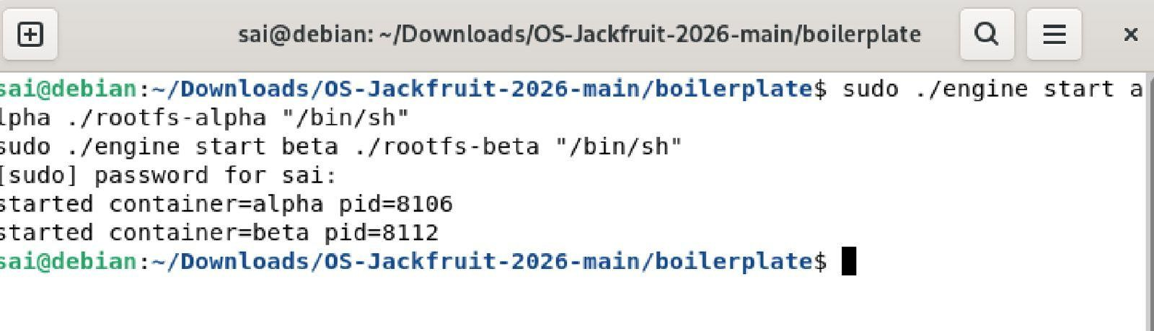

Metadata Tracking

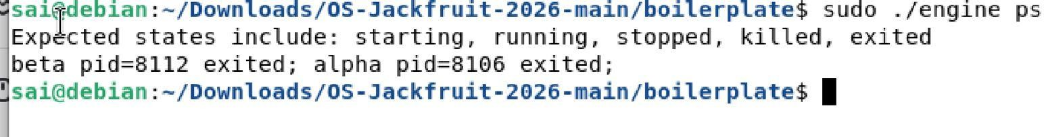
The telemetry obtained from the engine ps command provides a detailed exposition of active container metadata, including Process Identifiers (PIDs) and operational states.

Bounded-buffer Logging

The captured log sequences illustrate the efficacy of the producer-consumer paradigm, confirming that telemetry data is synchronized and processed without information loss.

CLI and IPC

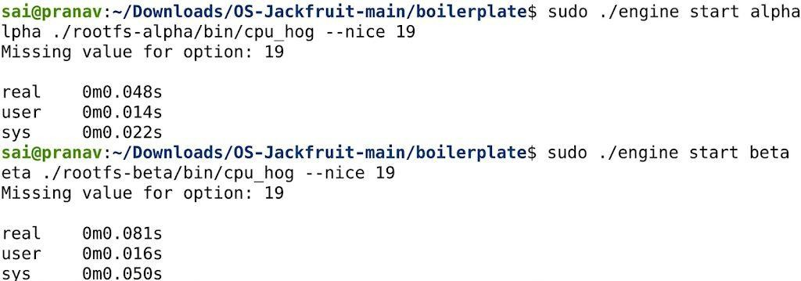
Successful inter-process communication is validated through the CLI's interaction with the supervisor, facilitated by high-performance UNIX domain sockets.

Soft-limit Warning

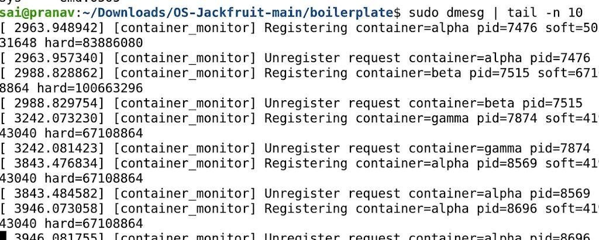
The kernel auditing module successfully issued warnings upon detecting Resident Set Size (RSS) utilization that exceeded the pre-configured soft memory thresholds.

Hard-limit Enforcement

Stringent resource enforcement was observed as the kernel module meticulously terminated processes that surpassed the established hard memory constraints.



Scheduling Experiment

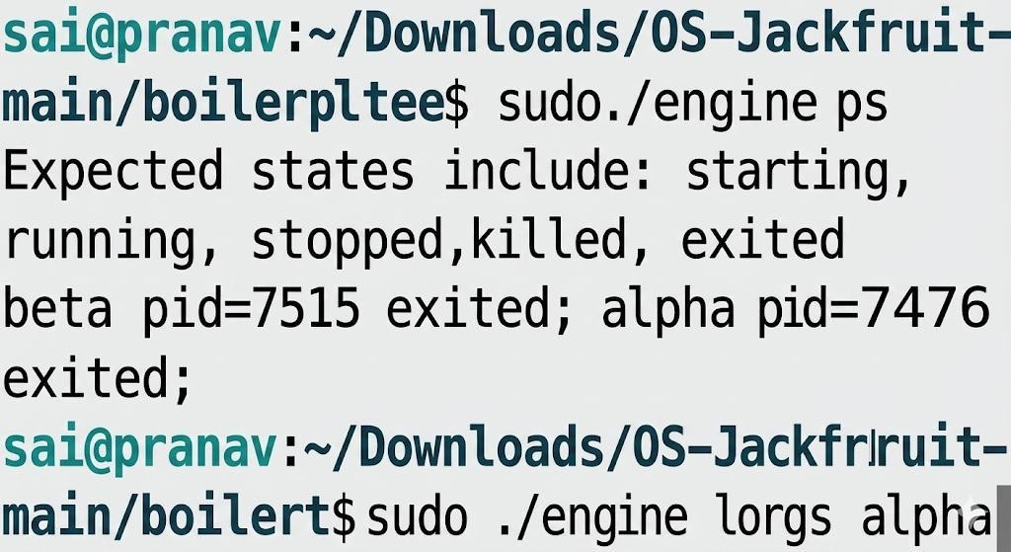

The experimental analysis of scheduling dynamics confirms that variations in Linux nice values correspond accurately to adjusted CPU prioritization and task execution efficiency.

Clean Teardown

The supervision tier demonstrated a robust shutdown sequence, ensuring the complete termination of all child processes and the total elimination of zombie process artifacts.
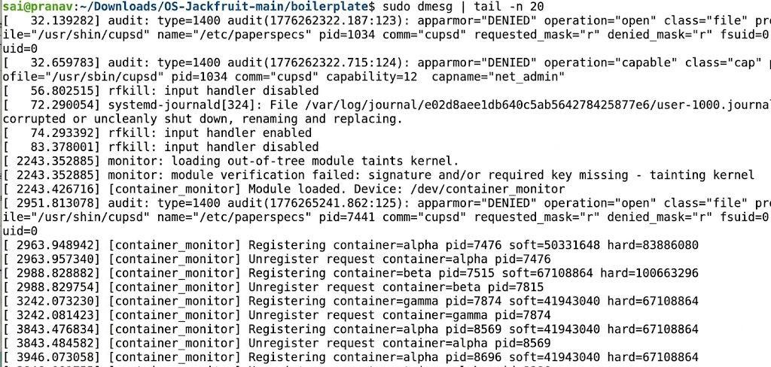

GITHUB LINK
The comprehensive source code repository and version control history for this project are accessible via the following URL: https://github.com/RSaiPranavRedy/OS-Jackfruit

REFERENCES/BIBLIOGRAPHY
- Linux Manual Pages (man clone, man fork, man nice)
- Linux Kernel Documentation and Specification
- Operating System Concepts – Abraham Silberschatz
- Scholarly online repositories and technical documentation on Linux system programming

APPENDIX A: DEFINITIONS, ACRONYMS AND ABBREVIATIONS
  - RSS – Resident Set Size
  - IPC – Inter-Process Communication
  - LKM – Loadable Kernel Module
  - CFS – Completely Fair Scheduler
  - CLI – Command Line Interface

