Markdown 2

Rachael Sanderson

5 November 2019

# **An Evaluation of the Use of Video**

Since the third cycle of the course, videos have been used as an educational method. The data collected has considered the video duration, total views and viewer location amongst other factors. It is important to reflect on the use of this method, and whether there is a high uptake by students to make them a worthwhile educational tool

## **The data itself**

Initially, the data was considered through 5 datasets, for each run of the course that used videos.The Video data itself is a strong dataset, with responses or quantities for all categories investigated.

## **Data Preparation**

The final dataset was constructed within a dataframe, as is seen below. Each column was selected from their respective datasets, then pulled together into a single object, with additional average and duration columns to support the analysis.

#creating each column  
StepPosition = Video3$step_position #seperating columns for vectors  
V3Views = Video3$total_views  
V4Views = Video4$total_views  
V5Views = Video5$total_views  
V6Views = Video6$total_views  
V7Views = Video7$total_views  
Average = (V3Views +V4Views +V5Views +V6Views +V7Views)/5 #average over the runs  
  
#Linking the columns together within a single dataframe  
DFViews = data.frame (Step = StepPosition, Video3 = V3Views, Video4 = V4Views, Video5 = V5Views,Video6 = V6Views,Video7 = V7Views,   
 Duration = Video3$video_duration, Mean = Average)

This dataframe allowed a clear comparison across the datasets, to inform the temporal analysis of the use of videos within the educational course. the final product can be seen below:

## **The Findings**

The final analysis produced a ggplot of each layer, to visualise how use of the video platform has changed over time.

Graph=ggplot (data = DFViews, aes (x = Step, y= V3Views))  
g3 = Graph + geom_point(aes(x = Step, y=V3Views, colour = "Course Run 3")) #adding each course run  
g4 = g3+ geom_point (aes (x=Step, y=V4Views, colour = "Course Run 4"))  
g5 = g4+ geom_point (aes (x=Step, y=V5Views, colour = "Course Run 5"))   
g6 = g5+ geom_point (aes (x=Step, y=V6Views, colour = "Course Run 6"))  
g7= g6+ geom_point (aes (x=Step, y=V7Views, colour = "Course Run 7"))  
  
g8 = g7 + geom_line (aes(x=Step, y=Mean, colour = "Average Views")) #adding the average line  
g8 #NEEDS LABELS BEFORE SUBMISSION

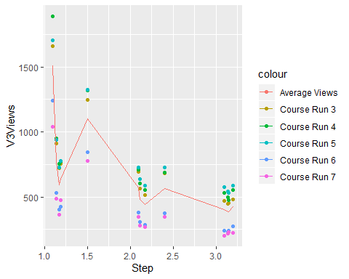

This could also be visualised as a line chart from a similar process, using geom_line instead of geom_point;

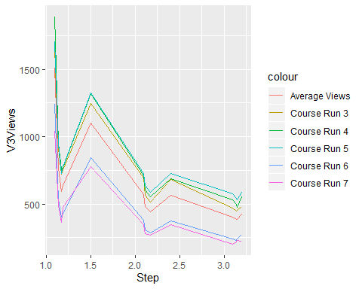 This chart reflects how the use of videos has varied over time since they were introduced throughout the course. Additionally,