Markdown 2

Rachael Sanderson

5 November 2019

NEED SOME FINAL CONCLUSION/POINT TO ALL OF THIS. # *An Evaluation of the Use of Video* Since the third cycle of the course, videos have been used as an educational method. The data collected has considered the video duration, total views, viewing method and viewer location amongst other factors. It is important to reflect on the use of this method, and whether there is a high uptake by students to make them a worthwhile educational tool. Awareness of this information has potential to inform whether videos are a worthwhile investment as an educational method, and so whether the use of them should be increased or decreased.

## *The data itself*

Initially, the data was considered through 5 datasets, for each run of the course that used videos.The Video data itself is a strong dataset, with responses or quantities for all categories investigated.

## *Data Preparation*

The final dataset was constructed within a dataframe, as is seen below. Each column was selected from their respective datasets, then pulled together into a single object, with additional average and duration columns to support the analysis.

#creating each column  
StepPosition = Video3$step_position #seperating columns for vectors  
V3Views = Video3$total_views  
V4Views = Video4$total_views  
V5Views = Video5$total_views  
V6Views = Video6$total_views  
V7Views = Video7$total_views  
Average = (V3Views +V4Views +V5Views +V6Views +V7Views)/5 #average over the runs  
  
#Linking the columns together within a single dataframe  
DFViews = data.frame (Step = StepPosition, Video3 = V3Views, Video4 = V4Views, Video5 = V5Views,Video6 = V6Views,Video7 = V7Views,   
 Duration = Video3$video_duration, Mean = Average)

This dataframe allowed a clear comparison across the datasets, to inform the temporal analysis of the use of videos within the educational course. the final product can be seen below:

## Step Video3 Video4 Video5 Video6 Video7 Duration Mean  
## 1 1.10 1659 1890 1706 1244 1041 99 1508.0  
## 2 1.14 910 952 941 533 489 362 765.0  
## 3 1.17 723 757 728 404 362 241 594.8  
## 4 1.19 755 770 780 423 476 348 640.8  
## 5 1.50 1248 1318 1324 843 777 281 1102.0  
## 6 2.10 694 708 726 381 345 37 570.8  
## 7 2.11 564 607 637 309 282 312 479.8  
## 8 2.17 516 552 585 284 270 92 441.4  
## 9 2.40 680 688 725 378 348 426 563.8  
## 10 3.10 473 530 576 243 203 59 405.0  
## 11 3.14 446 500 544 230 220 313 388.0  
## 12 3.15 455 478 530 241 228 227 386.4  
## 13 3.20 484 557 590 275 227 206 426.6

## *The Findings*

The final analysis produced a ggplot of each layer, to visualise how use of the video platform has changed over time.

Graph=ggplot (data = DFViews, aes (x = Step, y= Total.Video.Views))  
g3 = Graph + geom_point(aes(x = Step, y=V3Views, colour = "Course Run 3")) #adding each course run  
g4 = g3+ geom_point (aes (x=Step, y=V4Views, colour = "Course Run 4"))  
g5 = g4+ geom_point (aes (x=Step, y=V5Views, colour = "Course Run 5"))   
g6 = g5+ geom_point (aes (x=Step, y=V6Views, colour = "Course Run 6"))  
g7= g6+ geom_point (aes (x=Step, y=V7Views, colour = "Course Run 7"))  
  
g8 = g7 + geom_line (aes(x=Step, y=Mean, colour = "Average Views")) #adding the average line  
g9 = g8 +labs(title="Total Viewings of each Video",  
 x ="Video Step", y = "Total Views")  
g8

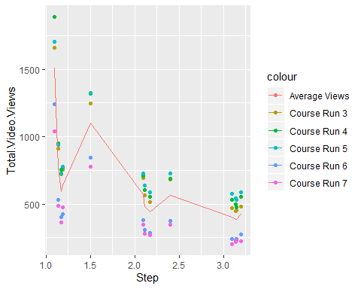

This could also be visualised as a line chart from a similar process, using geom_line instead of geom_point;

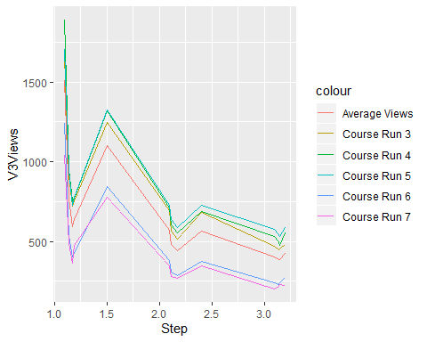 Alternatively, a proportional representation acknowledges the number of people who were accepted at the start of each course, to provide context to the changes;

DFViewsProportion = data.frame (Step = StepPosition, Video3 = (V3Views/(Cohort_Summaries$Entries[3])), Video4 = V4Views/ (Cohort_Summaries$Entries[4]), Video5 = V5Views/(Cohort_Summaries$Entries[5]),Video6 = V6Views/(Cohort_Summaries$Entries[6]),Video7 = V7Views/(Cohort_Summaries$Entries[7]),   
 Duration = Video3$video_duration)  
  
Line=ggplot (data = DFViewsProportion, aes (x = Step, y= Video3)) #initial line coordinates  
  
L3 = Line + geom_line(aes(x = Step, y=Video3, colour = "Course Run 3")) #adding each run  
L4 = L3+ geom_line (aes (x=Step, y=Video4, colour = "Course Run 4"))  
L5 = L4+ geom_line (aes (x=Step, y=Video5, colour = "Course Run 5"))   
L6 = L5+ geom_line (aes (x=Step, y=Video6, colour = "Course Run 6"))  
L7= L6+ geom_line (aes (x=Step, y=Video7, colour = "Course Run 7"))  
  
L7

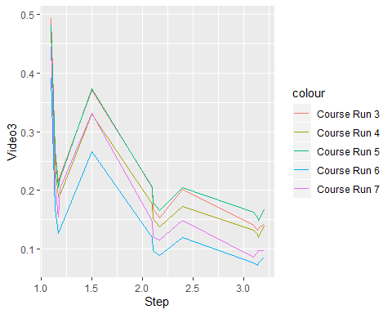 This reflects no clear pattern that differs when acknowledging the number of students that start the course.

## *The Impact of Duration*

Graph=ggplot (data = DFViews, aes (x = Duration, y= Total.Video.Views))  
g3 = Graph + geom_point(aes(x = Duration, y=V3Views, colour = "Course Run 3")) #adding each course run  
g4 = g3+ geom_point (aes (x=Duration, y=V4Views, colour = "Course Run 4"))  
g5 = g4+ geom_point (aes (x=Duration, y=V5Views, colour = "Course Run 5"))   
g6 = g5+ geom_point (aes (x=Duration, y=V6Views, colour = "Course Run 6"))  
g7= g6+ geom_point (aes (x=Duration, y=V7Views, colour = "Course Run 7"))  
  
g8 = g7 + geom_line (aes(x=Duration, y=Mean, colour = "Average Views")) #adding the average line  
g9 = g8 +labs(title="Total Viewings of each Video",  
 x ="Video Duration", y = "Total Views")  
g8

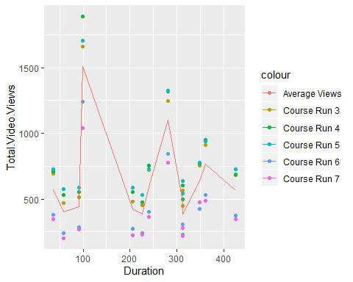 Duration apprears to have limited impact on the number of people watching the videos, particularly when compared to the trends shown when comparing to Steps.

## *Evaluation*

What has been shown? Reflect on the methods