This memo outlines the proposed architecture for including the macroalgae growth model   
(MAL) of Broch et al. (2011) in DELWAQ

# State variables

There will be 4 new state variables:

1. MALS - MacroALgae Structural biomass
2. MALN - MacroALgae Nitrogen storage
3. MALP - MacroALgae Phosphorous storage
4. MALC - MacroALgae Carbon storage

These are described in Figure 1.

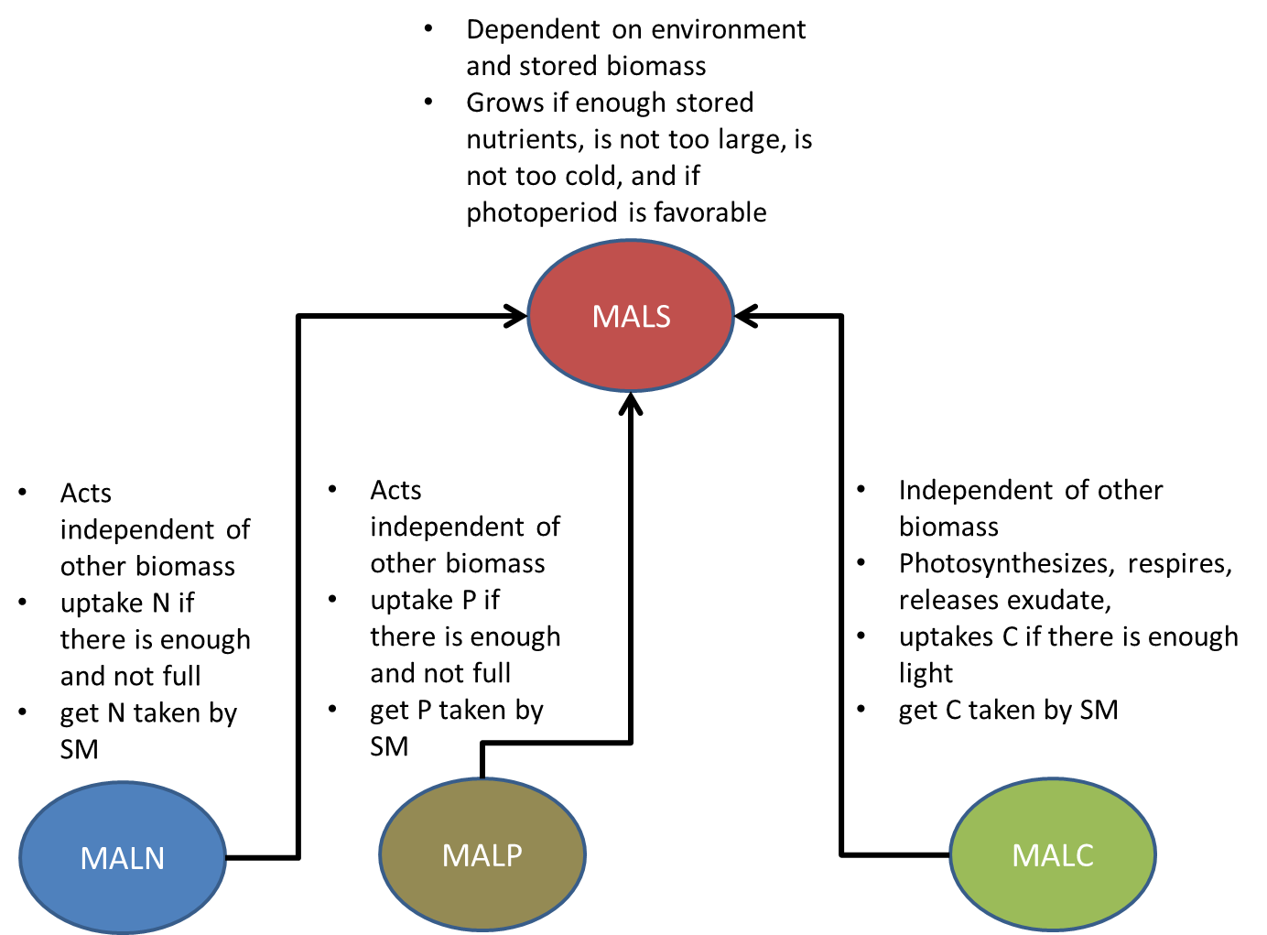

Figure 1- description of state variables

# Governing equations

The most important equations are listed here

## MALS

Change in biomass (gDM/day)

$$\frac{dM}{dt}= M(μ-ϑ)$$

Control on specific growth rate (d-1)

Temperature function

$$f_{temp}=\left\{0.08T+0.2 | 1 |\frac{19}{4}-\frac{T}{4} |0 \right\} for T=\left\{-1.8<T<10 \right|10≤T≤15 \left| 15<T≤19 \right|T>19\}$$

Biomass density function

$$f_{density}=m_{1}\exp\left[-{\left(\frac{MALS}{MALS_{0}}\right)}^{2}\right]+m_{2}$$

Photoperiod function

$$f_{photo}=a_{1}\left[1+\sin\left(τ\left(n\right){\left|τ\left(n\right)\right|}^{\frac{1}{2}}\right)\right]+a_{2}$$

$$τ=function expressing the normalized change in photoperiod at day n relative to day n-1=f(latitude,day)$$

Specific mortality rate (d-1)

## MALN

Change in storage

$$\frac{dMALN}{t}=J- μ(k_{N}MALS+MALN)$$

Uptake rate of N to storage

$$J=f_{velocity}J_{maximum}\left(\frac{NO_{3}^{-}}{K_{s}+NO_{3}^{-}}\right)\left(\frac{MALN_{maximum}-MALN}{MALN_{maximum}-MALN_{minimum}}\right)$$

$$f_{velocity}=\left[1-\exp\left(\frac{-U}{U_{0.65}}\right)\right]$$

## MALP

Change in storage

$$\frac{dMALP}{t}=J- μ(k_{P}MALS+MALP)$$

Uptake rate of N to storage

$$J=f_{velocity}J_{maximum}\left(\frac{PO_{4}^{3-}}{K_{s}+PO_{4}^{3-}}\right)\left(\frac{MALP_{maximum}-MALP}{MALP_{maximum}-MALP_{minimum}}\right)$$

## MALC

Change in storage

$$\frac{dC}{dt}=\left[P\left(1-E\right)-R\right]- μ(MALS+MALC)$$

Gross photosynthesis (production) rate

$$P=P_{s}\left(1-\exp\left(-\frac{αI}{P_{s}}\right)\right)\exp\left(-\frac{βI}{P_{s}}\right)$$

$$P_{s}=\frac{αI_{sat}}{\ln\left(1+\frac{α}{β}\right)}$$

$$P_{maximum}=\frac{αI_{sat}}{\ln\left(1+\frac{α}{β}\right)} \left(\frac{α}{α+β}\right){\left(\frac{β}{α+β}\right)}^{\frac{β}{α}}$$

*Solve for Beta using Newton’s method, also not all of these temperatures are specified*

$$P_{maximum}=\frac{P_{1}\exp\left(\frac{T_{AP}}{T_{P1}}-\frac{T_{AP}}{T}\right)}{1+\exp\left(\frac{T_{APL}}{T}-\frac{T_{APL}}{T_{PL}}\right)+\exp\left(\frac{T_{APH}}{T_{PH}}-\frac{T_{APH}}{T}\right)}$$

Respiration rate

$$R=r_{1}exp⁡\left(\frac{T_{A}}{T_{1}}-\frac{T_{A}}{T}\right)$$

Ratio Exudation

$$E=1-\exp\left(γ\left({MALC}_{minimum}-MALC\right)\right)$$

# Expected fluxes

## MALS

|  |  |
| --- | --- |
| **FROM** | **TO** |
| GroMALS | GroMALS |
|  |  |
|  |  |
|  |  |

## MALN

|  |  |
| --- | --- |
| **FROM** | **TO** |
| GroMALN | GroMALN |
|  | GroMALS |
|  |  |
|  |  |

## MALP

|  |  |
| --- | --- |
| **FROM** | **TO** |
| GroMALP | GroMALP |
|  | GroMALS |
|  |  |
|  |  |

## MALC

|  |  |
| --- | --- |
| **FROM** | **TO** |
| GroMALC | GroMALC |
|  | GroMALS |
|  |  |
|  |  |

## TIC

|  |  |
| --- | --- |
| **FROM** | **TO** |
| GroMALC | GroMALC |
|  |  |
|  |  |
|  |  |

## OXY

|  |  |
| --- | --- |
| **FROM** | **TO** |
| GroMALC | GroMALC |
|  |  |
|  |  |
|  |  |

## NO3

|  |  |
| --- | --- |
| **FROM** | **TO** |
| GroMALN | GroMALN |
|  |  |
|  |  |
|  |  |

## PO4

|  |  |
| --- | --- |
| **FROM** | **TO** |
| GroMALP | GroMALP |
|  |  |
|  |  |
|  |  |

## POC

|  |  |
| --- | --- |
| **FROM** | **TO** |
| GroMALS |  |
| GroMALC (exudate?) |  |
|  |  |
|  |  |

## PON

|  |  |
| --- | --- |
| **FROM** | **TO** |
| GroMALS |  |
|  |  |
|  |  |
|  |  |

## POP

|  |  |
| --- | --- |
| **FROM** | **TO** |
| GroMALS |  |
|  |  |
|  |  |
|  |  |

# Expected subroutine structure

## GroMALS

Calculate the change in biomass of MALS in each segment

**Input:**

MALNmin – minimum N in storage

MALPmin – minimum P in storage

MALCmin – minimum C in storage

## GroMALN (/GroMALP)

Calculate the change in nutrient storage

## GroMALC

Calculate the change in carbon storage

Takes TIC from the water based on rate of P

Produces O2 based on rate of R

## MALDIS

Determine distribution of biomass and storage over water column

Will rely on maximum height and maximum biomass density (g/m)

Can specify a min depth

Can specify a max depth

Plants will grow from min depth to max depth. Direction will depend on relative signs of min depth and max depth

There is inherently a planting density as well in g/m2. However we would not be able to distinguish between a few long plants and many short plants, which have the same biomass density in g/m2 but have much different effect on the ambient conditions.

To reduce this ambiguity we strive to maintain a length to weight ratio, or the g/m value for a given m2. Basically, what it describes is how much mass is required to get all of the algae in a m2 to grow a m in length. We can describe it as g/m2 * m = g/m3, or to better think about it as is g/m per m2. This is called the length density. It will depend on the farm and the algae.

If the seeding density is low, there will be a low value for this number. If is it high then more carbon is required to allow the whole group to extend its length

The overall sequence of the processes can be described as follows:

1. There is a certain mass g/m2 in the ibot seg
2. At the beginning of a time step you take the structural biomass MALS and divide it by the length density to get a length.
3. This length is divided into all relevant segments and each segment is given an FrBmMALS. The amount of MALN and MALC follows naturally from this as they are in units of gX/DM.
4. In each segment that has biomass, the calculations of biomass dynamics for MALS, MALN, MALC are done using the concentrations that arise from MALX * FrBmMALS. The fluxes on substances that do not have to do with MAL (POC, NH4, PO4, CO2) happen here in the segments using the ‘Ghost masses’ derived from fractions.
5. All of the fluxes for the MAL substances get communicated to the bottom segment and added up, the change in biomass of MALS, MALN, MALC are applied. This communication might be very challenging. Unless we prescribe a local flux as an output parameter, and the bottom segment it to all of its children and add up these fluxes for MALS, MALN, MALP, and MALC? Or another process that does the growth, whereas grMALS only computes the fluxes.

! Logic check

* so each segment receives a bit of ghost structural and storage mass
* the fluxes are calculated using this mass andthe local ambient environment
* the fluxes are applied to ambient dissolved parameters, but not algae parameters
* the fluxes of algae parameters are communicated to the bottom segment, whereby they are summed to compute the net change in MALS, MALN, MALP, and MALC
* this gives the new mass of each in the bottom segment
* the plant will have gotten longer or shorter, and overall reserves will have changed
* the local per segment reserves adopt the reserve ratio of the whole column
* what this means is the entire segment has a fixed structural to storage ratio, as in no segment can have a beefier part of the plant than the other
* This is similar to a communist farm field, whereby 6 workers all go to work their field and cultivate grain. Some will cultivate more grain than they need to eat if their field is favourable, and others will not if their field falters. Those with surplus at the end of the day will redistribute to those who did not get enough at the end of the day. There is therefore a per-person (segment) surplus or deficit, and a community deficit.

Summary

FLMALS – flux calculation for Macroalgae structural mass

FLMALN – flux calculation for Macroalgae Nitrogen mass

FLMALP – flux calculation for Macroalgae Phosphorous mass

FLMALC – flux calculation for Macroalgae carbon mass

MALDIS – calculates the fraction biomass in each layer

MALGRO – calculates the fluxes on MALS, MALN, MALP and MALC based on what happens in child segments

ExtVLMA – calculates extinction due to macroalgae in segment

Something to think about:

In the paper, g sw is not the same g/m2 as in delwaq, it is g of plant assuming the plant grows like a ball. The area of the plant in m2 is the actual state variable, but there is a fixed relationship between area and mass

Basically what is being modelled is ‘fattness’ ,which is the surface area of the plant

As the algae grow, as in the sw grows, their surface area increases because they get fatter

So in the model the g/m2 is analogous to the length of the plant. In our model they will not get fatter but they will get longer. But knowing the length alone will not help you, because you could have a single long or many long plants, which changes the area. Thus, like the length calculation, we calculate the area based on an Area Density and the mass. This flux needs to be computed in the segment for the purpose of calculating the decay products per cell. So what will happen is that the total area and the local area will be used to calculate the total decay product and the local decay will be that decay times the fraction biomass. Thus the algae will be inhibited uniformly (density, which is area in the water column), and the decay will be local depending on the area (mass) in that segment.

To keep track of the surface area of the plant material itself we need to have a relation between mass, length, total area, and mass per surface area water

So we know how many grams we have in a m2.

The length density tells us how long this plant should be

The area density tells us how much area this mass has

The fraction of the biomass will also give the fraction of the area

The user needs to know the length density and the area density of the particular macroalgae installation.