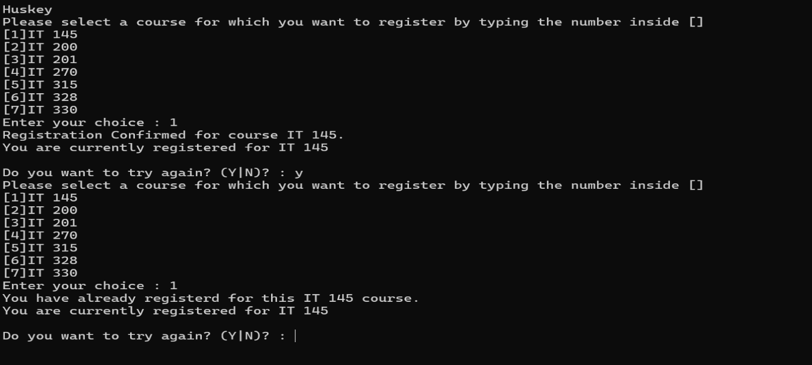
The program displays the available course menu and allows the student to select a course for registration. I selected option 1, and the program successfully registered me for IT 145 and displayed it as my current registration. I then selected IT 145 again, and the program correctly prevented me from registering for the same course more than once by displaying an error message.
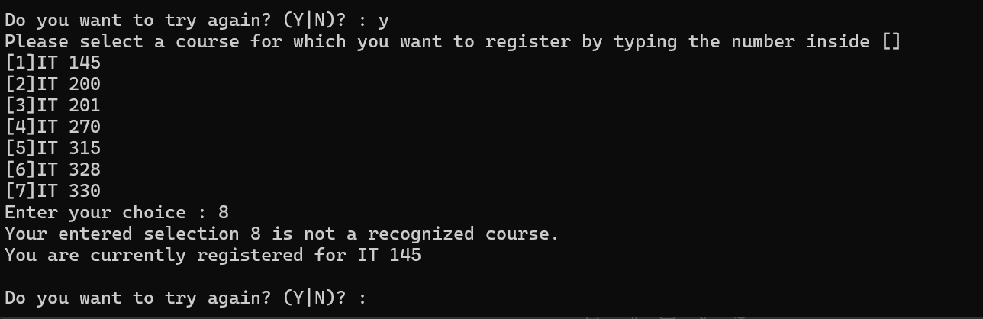
The program validates the student’s selection and prevents registration for courses that are not displayed in the menu. I entered option 8, which is outside the valid range of 1 through 7. The program displayed an error message and kept my existing IT 145 registration unchanged.
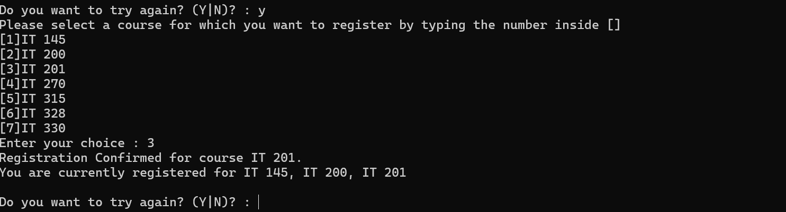
The program allows the student to register for multiple different courses. I successfully registered for IT 145, IT 200, and IT 201. Since each course is worth three credit hours, these three courses bring the registration total to the maximum of nine credit hours.
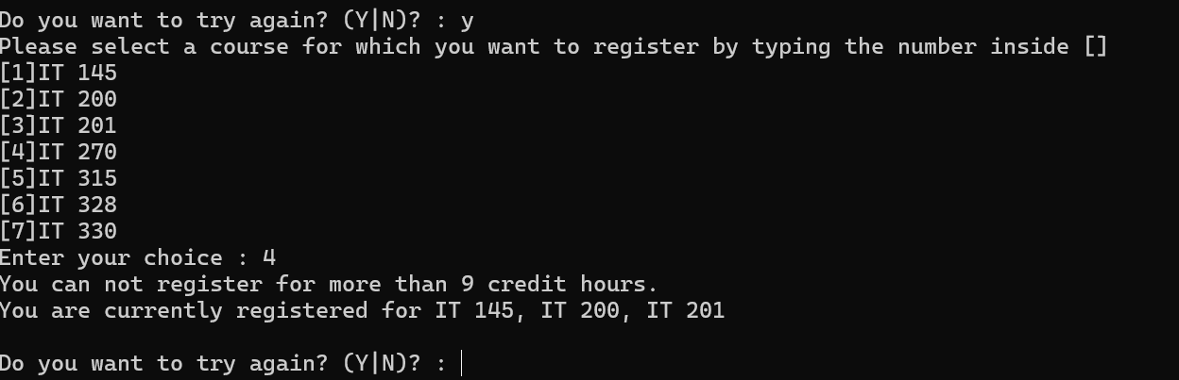
The program enforces the maximum registration limit of nine credit hours. After registering for IT 145, IT 200, and IT 201, I attempted to register for IT 270 as a fourth course. The program prevented the additional registration and displayed a message stating that I could not register for more than nine credit hours. My existing three-course registration remained unchanged.
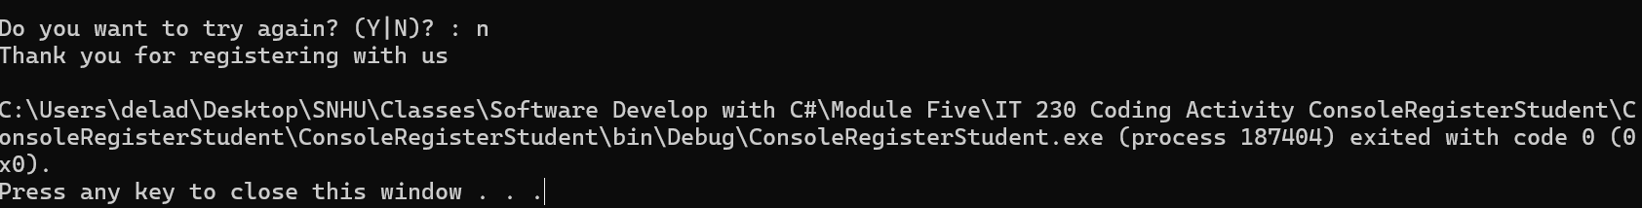
The program continues allowing the student to make registration selections until the student chooses to stop. I entered N when asked if I wanted to try again. The program displayed a thank-you message and then terminated successfully.

Source Code:
using System;
using System.Collections.Generic;
using System.Linq;
using System.Text;
using System.Threading.Tasks;

namespace ConsoleRegisterStudent
{
class Program
{
static void Main(string[] args)
{
(new Program()).run();
}

void run()
{
int choice;
int firstChoice = 0, secondChoice = 0, thirdChoice = 0;
int totalCredit = 0;
string yesOrNo = "";

System.Console.WriteLine("Huskey");

do
{
WritePrompt();
choice = Convert.ToInt32(Console.ReadLine());

switch (ValidateChoice(choice, firstChoice, secondChoice, thirdChoice, totalCredit))
{
case -1:
Console.WriteLine("Your entered selection {0} is not a recognized course.", choice);
break;
case -2:
Console.WriteLine("You have already registerd for this {0} course.", ChoiceToCourse(choice));
break;
case -3:
Console.WriteLine("You can not register for more than 9 credit hours.");
break;
case 1:
case 2:
case 3:
case 4:
case 5:
case 6:
case 7:
Console.WriteLine("Registration Confirmed for course {0}.", ChoiceToCourse(choice));
totalCredit += 3;
if (firstChoice == 0)
firstChoice = choice;
else if (secondChoice == 0)
secondChoice = choice;
else if (thirdChoice == 0)
thirdChoice = choice;
break;
}

WriteCurrentRegistration(firstChoice, secondChoice, thirdChoice);
Console.Write("\nDo you want to try again? (Y|N)? : ");
yesOrNo = (Console.ReadLine()).ToUpper();
} while (yesOrNo == "Y");

Console.WriteLine("Thank you for registering with us");
}

void WritePrompt()
{
Console.WriteLine("Please select a course for which you want to register by typing the number inside []");
Console.WriteLine("[1]IT 145\n[2]IT 200\n[3]IT 201\n[4]IT 270\n[5]IT 315\n[6]IT 328\n[7]IT 330");
Console.Write("Enter your choice : ");
}

int ValidateChoice(int choice, int firstChoice, int secondChoice, int thirdChoice, int totalCredit)
{
if (choice < 1 || choice > 7)
return -1;
else if (choice == firstChoice || choice == secondChoice || choice == thirdChoice)
return -2;
else if (totalCredit >= 9)
return -3;
return choice;
}

void WriteCurrentRegistration(int firstChoice, int secondChoice, int thirdChoice)
{
if (firstChoice == 0)
Console.WriteLine("You are currently registered for no courses.");
else if (secondChoice == 0)
Console.WriteLine("You are currently registered for {0}", ChoiceToCourse(firstChoice));
else if (thirdChoice == 0)
Console.WriteLine("You are currently registered for {0}, {1}", ChoiceToCourse(firstChoice), ChoiceToCourse(secondChoice));
else
Console.WriteLine("You are currently registered for {0}, {1}, {2}", ChoiceToCourse(firstChoice), ChoiceToCourse(secondChoice), ChoiceToCourse(thirdChoice));
}

string ChoiceToCourse(int choice)
{
string course = "";
switch (choice)
{
case 1:
course = "IT 145";
break;
case 2:
course = "IT 200";
break;
case 3:
course = "IT 201";
break;
case 4:
course = "IT 270";
break;
case 5:
course = "IT 315";
break;
case 6:
course = "IT 328";
break;
case 7:
course = "IT 330";
break;
default:
break;
}
return course;
}
}
}

