WPF Register Student — Final Project Part II
Screenshot 1: Successful Course Registration
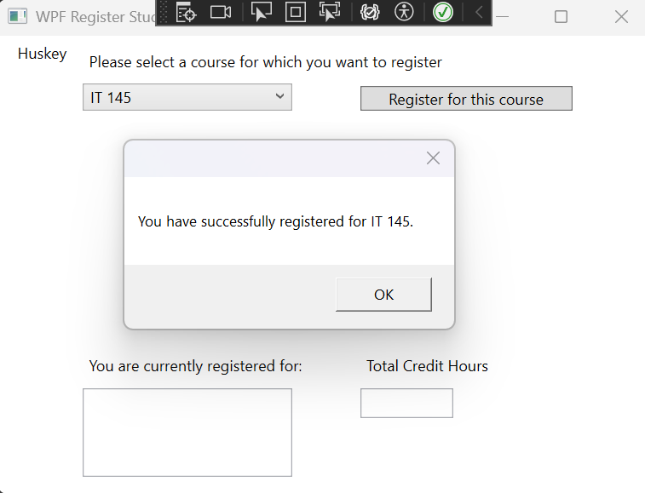
Description: This screenshot demonstrates a successful course registration in the WPF Register Student application. The student selected IT 145 and clicked the registration button. The program displayed a confirmation message indicating that the course was successfully registered. The application also added IT 145 to the registered-course list and updated the total credit hours to 3.
Screenshot 2: Duplicate Course Registration
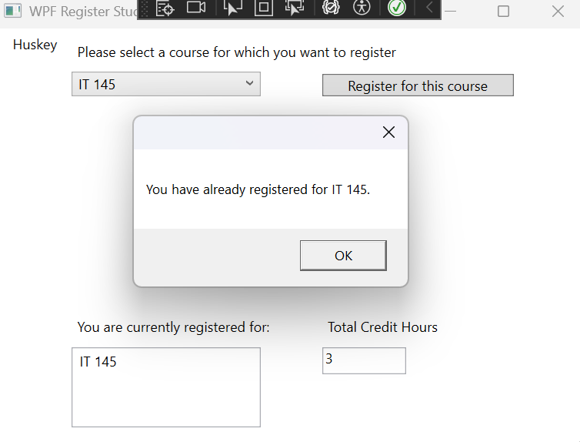
Description: This screenshot demonstrates how the program prevents duplicate course registrations. After successfully registering for IT 145, the student attempted to register for the same course again. The program displayed an error message stating that the student had already registered for IT 145. The registered-course list remained unchanged, and the total credit hours stayed at 3. This confirms that the program correctly enforces the rule preventing students from registering for the same course more than once.
Screenshot 3: Three-Course Registration
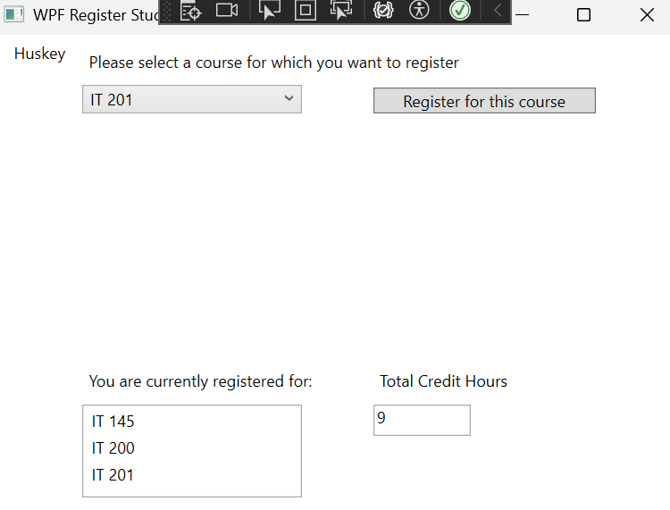
Description: This screenshot demonstrates that the program successfully registers multiple courses and correctly calculates the total credit hours. The student registered for IT 145, IT 200, and IT 201. Each course carries three credit hours, bringing the cumulative total to nine. All three courses appear in the registered-course list, confirming that the program correctly updates the list and total credit hours after each successful registration.

Screenshot 4: Maximum Credit-Hour Limit
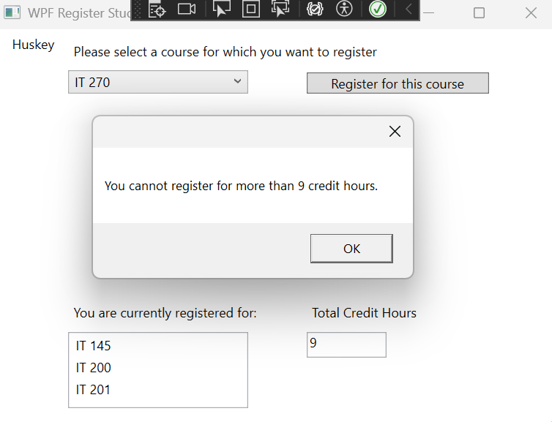
Description: This screenshot demonstrates how the program enforces the maximum registration limit of nine credit hours. After successfully registering for IT 145, IT 200, and IT 201, the student attempted to register for a fourth course, IT 270. The program displayed an error message stating that the student cannot register for more than nine credit hours. The registered-course list remained unchanged, and the total credit hours stayed at nine. This confirms that the program correctly prevents students from exceeding the maximum number of allowed courses.
C# Source Code — MainWindow.xaml.cs
using System;
using System.Collections.Generic;
using System.Linq;
using System.Text;
using System.Threading.Tasks;
using System.Windows;
using System.Windows.Controls;
using System.Windows.Data;
using System.Windows.Documents;
using System.Windows.Input;
using System.Windows.Media;
using System.Windows.Media.Imaging;
using System.Windows.Navigation;
using System.Windows.Shapes;

namespace WPFRegisterStudent
{
/// <summary>
/// Interaction logic for MainWindow.xaml
/// </summary>
public partial class MainWindow : Window
{
Course choice;
private int totalCreditHours = 0;
private const int maxCreditHours = 9;

public MainWindow()
{
InitializeComponent();
}

private void Window_Loaded(object sender, RoutedEventArgs e)
{

Course course1 = new Course("IT 145");
Course course2 = new Course("IT 200");
Course course3 = new Course("IT 201");
Course course4 = new Course("IT 270");
Course course5 = new Course("IT 315");
Course course6 = new Course("IT 328");
Course course7 = new Course("IT 330");

this.comboBox.Items.Add(course1);
this.comboBox.Items.Add(course2);
this.comboBox.Items.Add(course3);
this.comboBox.Items.Add(course4);
this.comboBox.Items.Add(course5);
this.comboBox.Items.Add(course6);
this.comboBox.Items.Add(course7);

this.textBox.Text = "";
}

private void button_Click(object sender, RoutedEventArgs e)
{
choice = (Course)(this.comboBox.SelectedItem);
if (choice == null)
{
MessageBox.Show("Please select a course.");
return;
}
if (choice.IsRegisteredAlready())
{
MessageBox.Show("You have already registered for " + choice.getName() + ".");
return;
}
if (totalCreditHours + 3 > maxCreditHours)
{
MessageBox.Show("You cannot register for more than 9 credit hours.");
return;
}
choice.SetToRegistered();
totalCreditHours += 3;

MessageBox.Show("You have successfully registered for " + choice.getName() + ".");

this.textBox.Text = totalCreditHours.ToString();

this.listBox.Items.Add(choice);
// TO DO - Create code to validate user selection (the choice object)
// and to display an error or a registation confirmation message accordinlgy
// Also update the total credit hours textbox if registration is confirmed for a selected course

}

}
}

