Digoxin Test vs. Digoxin Ref.
Pass/Fail is determined based on the allowable error, which is defined as the following.
< 2: ± 0.2 nmol/L
≥ 2: ±10%
The Reference Method (X) is: Digoxin Ref.
The Test Method (Y) is: Digoxin Test

Distribution of Measurements:
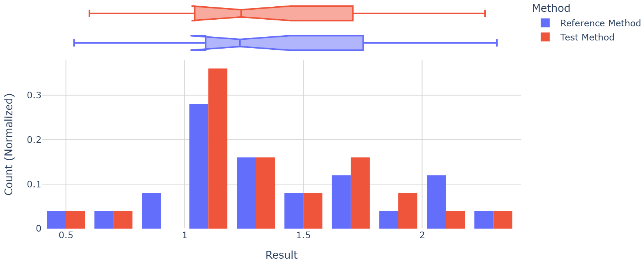
Variable | N | Mean ± SEM | Mean | SEM | SD | Min | Median | Max | %CV
Digoxin Ref. | 25 | 1.40+/-0.09 | 1.39588 | 0.091424 | 0.457122 | 0.534 | 1.233 | 2.315 | 32.75
Digoxin Test | 25 | 1.37+/-0.09 | 1.36692 | 0.087456 | 0.437281 | 0.599 | 1.238 | 2.265 | 31.99
Y-X | 25 | -0.029+/-0.008 | -0.02896 | 0.007819 | 0.039093 | -0.098 | -0.028 | 0.065 | -134.99
%(Y-X)/X | 25 | -1.6+/-0.7 | -1.60776 | 0.749668 | 3.748341 | -8.298 | -2.16 | 12.172 | -233.14

Regression & Bias Analysis
Regression is based on Deming method, assuming equal variance of both methods.
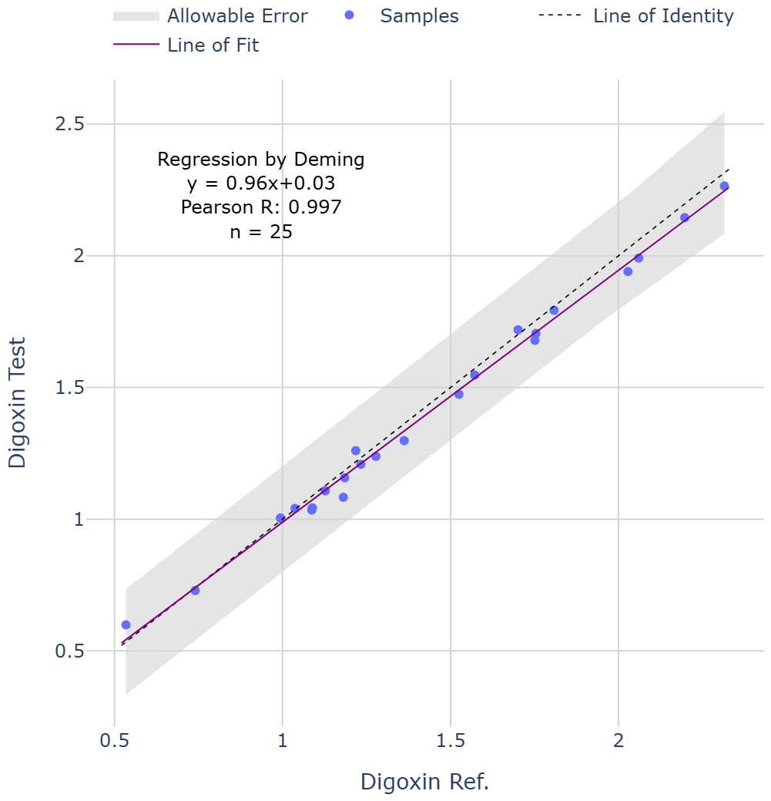
Comparison of Paired Measurements
Sample ID | Digoxin Ref. | Digoxin Test | Y-X | %(Y-X)/X | Pass/Fail
9 | 0.534 | 0.599 | 0.065 | 12.172 | pass
8 | 0.74 | 0.729 | -0.011 | -1.486 | pass
22 | 0.994 | 1.004 | 0.01 | 1.006 | pass
12 | 0.994 | 1.004 | 0.01 | 1.006 | pass
20 | 1.037 | 1.041 | 0.004 | 0.386 | pass
6 | 1.087 | 1.035 | -0.052 | -4.784 | pass
2 | 1.089 | 1.043 | -0.046 | -4.224 | pass
21 | 1.127 | 1.108 | -0.019 | -1.686 | pass
11 | 1.127 | 1.108 | -0.019 | -1.686 | pass
24 | 1.181 | 1.083 | -0.098 | -8.298 | pass
5 | 1.185 | 1.157 | -0.028 | -2.363 | pass
16 | 1.218 | 1.26 | 0.042 | 3.448 | pass
1 | 1.233 | 1.208 | -0.025 | -2.028 | pass
18 | 1.278 | 1.238 | -0.04 | -3.13 | pass
15 | 1.362 | 1.298 | -0.064 | -4.699 | pass
13 | 1.525 | 1.474 | -0.051 | -3.344 | pass
19 | 1.572 | 1.547 | -0.025 | -1.59 | pass
7 | 1.701 | 1.719 | 0.018 | 1.058 | pass
25 | 1.751 | 1.679 | -0.072 | -4.112 | pass
3 | 1.754 | 1.705 | -0.049 | -2.794 | pass
17 | 1.808 | 1.793 | -0.015 | -0.83 | pass
23 | 2.028 | 1.94 | -0.088 | -4.339 | pass
14 | 2.06 | 1.991 | -0.069 | -3.35 | pass
10 | 2.197 | 2.145 | -0.052 | -2.367 | pass
4 | 2.315 | 2.265 | -0.05 | -2.16 | pass

Difference Plots
