Lp(a) - Linearity Analysis
Regression is based on Ordinary Least Squares (OLS) regression. Shaded region represents the defined allowable performance limits.
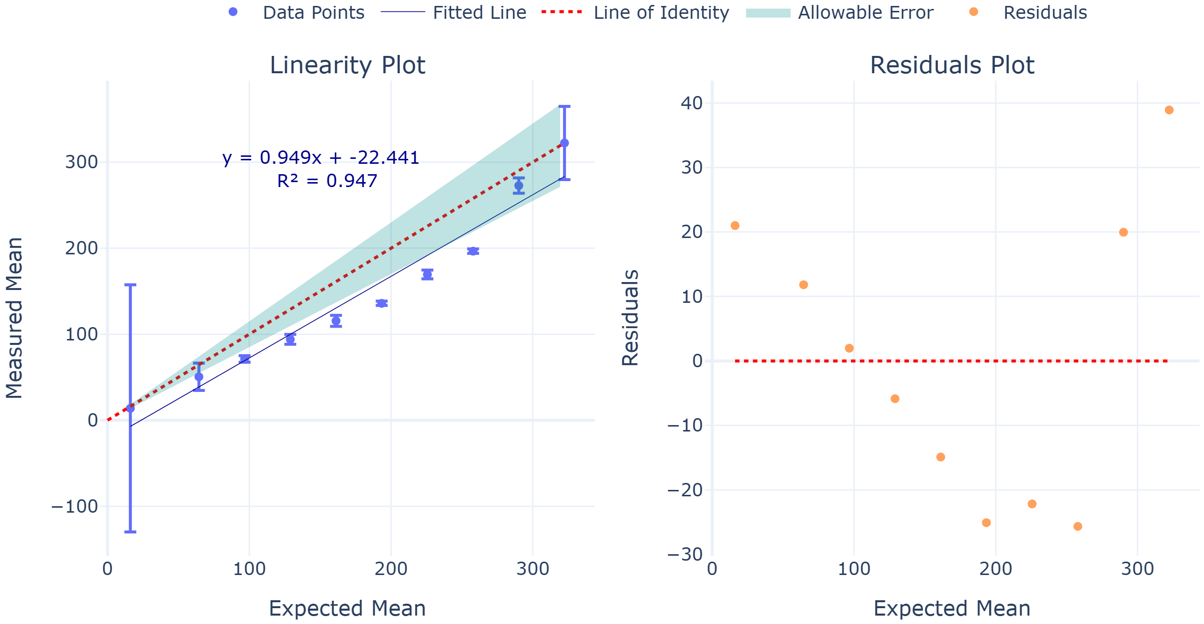
Summary of Linearity Results
Measured Mean | Expected Mean | Measured Mean Error | %Recovery
13.85 | 16.118 | 143.69 | 85.931
50.55 | 64.47 | 15.883 | 78.409
71.3 | 96.71 | 3.812 | 73.726
94.05 | 128.94 | 5.718 | 72.941
115.6 | 161.18 | 6.353 | 71.721
136.0 | 193.4 | 2.541 | 70.321
169.5 | 225.65 | 5.082 | 75.116
196.6 | 257.88 | 2.541 | 76.237
272.8 | 290.115 | 8.894 | 94.032
322.35 | 322.35 | 42.566 | 100.0

Linear interval assessed: 13.85 - 322.35 nmol/L

