Water Safe

Prakriti Biswas
Jennifer Magnus Gent
Elizabeth Lyman
Yuri Perdonati
Grant Roberts

Abstract

Water Safe is an Android app used to educate the user about any harmful bacteria, namely Enterococcus, when the user intends to go swimming or take a boat ride, or any other water utility sport. The waters of Martin County periodically suffer from algae blooms, and there is no app to inform smart phone users of the pollution. This app's great short coming is a lack of an internet database, which would allow it to update when new information is published.

Background

There are periodic water quality problems in the St. Lucie river and the cceans in Marin County. The excess nutrients promote algae blooms. Algae blooms block sunlight and reduce the oxygen in the water which leads to loss of sea grass and near shore coral reefs, the destruction of oyster beds, and fish kills. Sea grass and coral reefs are home to young fish, shellfish and other small marine life as well as being a food staple for many marine mammals. Oysters help to clean the water; one oyster can purify 50 gallons of water per day. In competition for the nutrients in the water, the algae blooms emit a bacteria that is toxic to the nerves system of other species. The toxic algae and the bacteria that it produces are very hazardous to the health of humans, animals and marine life. The human symptoms of contact include stomach and intestinal illness (nausea, upset stomach, diarrhea), allergic reactions (respiratory distress, eye irritations, skin rashes), and neurotoxic reactions (limb weakness or numbness, loss of memory, delusions). Children, pets, and those with immune deficiencies are at greater risk due to their size and compromised immune systems.
This app is targeted at users going to the beach, or boating in Martin County. There is a website run by the Flroida Department of Health that has water quality information on various counties in Florida. There is no smart phone friendly version of this site, and the information on water quality is not on the front page. Furthermore, internet access is required to retrieve infromation from the website, while Water Safe saves a recent water quality report locally. There is also an app called Toronto Beaches Water Quality, however the information is limited to select beaches in Toronto.
Users of this app can expect up to date infromation on the pollution levels of beaches and rivers in the Martin County area. The app has a menu with a list of all locations in the county that have water quality information issued to the public. There is also a map of Martin County and its locations for users who prefer it. If there is a reported presence of the bacteria a health advisory is issued to warn the users. Along with this advisory are specific numbers of the concentration of the bacteria Enterococcus in the water. There is a news section of the app where users can access links to news websites on Martin County water quality. Finally, there is information in the app about the bacteria and what different advisories mean. An entire screen is dedicated to what the bacteria is and why people should be concerned that it is in their swimming water.
Programming Methods
The prototype for Water Safe was created using App Inventor. The app was developed with the Eclipse IDE and made functional using the Java programming language. The Android 4.3 library was used for the android functionality. The UI is created in an .xml file. This file states exactly how an app will be visible to the user. This includes the layouts of the different widgets; like tables, buttons, text labels, icons, images; and their alignment to each other. Google maps v2 is used for the mapping functionality of the app.

Discussion

Water Safe is very similar to the comparable app, Toronto Beaches Water Quality. They have very similar functionality, in that they both have a menu with a list, a map, and an infromations screen. One major thing the app is missing is a database. Water Safe was originally intended to use the LAMP bundle to retrieve the most recent water quality reports for the app to use. If more time were available, a databse would be the most important feature to be added. Water Safe is also limited in scope to Martin County, but water pollution affects other regions in Florida. Incorporating other counties and adjusting the UI to handle other counties would make the app appeal to a wider audience.

Conclusion

This app is hopefully going to help the targeted users in remaining informed about the harmfull bacteria-infested locations. In that way they will be saved from any dire consequences that could have occurred when human beings come in contact with the harmfull bacteria, namely Enteroccus.

References

Florida Department of Health. Florida Healthy Beaches Program. Retrieved from
http://www.floridahealth.gov/healthy-environments/beach-water-quality/county-detail.html?County=Martin&Zip=34994-5060

Results

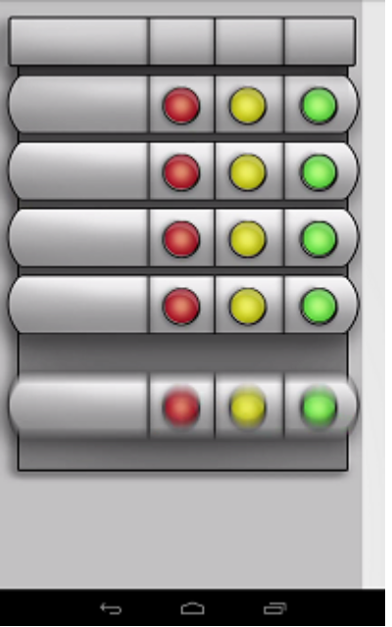
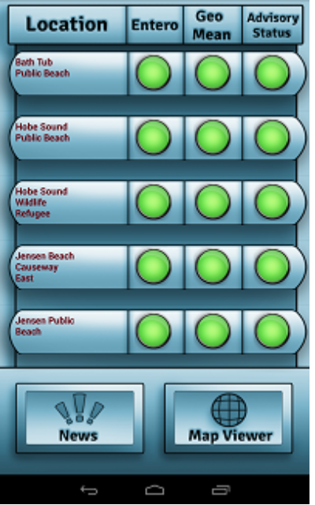
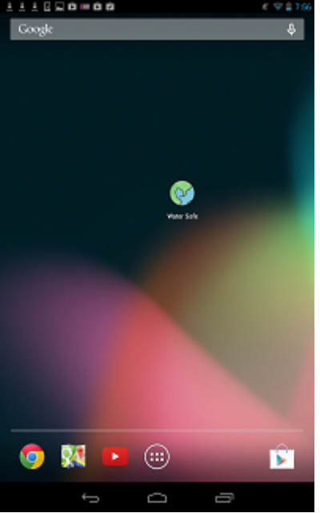
Icon Splash Screen Menu

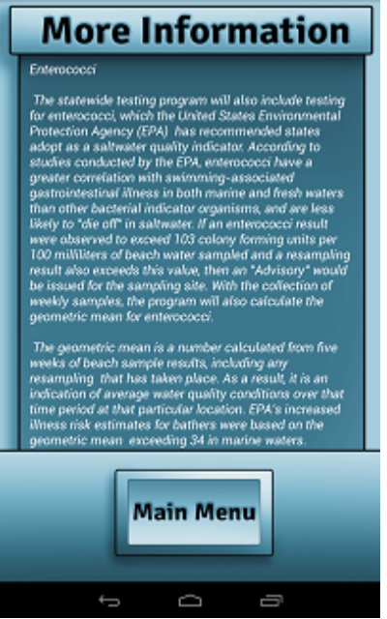
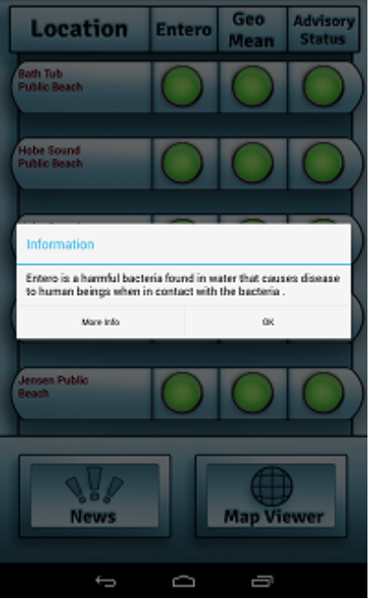
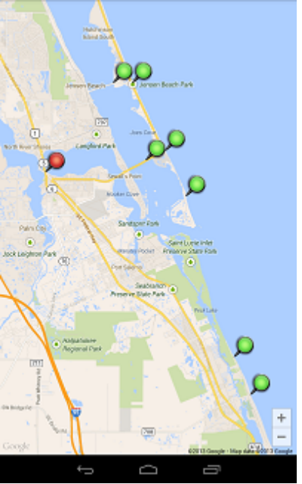
Pop-up More Information Map

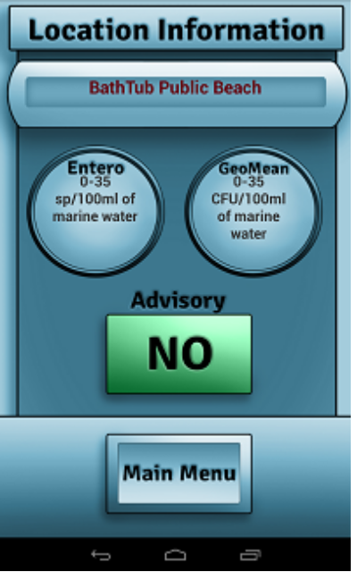
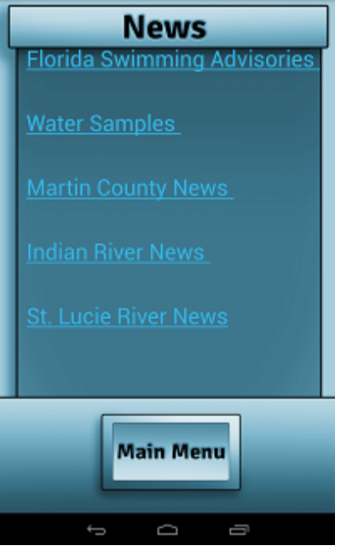
Report Links

